UNITED STATES
SECURITIES AND EXCHANGE COMMISSION
Washington, D.C. 20549

FORM 8-K

CURRENT REPORT
Pursuant to Section 13 OR 15(d)
of The Securities Exchange Act of 1934
Date of Report (Date of earliest event reported)
November 10, 2025

Bakkt Holdings, Inc.
(Exact name of registrant as specified in its charter)

Delaware |  | 001-39544 |  | 41-2324812
(State or Other Jurisdiction of  Incorporation or Organization) |  | (Commission  File Number) |  | (IRS Employer  Identification Number)
One Liberty Plaza, One Liberty St., Ste. 305-306,
New York, New York 10006
(Address of Principal Executive Offices)
Registrant’s telephone number, including area code: (678) 534-5849
(Address, including zip code, and telephone number, including area code, of registrant’s principal executive offices)

Check the appropriate box below if the Form 8-K filing is intended to simultaneously satisfy the filing obligation of the registrant under any of the following provisions (see General Instruction A.2. below):

☐ | Written communication pursuant to Rule 425 under the Securities Act (17 CFR 230.425)

☐ | Soliciting material pursuant to Rule 14a-12 under the Exchange Act (17 CFR 240.14a-12)

☐ | Pre-commencement communications pursuant to Rule 14d-2(b) under the Exchange Act (17 CFR 240.14d-2(b))

☐ | Pre-commencement communications pursuant to Rule 13e-4(c) under the Exchange Act (17 CFR 240.13e-4(c))
Securities registered pursuant to Section 12(b) of the Act:

Title of each class |  | Trading  Symbol(s) |  | Name of each exchange  on which registered
Class A Common Stock, par value $0.0001 per share |  | BKKT |  | The New York Stock Exchange
Warrants to purchase Class A Common Stock |  | BKKT WS |  | The New York Stock Exchange
Indicate by check mark whether the registrant is an emerging growth company as defined in Rule 405 of the Securities Act of 1933 (§230.405 of this chapter) or Rule 12b-2 of the Securities Exchange Act of 1934 (§240.12b-2 of this chapter).
Emerging growth company ☐
If an emerging growth company, indicate by check mark if the registrant has elected not to use the extended transition period for complying with any new or revised financial accounting standards provided pursuant to Section 13(a) of the Exchange Act. ☐

Item 2.02. | Results of Operations and Financial Condition.
On November 10, 2025, Bakkt Holdings, Inc. (the “Company”) held its conference call and webcast (the “Earnings Call”) with respect to its financial results for the quarter ended September 30, 2025. A copy of the script of the Earnings Call and the related presentation are attached hereto as Exhibits 99.1 and 99.2, respectively, and are hereby incorporated by reference.
The information in this Current Report on Form 8-K, including Exhibits 99.1 and 99.2, is furnished under Item 2.02 and shall not be deemed to be “filed” for purposes of Section 18 of the Securities Exchange Act of 1934, as amended (the “Exchange Act”), or otherwise subject to the liabilities of that section, nor shall it be deemed incorporated by reference into any of the Company’s filings under the Securities Act of 1933, as amended, or the Exchange Act, whether made before or after the date hereof, regardless of any general incorporation language in such filing, except as shall be expressly set forth by specific reference in such filing.

Item 9.01 | Exhibits.

Exhibit  No. |  | Description
99.1 |  | Script of Earnings Call.
99.2 |  | Slide Presentation entitled “Third Quarter 2025 Earnings Presentation”, dated November 10, 2025.
104 |  | Cover Page Interactive Data File (embedded within the Inline XBRL document).

SIGNATURE
Pursuant to the requirements of the Securities Exchange Act of 1934, the registrant has duly caused this report to be signed on its behalf by the undersigned, hereunto duly authorized.

BAKKT HOLDINGS, INC.
Date: November 12, 2025
/s/ Marc D’Annunzio
Name: Marc D’Annunzio
General Counsel and Secretary
Exhibit 99.1
Bakkt Holdings, Inc.
Bakkt Holdings, Inc. - Q3 2025 Earnings Call
Monday, November 10, 2025 8:30 AM

Event Participants
Executives 3
Cody Fletcher, Akshay Naheta, Karen Alexander
Analysts 3
Chris Brendler, Mark Palmer, Justin Pan

Operator Operator
Greetings, and welcome to the Bakkt’s Third Quarter 2025 Earnings Conference Call. [Operator Instructions]. As a reminder, today’s program is being recorded. I will now turn the call over to Cody Fletcher, Investor Relations Adviser at Bakkt. Please go ahead.
Cody Fletcher Executive
Hello, everyone. And thank you for joining Bakkt’s Third Quarter 2025 earnings call. Before we get started, I’d like to remind everyone that during today’s call, we may make certain forward-looking statements. These statements include, but are not limited to, our expectations regarding Bakkt’s transformation into a pure-play digital asset infrastructure company, the performance and future development of our Markets, Agent and Global, our international expansion strategy, including anticipated actions related to our Japan investment and future jurisdictions, our plans for platform upgrades, cost optimization, hiring and brand initiatives, expectations regarding the StableCoin, Bitcoin and tokenization markets and our outlook for 2026 KPIs in our planned Investor Day.

1/15

These statements are based on management’s current expectations and are subject to risks and uncertainties, which may cause actual results to differ materially from those expressed or implied in such forward-looking statements. For additional information regarding forward-looking statements and risk factors, please refer to our filings with the Securities and Exchange Commission.
Further, in addition to discussing results that are calculated in accordance with generally accepted accounting principles, we will also make reference to certain non-GAAP financial measures. For more detailed information on our non-GAAP financial disclosures, please refer to our full earnings release, which can be found on our Investor Relations website. Thank you.
And I will now turn the call over to Akshay.
Akshay Naheta Executive
Thank you, everyone. Thank you for joining the call. Today, our focus is around one clear mission to power the next generation of global finance. That clarity of purpose matters. It allows us to align our people, sharpen our strategy and channel our resources with conviction towards the future we see emerging.
Across the world, individuals and institutions are reevaluating what money really is, how it moves and how markets operate. We believe this shift will define the next era of global finance, and we see it unfolding across 3 major fronts. First, Bitcoins continue to rise as a globally recognized digital store of value, the new foundation for trust and savings. Second, the rapid transformation of banking and payments accelerated by AI and stablecoins, which are reshaping how value flows through the economy. And third, the tokenization of real-world assets, redefining how everything from bonds to commodities to property is traded and settled in the future.
Bakkt stands at the center of this evolution, building the compliance, secure and scalable infrastructure that enables these systems to connect and grow. Our vision is simple, yet bold, to be the trusted bridge between the physical and digital world of finance, enabling seamless value transfer as society accelerates into an AI-driven economy. If we take a step back, it’s clear the evolution of global finance is already underway, and the scale of opportunity is extraordinary. Out of an estimated $700 trillion in global assets, only a small fraction currently live on blockchain rails. That’s rapidly changing as digital infrastructure becomes increasingly integrated into traditional systems.

2/15

Bitcoin continues to gain acceptance as a credible treasury asset among corporates, sovereigns and institutions. Stablecoins, meanwhile, now settle over $30 trillion annually surpassing Visa and new policy frameworks such as the U.S. Genius Act, are establishing clear regulatory guardrails that legitimize this market. At the same time, tokenization is moving from pilots to production. Financial institutions are beginning to issue and settle assets on programmable rails with BCG forecasting nearly $19 trillion in tokenized value by 2033.
The takeaway, the total addressable market for digital asset infrastructure is enormous, and we are still in the very early innings. Bakkt is positioning itself at the center of this transformation with a regulated rails custody and settlement layer that will power this ecosystem. We are aligning our capital talent and road map to deliver tangible outcomes shaped by these powerful global trends. This quarter represents an important milestone in Bakkt’s journey.
[PREVIOUSLY REPORTED CONTENT INTENTIONALLY OMITTED FOR PURPOSES OF FURNISHING THIS EXHIBIT PURSUANT TO ITEM 2.02 OF FORM 8-K.]
On the balance sheet, we closed the quarter with approximately $64 million in cash and restricted cash and no debt, reflecting disciplined execution and a significantly strengthened financial foundation.
While I’m pleased with these results, I want to be absolutely clear, this is just the beginning. The heavy lifting of our transformation is largely behind us, and I expect to complete the process by the end of Q4 as the elements of our restructuring, product launches, distribution partnership and cost initiatives all start coming together. This quarter also affirms the strength of our Bakkt Global business model, a framework built for durability and scale. It validates the structural and strategic changes we made are already translating into tangible performance. And as we look ahead, I’ll walk you through the decisive actions we’ve taken since I became CEO, what remains in our road map and how Bakkt is uniquely positioned to power the structural rearchitecture of global finance.
When I stepped in as CEO following the Cooperation Agreement with DTR, Bakkt was spread too thin, a collection of disconnected initiatives burdened by noncore assets and inefficient cost structure and a lack of strategic focus that had built up over years of missteps. We acted with immense urgency. Over the past 2.5 quarters, we’ve executed a disciplined and deliberate transformation, one that touched every part of the business. We exited noncore operations, reconstituted the Board, streamlined our organization and refocused entirely around one mission, building a leading regulated digital asset infrastructure platform. We rebuilt Bakkt from the ground up, simplifying our technology stack, reducing external dependencies and attracting top-tier talent to lead our 3 core verticals.

3/15

Bakkt Markets, Bakkt Agent and Bakkt Global, which I’ll discuss shortly. We also strengthened governance and leadership. Phillip Lord, our President of International, is driving our expansion across Japan, Korea and India, connecting us to some of the world’s most dynamic capital markets. Ankit Khemka, our Chief Product Officer, who was the former Head of Growth at Revolut is accelerating innovation and integration across our products primarily on the stablecoin front. At the Board level, we previously welcomed Mike Alfred and Lyn Alden, and today, I’m very pleased to welcome Richard Galvin, 3 deeply independent thinkers and accomplished entrepreneurs.
These are not professional “directors” collecting fees. Each conducted their own diligence, challenged our assumptions and joined the Board after gaining conviction in our vision, our road map and the integrity of our transformation. That engagement brings institutional discipline and intellectual rigor to Bakkt’s covenants, not box sticky. We eliminated structural overhangs, significantly reduced costs and strengthened our balance sheet. Today, every dollar we spend is driving monetization through trading spreads, custody fees, stablecoin flows and recurring revenues.
This has not just been a cleanup exercise but instead a full-scale reboot of the company that is now ready for the exciting disruption currently underway for the next few decades of finance. And we did it at what many would consider lightning speed. As we approach the end of Q4, our transformation enters its final phase. From here the focus shifts from transformation to acceleration, integrating our platforms, expanding our regulated custody and advancing strategic partnerships across markets and stablecoin infrastructure. A key milestone this quarter was the simplification of our capital structure.
In Q3, we announced, and on November 3 close, the collapse of our Up-C structure, eliminating the dual-class share system that dates back to our deSPAC in 2021. That structure serves its purpose early on, but over time, it’s become a total drag. It added complexity, reduced liquidity and created friction for institutional investors. With the Up-C collapse complete, Bakkt now operates as one company, one cap table, one mission. Shareholders, management and employees are now aligned under a single corporate entity, a major step forward in transparency, governance and shareholder alignment.
We also strengthened our balance sheet. Between Q2 and Q3, we raised roughly $100 million in new capital and eliminated all outstanding debt giving Bakkt a cleaner, stronger financial foundation. We carry more than $120 million of tax loss carryforwards, a valuable asset that will offset future taxable income as profitability scale. To underscore my own conviction, I personally invested about $1.5 million in Bakkt shares in August through open market purchases. And as of October 31, shareholders have authorized me to purchase up to 13.4 million more stock through an option plan.

4/15

I view this not as a signal, but as a statement of belief. I’m fully aligned with our shareholders for the long term. And let me make one point very clear, Bakkt is not in the business of perpetual equity issuance. We are not “a digital asset treasury vehicle” chasing exposure through dilution. We’ve turned the corner financially, debt-free, disciplined and focused.
Any future capital raising will be done strategically, selectively and with a deep respect for shareholder value. This new structure and capital position gives us the flexibility to pursue opportunities, but always with the discipline and alignment that shareholders expect and that I personally demand. With our foundation reset and capital structure simplified, we are now focused on what defines Bakkt our 3 growth engines: Markets, Agent and Global. Bakkt markets is the foundation. It provides institutional-grade infrastructure for digital assets, connecting clients to liquidity, market-making and regulated custody through our nationwide money transmission licenses and New York BIT license.
This is how institutions trade on Bakkt, compliant, efficient and secure. Bakkt Agent is how money moves. It’s our programmable finance platform, combining stablecoins, AI agents and cross-border payments into one seamless system, making sending, spending, saving and transacting as easy as messaging. This positions Bakkt at the heart of the stablecoin adoption wave and global remittance demand. Bakkt Global takes our technology into new jurisdictions through a minority investment model designed to generate investment gains and our long-term recurring revenue.
We started in Japan where early progress in validating the model, and we’ll share more updates as it scales in the quarters ahead. Together, these businesses form a unified regulated digital asset company, connecting how markets trade, how money moves and how value is stored. Let’s start with Bakkt Markets, our core business, the engine of our infrastructure and the foundation of how modern digital markets will eventually trade in my opinion. This division is primarily U.S.-based and built around a simple but powerful flywheel, market infrastructure, balance sheet strength and regulatory licensing, each reinforcing the other as volumes grow and liquidity deepens. Our regulated core is anchored by MTL licenses across the U.S. and our New York BIT license. It’s designed for institutional-grade performance, offering deep liquidity, stablecoin on and off ramps, OTC trading and secure custody through the new partnership of Bakkt ICE Storage with Intercontinental Exchange scheduled to launch in Q1 2026. We are also expanding through Bakkt FX and evolution of our brokerage-in-a-box business. It provides a single point of access for B2B2C clients to route, trade, settle and custody assets, serving exchanges, fintechs and brokers that want to operate compliantly in the U.S. without building the regulatory stack themselves.

5/15

Together, these elements make Bakkt Markets, the engine room of our platform compliant, connected and built to scale.
Next, Bakkt Agent is how money moves seamlessly, intelligently and globally. Stablecoins have become one of the most disruptive forces in modern finance. They’re reshaping how money is stored, sent and earned at a fraction of the cost of legacy rails. Bakkt Agent is our response, a programmable finance platform operating behind the scenes as the AI-driven architecture powering the next wave of digital banking. Under the hood, Bakkt Agent is an AI-first modular stack, built from the ground up.
Multiple AI agents coordinate workflows across payments, compliance and treasury, integrating with partner banks, card networks and payment providers worldwide. The result is a white label customizable foundation that allows any partner to launch a neobank grade experience quickly and compliantly. Rather than building a direct-to-consumer business, our model is distribution partnerships driven and asset-light. Partners embed Bakkt Agent into their products, leveraging our licensing coverage, global partnerships and modern APIs without the heavy integration costs. Through our conversational interface, Zaira we are starting with cross-border remittances, a nearly $850 billion market, where consumers still pay up to 7% fees.
Bakkt Agent enables faster, cheaper and more intuitive transfers built for scale. At its core, Bakkt Agent is the programmable financial stack unifying global money movement, rewards and AI-driven finance into one seamless platform. We expect to announce significant distribution partnerships in the near term as we move to a scale rollout in the quarters ahead. Bakkt Global is where our infrastructure model meets international scale, enabling entry into high-value markets while compounding long-term shareholder value. At its core, Bakkt Global may give our shareholders look through exposure to Bitcoin through publicly listed entities and select jurisdictions if those entities decide to pursue a strategy to hold Bitcoin on their balance sheet.
When these entities deploy capital into Bitcoin, Bakkt earns recurring custody and management fees by being the lowest cost regulated provider to these entities, while our shareholders indirectly participate in Bitcoin upside. Each of these entities will maintain independent governance and boards to ensure transparency and credibility. Our first investment is already underway in Japan for which the EGM is set for November 11 and where we expect the company, Bitcoin Japan Corporation, to outline its strategy. This model deliberately extends our markets and agent infrastructure globally, enabling us to own minority stakes in high-potential jurisdictions, expand our footprint, compound fee income and generate recurring revenue, all while maintaining discipline on capital intensity. As we look ahead for 2026 KPIs, I want to provide a clear view of how Bakkt makes money going forward ahead of the Investor Day scheduled for some time in Q1 2026.

6/15

Our model is diversified, recurring and designed to compound as we scale dramatically over the coming quarters. Across markets, Agent and Global, each vertical contributes revenue streams, each reinforcing the other. Bakkt Markets generates B2B and B2B2C revenue through market-making OTC spreads, trading volume and lending fees, the core liquidity engine of the platform. Bakkt Agent earns stablecoin on-ramp, off-ramp revenue from transaction volume, spreads and FX conversion, powered by our AI-first architecture and embedded through distribution partnerships. Bakkt Global adds licensing, management fees, NAV accretion and investment gains from our minority holdings in international partners.
Together, these form a resilient multilayered revenue engine where Markets provides liquidity, Agent drives stablecoin and payment flows and Global expands our reach into new jurisdictions that can amplify both. As we look across our milestones for the fourth quarter, our goals are clear: Bakkt aims to complete its transformation while strengthening the core engine that will position us to drive growth in 2026. Everything we’ve done, the operational reset, technology upgrades and cost optimization moves in one direction towards a leaner, faster and more disciplined platform built for scale and sustained profitability for which we’ve already seen the green shoots in this quarter’s results. At the same time, we’re expanding our reach across all 3 growth engines. In Markets, we are driving customer growth, completing key technology upgrades that will enhance liquidity and trading performance.
For Bakkt Agent, we are opening new distribution corridors and advancing partnerships that will expand our stablecoin and cross-border flows and through Bakkt Global, we are extending our infrastructure into additional jurisdictions beyond Japan continuing to do so in a capital-light disciplined manner. We are also staying focused on the foundation, continuing to fine-tune our cost base, bringing in exceptional talent and rolling out the refreshed brand and website much needed that will reflect who we are today. As we released our 2026 KPIs and prepare for our to-be-announced Investor Day in Q1, shareholders will have a clear line of sight into how all these pieces come together into one cohesive strategy. And if we keep with the baseball analogy, I’ve been using on X recently, it feels like we are at the top of the ninth. The transformation innings are nearly behind us.
Now it’s about execution, closing out the quarter cleanly, staying focused and finishing strong. By December 31, I’m feeling quite confident sitting here that we’ll be able to look back and call this turnaround complete at that time. With that, I’d like to hand over the call to Karen Alexander, our CFO, for a deeper dive into the financials. Karen?

7/15

Karen Alexander Executive
Thank you, Akshay. Before I get into the numbers, I want to acknowledge that this quarter still reflects some residual impact from our Loyalty business, which remains part of our results through year-end 2025. This means you’ll continue to see some accounting noise as we report both continuing and discontinued operations. While this may make the GAAP figures appear uneven, the underlying economics of our core digital asset business are much clearer when you look at our adjusted metrics. As a reminder, beginning in Q1 2026, once Loyalty is fully behind us, our financial reporting will be clean and directly aligned with the diversified revenue model, Akshay, outlined earlier.
For the quarter, total GAAP revenue was $402 million, up 27% year-over-year, primarily driven by higher crypto trading activities. Crypto costs and execution clearing and brokerage fees increased proportionately consistent with volume growth. Operating expenses, excluding those costs, were roughly flat at $26.7 million, reflecting lower compensation and SG&A following restructuring initiatives. Excluding about $5 million of nonrecurring restructuring charges, operating expenses would have declined by over 18% year-over-year, demonstrating continued cost discipline.
[PREVIOUSLY REPORTED CONTENT INTENTIONALLY OMITTED FOR PURPOSES OF FURNISHING THIS EXHIBIT PURSUANT TO ITEM 2.02 OF FORM 8-K.]
These measures better represent the earnings power of our digital asset infrastructure platform. They exclude discontinued operations and onetime noncash items, such as fair value changes and warrants, allowing investors to see the true progress of our core business. We expect the remaining transition noise to taper through year-end by Q1 2026, Bakkt’s financials will be — will fully reflect the leaner, more focused company we’ve rebuilt with clear visibility into sustainable growth and profitability. Turning to the balance sheet.
We ended the quarter with $64 million in cash, cash equivalents and restricted cash and importantly, no long-term debt. As we complete our transformation, this balance sheet reflects a disciplined financial foundation, strong liquidity, no structural overhangs and sufficient flexibility to support both near-term commitments and future growth. We expect to use a portion of this cash in the fourth quarter to close the Loyalty divestiture and fund working capital, as we complete the transition to a pure-play digital asset platform. In our financial statements this quarter, you’ll also notice the inclusion of current and noncurrent assets held for sale, which represents the Loyalty business and associated balances. Upon closing, these will roll off the balance sheet, leaving behind a streamlined digital asset infrastructure company that clearly reflects the economics of our continuing operations.

8/15

Our focus remains on maintaining a resilient and efficient balance sheet, ensuring that we have the liquidity and flexibility to execute on our road map, pursue strategic opportunities responsibly and continue delivering long-term value for shareholders. With that, I’ll hand it back to Akshay for closing remarks.
Akshay Naheta Executive
Thank you, Karen. To reiterate, this quarter marks another important step forward in Bakkt’s transformation. As we move through the fourth quarter, you’ll begin to see the changing of the guard, a new Bakkt taking shape. What’s emerging reflects the culmination of a year of tough decisions, disciplined execution and the establishment of a foundation built for scale and long-term profitability. The heavy lifting is largely behind us, and the momentum heading into 2026 is not just exciting, it’s real.
The structure is now in place. The strategy is clear and the alignment across our people, partners and shareholders has never been stronger. Over the coming weeks, we’ll work to finalize the remaining elements of this transformation. And by the time we speak again, I’m confident Bakkt will have completed its restructuring phase and will be operating with a clear line of sight to sustain profitable growth in 2026 and beyond. To our partners, our customers and especially our shareholders, thank you for your continued trust, patience and belief in what we are building.
That concludes our third quarter 2025 earnings call. I’ll hand it back to the operator.
Operator Operator
[Operator Instructions] And our first question comes from the line of Chris Brendler from Rosenblatt Securities.
Chris Brendler Analyst
Congrats on the progress here. I’d just like to think about the business as it stands today? And maybe, Akshay, if you could sort of give us a little more insight on to the core offerings on the sort of the brokerage side? And how that might compare to Bakkt Zero Hash is offering? I think that’s been a pretty major transaction in the space.

9/15

And it feels like they’re kind of similar to what Bakkt is doing, but I feel like I’m not quite sure where all the dots connect and how this sort of fits from a competitive standpoint. So maybe you could help me with that sort of area of questioning sort of how is Bakkt compared to Zero Hash?
Akshay Naheta Executive
Sure. Look, I think as far as Bakkt and Zero Hash, the direct comparison is concerned, I think we’re both looking at being the picks and shovels layer, the regulated infrastructure that lets the ecosystem operate securely and at scale. I think there are lots of similarities and comparisons on that front. And as you can see, I think there is a lot of talk around stablecoins and the new payment rails these days. And so from my perspective, when I look at everything that’s happening in the space from the recent M&A activity, whether it’s Zero Hash and others as well as private market valuations in the space, you can really draw your own conclusions in terms of what their value is relative to Bakkt, et cetera.
But I think that, look, we bring a pretty similar product suite just on the Bakkt Markets business relative to Zero Hash, except that we are doing this in a public setting where we plan on doing it without any heavy burn and not chasing top line volume and revenue growth, which is not profitable and doing it in a disciplined manner. So that’s my perspective on this from what I know.
Chris Brendler Analyst
Okay. Great. Very exciting. Towards the back of the slides on your milestones. #9 is release KPIs for 2026.
I’m not looking for a sneak preview of what your targets are. But what are the key KPIs? If you can talk about them at this point, just sort of what should we be following here to monitor the progress on the new Bakkt?
Akshay Naheta Executive
So look, that’s the reason why I laid out the slide earlier because I knew that there would be this question around key KPIs for 2026. And the slide earlier gives you exactly how we look at our business in terms of how the revenues are generated and how that all flows down to the bottom line. And so I would just say that in terms of KPIs, I think it will be driven from each of these 6 different boxes that I’ve highlighted. And the key variable for each of these boxes to actually make money and for it to actually flow down into revenues and then finally into profit. So I think when you look at Bakkt Markets, as an example, it will be around trading volume and the spreads that we are generating — spreads and fees that we’re generating, which then flows down to revenue.

10/15

So that’s very straightforward. On the Bakkt Agent side, I think you’d look at something around stablecoin transaction volume and the combined blended spread and FX conversion rates that we are making on that front. And when it comes to Bakkt Global, I think you’re looking at 2 aspects of it. One is the NAV accretion of our investments that we are making because that’s —all of the investments that we’re making are booked based on an equity method of accounting.
So for example, our $11 million investment or so in Japan is today worth significantly higher than that, but we haven’t put it through the P&L statement. And so that’s something that sits on our balance sheet marked that at — sorry, at our cost value. But — however, depending on — as I mentioned in my prepared remarks, depending on whether these companies, that we invest in, decide to go and pursue a Bitcoin treasury strategy or want to leverage some of our technology and license that, then there will be additional licensing and recurring revenue in terms of revenues that we’ll end up generating. And I think we’ll give you more color on all of these fronts as we go ahead and release the KPIs for 2026.
Operator Operator
And our next question comes from the line of Mark Palmer from Benchmark.
Mark Palmer Analyst
I know you touched on this during your prepared remarks, but just wanted to dig into it a little bit more, can you talk about the role of partnerships, joint ventures on the one hand and M&A on the other as potential accelerants of each of the company’s strategies?
Akshay Naheta Executive
So we are very focused on organic growth, Mark, for the moment. And so I can’t really speak too much about M&A because we really haven’t thought about that. But in terms of distribution partnerships, as I said, we are — we’ve been hard at work to work on these distribution partnerships. In my prepared remarks, I alluded to the fact that we expect to have something that we can publicly share with everyone over the next — over the coming quarter or two. And I think that is actually one of the gating factors for actually releasing the KPIs because until we get this in hand or are very close to doing it, we don’t want to go out and release the KPIs.
So our model is to grow through partnerships because that’s the best way to grow. We don’t want to be consumer-facing directly. I think that costs a lot of money to go out and expand and spend the money on customer acquisition costs. And so we will definitely continue pursuing a distribution-led partnership model to get the volumes onto the platform, and we look forward to updating everyone as and when we are ready to announce these partnerships publicly.

11/15

Mark Palmer Analyst
Congratulations on the progress.
Akshay Naheta Executive
Thank you.
Operator Operator
[Operator Instructions] Our next question comes from the line of Justin Pan from Clear Street.
Justin Pan Analyst
It’s Justin on for Brian. Obviously, a ton of exciting work over the past quarters on [ deploying ] the structure of the business and paving a clear path for next year. I guess when we think about ‘26, what are some of the considerations on both the macro and the policy side you would call out that would be both potential tailwinds and headwinds to growth as we think about the outlook for 2026?
Akshay Naheta Executive
I mean, the most exciting thing is the CLARITY Act that’s hopefully going to get passed soon, certainly, hopefully, next year. I think that’s a very exciting development for us. And just getting the regulatory clarity as it relates to real-world asset tokenization is a big opportunity for us in general. Other than that, I think not much else on the policy front in the U.S. I think the administration has already paved away.
And from day 1, they’ve declared their intention to make sure that America becomes a crypto capital of the world. And increasingly, it’s already — if it hasn’t already become that, it’s definitely well along its way to become that.
I think the other thing that’s very exciting is looking at all of these very large financial institutions getting their sleeves rolled out to participate in the stablecoin space because we are the picks and shovels, and we are stablecoin agnostic, and I just see a very, very bright future in terms of volume growth, cross currency, stablecoin FX-related growth and so on. And so we built a business which is ready to take advantage of all of those opportunities that lie ahead of us. And like I said, we’re very early in the story, very, very early innings for what’s to transpire here over the next several decades. So that’s my view.

12/15

Justin Pan Analyst
Got it. That’s helpful. And just one more for me. You talked a bit about your international expansion model, beginning with Japan. I guess could you touch on some geographies that you’re focused on next?
And what’s the strategy for scaling beyond the U.S. and Europe?
Akshay Naheta Executive
I think the model is the same. I explained it in my prepared remarks. But I think, look, you’re going to hear from the company in Japan tomorrow, there is the EGM tomorrow. And I think it will become clearer as to what that company’s strategy is going forward. The other jurisdictions that I alluded to in my prepared remarks are South Korea and India.
And again, the idea will be to see what we can leverage on the markets and agent infrastructure side to grow in these high potential jurisdictions and expanding our footprint, so that we are very focused on our core market, which is the U.S., but then these companies are leveraging either our product services or technology to then grow, but then also give back some licensing and other revenue back to Bakkt.
Operator Operator
If there are no further questions from analysts, I’ll pass the call back to Cody Fletcher for some questions from the retail community.
Cody Fletcher Executive
Thank you, operator. We have our first question from X user at [indiscernible] 333. His question was Visa, Mastercard, Zelle, they’re all now talking about stablecoins. So how can Bakkt kind of compete with these companies. Akshay, you want to take this one?
Akshay Naheta Executive
I mean, it’s similar to what Chris was alluding to as it relates to Zero Ash. But look, I’ll answer this as well. So it’s a fair question. We don’t really see ourselves competing head-on with the big card networks of peer-to-peer systems. What Bakkt is doing is more of the picks and shovels layer, the regulated infrastructure that lets the whole ecosystem operate securely and at scale.
And so there’s a lot being said about stablecoins and new payment rails these days, and it’s a good thing because it validates the overall direction that we are heading in. But there are still some very big gaps in how those systems work, particularly around compliance, custody, the payment rails and then the integration of it all into the TradFi rails.

13/15

And for Bakkt, the cooperation agreement with DTR brings those capabilities directly inside Bakkt. And that really gives us a very solid footing as this market continues to evolve and grow materially over years to come, in my opinion. So the fintech space is huge. That’s why I left a very lucrative career to be involved in this space because I believe that it’s never going to be a winner-take-all space. It’s that big.
Different players can coexist, some consumer-facing, others like us providing the regulated backbone underneath. And if you look at, generally speaking, what’s happening in terms of the recent M&A activity, by some of the very companies that you were mentioned in the questions and the private market valuations in the space, you can draw your own conclusions. Many of these companies are being bought by the very large names that were mentioned while they might not be showing any top line growth and are doing it with a lot of heavy burn and with our profitability. At least that’s what the bankers are telling us. So we are taking a much more disciplined approach.
We’re building a sustainable compliant business that can scale responsibly and as the transformation ramps up here at year-end, I think that discipline combined with where the broader market is headed would speak for itself as to what Bakkt is building at this end. Hope that answers the question.
Cody Fletcher Executive
That’s great. And our last question here is from another X user at [ Amir X Trades ]. Amir said, being invested in your company for 4-plus years like so many other shareholders, Bakkt time and time again loses all of its gains due to poor decisions and lack of updates. What will this new leadership team do differently to improve shareholder value over time.
Akshay Naheta Executive
So yes, Amir and a few other users on X have messaged me from time to time directly or tweeted at me, and I completely understand their frustration. I mean this is exactly why this new leadership team came in to fix the structure, clean up the balance sheet and refocus Bakkt on its core mission. I definitely cannot control or manage the company based on short-term stock price moves. As Mr. Buffett famously says, in the short term, the markets are voting machine.
But in the long term, it’s a weighing machine. And our job really is to build the kind of substance that the market will weigh over time.

14/15

I believe we’ve made a lot of strong progress on the transformation, and we expect to have it largely completed by year-end. Either before year-end or at our Investor Day in Q1 ‘26, we’ll share clear KPIs. We hope to announce the distribution partnerships that are currently being worked out, and we’ll outline the next phase of our road map accordingly. And I hope that, Amir, you will see that progress and you’ll continue supporting us as a long-term shareholder. Back to you, Cody.
Cody Fletcher Executive
Thanks, Akshay. That’s all the questions we have in retail. So back to you, operator, to close this out.
Operator Operator
Certainly. Thank you, ladies and gentlemen, for your participation in today’s conference.

15/15
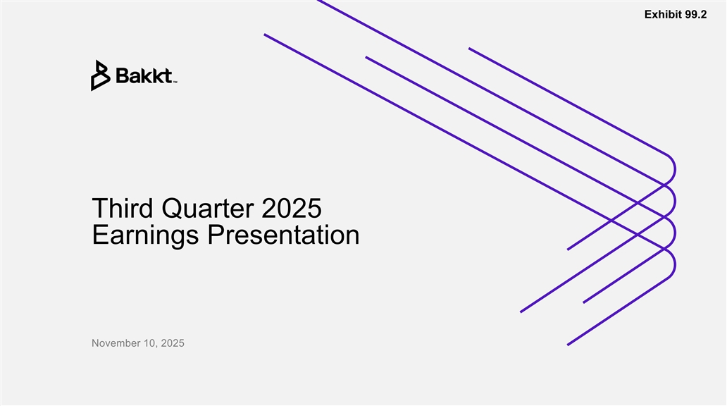
Exhibit 99.2 Third Quarter 2025 Earnings Presentation November 10, 2025

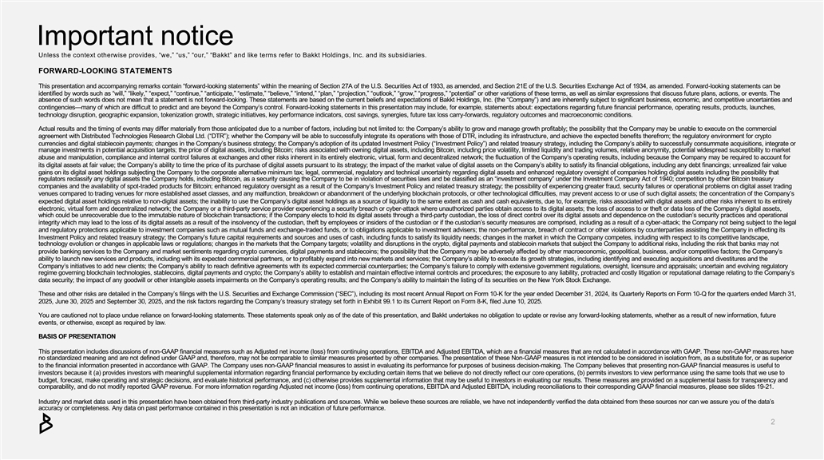
Important notice Unless the context otherwise provides, “we,” “us,” “our,” “Bakkt” and like terms refer to Bakkt Holdings, Inc. and its subsidiaries. FORWARD-LOOKING STATEMENTS This presentation and accompanying remarks contain “forward-looking statements” within the meaning of Section 27A of the U.S. Se curities Act of 1933, as amended, and Section 21E of the U.S. Securities Exchange Act of 1934, as amended. Forwar-d looking statements can be identified by words such as “will,” “likely,” “expect,” “continue,” “anticipate,” “estimate,” “believe,” “intend,” “plan,” “p rojection,” “outlook,” “grow,” “progress,” “potential” or other variations of these terms, as well as similar expressions that id scuss future plans, actions, or events. The absence of such words does not mean that a statement is not forward -looking. These statements are based on the current beliefs a nd expectations of Bakkt Holdings, Inc. (the “Company”) and are inherently subject to significant business, economic, and com petitive uncertainties and contingencies—many of which are difficult to predict and are beyond the Company’s control. Forward -looking statements in this presentation may include, for example, statements about: expectations regarding future financial performance, operating results , products, launches, technology disruption, geographic expansion, tokenization growth, strategic initiatives, key performance indicators, cost sav ings, synergies, future tax loss carry-forwards, regulatory outcomes and macroeconomic conditions. Actual results and the timing of events may differ materially from those anticipated due to a number of factors, including bu t not limited to: the Company’s ability to grow and manage growth profitably; the possibility that the Company may be unable to execute on the commercial agreement with Distributed Technologies Research Global Ltd. (“DTR”); whether the Company will be able to successfully integr ate its operations with those of DTR, including its infrastructure, and achieve the expected benefits therefrom; the regulatory nv e ironment for crypto currencies and digital stablecoin payments; changes in the Company’s business strategy; the Company's adoption of its update d Investment Policy (“Investment Policy”) and related treasury strategy, including the Company’s ability to successfully consumma te acquisitions, integrate or manage investments in potential acquisition targets; the price of digital assets, including Bitcoin; risks associated with ow ning digital assets, including Bitcoin, including price volatility, limited liquidity and trading volumes, relative anonymity, p otential widespread susceptibility to market abuse and manipulation, compliance and internal control failures at exchanges and other risks inherent in its entirely electoni r c, virtual, form and decentralized network; the fluctuation of the Company’s operating results, including because the Compan y may be required to account for its digital assets at fair value; the Company’s ability to time the price of its purchase of digital assets pursuant to its ts rategy; the impact of the market value of digital assets on the Company’s ability to satisfy its financial obligations, includi ng any debt financings; unrealized fair value gains on its digital asset holdings subjecting the Company to the corporate alternative minimum tax; legal, commercial, regul atory and technical uncertainty regarding digital assets and enhanced regulatory oversight of companies holding digital assetsnc i luding the possibility that regulators reclassify any digital assets the Company holds, including Bitcoin, as a security causing the Company to be in vilo ation of securities laws and be classified as an “investment company” under the Investment Company Act of 1940; competition by ot her Bitcoin treasury companies and the availability of spot-traded products for Bitcoin; enhanced regulatory oversight as a result of the Company’s nv I estment Policy and related treasury strategy; the possibility of experiencing greater fraud, security failures or operation al problems on digital asset trading venues compared to trading venues for more established asset classes, and any malfunction, breakdown or abandonment of the uder n lying blockchain protocols, or other technological difficulties, may prevent access to or use of such digital assets; the con centration of the Company’s expected digital asset holdings relative to non-digital assets; the inability to use the Company’s digital asset holdings as a s ource of liquidity to the same extent as cash and cash equivalents, due to, for example, risks associated with digital asset s and other risks inherent to its entirely electronic, virtual form and decentralized network; the Company or a third -party service provider experiencing a security breach or cyber-attack where unauthorized parties obtain access to its digital assets; the loss of access to or theft or data loss of the Company’s digital assets, which could be unrecoverable due to the immutable nature of blockchain transactions; if the Company elects to hold its digitl aassets through a third-party custodian, the loss of direct control over its digital assets and dependence on the custodian’s secr uity practices and operational integrity which may lead to the loss of its digital assets as a result of the insolvency of the custodian, theft by employees or insiders of the custodian or if the custodian’s security measures are comprised, including as a result of a cyber -attack; the Company not being subject to the legal and regulatory protections applicable to investment companies such as mutual funds and exchange -traded funds, or to obligations applicable to investment advisers; the non-performance, breach of contract or other violations by counterparties assisting the C ompany in effecting its Investment Policy and related treasury strategy; the Company’s future capital requirements and sources and uses of cash, inc udi l ng funds to satisfy its liquidity needs; changes in the market in which the Company competes, including with respect to its o cmpetitive landscape, technology evolution or changes in applicable laws or regulations; changes in the markets that the Company targets; volatily it and disruptions in the crypto, digital payments and stablecoin markets that subject the Company to additional risks, including the risk that banks may not provide banking services to the Company and market sentiments regarding crypto currencies, digital payments and stablecoins;t he possibility that the Company may be adversely affected by other macroeconomic, geopolitical, business, and/or competitive fac tors; the Company’s ability to launch new services and products, including with its expected commercial partners, or to profitably expand into ne w markets and services; the Company’s ability to execute its growth strategies, including identifying and executing acquisitions and divestitures and the Company’s initiatives to add new clients; the Company’s ability to reach definitive agreements with its expected commercial oun c terparties; the Company’s failure to comply with extensive government regulations, oversight, licensure and appraisals; uncer tain and evolving regulatory regime governing blockchain technologies, stablecoins, digital payments and crypto; the Company’s ability to establish and ma intain effective internal controls and procedures; the exposure to any liability, protracted and costly litigation or reputation al damage relating to the Company’s data security; the impact of any goodwill or other intangible assets impairments on the Company’s operating results; and the Company’s ability to maintain the listing of its securities on the New York Stock Exchange. These and other risks are detailed in the Company’s filings with the U.S. Securities and Exchange Commission (“SEC”), includ ng i its most recent Annual Report on Form 10-K for the year ended December 31, 2024, its Quarterly Reports on Form 10 -Q for the quarters ended March 31, 2025, June 30, 2025 and September 30, 2025, and the risk factors regarding the Company’s treasury strategy set forth in Exhiit b 99.1 to its Current Report on Form 8-K, filed June 10, 2025. You are cautioned not to place undue reliance on forward -looking statements. These statements speak only as of the date of thispr esentation, and Bakkt undertakes no obligation to update or revise any forward -looking statements, whether as a result of new information, future events, or otherwise, except as required by law. BASIS OF PRESENTATION This presentation includes discussions of non-GAAP financial measures such as Adjusted net income (loss) from continuing operatons i , EBITDA and Adjusted EBITDA, which are a financial measures that are not calculated in accordance with GAAP. These non -GAAP measures have no standardized meaning and are not defined under GAAP and, therefore, may not be comparable to similar measures presented by other companies. The presentation of these Non-GAAP measures is not intended to be considered in isolation from, as a substitute or f , or as superior to the financial information presented in accordance with GAAP. The Company uses non -GAAP financial measures to assist in evaluating its performance for purposes of business decision-making. The Company believes that presenting non-GAAP financial measures is useful to investors because it (a) provides investors with meaningful supplemental information regarding financial performance by exclu ding certain items that we believe do not directly reflect our core operations, (b) permits investors to view performance using the same tools that we use to budget, forecast, make operating and strategic decisions, and evaluate historical performance, and (c) otherwise provides sup plemental information that may be useful to investors in evaluating our results. These measures are provided on a supplemental as b is for transparency and comparability, and do not modify reported GAAP revenue. For more information regarding Adjusted net income (loss) from contiui nng operations, EBITDA and Adjusted EBITDA, including reconciliations to their corresponding GAAP financial measures, please se e slides 19-21. Industry and market data used in this presentation have been obtained from third -party industry publications and sources. While we believe these sources are reliable, we have not independently verified the data obtained from these sources nor can we asur se you of the data’s accuracy or completeness. Any data on past performance contained in this presentation is not an indication of future performnc a e.

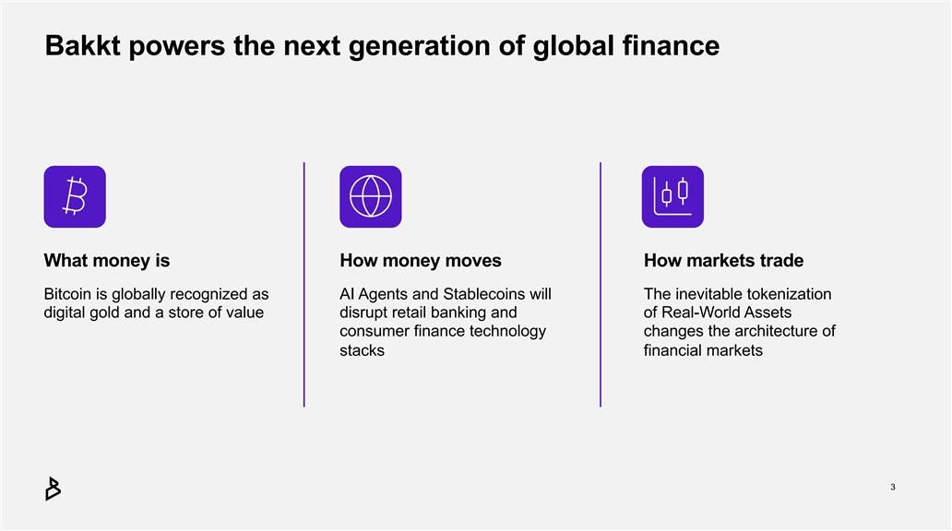
Bakkt powers the next generation of global finance What money is How money moves How markets trade Bitcoin is globally recognized as AI Agents and Stablecoins will The inevitable tokenization digital gold and a store of value disrupt retail banking and of Real-World Assets consumer finance technology changes the architecture of stacks financial markets 3

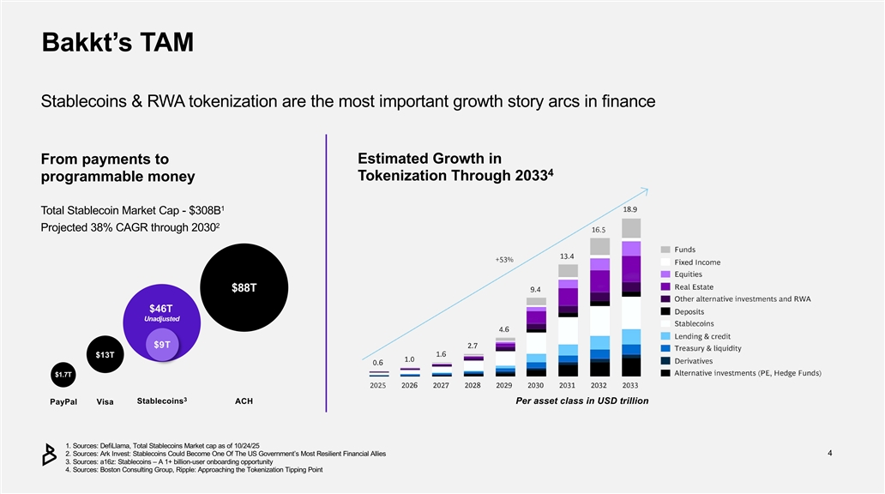
Bakkt’s TAM Stablecoins & RWA tokenization are the most important growth story arcs in finance Estimated Growth in From payments to 4 Tokenization Through 2033 programmable money 1 Total Stablecoin Market Cap - $308B 2 Projected 38% CAGR through 2030 $88T $46T U nadjusted $ 9 T $13T $1.7T 3 Stablecoins ACH Per asset class in USD trillion PayPal Visa 1. Sources: DefiLlama, Total Stablecoins Market cap as of 10/24/25 2. Sources: Ark Invest: Stablecoins Could Become One Of The US Government’s Most Resilient Financial Allies4 3. Sources: a16z: Stablecoins – A 1+ billion-user onboarding opportunity 4. Sources: Boston Consulting Group, Ripple: Approaching the Tokenization Tipping Point

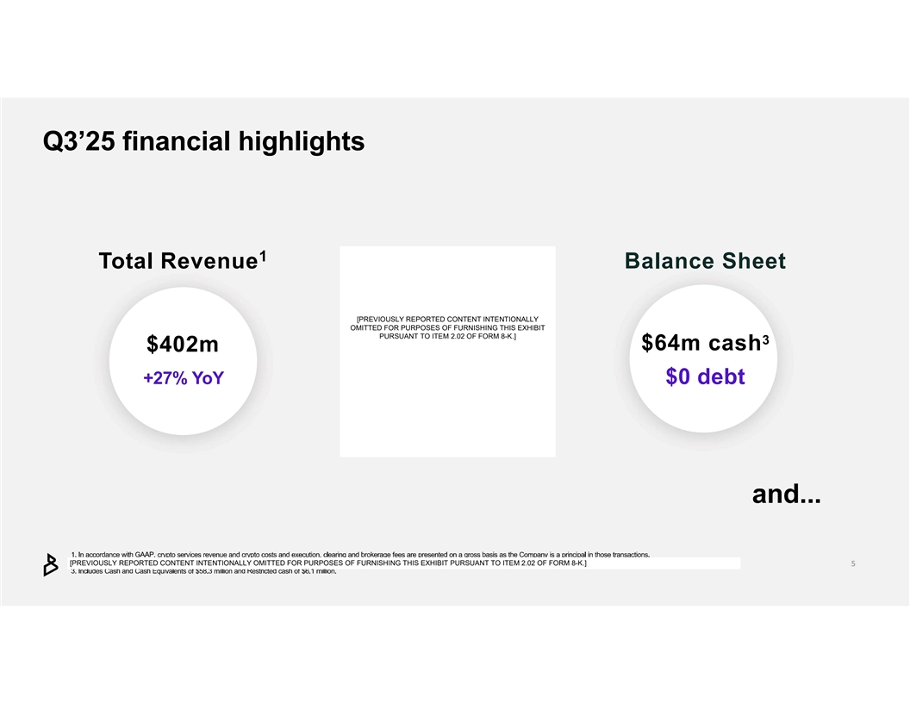
[PREVIOUSLY REPORTED CONTENT INTENTIONALLY OMITTED FOR PURPOSES OF FURNISHING THIS EXHIBIT PURSUANT TO ITEM 2.02 OF FORM 8-K.] [PREVIOUSLY REPORTED CONTENT INTENTIONALLY OMITTED FOR PURPOSES OF FURNISHING THIS EXHIBIT PURSUANT TO ITEM 2.02 OF FORM 8-K.]

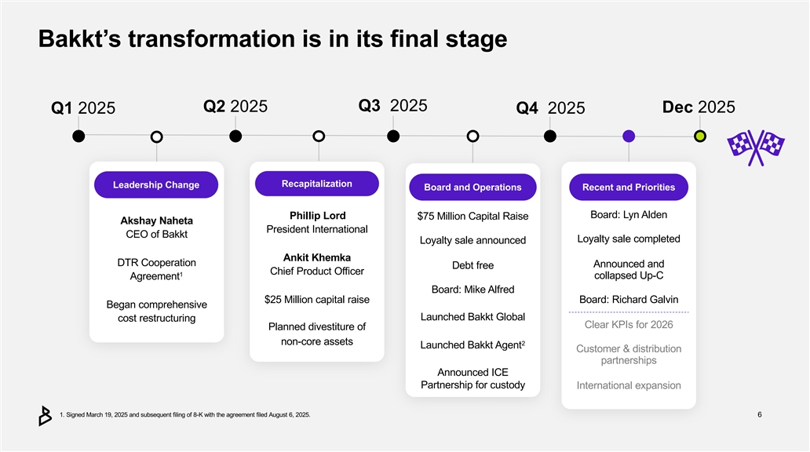
Bakkt’s transformation is in its final stage Q3 2025 Q2 2025 Dec 2025 Q1 2025 Q4 2025 Recapitalization Leadership Change Board and Operations Recent and Priorities Board: Lyn Alden Phillip Lord $75 Million Capital Raise Akshay Naheta President International CEO of Bakkt Loyalty sale completed Loyalty sale announced Ankit Khemka DTR Cooperation Announced and Debt free Chief Product Officer 1 collapsed Up-C Agreement Board: Mike Alfred $25 Million capital raise Board: Richard Galvin Began comprehensive Launched Bakkt Global cost restructuring Clear KPIs for 2026 Planned divestiture of non-core assets 2 Launched Bakkt Agent Customer & distribution partnerships Announced ICE Partnership for custody International expansion 1. Signed March 19, 2025 and subsequent filing of 8-K with the agreement filed August 6, 2025.6

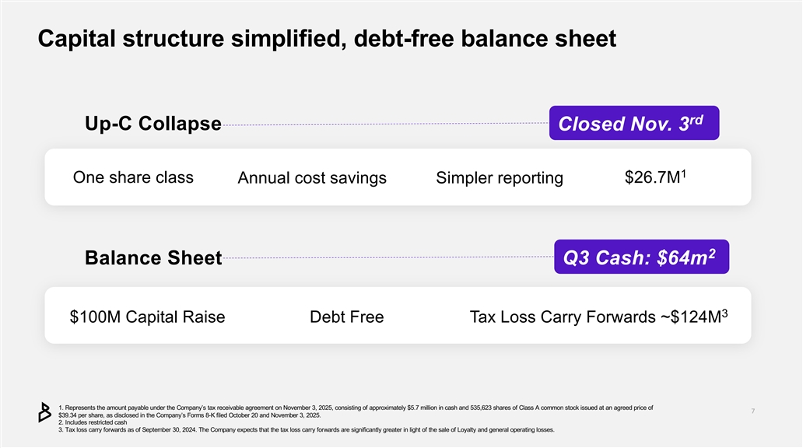
Capital structure simplified, debt-free balance sheet rd Up-C Collapse Closed Nov. 3 1 One share class Annual cost savings Simpler reporting $26.7M 2 Balance Sheet Q3 Cash: $64m 3 $100M Capital Raise Debt Free Tax Loss Carry Forwards ~$124M 1. Represents the amount payable under the Company’s tax receivable agreement on November 3, 2025, consisting of approximately $5.7 million in cash and 535,623 shares of Class A common stock issued at an agreed price of $39.34 per share, as disclosed in the Company’s Forms 8-K filed October 20 and November 3, 2025. 2. Includes restricted cash 3. Tax loss carry forwards as of September 30, 2024. The Company expects that the tax loss carry forwards are significantly rg eater in light of the sale of Loyalty and general operating losses.

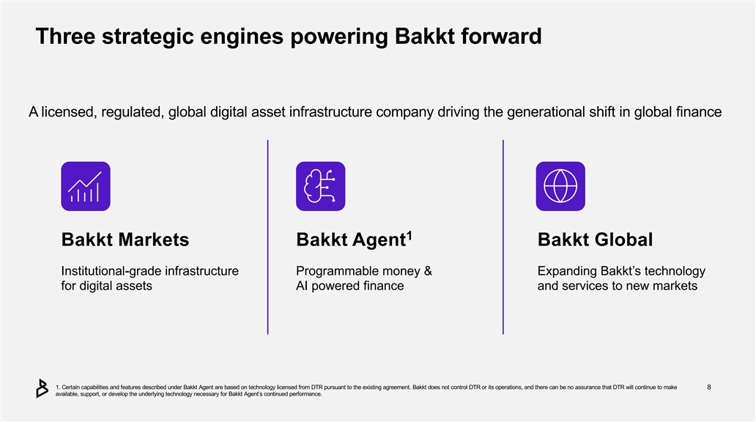
Three strategic engines powering Bakkt forward A licensed, regulated, global digital asset infrastructure company driving the generational shift in global finance 1 Bakkt Markets Bakkt Agent Bakkt Global Institutional-grade infrastructure Programmable money & Expanding Bakkt’s technology for digital assets AI powered finance and services to new markets 1. Certain capabilities and features described under Bakkt Agent are based on technology licensed from DTR pursuant to the existing agreement.B akkt does not control DTR or its operations, and there can be no assurance that DTR will continue to make 8 available, support, or develop the underlying technology necessary for Bakkt Agent’s continued performance.

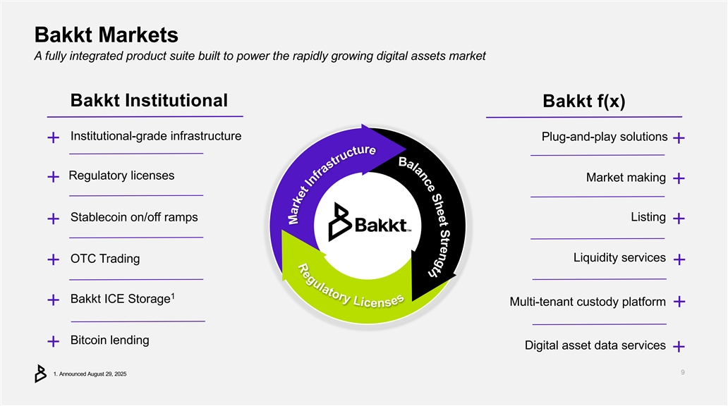
Bakkt Markets A fully integrated product suite built to power the rapidly growing digital assets market Bakkt Institutional Bakkt f(x) Institutional-grade infrastructure Plug-and-play solutions ++ ++ Regulatory licenses Market making ++ ++ Listing Stablecoin on/off ramps ++ ++ Liquidity services OTC Trading ++ ++ 1 Bakkt ICE Storage ++ Multi-tenant custody platform ++ Bitcoin lending ++ Digital asset data services ++ 1. Announced August 29, 2025

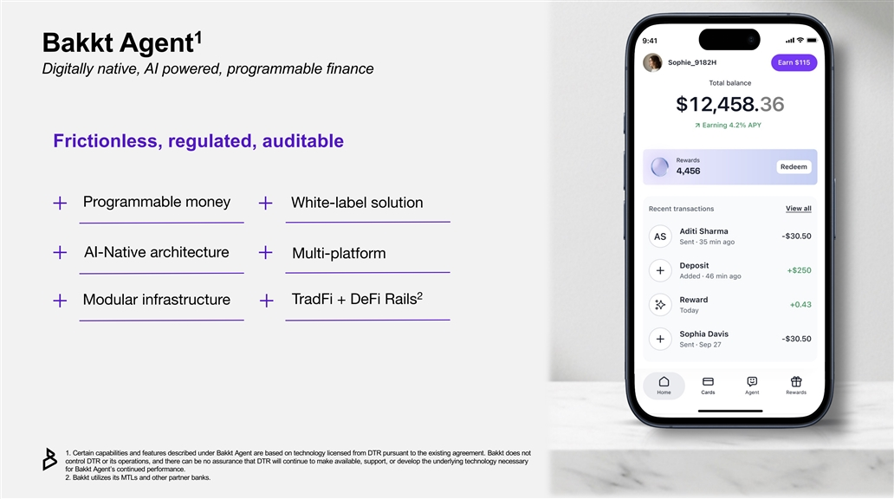
1 Bakkt Agent Digitally native, AI powered, programmable finance Frictionless, regulated, auditable Programmable money White-label solution + + AI-Native architecture Multi-platform + + 2 TradFi + DeFi Rails Modular infrastructure + + 1. Certain capabilities and features described under Bakkt Agent are based on technology licensed from DTR pursuant to the existing agreement.B akkt does not control DTR or its operations, and there can be no assurance that DTR will continue to make available, support, or develop te hunderlying technology necessary for Bakkt Agent’s continued performance. 2. Bakkt utilizes its MTLs and other partner banks.

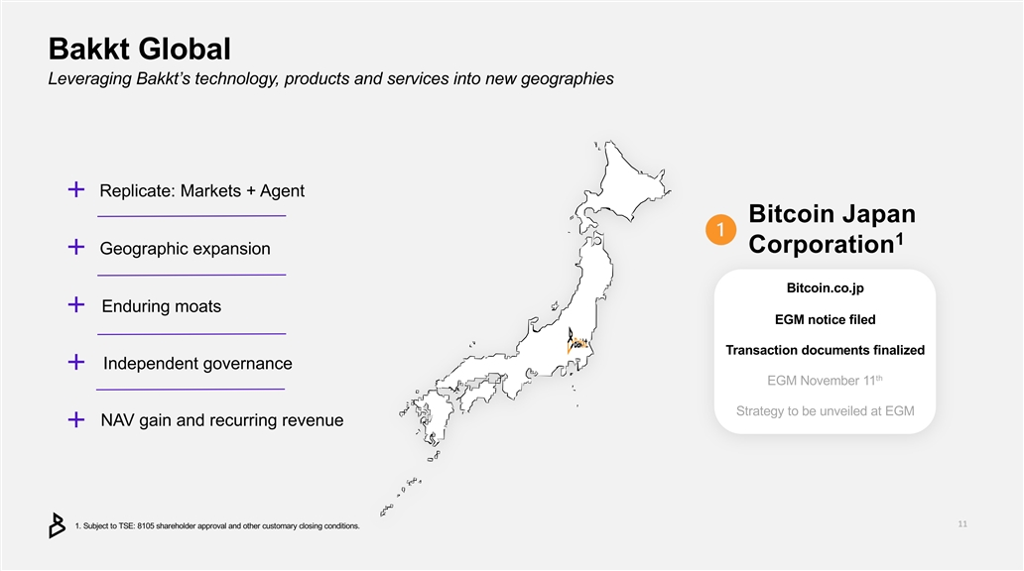
Bakkt Global Leveraging Bakkt’s technology, products and services into new geographies ++ Replicate: Markets + Agent Bitcoin Japan 1 Corporation ++ Geographic expansion Bitcoin.co.jp ++ Enduring moats EGM notice filed Transaction documents finalized Independent governance ++ th EGM November 11 Strategy to be unveiled at EGM NAV gain and recurring revenue ++ 1. Subject to TSE: 8105 shareholder approval and other customary closing conditions.

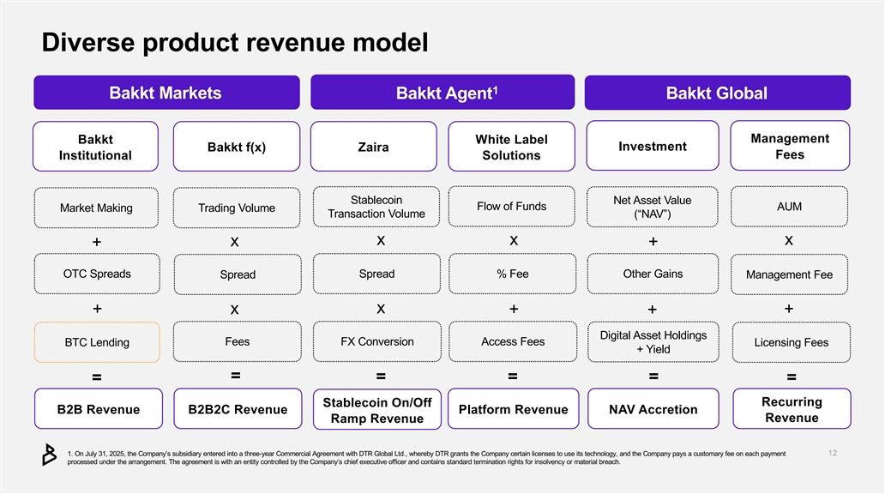
Diverse product revenue model 1 Bakkt Markets Bakkt Agent Bakkt Global Management Bakkt White Label Investment Bakkt f(x) Zaira Fees Institutional Solutions Stablecoin Net Asset Value Flow of Funds AUM Market Making Trading Volume Transaction Volume (“NAV”) x x x x + + OTC Spreads Spread % Fee Other Gains Spread Management Fee x + x + + + Digital Asset Holdings Fees FX Conversion Access Fees BTC Lending Licensing Fees + Yield = = = = = = Recurring Stablecoin On/Off B2B Revenue B2B2C Revenue Platform Revenue NAV Accretion Revenue Ramp Revenue 1. On July 31, 2025, the Company’s subsidiary entered into a three -year Commercial Agreement with DTR Global Ltd., whereby DTR g rants the Company certain licenses to use its technology, and the Company pays a customary fee on each payment processed under the arrangement. The agreement is with an entity controlled by the Company’sc hief executive officer and contains standard termination rights for insolvency or material breach.

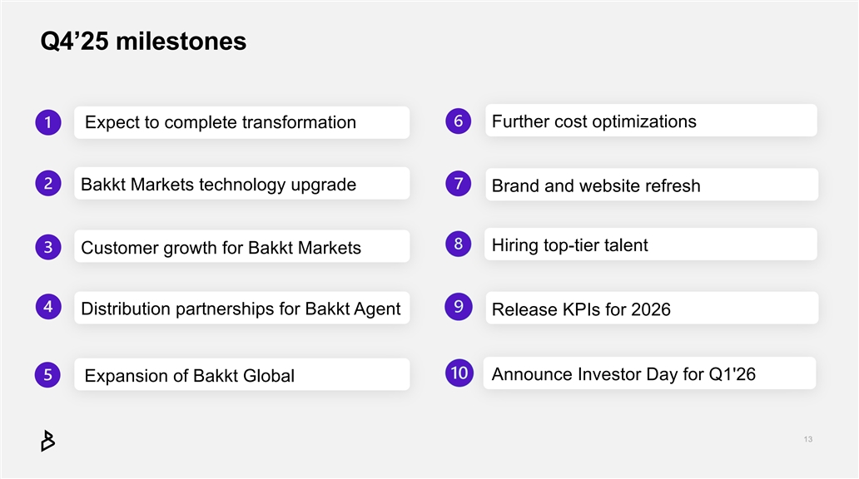
Q4’25 milestones Further cost optimizations Expect to complete transformation Bakkt Markets technology upgrade Brand and website refresh Hiring top-tier talent Customer growth for Bakkt Markets Distribution partnerships for Bakkt Agent Release KPIs for 2026 Announce Investor Day for Q1'26 Expansion of Bakkt Global

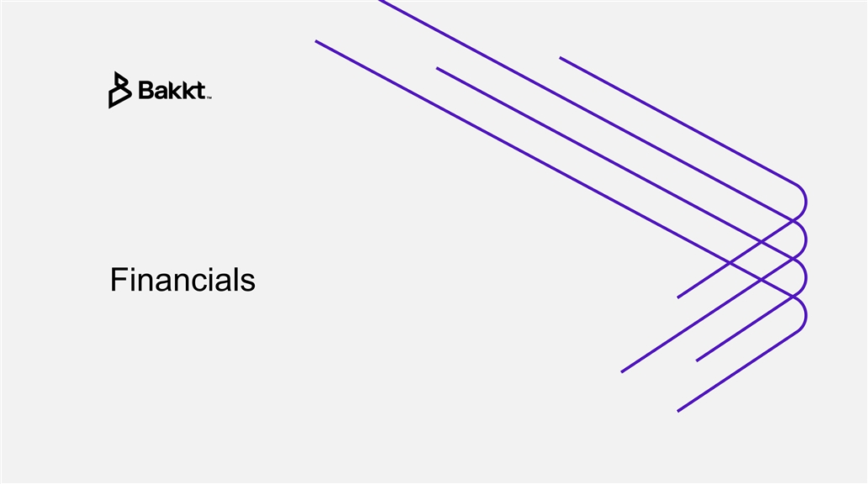
Financials

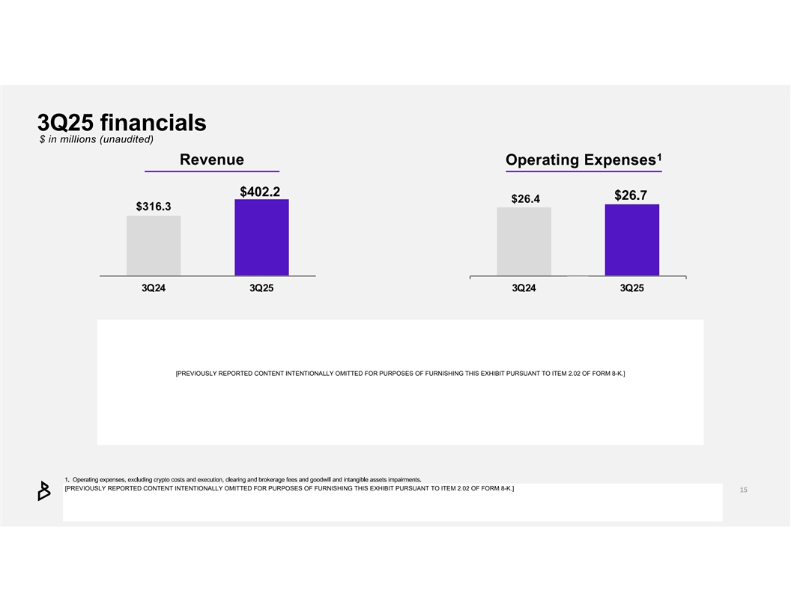
[PREVIOUSLY REPORTED CONTENT INTENTIONALLY OMITTED FOR PURPOSES OF FURNISHING THIS EXHIBIT PURSUANT TO ITEM 2.02 OF FORM 8-K.] [PREVIOUSLY REPORTED CONTENT INTENTIONALLY OMITTED FOR PURPOSES OF FURNISHING THIS EXHIBIT PURSUANT TO ITEM 2.02 OF FORM 8-K.]

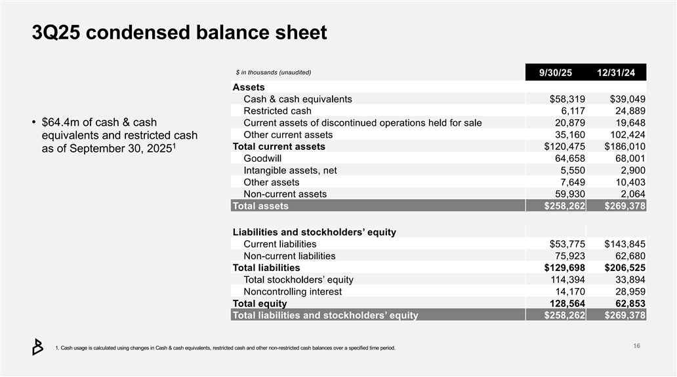
3Q25 condensed balance sheet $ in thousands (unaudited) 9/30/25 12/31/24 Assets Cash & cash equivalents $58,319 $39,049 Restricted cash 6,117 24,889 • $64.4m of cash & cash Current assets of discontinued operations held for sale 20,879 19,648 Other current assets 35,160 102,424 equivalents and restricted cash 1 Total current assets $120,475 $186,010 as of September 30, 2025 Goodwill 64,658 68,001 Intangible assets, net 5,550 2,900 Other assets 7,649 10,403 Non-current assets 59,930 2,064 Total assets $258,262 $269,378 Liabilities and stockholders’ equity Current liabilities $53,775 $143,845 Non-current liabilities 75,923 62,680 Total liabilities $129,698 $206,525 Total stockholders’ equity 114,394 33,894 Noncontrolling interest 14,170 28,959 Total equity 128,564 62,853 Total liabilities and stockholders’ equity $258,262 $269,378 1. Cash usage is calculated using changes in Cash & cash equivalents, restricted cash and other non -restricted cash balances over a specified time period.

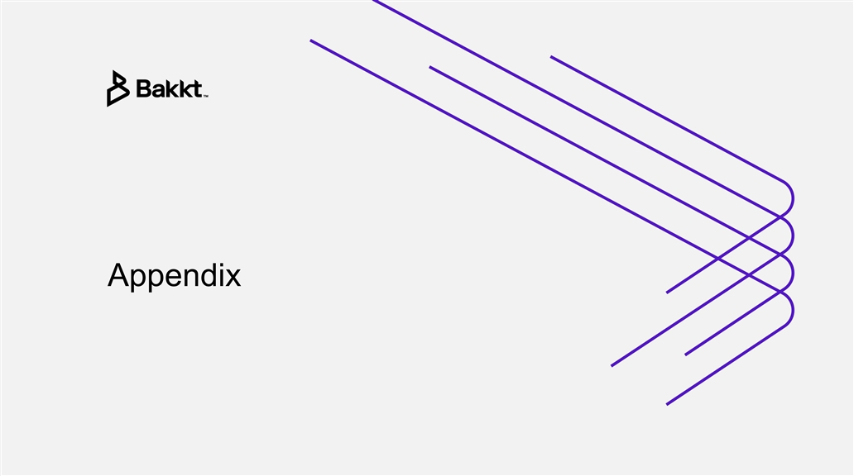
Appendix

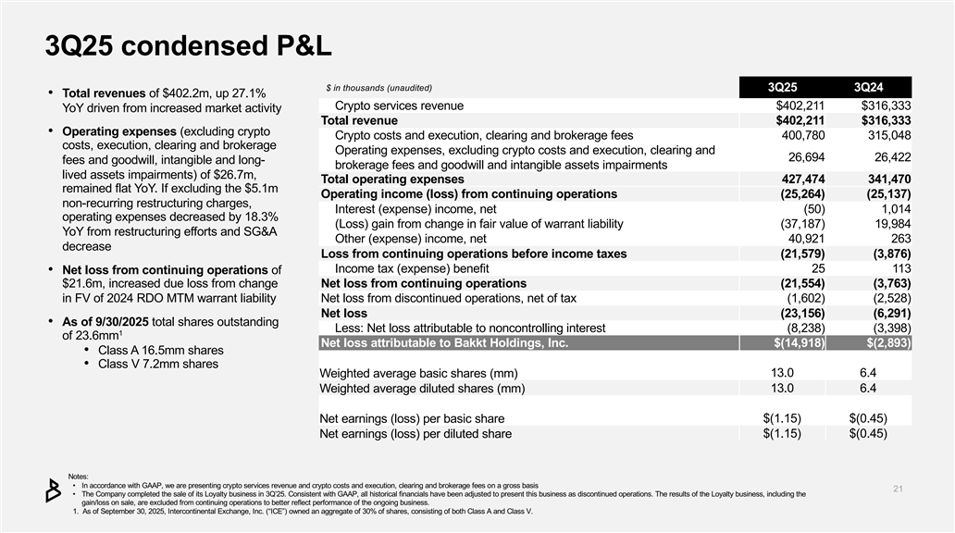
3Q25 condensed P&L $ in thousands (unaudited) 3Q25 3Q24 • Total revenues of $402.2m, up 27.1% Crypto services revenue $402,211 $316,333 YoY driven from increased market activity Total revenue $402,211 $316,333 • Operating expenses (excluding crypto Crypto costs and execution, clearing and brokerage fees 400,780 315,048 costs, execution, clearing and brokerage Operating expenses, excluding crypto costs and execution, clearing and 26,694 26,422 fees and goodwill, intangible and long- brokerage fees and goodwill and intangible assets impairments lived assets impairments) of $26.7m, Total operating expenses 427,474 341,470 remained flat YoY. If excluding the $5.1m Operating income (loss) from continuing operations (25,264) (25,137) non-recurring restructuring charges, Interest (expense) income, net (50) 1,014 operating expenses decreased by 18.3% (Loss) gain from change in fair value of warrant liability (37,187) 19,984 YoY from restructuring efforts and SG&A Other (expense) income, net 40,921 263 decrease Loss from continuing operations before income taxes (21,579) (3,876) Income tax (expense) benefit 25 113 • Net loss from continuing operations of $21.6m, increased due loss from change Net loss from continuing operations (21,554) (3,763) in FV of 2024 RDO MTM warrant liability Net loss from discontinued operations, net of tax (1,602) (2,528) Net loss (23,156) (6,291) • As of 9/30/2025 total shares outstanding Less: Net loss attributable to noncontrolling interest (8,238) (3,398) 1 of 23.6mm Net loss attributable to Bakkt Holdings, Inc. $(14,918) $(2,893) • Class A 16.5mm shares • Class V 7.2mm shares Weighted average basic shares (mm) 13.0 6.4 Weighted average diluted shares (mm) 13.0 6.4 Net earnings (loss) per basic share $(1.15) $(0.45) Net earnings (loss) per diluted share $(1.15) $(0.45) Notes: • In accordance with GAAP, we are presentingcrypto services revenue and crypto costs and execution, clearing and brokerage fees o n a gross basis • The Company completed the sale of its Loyalty business in 3Q’25. Consistent with GAAP, all historical financials have been ajd usted to present this business as discontinued operations. The results of the Loyalty business, including the gain/loss on sale, are excluded from continuing operations to better reflect performance of the ongoing business. 1. As of September 30, 2025, Intercontinental Exchange, Inc. (“ICE”) owned an aggregate of 3 0% of shares, consisting of both Class A and Class V.

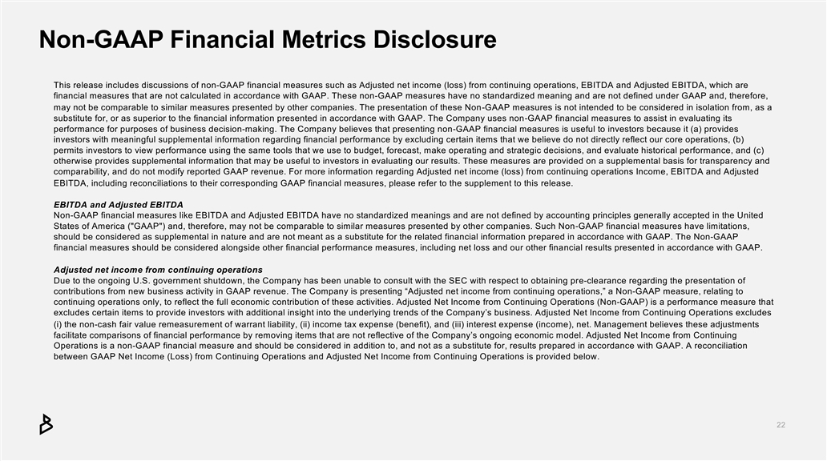
Non-GAAP Financial Metrics Disclosure This release includes discussions of non-GAAP financial measures such as Adjusted net income (loss) from continuing operations, EBITDA and Ad justed EBITDA, which are financial measures that are not calculated in accordance with GAAP. These non -GAAP measures have no standardized meaning and are not defined under GAAP and, therefore, may not be comparable to similar measures presented by other companies. The presentation of these Non -GAAP measures is not intended to be considered in isolation from, as a substitute for, or as superior to the financial information presented in accordance with GAAP. The Company uses non -GAAP financial measures to assist in evaluating its performance for purposes of business decision-making. The Company believes that presenting non -GAAP financial measures is useful to investors because it (a) provides investors with meaningful supplemental information regarding financial performance by excluding certain items that we believe do not directly reflect our core operations, (b) permits investors to view performance using the same tools that we use to budget, forecast, make operating and strategic deci sions, and evaluate historical performance, and (c) otherwise provides supplemental information that may be useful to investors in evaluating our results. These measures are provid ed on a supplemental basis for transparency and comparability, and do not modify reported GAAP revenue. For more information regarding Adjusted net income (loss) from contin uing operations Income, EBITDA and Adjusted EBITDA, including reconciliations to their corresponding GAAP financial measures, please refer to the supplement to this release. EBITDA and Adjusted EBITDA Non-GAAP financial measures like EBITDA and Adjusted EBITDA have no standardized meanings and are not defined by accounting prin ciples generally accepted in the United States of America ( GAAP ) and, therefore, may not be comparable to similar measures presented by other companies. Such Non -GAAP financial measures have limitations, should be considered as supplemental in nature and are not meant as a substitute for the related financial information prepar ed in accordance with GAAP. The Non-GAAP financial measures should be considered alongside other financial performance measures, including net loss and our other fina ncial results presented in accordance with GAAP. Adjusted net income from continuing operations Due to the ongoing U.S. government shutdown, the Company has been unable to consult with the SEC with respect to obtaining pr e-clearance regarding the presentation of contributions from new business activity in GAAP revenue. The Company is presenting “Adjusted net income from continuing oper ations,” a Non-GAAP measure, relating to continuing operations only, to reflect the full economic contribution of these activities. Adjusted Net Income from Continuin g Operations (Non-GAAP) is a performance measure that excludes certain items to provide investors with additional insight into the underlying trends of the Company’s business. Adj usted Net Income from Continuing Operations excludes (i) the non-cash fair value remeasurement of warrant liability, (ii) income tax expense (benefit), and (iii) interest expense (inc ome), net. Management believes these adjustments facilitate comparisons of financial performance by removing items that are not reflective of the Company’s ongoing economic m odel. Adjusted Net Income from Continuing Operations is a non-GAAP financial measure and should be considered in addition to, and not as a substitute for, results prepare d in accordance with GAAP. A reconciliation between GAAP Net Income (Loss) from Continuing Operations and Adjusted Net Income from Continuing Operations is provided belo w.

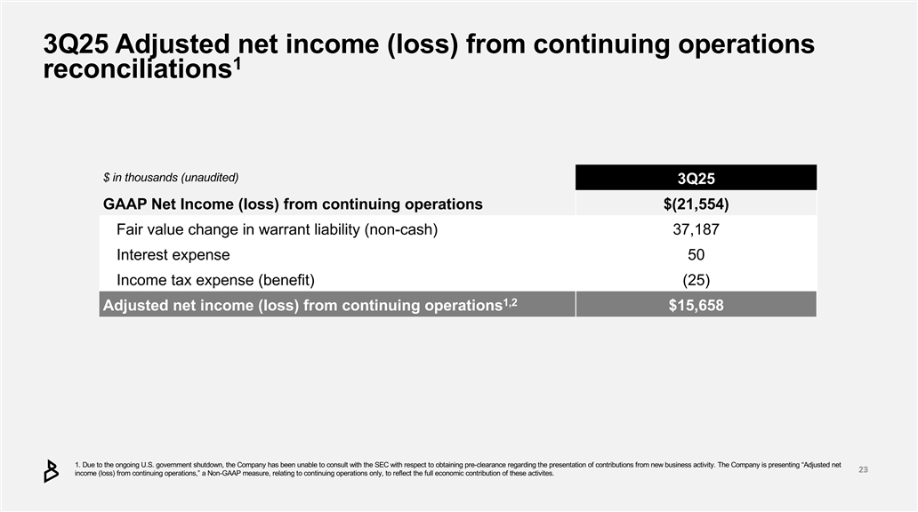
3Q25 Adjusted net income (loss) from continuing operations 1 reconciliations $ in thousands (unaudited) 3Q25 GAAP Net Income (loss) from continuing operations $(21,554) Fair value change in warrant liability (non-cash) 37,187 Interest expense 50 Income tax expense (benefit) (25) 1,2 Adjusted net income (loss) from continuing operations $15,658 1. Due to the ongoing U.S. government shutdown, the Company has been unable to consult with the SEC with respect to obtaining p er-clearance regarding the presentation of contributions from new business activity.Th e Company is presenting “Adjusted net income (loss) from continuing operations,” a Non-GAAP measure, relating to continuing operations only, to reflect the full econo mic contribution of these activites.

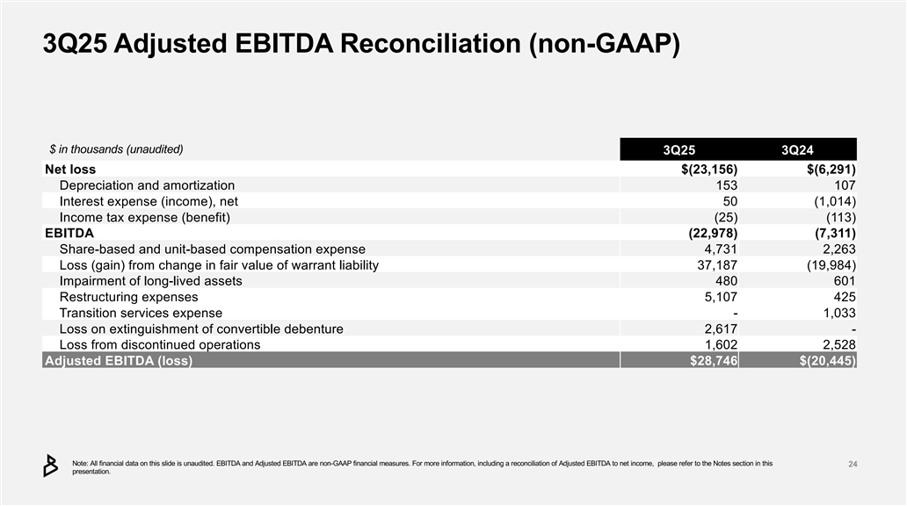
3Q25 Adjusted EBITDA Reconciliation (non-GAAP) $ in thousands (unaudited) 3Q25 3Q24 Net loss $(23,156) $(6,291) Depreciation and amortization 153 107 Interest expense (income), net 50 (1,014) Income tax expense (benefit) (25) (113) EBITDA (22,978) (7,311) Share-based and unit-based compensation expense 4,731 2,263 Loss (gain) from change in fair value of warrant liability 37,187 (19,984) Impairment of long-lived assets 480 601 Restructuring expenses 5,107 425 Transition services expense - 1,033 Loss on extinguishment of convertible debenture 2,617 - Loss from discontinued operations 1,602 2,528 Adjusted EBITDA (loss) $28,746 $(20,445) Note: All financial data on this slide is unaudited. EBITDA and Adjusted EBITDA are non -GAAP financial measures. For more information, including a reconciliation of Adjusted EBITDA to net income, please refer to the Notes section in this presentation.

