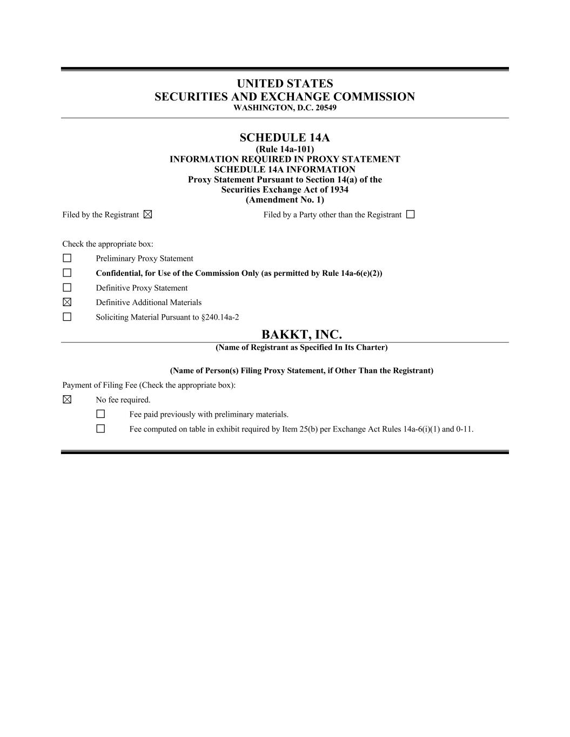
UNITED STATES SECURITIES AND EXCHANGE COMMISSION WASHINGTON, D.C. 20549 SCHEDULE 14A (Rule 14a-101) INFORMATION REQUIRED IN PROXY STATEMENT SCHEDULE 14A INFORMATION Proxy Statement Pursuant to Section 14(a) of the Securities Exchange Act of 1934 (Amendment No. 1) Filed by the Registrant Filed by a Party other than the Registrant Check the appropriate box: Preliminary Proxy Statement Confidential, for Use of the Commission Only (as permitted by Rule 14a-6(e)(2)) Definitive Proxy Statement Definitive Additional Materials Soliciting Material Pursuant to §240.14a-2 BAKKT, INC. (Name of Registrant as Specified In Its Charter) (Name of Person(s) Filing Proxy Statement, if Other Than the Registrant) Payment of Filing Fee (Check the appropriate box): No fee required. Fee paid previously with preliminary materials. Fee computed on table in exhibit required by Item 25(b) per Exchange Act Rules 14a-6(i)(1) and 0-11.

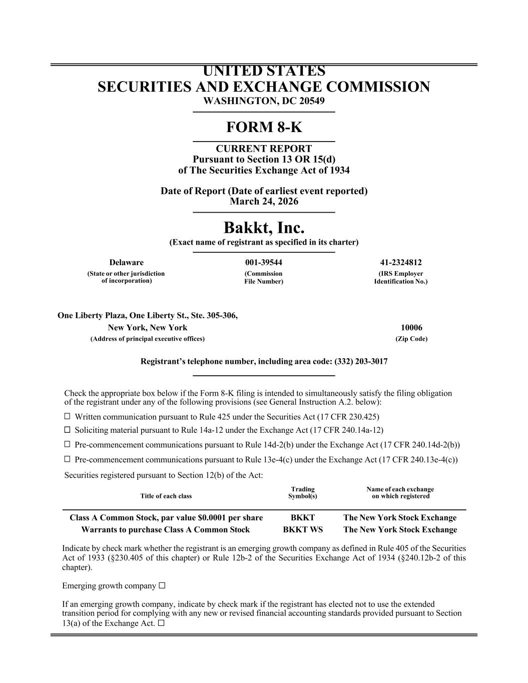
UNITED STATES SECURITIES AND EXCHANGE COMMISSION WASHINGTON, DC 20549 FORM 8-K CURRENT REPORT Pursuant to Section 13 OR 15(d) of The Securities Exchange Act of 1934 Date of Report (Date of earliest event reported) March 24, 2026 Bakkt, Inc. (Exact name of registrant as specified in its charter) Delaware 001-39544 41-2324812 (State or other jurisdiction of incorporation) (Commission File Number) (IRS Employer Identification No.) One Liberty Plaza, One Liberty St., Ste. 305-306, New York, New York 10006 (Address of principal executive offices) (Zip Code) Registrant’s telephone number, including area code: (332) 203-3017 Check the appropriate box below if the Form 8-K filing is intended to simultaneously satisfy the filing obligation of the registrant under any of the following provisions (see General Instruction A.2. below): ☐ Written communication pursuant to Rule 425 under the Securities Act (17 CFR 230.425) ☐ Soliciting material pursuant to Rule 14a-12 under the Exchange Act (17 CFR 240.14a-12) ☐ Pre-commencement communications pursuant to Rule 14d-2(b) under the Exchange Act (17 CFR 240.14d-2(b)) ☐ Pre-commencement communications pursuant to Rule 13e-4(c) under the Exchange Act (17 CFR 240.13e-4(c)) Securities registered pursuant to Section 12(b) of the Act: Title of each class Trading Symbol(s) Name of each exchange on which registered Class A Common Stock, par value $0.0001 per share BKKT The New York Stock Exchange Warrants to purchase Class A Common Stock BKKT WS The New York Stock Exchange Indicate by check mark whether the registrant is an emerging growth company as defined in Rule 405 of the Securities Act of 1933 (§230.405 of this chapter) or Rule 12b-2 of the Securities Exchange Act of 1934 (§240.12b-2 of this chapter). Emerging growth company ☐ If an emerging growth company, indicate by check mark if the registrant has elected not to use the extended transition period for complying with any new or revised financial accounting standards provided pursuant to Section 13(a) of the Exchange Act. ☐

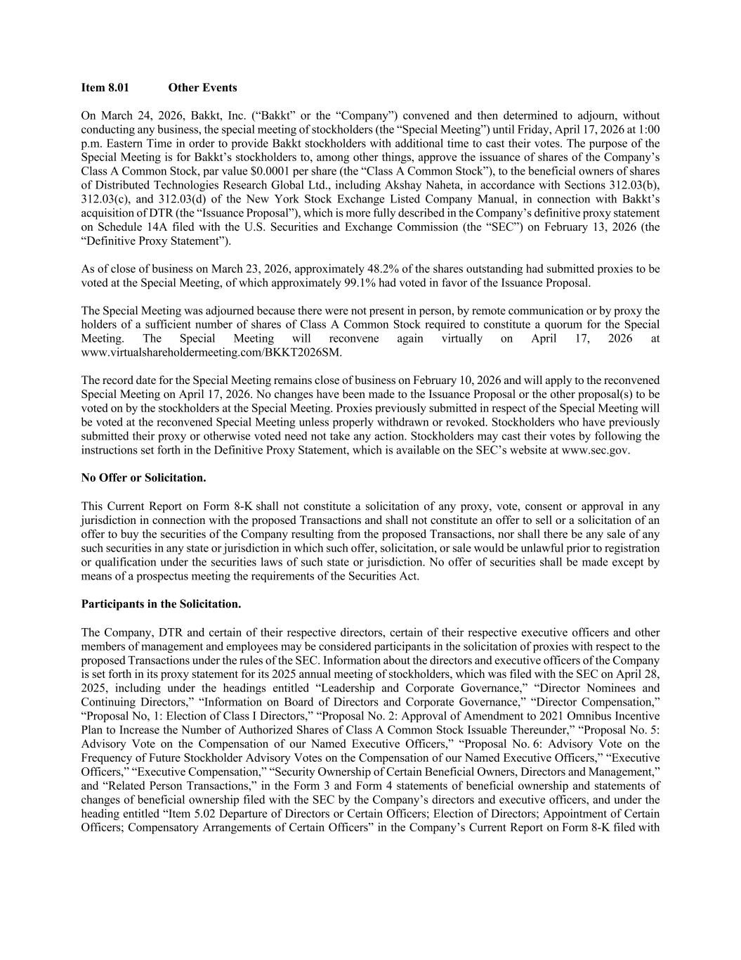
Item 8.01 Other Events On March 24, 2026, Bakkt, Inc. (“Bakkt” or the “Company”) convened and then determined to adjourn, without conducting any business, the special meeting of stockholders (the “Special Meeting”) until Friday, April 17, 2026 at 1:00 p.m. Eastern Time in order to provide Bakkt stockholders with additional time to cast their votes. The purpose of the Special Meeting is for Bakkt’s stockholders to, among other things, approve the issuance of shares of the Company’s Class A Common Stock, par value $0.0001 per share (the “Class A Common Stock”), to the beneficial owners of shares of Distributed Technologies Research Global Ltd., including Akshay Naheta, in accordance with Sections 312.03(b), 312.03(c), and 312.03(d) of the New York Stock Exchange Listed Company Manual, in connection with Bakkt’s acquisition of DTR (the “Issuance Proposal”), which is more fully described in the Company’s definitive proxy statement on Schedule 14A filed with the U.S. Securities and Exchange Commission (the “SEC”) on February 13, 2026 (the “Definitive Proxy Statement”). As of close of business on March 23, 2026, approximately 48.2% of the shares outstanding had submitted proxies to be voted at the Special Meeting, of which approximately 99.1% had voted in favor of the Issuance Proposal. The Special Meeting was adjourned because there were not present in person, by remote communication or by proxy the holders of a sufficient number of shares of Class A Common Stock required to constitute a quorum for the Special Meeting. The Special Meeting will reconvene again virtually on April 17, 2026 at www.virtualshareholdermeeting.com/BKKT2026SM. The record date for the Special Meeting remains close of business on February 10, 2026 and will apply to the reconvened Special Meeting on April 17, 2026. No changes have been made to the Issuance Proposal or the other proposal(s) to be voted on by the stockholders at the Special Meeting. Proxies previously submitted in respect of the Special Meeting will be voted at the reconvened Special Meeting unless properly withdrawn or revoked. Stockholders who have previously submitted their proxy or otherwise voted need not take any action. Stockholders may cast their votes by following the instructions set forth in the Definitive Proxy Statement, which is available on the SEC’s website at www.sec.gov. No Offer or Solicitation. This Current Report on Form 8-K shall not constitute a solicitation of any proxy, vote, consent or approval in any jurisdiction in connection with the proposed Transactions and shall not constitute an offer to sell or a solicitation of an offer to buy the securities of the Company resulting from the proposed Transactions, nor shall there be any sale of any such securities in any state or jurisdiction in which such offer, solicitation, or sale would be unlawful prior to registration or qualification under the securities laws of such state or jurisdiction. No offer of securities shall be made except by means of a prospectus meeting the requirements of the Securities Act. Participants in the Solicitation. The Company, DTR and certain of their respective directors, certain of their respective executive officers and other members of management and employees may be considered participants in the solicitation of proxies with respect to the proposed Transactions under the rules of the SEC. Information about the directors and executive officers of the Company is set forth in its proxy statement for its 2025 annual meeting of stockholders, which was filed with the SEC on April 28, 2025, including under the headings entitled “Leadership and Corporate Governance,” “Director Nominees and Continuing Directors,” “Information on Board of Directors and Corporate Governance,” “Director Compensation,” “Proposal No, 1: Election of Class I Directors,” “Proposal No. 2: Approval of Amendment to 2021 Omnibus Incentive Plan to Increase the Number of Authorized Shares of Class A Common Stock Issuable Thereunder,” “Proposal No. 5: Advisory Vote on the Compensation of our Named Executive Officers,” “Proposal No. 6: Advisory Vote on the Frequency of Future Stockholder Advisory Votes on the Compensation of our Named Executive Officers,” “Executive Officers,” “Executive Compensation,” “Security Ownership of Certain Beneficial Owners, Directors and Management,” and “Related Person Transactions,” in the Form 3 and Form 4 statements of beneficial ownership and statements of changes of beneficial ownership filed with the SEC by the Company’s directors and executive officers, and under the heading entitled “Item 5.02 Departure of Directors or Certain Officers; Election of Directors; Appointment of Certain Officers; Compensatory Arrangements of Certain Officers” in the Company’s Current Report on Form 8-K filed with

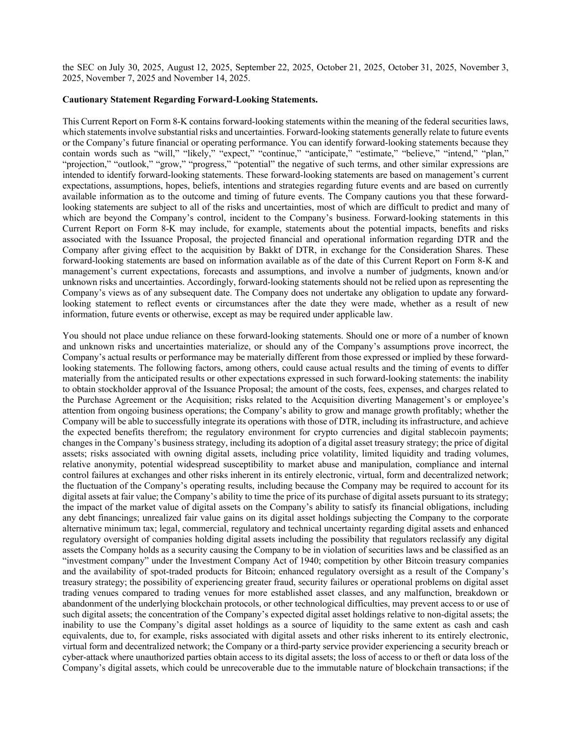
the SEC on July 30, 2025, August 12, 2025, September 22, 2025, October 21, 2025, October 31, 2025, November 3, 2025, November 7, 2025 and November 14, 2025. Cautionary Statement Regarding Forward-Looking Statements. This Current Report on Form 8-K contains forward-looking statements within the meaning of the federal securities laws, which statements involve substantial risks and uncertainties. Forward-looking statements generally relate to future events or the Company’s future financial or operating performance. You can identify forward-looking statements because they contain words such as “will,” “likely,” “expect,” “continue,” “anticipate,” “estimate,” “believe,” “intend,” “plan,” “projection,” “outlook,” “grow,” “progress,” “potential” the negative of such terms, and other similar expressions are intended to identify forward-looking statements. These forward-looking statements are based on management’s current expectations, assumptions, hopes, beliefs, intentions and strategies regarding future events and are based on currently available information as to the outcome and timing of future events. The Company cautions you that these forward- looking statements are subject to all of the risks and uncertainties, most of which are difficult to predict and many of which are beyond the Company’s control, incident to the Company’s business. Forward-looking statements in this Current Report on Form 8-K may include, for example, statements about the potential impacts, benefits and risks associated with the Issuance Proposal, the projected financial and operational information regarding DTR and the Company after giving effect to the acquisition by Bakkt of DTR, in exchange for the Consideration Shares. These forward-looking statements are based on information available as of the date of this Current Report on Form 8-K and management’s current expectations, forecasts and assumptions, and involve a number of judgments, known and/or unknown risks and uncertainties. Accordingly, forward-looking statements should not be relied upon as representing the Company’s views as of any subsequent date. The Company does not undertake any obligation to update any forward- looking statement to reflect events or circumstances after the date they were made, whether as a result of new information, future events or otherwise, except as may be required under applicable law. You should not place undue reliance on these forward-looking statements. Should one or more of a number of known and unknown risks and uncertainties materialize, or should any of the Company’s assumptions prove incorrect, the Company’s actual results or performance may be materially different from those expressed or implied by these forward- looking statements. The following factors, among others, could cause actual results and the timing of events to differ materially from the anticipated results or other expectations expressed in such forward-looking statements: the inability to obtain stockholder approval of the Issuance Proposal; the amount of the costs, fees, expenses, and charges related to the Purchase Agreement or the Acquisition; risks related to the Acquisition diverting Management’s or employee’s attention from ongoing business operations; the Company’s ability to grow and manage growth profitably; whether the Company will be able to successfully integrate its operations with those of DTR, including its infrastructure, and achieve the expected benefits therefrom; the regulatory environment for crypto currencies and digital stablecoin payments; changes in the Company’s business strategy, including its adoption of a digital asset treasury strategy; the price of digital assets; risks associated with owning digital assets, including price volatility, limited liquidity and trading volumes, relative anonymity, potential widespread susceptibility to market abuse and manipulation, compliance and internal control failures at exchanges and other risks inherent in its entirely electronic, virtual, form and decentralized network; the fluctuation of the Company’s operating results, including because the Company may be required to account for its digital assets at fair value; the Company’s ability to time the price of its purchase of digital assets pursuant to its strategy; the impact of the market value of digital assets on the Company’s ability to satisfy its financial obligations, including any debt financings; unrealized fair value gains on its digital asset holdings subjecting the Company to the corporate alternative minimum tax; legal, commercial, regulatory and technical uncertainty regarding digital assets and enhanced regulatory oversight of companies holding digital assets including the possibility that regulators reclassify any digital assets the Company holds as a security causing the Company to be in violation of securities laws and be classified as an “investment company” under the Investment Company Act of 1940; competition by other Bitcoin treasury companies and the availability of spot-traded products for Bitcoin; enhanced regulatory oversight as a result of the Company’s treasury strategy; the possibility of experiencing greater fraud, security failures or operational problems on digital asset trading venues compared to trading venues for more established asset classes, and any malfunction, breakdown or abandonment of the underlying blockchain protocols, or other technological difficulties, may prevent access to or use of such digital assets; the concentration of the Company’s expected digital asset holdings relative to non-digital assets; the inability to use the Company’s digital asset holdings as a source of liquidity to the same extent as cash and cash equivalents, due to, for example, risks associated with digital assets and other risks inherent to its entirely electronic, virtual form and decentralized network; the Company or a third-party service provider experiencing a security breach or cyber-attack where unauthorized parties obtain access to its digital assets; the loss of access to or theft or data loss of the Company’s digital assets, which could be unrecoverable due to the immutable nature of blockchain transactions; if the

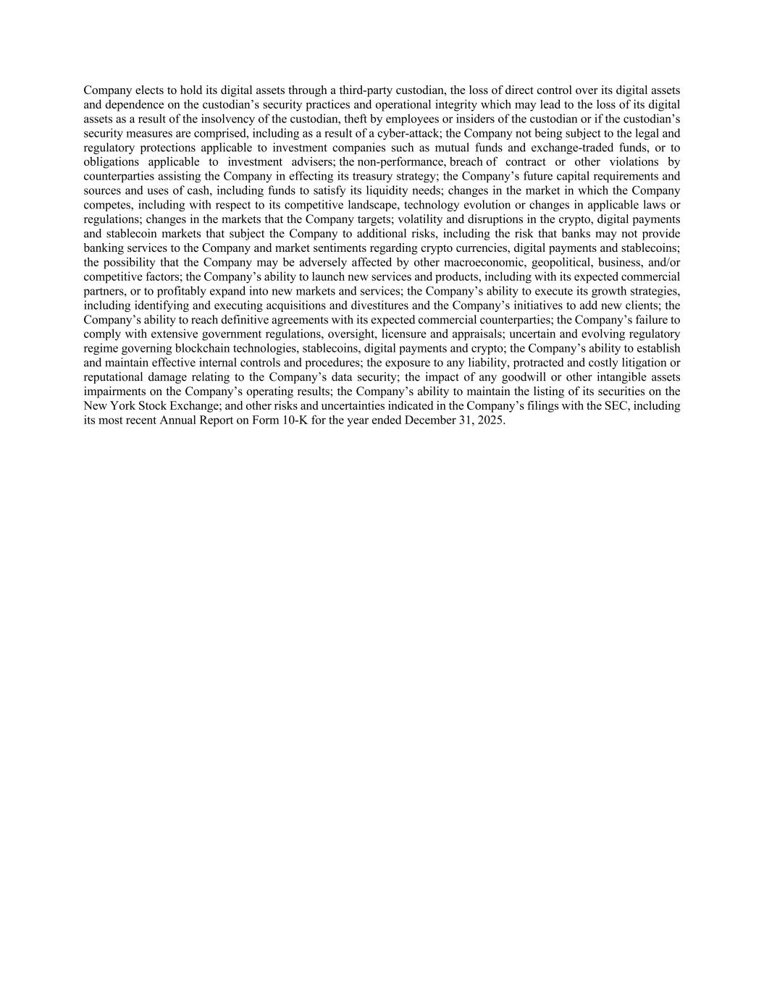
Company elects to hold its digital assets through a third-party custodian, the loss of direct control over its digital assets and dependence on the custodian’s security practices and operational integrity which may lead to the loss of its digital assets as a result of the insolvency of the custodian, theft by employees or insiders of the custodian or if the custodian’s security measures are comprised, including as a result of a cyber-attack; the Company not being subject to the legal and regulatory protections applicable to investment companies such as mutual funds and exchange-traded funds, or to obligations applicable to investment advisers; the non-performance, breach of contract or other violations by counterparties assisting the Company in effecting its treasury strategy; the Company’s future capital requirements and sources and uses of cash, including funds to satisfy its liquidity needs; changes in the market in which the Company competes, including with respect to its competitive landscape, technology evolution or changes in applicable laws or regulations; changes in the markets that the Company targets; volatility and disruptions in the crypto, digital payments and stablecoin markets that subject the Company to additional risks, including the risk that banks may not provide banking services to the Company and market sentiments regarding crypto currencies, digital payments and stablecoins; the possibility that the Company may be adversely affected by other macroeconomic, geopolitical, business, and/or competitive factors; the Company’s ability to launch new services and products, including with its expected commercial partners, or to profitably expand into new markets and services; the Company’s ability to execute its growth strategies, including identifying and executing acquisitions and divestitures and the Company’s initiatives to add new clients; the Company’s ability to reach definitive agreements with its expected commercial counterparties; the Company’s failure to comply with extensive government regulations, oversight, licensure and appraisals; uncertain and evolving regulatory regime governing blockchain technologies, stablecoins, digital payments and crypto; the Company’s ability to establish and maintain effective internal controls and procedures; the exposure to any liability, protracted and costly litigation or reputational damage relating to the Company’s data security; the impact of any goodwill or other intangible assets impairments on the Company’s operating results; the Company’s ability to maintain the listing of its securities on the New York Stock Exchange; and other risks and uncertainties indicated in the Company’s filings with the SEC, including its most recent Annual Report on Form 10-K for the year ended December 31, 2025.

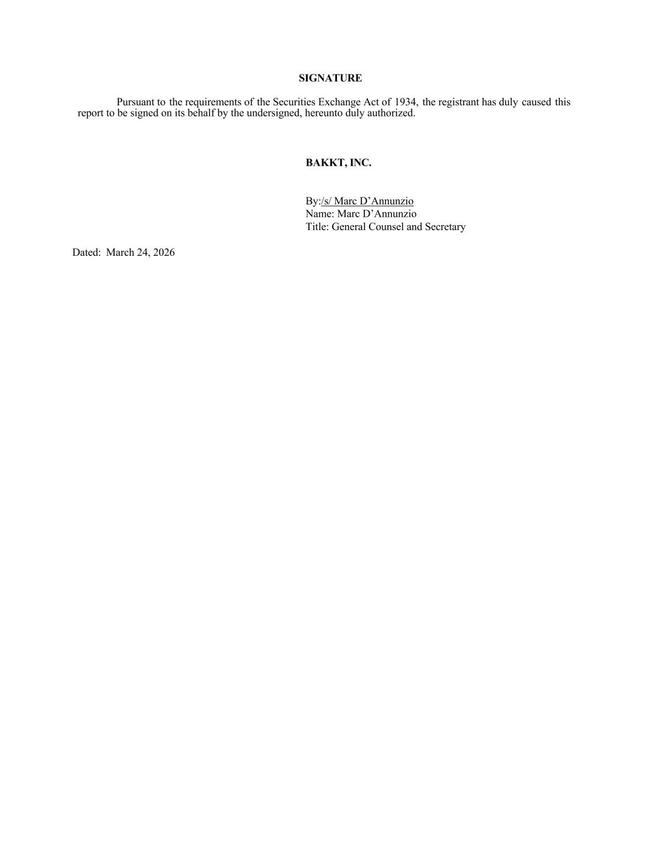
SIGNATURE Pursuant to the requirements of the Securities Exchange Act of 1934, the registrant has duly caused this report to be signed on its behalf by the undersigned, hereunto duly authorized. BAKKT, INC. By:/s/ Marc D’Annunzio Name: Marc D’Annunzio Title: General Counsel and Secretary Dated: March 24, 2026

