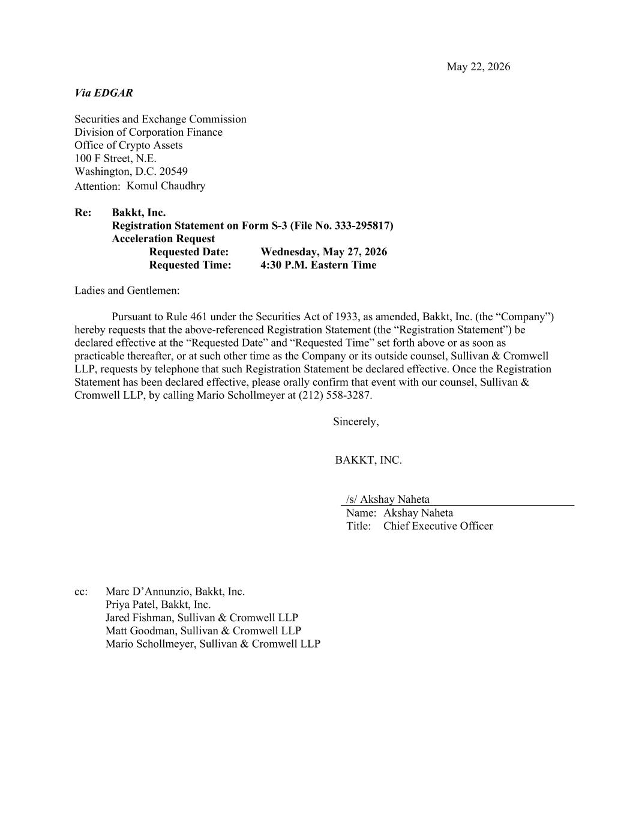
May 22, 2026 Via EDGAR Securities and Exchange Commission Division of Corporation Finance Office of Crypto Assets 100 F Street, N.E. Washington, D.C. 20549 Attention: Komul Chaudhry Re: Bakkt, Inc. Registration Statement on Form S-3 (File No. 333-295817) Acceleration Request Requested Date: Wednesday, May 27, 2026 Requested Time: 4:30 P.M. Eastern Time Ladies and Gentlemen: Pursuant to Rule 461 under the Securities Act of 1933, as amended, Bakkt, Inc. (the “Company”) hereby requests that the above-referenced Registration Statement (the “Registration Statement”) be declared effective at the “Requested Date” and “Requested Time” set forth above or as soon as practicable thereafter, or at such other time as the Company or its outside counsel, Sullivan & Cromwell LLP, requests by telephone that such Registration Statement be declared effective. Once the Registration Statement has been declared effective, please orally confirm that event with our counsel, Sullivan & Cromwell LLP, by calling Mario Schollmeyer at (212) 558-3287. Sincerely, BAKKT, INC. /s/ Akshay Naheta Name: Akshay Naheta Title: Chief Executive Officer cc: Marc D’Annunzio, Bakkt, Inc. Priya Patel, Bakkt, Inc. Jared Fishman, Sullivan & Cromwell LLP Matt Goodman, Sullivan & Cromwell LLP Mario Schollmeyer, Sullivan & Cromwell LLP

