UNITED STATES
SECURITIES AND EXCHANGE COMMISSION
WASHINGTON, DC 20549
FORM 8-K
CURRENT REPORT
Pursuant to Section 13 OR 15(d)
of The Securities Exchange Act of 1934

Date of Report (Date of earliest event reported)
October 31, 2025
Bakkt Holdings, Inc.
(Exact name of registrant as specified in its charter)
Delaware |  |  |  |  |  | 001-39544 |  |  |  |  |  | 98-1550750
(State or other jurisdiction  of incorporation) |  |  |  |  |  | (Commission  File Number) |  |  |  |  |  | (IRS Employer  Identification No.)
One Liberty Plaza  1 Liberty Street, Floor 3, Suite 305-306,  New York, New York |  |  |  |  |  | 10006
(Address of principal executive offices) |  |  |  |  |  | (Zip Code)
Registrant’s telephone number, including area code: (678) 534-5849

Check the appropriate box below if the Form 8-K filing is intended to simultaneously satisfy the filing obligation of the registrant under any of the following provisions (see General Instruction A.2. below):
☐ |  |  | Written communication pursuant to Rule 425 under the Securities Act (17 CFR 230.425)
☐ |  |  | Soliciting material pursuant to Rule 14a-12 under the Exchange Act (17 CFR 240.14a-12)
☐ |  |  | Pre-commencement communications pursuant to Rule 14d-2(b) under the Exchange Act (17 CFR 240.14d-2(b))
☐ |  |  | Pre-commencement communications pursuant to Rule 13e-4(c) under the Exchange Act (17 CFR 240.13e-4(c))
Securities registered pursuant to Section 12(b) of the Act:
Title of each class |  |  |  |  |  |  |  |  | Trading Symbol(s) |  |  |  |  |  | Name of each exchange  on which registered
Class A Common Stock, par value $0.0001 per share |  |  |  |  |  |  |  |  | BKKT |  |  |  |  |  | The New York Stock Exchange
Warrants to purchase Class A Common Stock |  |  |  |  |  |  |  |  | BKKT WS |  |  |  |  |  | The New York Stock Exchange
Indicate by check mark whether the registrant is an emerging growth company as defined in Rule 405 of the Securities Act of 1933 (§230.405 of this chapter) or Rule 12b-2 of the Securities Exchange Act of 1934 (§240.12b-2 of this chapter).

Emerging growth company ☐

If an emerging growth company, indicate by check mark if the registrant has elected not to use the extended transition period for complying with any new or revised financial accounting standards provided pursuant to Section 13(a) of the Exchange Act. ☐

Item 5.02 Departure of Directors or Certain Officers; Election of Directors; Appointment of Certain Officers; Compensatory Arrangements of Certain Officers.

On October 31, 2025, David Clifton notified the Board of Directors (the “Board”) of Bakkt Holdings, Inc. (the “Company”) of his decision to resign as a director of the Company, effective immediately. Mr. Clifton’s resignation was not the result of any dispute or disagreement with the Company or the Board on any matter relating to the Company's operations, policies or practices.

Item 7.01 Regulation FD Disclosure.

On October 31 2025, the Company issued a press release announcing the resignation of Mr. David Clifton, effective October 31, 2025. A copy of the press release is attached hereto as Exhibit 99.1 and is incorporated herein by reference.

The information contained in this Item 7.01, including Exhibit 99.1, is being furnished and shall not be deemed “filed” for purposes of Section 18 of the Securities Exchange Act of 1934, as amended (the “Exchange Act”), or otherwise subject to the liabilities of that section.

Item 9.01 Financial Statements and Exhibits.

(d) Exhibits

Exhibit Number |  |  | Description
99.1 |  |  | Press Release issued by Bakkt Holdings, Inc. dated October 31, 2025.

SIGNATURE
Pursuant to the requirements of the Securities Exchange Act of 1934, the registrant has duly caused this report to be signed on its behalf by the undersigned, hereunto duly authorized.
Dated: October 31, 2025
 |  |  | BAKKT HOLDINGS, INC.
 |  |  | By: |  |  | /s/ Marc D'Annunzio
 |  |  | Name: |  |  | Marc D’Annunzio
 |  |  | Title: |  |  | General Counsel and Secretary

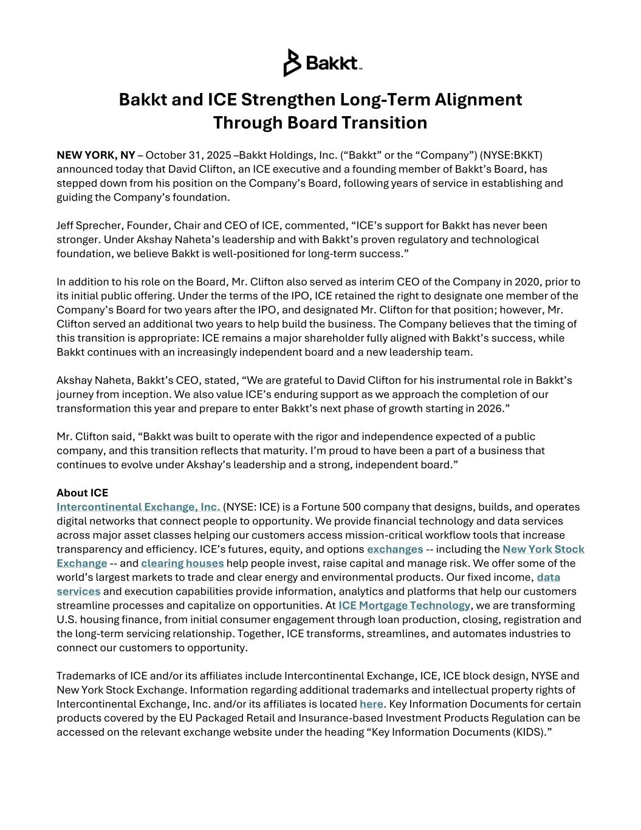

Bakkt and ICE Strengthen Long-Term Alignment Through Board Transition NEW YORK, NY – October 31, 2025 –Bakkt Holdings, Inc. (“Bakkt” or the “Company”) (NYSE:BKKT) announced today that David Clifton, an ICE executive and a founding member of Bakkt’s Board, has stepped down from his position on the Company’s Board, following years of service in establishing and guiding the Company’s foundation. Jeff Sprecher, Founder, Chair and CEO of ICE, commented, “ICE’s support for Bakkt has never been stronger. Under Akshay Naheta’s leadership and with Bakkt’s proven regulatory and technological foundation, we believe Bakkt is well-positioned for long-term success.” In addition to his role on the Board, Mr. Clifton also served as interim CEO of the Company in 2020, prior to its initial public offering. Under the terms of the IPO, ICE retained the right to designate one member of the Company’s Board for two years after the IPO, and designated Mr. Clifton for that position; however, Mr. Clifton served an additional two years to help build the business. The Company believes that the timing of this transition is appropriate: ICE remains a major shareholder fully aligned with Bakkt’s success, while Bakkt continues with an increasingly independent board and a new leadership team. Akshay Naheta, Bakkt’s CEO, stated, “We are grateful to David Clifton for his instrumental role in Bakkt’s journey from inception. We also value ICE’s enduring support as we approach the completion of our transformation this year and prepare to enter Bakkt’s next phase of growth starting in 2026.” Mr. Clifton said, “Bakkt was built to operate with the rigor and independence expected of a public company, and this transition reflects that maturity. I’m proud to have been a part of a business that continues to evolve under Akshay’s leadership and a strong, independent board.” About ICE Intercontinental Exchange, Inc. (NYSE: ICE) is a Fortune 500 company that designs, builds, and operates digital networks that connect people to opportunity. We provide financial technology and data services across major asset classes helping our customers access mission-critical workflow tools that increase transparency and efficiency. ICE’s futures, equity, and options exchanges -- including the New York Stock Exchange -- and clearing houses help people invest, raise capital and manage risk. We offer some of the world’s largest markets to trade and clear energy and environmental products. Our fixed income, data services and execution capabilities provide information, analytics and platforms that help our customers streamline processes and capitalize on opportunities. At ICE Mortgage Technology, we are transforming U.S. housing finance, from initial consumer engagement through loan production, closing, registration and the long-term servicing relationship. Together, ICE transforms, streamlines, and automates industries to connect our customers to opportunity. Trademarks of ICE and/or its affiliates include Intercontinental Exchange, ICE, ICE block design, NYSE and New York Stock Exchange. Information regarding additional trademarks and intellectual property rights of Intercontinental Exchange, Inc. and/or its affiliates is located here. Key Information Documents for certain products covered by the EU Packaged Retail and Insurance-based Investment Products Regulation can be accessed on the relevant exchange website under the heading “Key Information Documents (KIDS).”

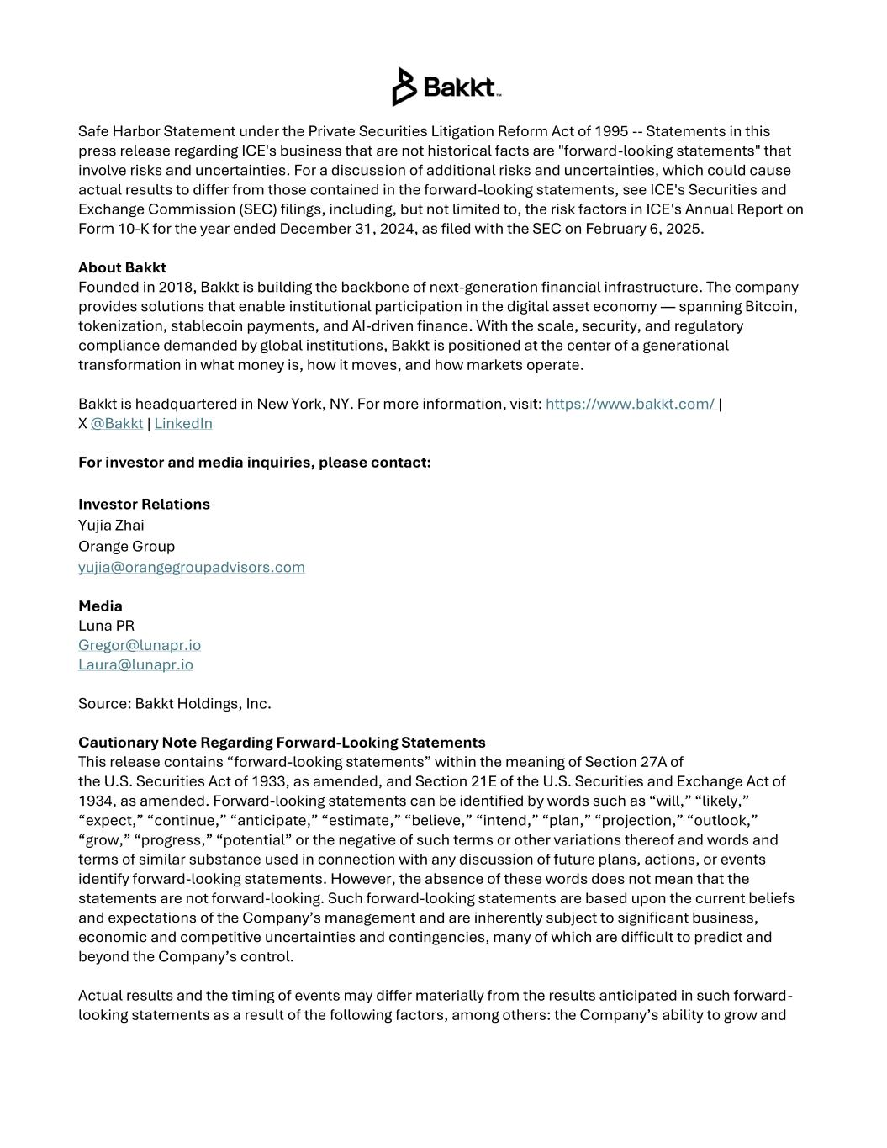
Safe Harbor Statement under the Private Securities Litigation Reform Act of 1995 -- Statements in this press release regarding ICE's business that are not historical facts are "forward-looking statements" that involve risks and uncertainties. For a discussion of additional risks and uncertainties, which could cause actual results to differ from those contained in the forward-looking statements, see ICE's Securities and Exchange Commission (SEC) filings, including, but not limited to, the risk factors in ICE's Annual Report on Form 10-K for the year ended December 31, 2024, as filed with the SEC on February 6, 2025. About Bakkt Founded in 2018, Bakkt is building the backbone of next-generation financial infrastructure. The company provides solutions that enable institutional participation in the digital asset economy — spanning Bitcoin, tokenization, stablecoin payments, and AI-driven finance. With the scale, security, and regulatory compliance demanded by global institutions, Bakkt is positioned at the center of a generational transformation in what money is, how it moves, and how markets operate. Bakkt is headquartered in New York, NY. For more information, visit: https://www.bakkt.com/ | X @Bakkt | LinkedIn For investor and media inquiries, please contact: Investor Relations Yujia Zhai Orange Group yujia@orangegroupadvisors.com Media Luna PR Gregor@lunapr.io Laura@lunapr.io Source: Bakkt Holdings, Inc. Cautionary Note Regarding Forward-Looking Statements This release contains “forward-looking statements” within the meaning of Section 27A of the U.S. Securities Act of 1933, as amended, and Section 21E of the U.S. Securities and Exchange Act of 1934, as amended. Forward-looking statements can be identified by words such as “will,” “likely,” “expect,” “continue,” “anticipate,” “estimate,” “believe,” “intend,” “plan,” “projection,” “outlook,” “grow,” “progress,” “potential” or the negative of such terms or other variations thereof and words and terms of similar substance used in connection with any discussion of future plans, actions, or events identify forward-looking statements. However, the absence of these words does not mean that the statements are not forward-looking. Such forward-looking statements are based upon the current beliefs and expectations of the Company’s management and are inherently subject to significant business, economic and competitive uncertainties and contingencies, many of which are difficult to predict and beyond the Company’s control. Actual results and the timing of events may differ materially from the results anticipated in such forward- looking statements as a result of the following factors, among others: the Company’s ability to grow and

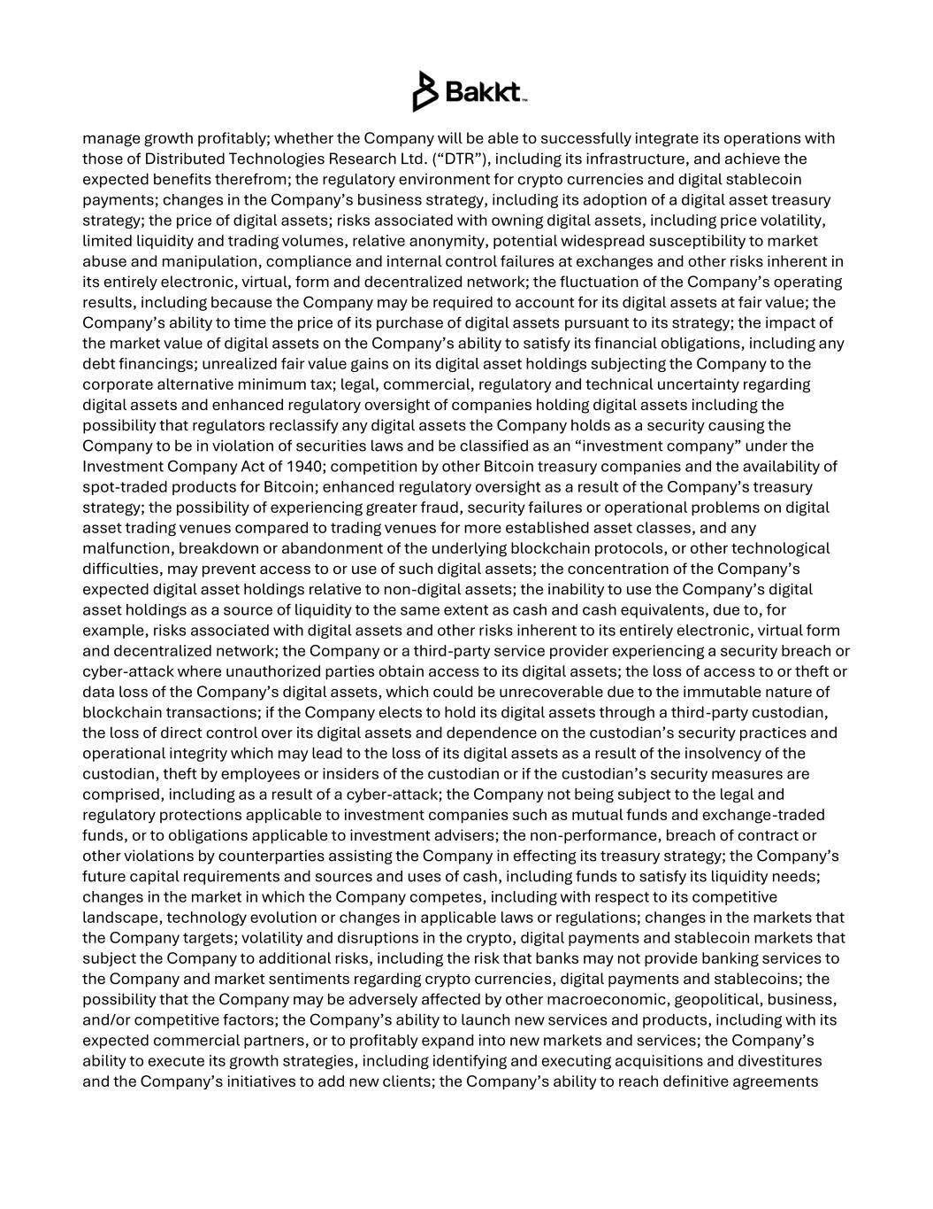
manage growth profitably; whether the Company will be able to successfully integrate its operations with those of Distributed Technologies Research Ltd. (“DTR”), including its infrastructure, and achieve the expected benefits therefrom; the regulatory environment for crypto currencies and digital stablecoin payments; changes in the Company’s business strategy, including its adoption of a digital asset treasury strategy; the price of digital assets; risks associated with owning digital assets, including price volatility, limited liquidity and trading volumes, relative anonymity, potential widespread susceptibility to market abuse and manipulation, compliance and internal control failures at exchanges and other risks inherent in its entirely electronic, virtual, form and decentralized network; the fluctuation of the Company’s operating results, including because the Company may be required to account for its digital assets at fair value; the Company’s ability to time the price of its purchase of digital assets pursuant to its strategy; the impact of the market value of digital assets on the Company’s ability to satisfy its financial obligations, including any debt financings; unrealized fair value gains on its digital asset holdings subjecting the Company to the corporate alternative minimum tax; legal, commercial, regulatory and technical uncertainty regarding digital assets and enhanced regulatory oversight of companies holding digital assets including the possibility that regulators reclassify any digital assets the Company holds as a security causing the Company to be in violation of securities laws and be classified as an “investment company” under the Investment Company Act of 1940; competition by other Bitcoin treasury companies and the availability of spot-traded products for Bitcoin; enhanced regulatory oversight as a result of the Company’s treasury strategy; the possibility of experiencing greater fraud, security failures or operational problems on digital asset trading venues compared to trading venues for more established asset classes, and any malfunction, breakdown or abandonment of the underlying blockchain protocols, or other technological difficulties, may prevent access to or use of such digital assets; the concentration of the Company’s expected digital asset holdings relative to non-digital assets; the inability to use the Company’s digital asset holdings as a source of liquidity to the same extent as cash and cash equivalents, due to, for example, risks associated with digital assets and other risks inherent to its entirely electronic, virtual form and decentralized network; the Company or a third-party service provider experiencing a security breach or cyber-attack where unauthorized parties obtain access to its digital assets; the loss of access to or theft or data loss of the Company’s digital assets, which could be unrecoverable due to the immutable nature of blockchain transactions; if the Company elects to hold its digital assets through a third-party custodian, the loss of direct control over its digital assets and dependence on the custodian’s security practices and operational integrity which may lead to the loss of its digital assets as a result of the insolvency of the custodian, theft by employees or insiders of the custodian or if the custodian’s security measures are comprised, including as a result of a cyber-attack; the Company not being subject to the legal and regulatory protections applicable to investment companies such as mutual funds and exchange-traded funds, or to obligations applicable to investment advisers; the non-performance, breach of contract or other violations by counterparties assisting the Company in effecting its treasury strategy; the Company’s future capital requirements and sources and uses of cash, including funds to satisfy its liquidity needs; changes in the market in which the Company competes, including with respect to its competitive landscape, technology evolution or changes in applicable laws or regulations; changes in the markets that the Company targets; volatility and disruptions in the crypto, digital payments and stablecoin markets that subject the Company to additional risks, including the risk that banks may not provide banking services to the Company and market sentiments regarding crypto currencies, digital payments and stablecoins; the possibility that the Company may be adversely affected by other macroeconomic, geopolitical, business, and/or competitive factors; the Company’s ability to launch new services and products, including with its expected commercial partners, or to profitably expand into new markets and services; the Company’s ability to execute its growth strategies, including identifying and executing acquisitions and divestitures and the Company’s initiatives to add new clients; the Company’s ability to reach definitive agreements

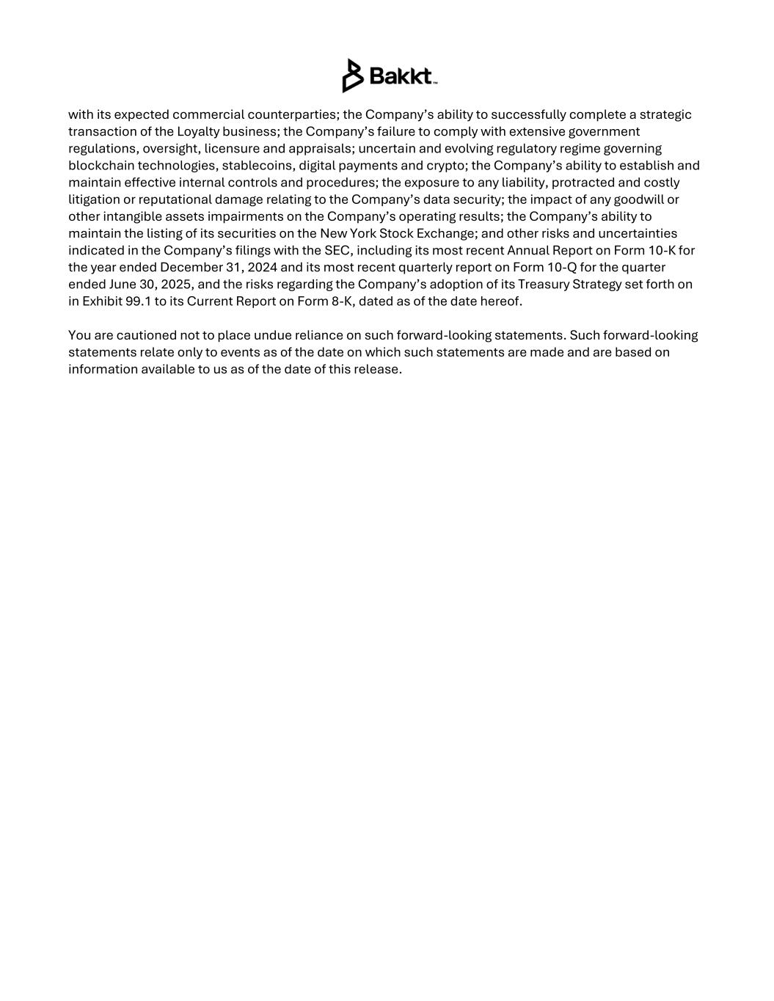
with its expected commercial counterparties; the Company’s ability to successfully complete a strategic transaction of the Loyalty business; the Company’s failure to comply with extensive government regulations, oversight, licensure and appraisals; uncertain and evolving regulatory regime governing blockchain technologies, stablecoins, digital payments and crypto; the Company’s ability to establish and maintain effective internal controls and procedures; the exposure to any liability, protracted and costly litigation or reputational damage relating to the Company’s data security; the impact of any goodwill or other intangible assets impairments on the Company’s operating results; the Company’s ability to maintain the listing of its securities on the New York Stock Exchange; and other risks and uncertainties indicated in the Company’s filings with the SEC, including its most recent Annual Report on Form 10-K for the year ended December 31, 2024 and its most recent quarterly report on Form 10-Q for the quarter ended June 30, 2025, and the risks regarding the Company’s adoption of its Treasury Strategy set forth on in Exhibit 99.1 to its Current Report on Form 8-K, dated as of the date hereof. You are cautioned not to place undue reliance on such forward-looking statements. Such forward-looking statements relate only to events as of the date on which such statements are made and are based on information available to us as of the date of this release.

