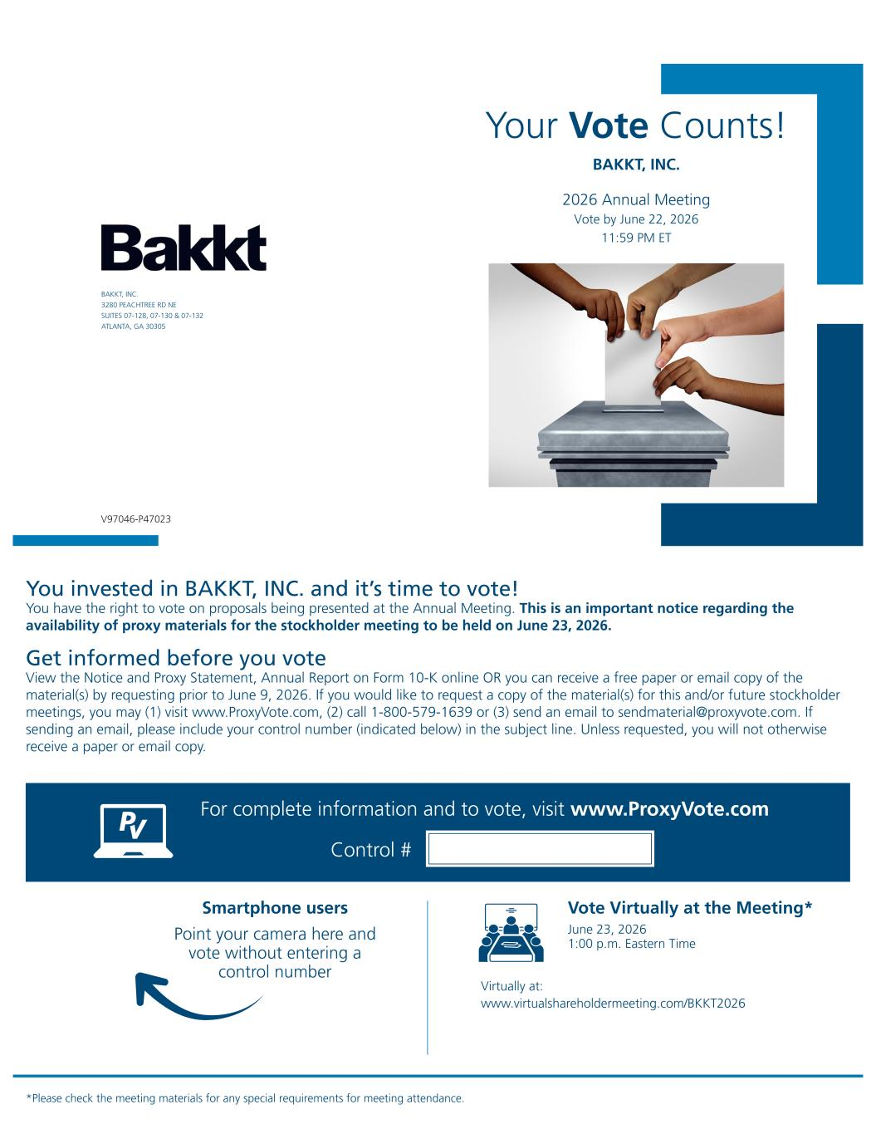
Your Vote Counts! *Please check the meeting materials for any special requirements for meeting attendance. Smartphone users Point your camera here and vote without entering a control number For complete information and to vote, visit www.ProxyVote.com Control # V97046-P47023 BAKKT, INC. 2026 Annual Meeting Vote by June 22, 2026 11:59 PM ET BAKKT, INC. 3280 PEACHTREE RD NE SUITES 07-128, 07-130 & 07-132 ATLANTA, GA 30305 Vote Virtually at the Meeting* June 23, 2026 1:00 p.m. Eastern Time Virtually at: www.virtualshareholdermeeting.com/BKKT2026 You invested in BAKKT, INC. and it’s time to vote! You have the right to vote on proposals being presented at the Annual Meeting. This is an important notice regarding the availability of proxy materials for the stockholder meeting to be held on June 23, 2026. Get informed before you vote View the Notice and Proxy Statement, Annual Report on Form 10-K online OR you can receive a free paper or email copy of the material(s) by requesting prior to June 9, 2026. If you would like to request a copy of the material(s) for this and/or future stockholder meetings, you may (1) visit www.ProxyVote.com, (2) call 1-800-579-1639 or (3) send an email to sendmaterial@proxyvote.com. If sending an email, please include your control number (indicated below) in the subject line. Unless requested, you will not otherwise receive a paper or email copy.

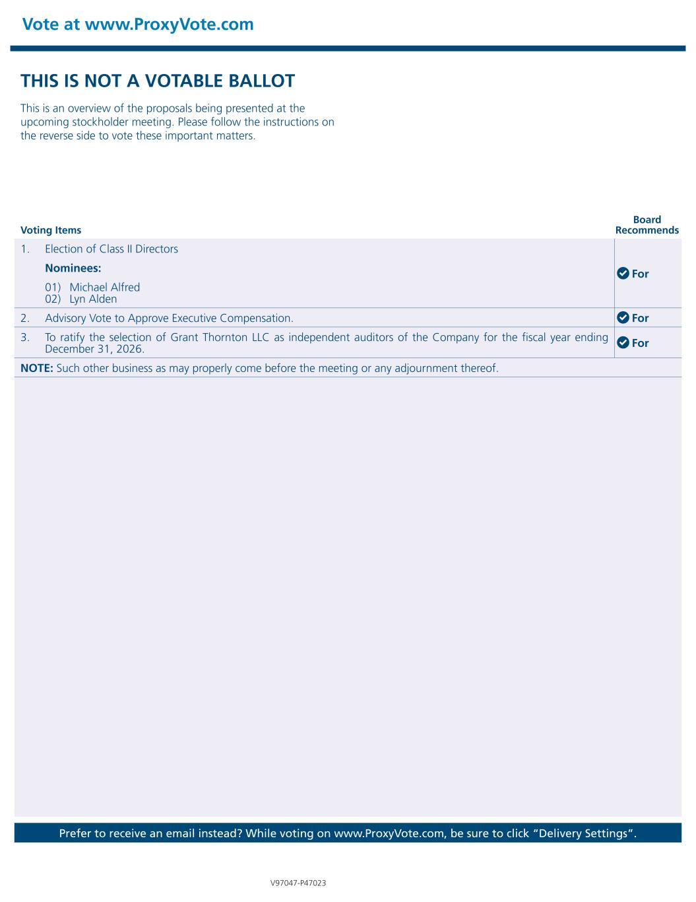
Vote at www.ProxyVote.com Prefer to receive an email instead? While voting on www.ProxyVote.com, be sure to click “Delivery Settings”. Voting Items Board Recommends V97047-P47023 THIS IS NOT A VOTABLE BALLOT This is an overview of the proposals being presented at the upcoming stockholder meeting. Please follow the instructions on the reverse side to vote these important matters. 1. Election of Class II Directors For Nominees: 01) Michael Alfred 02) Lyn Alden 2. Advisory Vote to Approve Executive Compensation. For 3. To ratify the selection of Grant Thornton LLC as independent auditors of the Company for the fiscal year ending December 31, 2026. For NOTE: Such other business as may properly come before the meeting or any adjournment thereof.

