UNITED STATES
SECURITIES AND EXCHANGE COMMISSION
WASHINGTON, DC 20549
FORM 8-K
CURRENT REPORT
Pursuant to Section 13 OR 15(d)
of The Securities Exchange Act of 1934

Date of Report (Date of earliest event reported)
August 10, 2026
Bakkt, Inc.
(Exact name of registrant as specified in its charter)
Delaware |  |  |  |  |  | 001-39544 |  |  |  |  |  | 41-2324812
(State or other jurisdiction  of incorporation) |  |  |  |  |  | (Commission  File Number) |  |  |  |  |  | (IRS Employer  Identification No.)
3280 Peachtree Road NE, 7th Floor  Atlanta, Georgia |  |  |  |  |  | 30305
(Address of principal executive offices) |  |  |  |  |  | (Zip Code)
Registrant’s telephone number, including area code: (332) 203-3017

Check the appropriate box below if the Form 8-K filing is intended to simultaneously satisfy the filing obligation of the registrant under any of the following provisions (see General Instruction A.2. below):
☐ |  |  | Written communication pursuant to Rule 425 under the Securities Act (17 CFR 230.425)
☐ |  |  | Soliciting material pursuant to Rule 14a-12 under the Exchange Act (17 CFR 240.14a-12)
☐ |  |  | Pre-commencement communications pursuant to Rule 14d-2(b) under the Exchange Act (17 CFR 240.14d-2(b))
☐ |  |  | Pre-commencement communications pursuant to Rule 13e-4(c) under the Exchange Act (17 CFR 240.13e-4(c))
Securities registered pursuant to Section 12(b) of the Act:
Title of each class |  |  |  |  |  |  |  |  | Trading Symbol(s) |  |  |  |  |  | Name of each exchange  on which registered
Class A Common Stock, par value $0.0001 per share |  |  |  |  |  |  |  |  | BKKT |  |  |  |  |  | The New York Stock Exchange
Warrants to purchase Class A Common Stock |  |  |  |  |  |  |  |  | BKKT WS |  |  |  |  |  | The New York Stock Exchange
Indicate by check mark whether the registrant is an emerging growth company as defined in Rule 405 of the Securities Act of 1933 (§230.405 of this chapter) or Rule 12b-2 of the Securities Exchange Act of 1934 (§240.12b-2 of this chapter).

Emerging growth company ☐

If an emerging growth company, indicate by check mark if the registrant has elected not to use the extended transition period for complying with any new or revised financial accounting standards provided pursuant to Section 13(a) of the Exchange Act. ☐

Item 2.02 Results of Operations and Financial Conditions.

On August 10, 2026, Bakkt, Inc. (the “Company”) issued a press release regarding the Company’s results for the quarter ended June 30, 2026. A copy of the press release is attached hereto as Exhibit 99.1 and incorporated herein by reference.

The information in this Item 2.02, including Exhibit 99.1 attached hereto, is being furnished and shall not be deemed “filed” for purposes of Section 18 of the Securities Exchange Act of 1934, as amended (the “Exchange Act”), or otherwise subject to the liabilities of such section, nor shall it be deemed incorporated by reference in any filing under the Exchange Act or the Securities Act of 1933, as amended, except as shall be expressly set forth by specific reference in such filing.

Item 9.01 Financial Statements and Exhibits.
(d) Exhibits

Exhibit No. |  |  | Description
99.1 |  |  | Press release issued by Bakkt, Inc. on August 10, 2026
104 |  |  | Cover Page Interactive Data File (embedded within the Inline XBRL document)

SIGNATURE
Pursuant to the requirements of the Securities Exchange Act of 1934, the registrant has duly caused this report to be signed on its behalf by the undersigned, hereunto duly authorized.
Dated: August 10, 2026
 |  |  | BAKKT, INC.
 |  |  | By: |  |  | /s/ Marc D'Annunzio
 |  |  | Name: |  |  | Marc D’Annunzio
 |  |  | Title: |  |  | General Counsel and Secretary

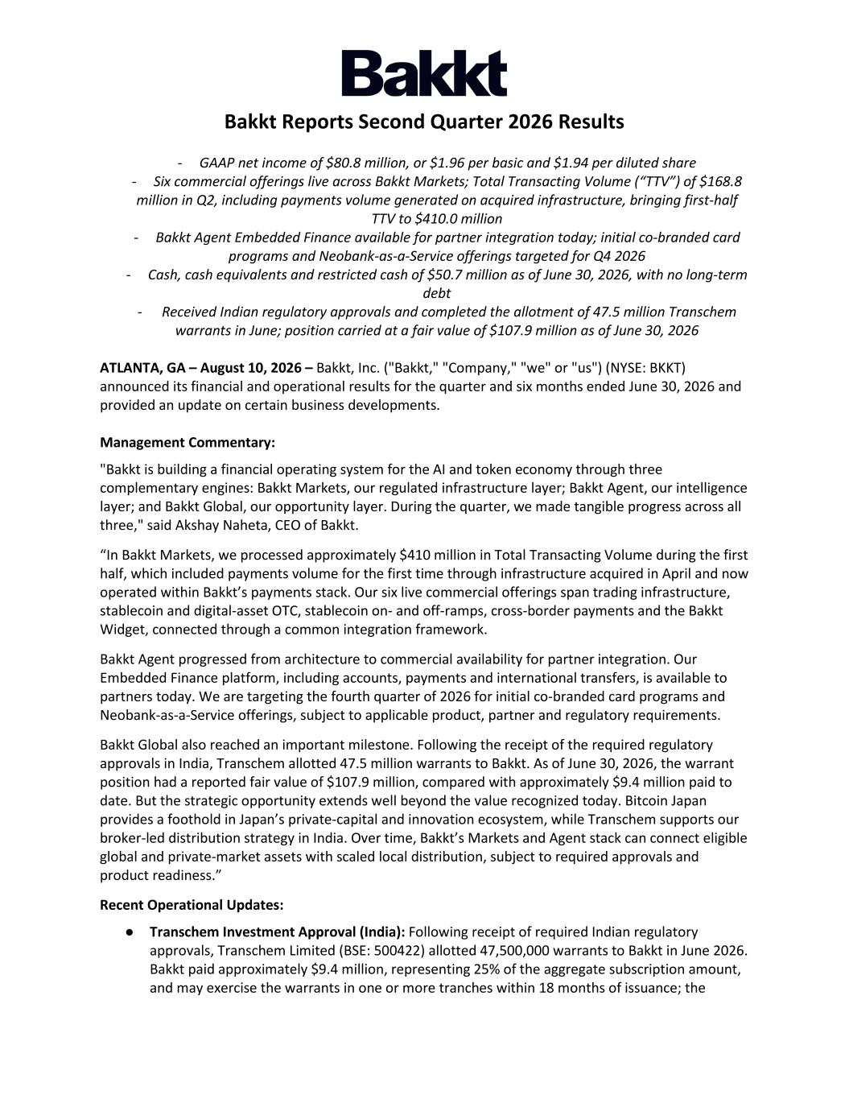

Bakkt Reports Second Quarter 2026 Results - GAAP net income of $80.8 million, or $1.96 per basic and $1.94 per diluted share - Six commercial offerings live across Bakkt Markets; Total Transacting Volume (“TTV”) of $168.8 million in Q2, including payments volume generated on acquired infrastructure, bringing first-half TTV to $410.0 million - Bakkt Agent Embedded Finance available for partner integration today; initial co-branded card programs and Neobank-as-a-Service offerings targeted for Q4 2026 - Cash, cash equivalents and restricted cash of $50.7 million as of June 30, 2026, with no long-term debt - Received Indian regulatory approvals and completed the allotment of 47.5 million Transchem warrants in June; position carried at a fair value of $107.9 million as of June 30, 2026 ATLANTA, GA – August 10, 2026 – Bakkt, Inc. ("Bakkt," "Company," "we" or "us") (NYSE: BKKT) announced its financial and operational results for the quarter and six months ended June 30, 2026 and provided an update on certain business developments. Management Commentary: "Bakkt is building a financial operating system for the AI and token economy through three complementary engines: Bakkt Markets, our regulated infrastructure layer; Bakkt Agent, our intelligence layer; and Bakkt Global, our opportunity layer. During the quarter, we made tangible progress across all three," said Akshay Naheta, CEO of Bakkt. “In Bakkt Markets, we processed approximately $410 million in Total Transacting Volume during the first half, which included payments volume for the first time through infrastructure acquired in April and now operated within Bakkt’s payments stack. Our six live commercial offerings span trading infrastructure, stablecoin and digital-asset OTC, stablecoin on- and off-ramps, cross-border payments and the Bakkt Widget, connected through a common integration framework. Bakkt Agent progressed from architecture to commercial availability for partner integration. Our Embedded Finance platform, including accounts, payments and international transfers, is available to partners today. We are targeting the fourth quarter of 2026 for initial co-branded card programs and Neobank-as-a-Service offerings, subject to applicable product, partner and regulatory requirements. Bakkt Global also reached an important milestone. Following the receipt of the required regulatory approvals in India, Transchem allotted 47.5 million warrants to Bakkt. As of June 30, 2026, the warrant position had a reported fair value of $107.9 million, compared with approximately $9.4 million paid to date. But the strategic opportunity extends well beyond the value recognized today. Bitcoin Japan provides a foothold in Japan’s private-capital and innovation ecosystem, while Transchem supports our broker-led distribution strategy in India. Over time, Bakkt’s Markets and Agent stack can connect eligible global and private-market assets with scaled local distribution, subject to required approvals and product readiness.” Recent Operational Updates: ● Transchem Investment Approval (India): Following receipt of required Indian regulatory approvals, Transchem Limited (BSE: 500422) allotted 47,500,000 warrants to Bakkt in June 2026. Bakkt paid approximately $9.4 million, representing 25% of the aggregate subscription amount, and may exercise the warrants in one or more tranches within 18 months of issuance; the

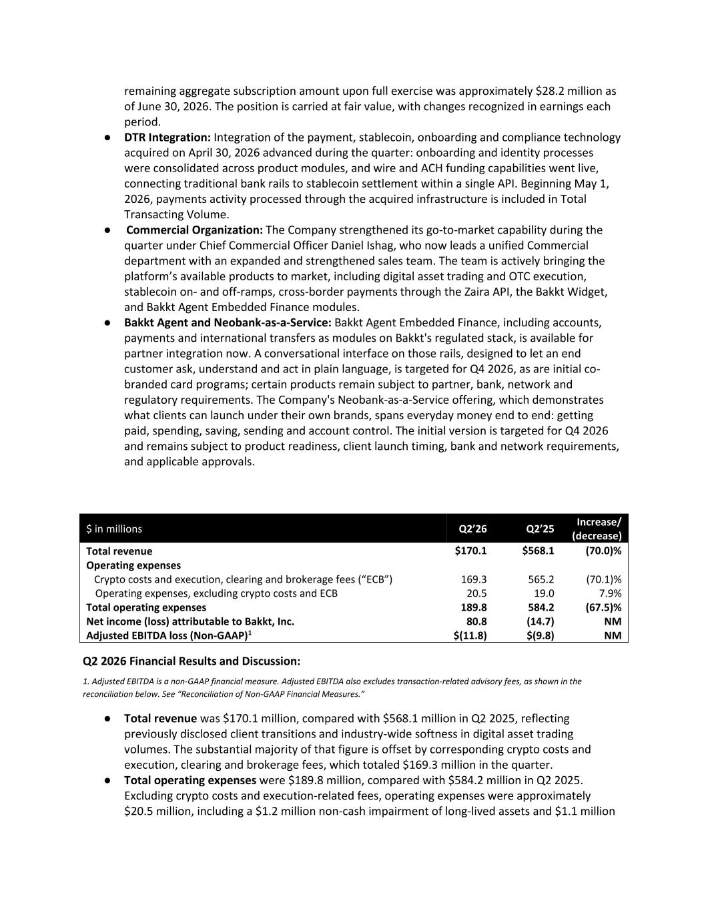
remaining aggregate subscription amount upon full exercise was approximately $28.2 million as of June 30, 2026. The position is carried at fair value, with changes recognized in earnings each period. ● DTR Integration: Integration of the payment, stablecoin, onboarding and compliance technology acquired on April 30, 2026 advanced during the quarter: onboarding and identity processes were consolidated across product modules, and wire and ACH funding capabilities went live, connecting traditional bank rails to stablecoin settlement within a single API. Beginning May 1, 2026, payments activity processed through the acquired infrastructure is included in Total Transacting Volume. ● Commercial Organization: The Company strengthened its go-to-market capability during the quarter under Chief Commercial Officer Daniel Ishag, who now leads a unified Commercial department with an expanded and strengthened sales team. The team is actively bringing the platform’s available products to market, including digital asset trading and OTC execution, stablecoin on- and off-ramps, cross-border payments through the Zaira API, the Bakkt Widget, and Bakkt Agent Embedded Finance modules. ● Bakkt Agent and Neobank-as-a-Service: Bakkt Agent Embedded Finance, including accounts, payments and international transfers as modules on Bakkt's regulated stack, is available for partner integration now. A conversational interface on those rails, designed to let an end customer ask, understand and act in plain language, is targeted for Q4 2026, as are initial co- branded card programs; certain products remain subject to partner, bank, network and regulatory requirements. The Company's Neobank-as-a-Service offering, which demonstrates what clients can launch under their own brands, spans everyday money end to end: getting paid, spending, saving, sending and account control. The initial version is targeted for Q4 2026 and remains subject to product readiness, client launch timing, bank and network requirements, and applicable approvals. Q2 2026 Financial Results and Discussion: 1. Adjusted EBITDA is a non-GAAP financial measure. Adjusted EBITDA also excludes transaction-related advisory fees, as shown in the reconciliation below. See “Reconciliation of Non-GAAP Financial Measures.” ● Total revenue was $170.1 million, compared with $568.1 million in Q2 2025, reflecting previously disclosed client transitions and industry-wide softness in digital asset trading volumes. The substantial majority of that figure is offset by corresponding crypto costs and execution, clearing and brokerage fees, which totaled $169.3 million in the quarter. ● Total operating expenses were $189.8 million, compared with $584.2 million in Q2 2025. Excluding crypto costs and execution-related fees, operating expenses were approximately $20.5 million, including a $1.2 million non-cash impairment of long-lived assets and $1.1 million $ in millions Q2’26 Q2’25 Increase/ (decrease) Total revenue $170.1 $568.1 (70.0)% Operating expenses Crypto costs and execution, clearing and brokerage fees (“ECB”) 169.3 565.2 (70.1)% Operating expenses, excluding crypto costs and ECB 20.5 19.0 7.9% Total operating expenses 189.8 584.2 (67.5)% Net income (loss) attributable to Bakkt, Inc. 80.8 (14.7) NM Adjusted EBITDA loss (Non-GAAP)1 $(11.8) $(9.8) NM

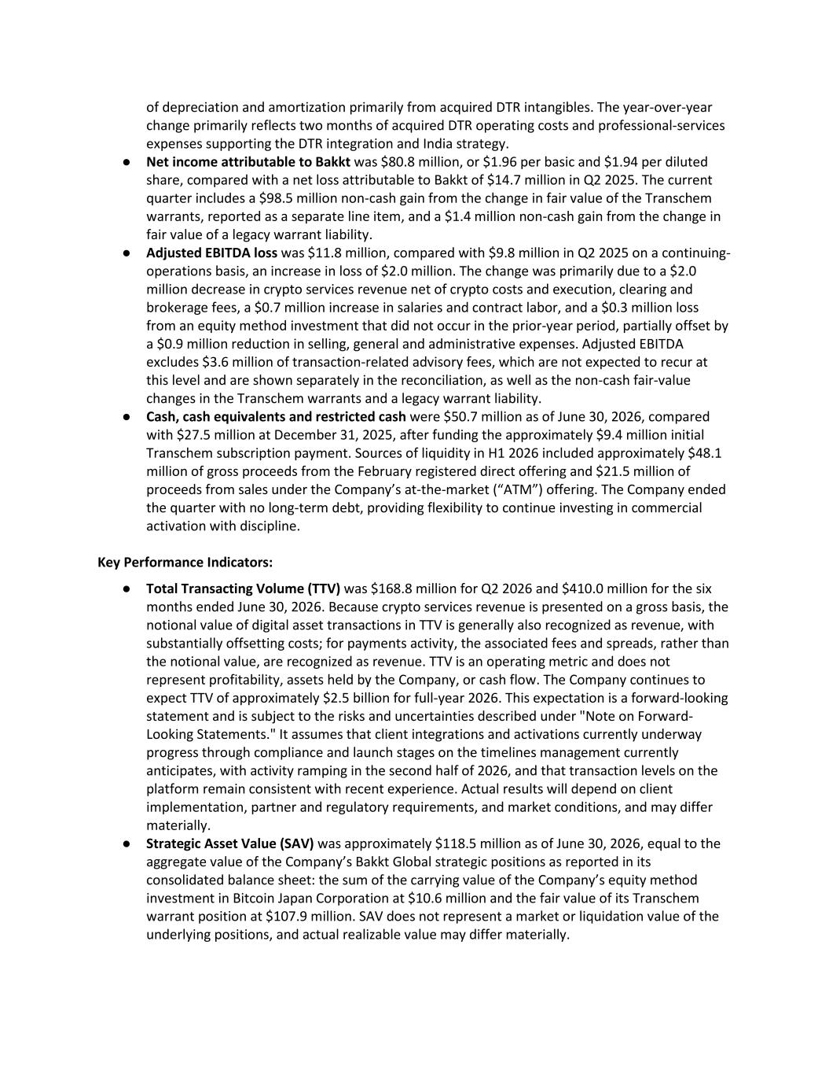
of depreciation and amortization primarily from acquired DTR intangibles. The year-over-year change primarily reflects two months of acquired DTR operating costs and professional-services expenses supporting the DTR integration and India strategy. ● Net income attributable to Bakkt was $80.8 million, or $1.96 per basic and $1.94 per diluted share, compared with a net loss attributable to Bakkt of $14.7 million in Q2 2025. The current quarter includes a $98.5 million non-cash gain from the change in fair value of the Transchem warrants, reported as a separate line item, and a $1.4 million non-cash gain from the change in fair value of a legacy warrant liability. ● Adjusted EBITDA loss was $11.8 million, compared with $9.8 million in Q2 2025 on a continuing- operations basis, an increase in loss of $2.0 million. The change was primarily due to a $2.0 million decrease in crypto services revenue net of crypto costs and execution, clearing and brokerage fees, a $0.7 million increase in salaries and contract labor, and a $0.3 million loss from an equity method investment that did not occur in the prior-year period, partially offset by a $0.9 million reduction in selling, general and administrative expenses. Adjusted EBITDA excludes $3.6 million of transaction-related advisory fees, which are not expected to recur at this level and are shown separately in the reconciliation, as well as the non-cash fair-value changes in the Transchem warrants and a legacy warrant liability. ● Cash, cash equivalents and restricted cash were $50.7 million as of June 30, 2026, compared with $27.5 million at December 31, 2025, after funding the approximately $9.4 million initial Transchem subscription payment. Sources of liquidity in H1 2026 included approximately $48.1 million of gross proceeds from the February registered direct offering and $21.5 million of proceeds from sales under the Company’s at-the-market (“ATM”) offering. The Company ended the quarter with no long-term debt, providing flexibility to continue investing in commercial activation with discipline. Key Performance Indicators: ● Total Transacting Volume (TTV) was $168.8 million for Q2 2026 and $410.0 million for the six months ended June 30, 2026. Because crypto services revenue is presented on a gross basis, the notional value of digital asset transactions in TTV is generally also recognized as revenue, with substantially offsetting costs; for payments activity, the associated fees and spreads, rather than the notional value, are recognized as revenue. TTV is an operating metric and does not represent profitability, assets held by the Company, or cash flow. The Company continues to expect TTV of approximately $2.5 billion for full-year 2026. This expectation is a forward-looking statement and is subject to the risks and uncertainties described under "Note on Forward- Looking Statements." It assumes that client integrations and activations currently underway progress through compliance and launch stages on the timelines management currently anticipates, with activity ramping in the second half of 2026, and that transaction levels on the platform remain consistent with recent experience. Actual results will depend on client implementation, partner and regulatory requirements, and market conditions, and may differ materially. ● Strategic Asset Value (SAV) was approximately $118.5 million as of June 30, 2026, equal to the aggregate value of the Company’s Bakkt Global strategic positions as reported in its consolidated balance sheet: the sum of the carrying value of the Company’s equity method investment in Bitcoin Japan Corporation at $10.6 million and the fair value of its Transchem warrant position at $107.9 million. SAV does not represent a market or liquidation value of the underlying positions, and actual realizable value may differ materially.

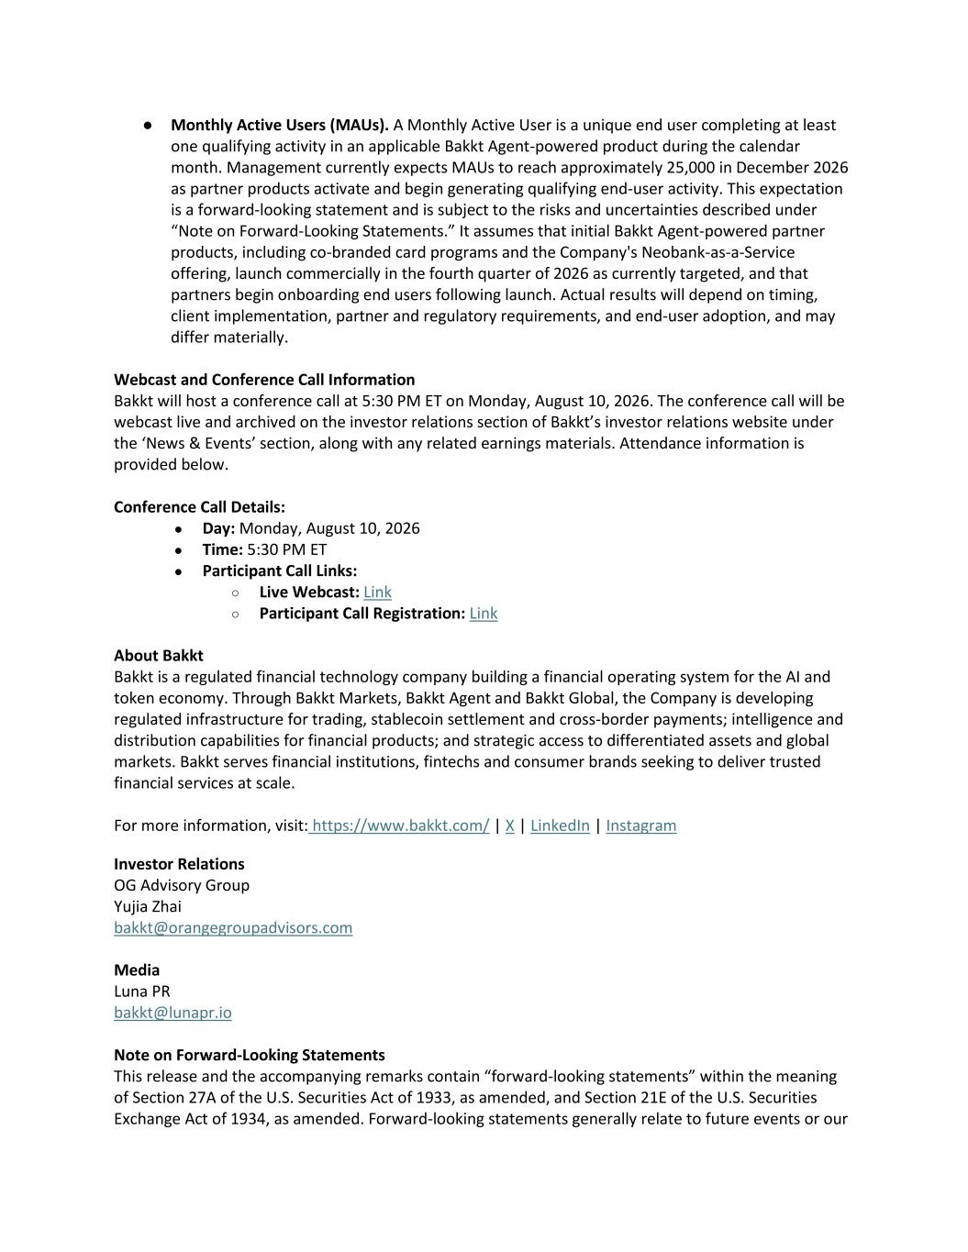
● Monthly Active Users (MAUs). A Monthly Active User is a unique end user completing at least one qualifying activity in an applicable Bakkt Agent-powered product during the calendar month. Management currently expects MAUs to reach approximately 25,000 in December 2026 as partner products activate and begin generating qualifying end-user activity. This expectation is a forward-looking statement and is subject to the risks and uncertainties described under “Note on Forward-Looking Statements.” It assumes that initial Bakkt Agent-powered partner products, including co-branded card programs and the Company's Neobank-as-a-Service offering, launch commercially in the fourth quarter of 2026 as currently targeted, and that partners begin onboarding end users following launch. Actual results will depend on timing, client implementation, partner and regulatory requirements, and end-user adoption, and may differ materially. Webcast and Conference Call Information Bakkt will host a conference call at 5:30 PM ET on Monday, August 10, 2026. The conference call will be webcast live and archived on the investor relations section of Bakkt’s investor relations website under the ‘News & Events’ section, along with any related earnings materials. Attendance information is provided below. Conference Call Details: ● Day: Monday, August 10, 2026 ● Time: 5:30 PM ET ● Participant Call Links: ○ Live Webcast: Link ○ Participant Call Registration: Link About Bakkt Bakkt is a regulated financial technology company building a financial operating system for the AI and token economy. Through Bakkt Markets, Bakkt Agent and Bakkt Global, the Company is developing regulated infrastructure for trading, stablecoin settlement and cross-border payments; intelligence and distribution capabilities for financial products; and strategic access to differentiated assets and global markets. Bakkt serves financial institutions, fintechs and consumer brands seeking to deliver trusted financial services at scale. For more information, visit: https://www.bakkt.com/ | X | LinkedIn | Instagram Investor Relations OG Advisory Group Yujia Zhai bakkt@orangegroupadvisors.com Media Luna PR bakkt@lunapr.io Note on Forward-Looking Statements This release and the accompanying remarks contain “forward-looking statements” within the meaning of Section 27A of the U.S. Securities Act of 1933, as amended, and Section 21E of the U.S. Securities Exchange Act of 1934, as amended. Forward-looking statements generally relate to future events or our

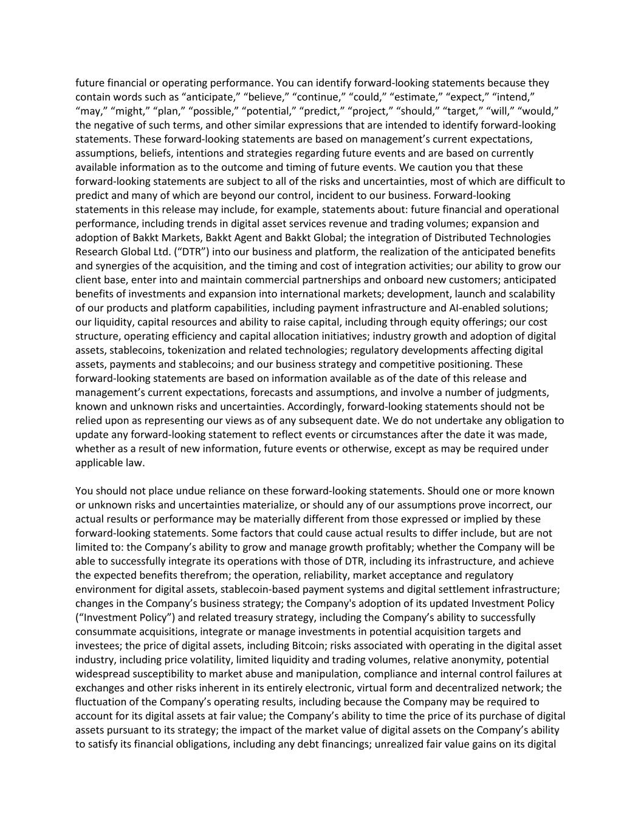
future financial or operating performance. You can identify forward-looking statements because they contain words such as “anticipate,” “believe,” “continue,” “could,” “estimate,” “expect,” “intend,” “may,” “might,” “plan,” “possible,” “potential,” “predict,” “project,” “should,” “target,” “will,” “would,” the negative of such terms, and other similar expressions that are intended to identify forward-looking statements. These forward-looking statements are based on management’s current expectations, assumptions, beliefs, intentions and strategies regarding future events and are based on currently available information as to the outcome and timing of future events. We caution you that these forward-looking statements are subject to all of the risks and uncertainties, most of which are difficult to predict and many of which are beyond our control, incident to our business. Forward-looking statements in this release may include, for example, statements about: future financial and operational performance, including trends in digital asset services revenue and trading volumes; expansion and adoption of Bakkt Markets, Bakkt Agent and Bakkt Global; the integration of Distributed Technologies Research Global Ltd. (“DTR”) into our business and platform, the realization of the anticipated benefits and synergies of the acquisition, and the timing and cost of integration activities; our ability to grow our client base, enter into and maintain commercial partnerships and onboard new customers; anticipated benefits of investments and expansion into international markets; development, launch and scalability of our products and platform capabilities, including payment infrastructure and AI-enabled solutions; our liquidity, capital resources and ability to raise capital, including through equity offerings; our cost structure, operating efficiency and capital allocation initiatives; industry growth and adoption of digital assets, stablecoins, tokenization and related technologies; regulatory developments affecting digital assets, payments and stablecoins; and our business strategy and competitive positioning. These forward-looking statements are based on information available as of the date of this release and management’s current expectations, forecasts and assumptions, and involve a number of judgments, known and unknown risks and uncertainties. Accordingly, forward-looking statements should not be relied upon as representing our views as of any subsequent date. We do not undertake any obligation to update any forward-looking statement to reflect events or circumstances after the date it was made, whether as a result of new information, future events or otherwise, except as may be required under applicable law. You should not place undue reliance on these forward-looking statements. Should one or more known or unknown risks and uncertainties materialize, or should any of our assumptions prove incorrect, our actual results or performance may be materially different from those expressed or implied by these forward-looking statements. Some factors that could cause actual results to differ include, but are not limited to: the Company’s ability to grow and manage growth profitably; whether the Company will be able to successfully integrate its operations with those of DTR, including its infrastructure, and achieve the expected benefits therefrom; the operation, reliability, market acceptance and regulatory environment for digital assets, stablecoin-based payment systems and digital settlement infrastructure; changes in the Company’s business strategy; the Company's adoption of its updated Investment Policy (“Investment Policy”) and related treasury strategy, including the Company’s ability to successfully consummate acquisitions, integrate or manage investments in potential acquisition targets and investees; the price of digital assets, including Bitcoin; risks associated with operating in the digital asset industry, including price volatility, limited liquidity and trading volumes, relative anonymity, potential widespread susceptibility to market abuse and manipulation, compliance and internal control failures at exchanges and other risks inherent in its entirely electronic, virtual form and decentralized network; the fluctuation of the Company’s operating results, including because the Company may be required to account for its digital assets at fair value; the Company’s ability to time the price of its purchase of digital assets pursuant to its strategy; the impact of the market value of digital assets on the Company’s ability to satisfy its financial obligations, including any debt financings; unrealized fair value gains on its digital

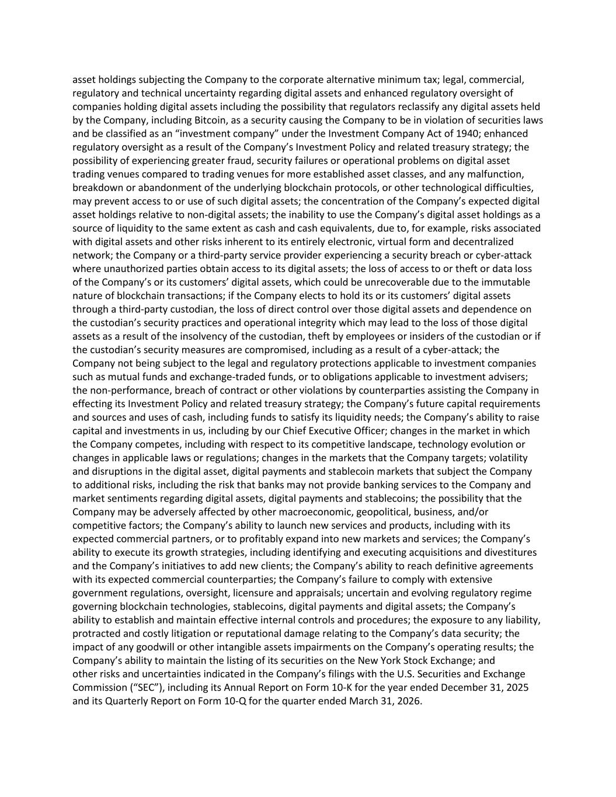
asset holdings subjecting the Company to the corporate alternative minimum tax; legal, commercial, regulatory and technical uncertainty regarding digital assets and enhanced regulatory oversight of companies holding digital assets including the possibility that regulators reclassify any digital assets held by the Company, including Bitcoin, as a security causing the Company to be in violation of securities laws and be classified as an “investment company” under the Investment Company Act of 1940; enhanced regulatory oversight as a result of the Company’s Investment Policy and related treasury strategy; the possibility of experiencing greater fraud, security failures or operational problems on digital asset trading venues compared to trading venues for more established asset classes, and any malfunction, breakdown or abandonment of the underlying blockchain protocols, or other technological difficulties, may prevent access to or use of such digital assets; the concentration of the Company’s expected digital asset holdings relative to non-digital assets; the inability to use the Company’s digital asset holdings as a source of liquidity to the same extent as cash and cash equivalents, due to, for example, risks associated with digital assets and other risks inherent to its entirely electronic, virtual form and decentralized network; the Company or a third-party service provider experiencing a security breach or cyber-attack where unauthorized parties obtain access to its digital assets; the loss of access to or theft or data loss of the Company’s or its customers’ digital assets, which could be unrecoverable due to the immutable nature of blockchain transactions; if the Company elects to hold its or its customers’ digital assets through a third-party custodian, the loss of direct control over those digital assets and dependence on the custodian’s security practices and operational integrity which may lead to the loss of those digital assets as a result of the insolvency of the custodian, theft by employees or insiders of the custodian or if the custodian’s security measures are compromised, including as a result of a cyber-attack; the Company not being subject to the legal and regulatory protections applicable to investment companies such as mutual funds and exchange-traded funds, or to obligations applicable to investment advisers; the non-performance, breach of contract or other violations by counterparties assisting the Company in effecting its Investment Policy and related treasury strategy; the Company’s future capital requirements and sources and uses of cash, including funds to satisfy its liquidity needs; the Company’s ability to raise capital and investments in us, including by our Chief Executive Officer; changes in the market in which the Company competes, including with respect to its competitive landscape, technology evolution or changes in applicable laws or regulations; changes in the markets that the Company targets; volatility and disruptions in the digital asset, digital payments and stablecoin markets that subject the Company to additional risks, including the risk that banks may not provide banking services to the Company and market sentiments regarding digital assets, digital payments and stablecoins; the possibility that the Company may be adversely affected by other macroeconomic, geopolitical, business, and/or competitive factors; the Company’s ability to launch new services and products, including with its expected commercial partners, or to profitably expand into new markets and services; the Company’s ability to execute its growth strategies, including identifying and executing acquisitions and divestitures and the Company’s initiatives to add new clients; the Company’s ability to reach definitive agreements with its expected commercial counterparties; the Company’s failure to comply with extensive government regulations, oversight, licensure and appraisals; uncertain and evolving regulatory regime governing blockchain technologies, stablecoins, digital payments and digital assets; the Company’s ability to establish and maintain effective internal controls and procedures; the exposure to any liability, protracted and costly litigation or reputational damage relating to the Company’s data security; the impact of any goodwill or other intangible assets impairments on the Company’s operating results; the Company’s ability to maintain the listing of its securities on the New York Stock Exchange; and other risks and uncertainties indicated in the Company’s filings with the U.S. Securities and Exchange Commission (“SEC”), including its Annual Report on Form 10-K for the year ended December 31, 2025 and its Quarterly Report on Form 10-Q for the quarter ended March 31, 2026.



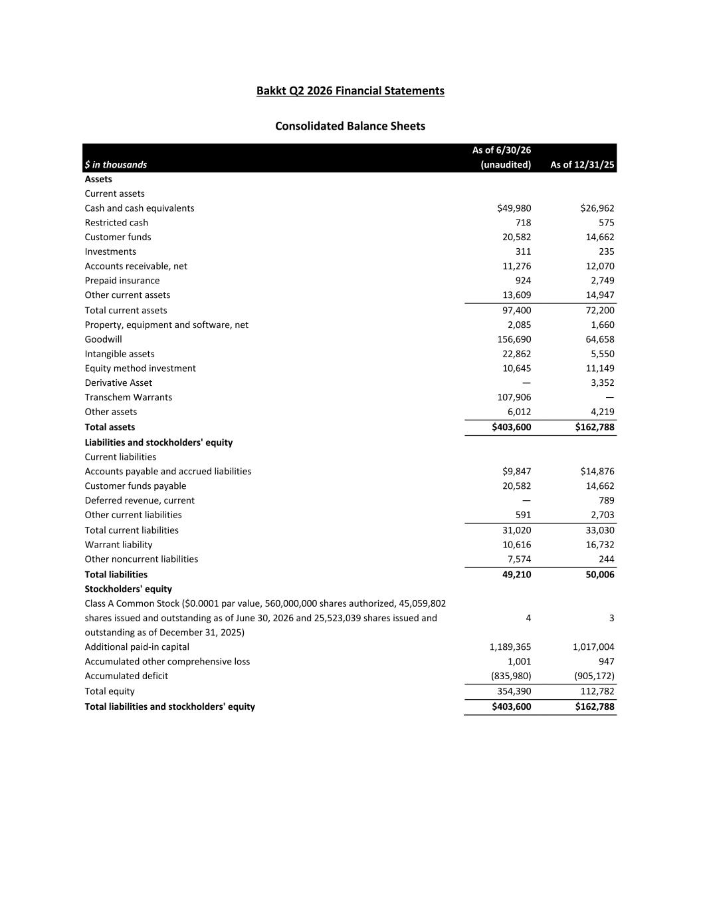
Bakkt Q2 2026 Financial Statements Consolidated Balance Sheets $ in thousands As of 6/30/26 (unaudited) As of 12/31/25 Assets Current assets Cash and cash equivalents $49,980 $26,962 Restricted cash 718 575 Customer funds 20,582 14,662 Investments 311 235 Accounts receivable, net 11,276 12,070 Prepaid insurance 924 2,749 Other current assets 13,609 14,947 Total current assets 97,400 72,200 Property, equipment and software, net 2,085 1,660 Goodwill 156,690 64,658 Intangible assets 22,862 5,550 Equity method investment 10,645 11,149 Derivative Asset — 3,352 Transchem Warrants 107,906 — Other assets 6,012 4,219 Total assets $403,600 $162,788 Liabilities and stockholders' equity Current liabilities Accounts payable and accrued liabilities $9,847 $14,876 Customer funds payable 20,582 14,662 Deferred revenue, current — 789 Other current liabilities 591 2,703 Total current liabilities 31,020 33,030 Warrant liability 10,616 16,732 Other noncurrent liabilities 7,574 244 Total liabilities 49,210 50,006 Stockholders' equity Class A Common Stock ($0.0001 par value, 560,000,000 shares authorized, 45,059,802 shares issued and outstanding as of June 30, 2026 and 25,523,039 shares issued and outstanding as of December 31, 2025) 4 3 Additional paid-in capital 1,189,365 1,017,004 Accumulated other comprehensive loss 1,001 947 Accumulated deficit (835,980) (905,172) Total equity 354,390 112,782 Total liabilities and stockholders' equity $403,600 $162,788

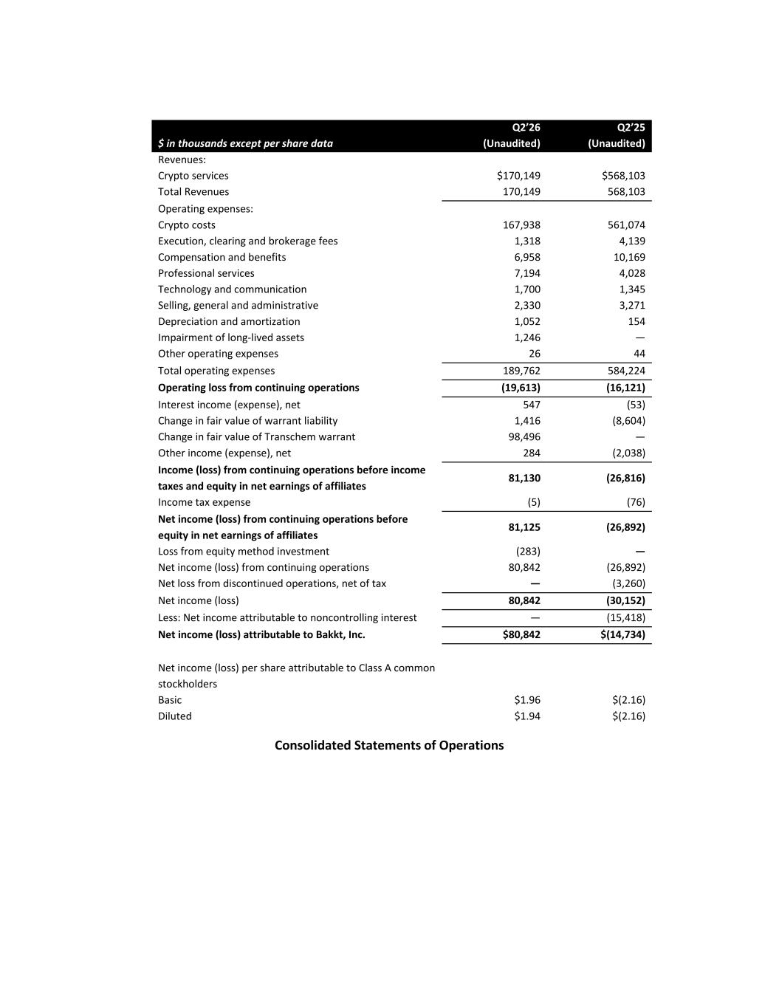
Consolidated Statements of Operations $ in thousands except per share data Q2’26 (Unaudited) Q2’25 (Unaudited) Revenues: Crypto services $170,149 $568,103 Total Revenues 170,149 568,103 Operating expenses: Crypto costs 167,938 561,074 Execution, clearing and brokerage fees 1,318 4,139 Compensation and benefits 6,958 10,169 Professional services 7,194 4,028 Technology and communication 1,700 1,345 Selling, general and administrative 2,330 3,271 Depreciation and amortization 1,052 154 Impairment of long-lived assets 1,246 — Other operating expenses 26 44 Total operating expenses 189,762 584,224 Operating loss from continuing operations (19,613) (16,121) Interest income (expense), net 547 (53) Change in fair value of warrant liability 1,416 (8,604) Change in fair value of Transchem warrant 98,496 — Other income (expense), net 284 (2,038) Income (loss) from continuing operations before income taxes and equity in net earnings of affiliates 81,130 (26,816) Income tax expense (5) (76) Net income (loss) from continuing operations before equity in net earnings of affiliates 81,125 (26,892) Loss from equity method investment (283) — Net income (loss) from continuing operations 80,842 (26,892) Net loss from discontinued operations, net of tax — (3,260) Net income (loss) 80,842 (30,152) Less: Net income attributable to noncontrolling interest — (15,418) Net income (loss) attributable to Bakkt, Inc. $80,842 $(14,734) Net income (loss) per share attributable to Class A common stockholders Basic $1.96 $(2.16) Diluted $1.94 $(2.16)

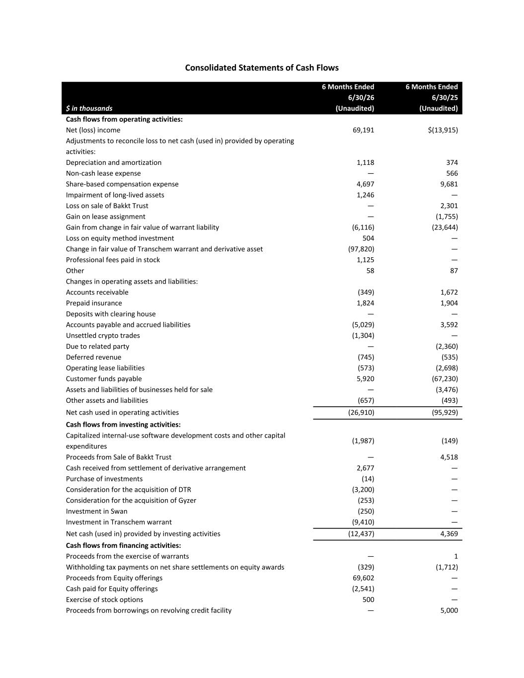
Consolidated Statements of Cash Flows $ in thousands 6 Months Ended 6/30/26 (Unaudited) 6 Months Ended 6/30/25 (Unaudited) Cash flows from operating activities: Net (loss) income 69,191 $(13,915) Adjustments to reconcile loss to net cash (used in) provided by operating activities: Depreciation and amortization 1,118 374 Non-cash lease expense — 566 Share-based compensation expense 4,697 9,681 Impairment of long-lived assets 1,246 — Loss on sale of Bakkt Trust — 2,301 Gain on lease assignment — (1,755) Gain from change in fair value of warrant liability (6,116) (23,644) Loss on equity method investment 504 — Change in fair value of Transchem warrant and derivative asset (97,820) — Professional fees paid in stock 1,125 — Other 58 87 Changes in operating assets and liabilities: Accounts receivable (349) 1,672 Prepaid insurance 1,824 1,904 Deposits with clearing house — — Accounts payable and accrued liabilities (5,029) 3,592 Unsettled crypto trades (1,304) — Due to related party — (2,360) Deferred revenue (745) (535) Operating lease liabilities (573) (2,698) Customer funds payable 5,920 (67,230) Assets and liabilities of businesses held for sale — (3,476) Other assets and liabilities (657) (493) Net cash used in operating activities (26,910) (95,929) Cash flows from investing activities: Capitalized internal-use software development costs and other capital expenditures (1,987) (149) Proceeds from Sale of Bakkt Trust — 4,518 Cash received from settlement of derivative arrangement 2,677 — Purchase of investments (14) — Consideration for the acquisition of DTR (3,200) — Consideration for the acquisition of Gyzer (253) — Investment in Swan (250) — Investment in Transchem warrant (9,410) — Net cash (used in) provided by investing activities (12,437) 4,369 Cash flows from financing activities: Proceeds from the exercise of warrants — 1 Withholding tax payments on net share settlements on equity awards (329) (1,712) Proceeds from Equity offerings 69,602 — Cash paid for Equity offerings (2,541) — Exercise of stock options 500 — Proceeds from borrowings on revolving credit facility — 5,000

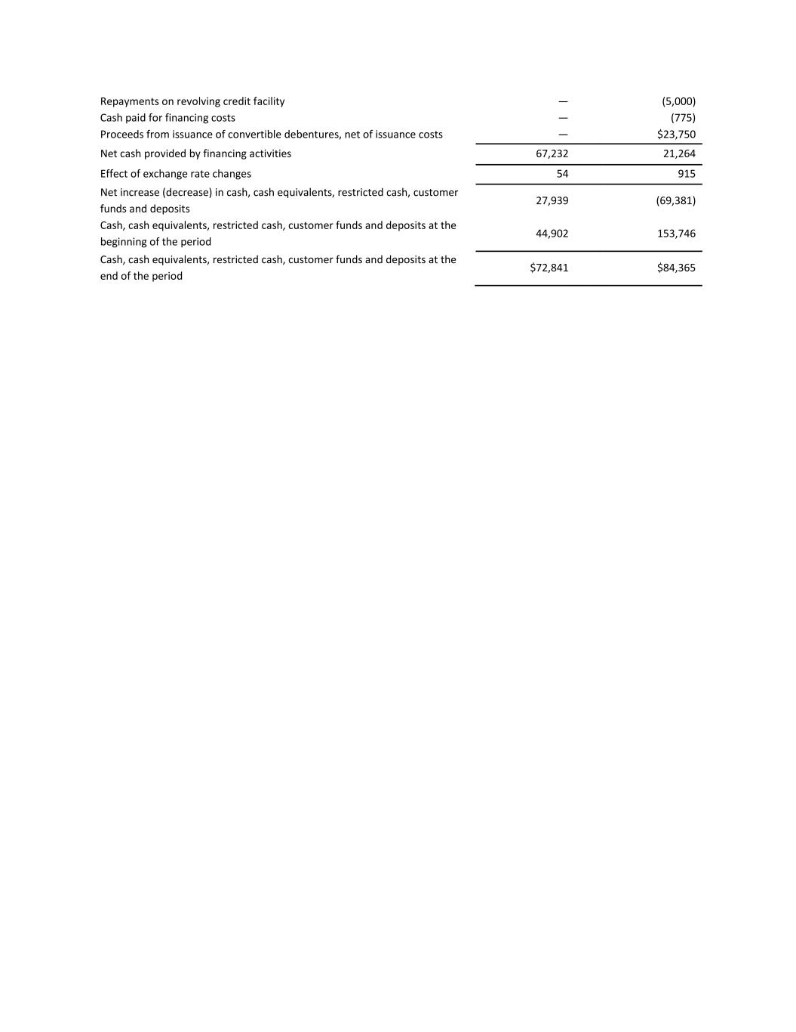
Repayments on revolving credit facility — (5,000) Cash paid for financing costs — (775) Proceeds from issuance of convertible debentures, net of issuance costs — $23,750 Net cash provided by financing activities 67,232 21,264 Effect of exchange rate changes 54 915 Net increase (decrease) in cash, cash equivalents, restricted cash, customer funds and deposits 27,939 (69,381) Cash, cash equivalents, restricted cash, customer funds and deposits at the beginning of the period 44,902 153,746 Cash, cash equivalents, restricted cash, customer funds and deposits at the end of the period $72,841 $84,365

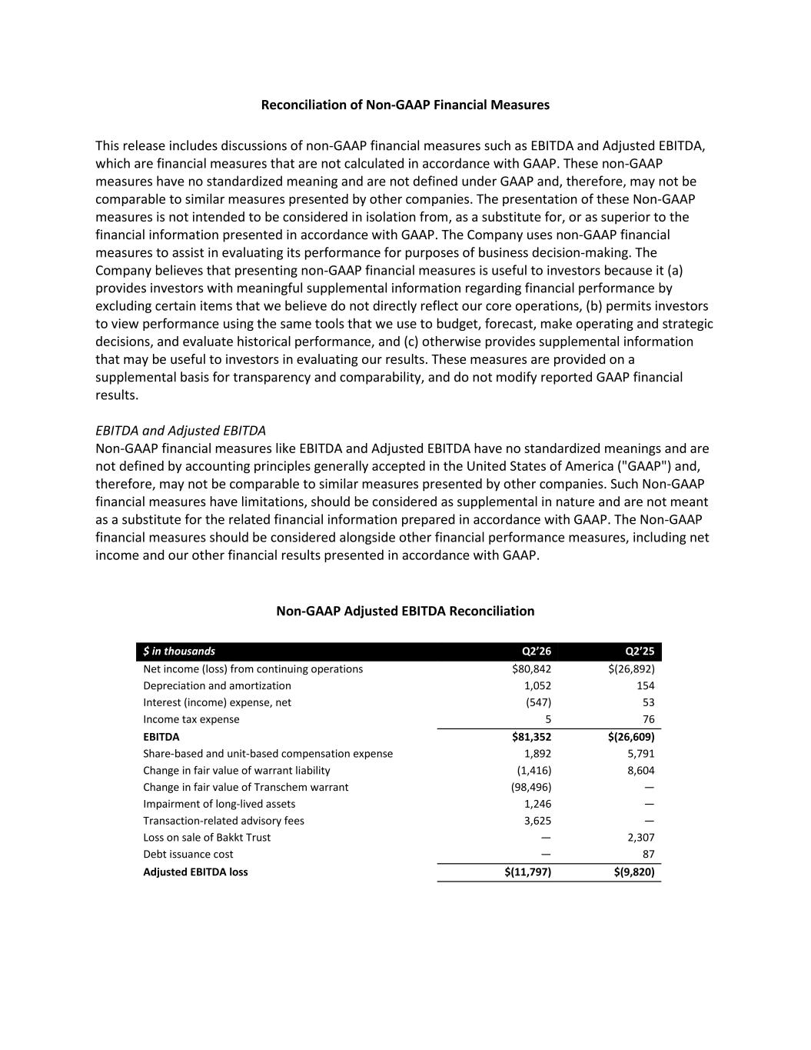
Reconciliation of Non-GAAP Financial Measures This release includes discussions of non-GAAP financial measures such as EBITDA and Adjusted EBITDA, which are financial measures that are not calculated in accordance with GAAP. These non-GAAP measures have no standardized meaning and are not defined under GAAP and, therefore, may not be comparable to similar measures presented by other companies. The presentation of these Non-GAAP measures is not intended to be considered in isolation from, as a substitute for, or as superior to the financial information presented in accordance with GAAP. The Company uses non-GAAP financial measures to assist in evaluating its performance for purposes of business decision-making. The Company believes that presenting non-GAAP financial measures is useful to investors because it (a) provides investors with meaningful supplemental information regarding financial performance by excluding certain items that we believe do not directly reflect our core operations, (b) permits investors to view performance using the same tools that we use to budget, forecast, make operating and strategic decisions, and evaluate historical performance, and (c) otherwise provides supplemental information that may be useful to investors in evaluating our results. These measures are provided on a supplemental basis for transparency and comparability, and do not modify reported GAAP financial results. EBITDA and Adjusted EBITDA Non-GAAP financial measures like EBITDA and Adjusted EBITDA have no standardized meanings and are not defined by accounting principles generally accepted in the United States of America ("GAAP") and, therefore, may not be comparable to similar measures presented by other companies. Such Non-GAAP financial measures have limitations, should be considered as supplemental in nature and are not meant as a substitute for the related financial information prepared in accordance with GAAP. The Non-GAAP financial measures should be considered alongside other financial performance measures, including net income and our other financial results presented in accordance with GAAP. Non-GAAP Adjusted EBITDA Reconciliation $ in thousands Q2’26 Q2’25 Net income (loss) from continuing operations $80,842 $(26,892) Depreciation and amortization 1,052 154 Interest (income) expense, net (547) 53 Income tax expense 5 76 EBITDA $81,352 $(26,609) Share-based and unit-based compensation expense 1,892 5,791 Change in fair value of warrant liability (1,416) 8,604 Change in fair value of Transchem warrant (98,496) — Impairment of long-lived assets 1,246 — Transaction-related advisory fees 3,625 — Loss on sale of Bakkt Trust — 2,307 Debt issuance cost — 87 Adjusted EBITDA loss $(11,797) $(9,820)

