UNITED STATES
SECURITIES AND EXCHANGE COMMISSION
WASHINGTON, DC 20549
FORM 8-K
CURRENT REPORT
Pursuant to Section 13 OR 15(d)
of The Securities Exchange Act of 1934

Date of Report (Date of earliest event reported)
May 11, 2026
Bakkt, Inc.
(Exact name of registrant as specified in its charter)
Delaware |  |  |  |  |  | 001-39544 |  |  |  |  |  | 41-2324812
(State or other jurisdiction  of incorporation) |  |  |  |  |  | (Commission  File Number) |  |  |  |  |  | (IRS Employer  Identification No.)
3280 Peachtree Road NE, 7th Floor  Atlanta, Georgia |  |  |  |  |  | 30305
(Address of principal executive offices) |  |  |  |  |  | (Zip Code)
Registrant’s telephone number, including area code: (332) 203-3017

Check the appropriate box below if the Form 8-K filing is intended to simultaneously satisfy the filing obligation of the registrant under any of the following provisions (see General Instruction A.2. below):
☐ |  |  | Written communication pursuant to Rule 425 under the Securities Act (17 CFR 230.425)
☐ |  |  | Soliciting material pursuant to Rule 14a-12 under the Exchange Act (17 CFR 240.14a-12)
☐ |  |  | Pre-commencement communications pursuant to Rule 14d-2(b) under the Exchange Act (17 CFR 240.14d-2(b))
☐ |  |  | Pre-commencement communications pursuant to Rule 13e-4(c) under the Exchange Act (17 CFR 240.13e-4(c))
Securities registered pursuant to Section 12(b) of the Act:
Title of each class |  |  |  |  |  |  |  |  | Trading Symbol(s) |  |  |  |  |  | Name of each exchange  on which registered
Class A Common Stock, par value $0.0001 per share |  |  |  |  |  |  |  |  | BKKT |  |  |  |  |  | The New York Stock Exchange
Warrants to purchase Class A Common Stock |  |  |  |  |  |  |  |  | BKKT WS |  |  |  |  |  | The New York Stock Exchange
Indicate by check mark whether the registrant is an emerging growth company as defined in Rule 405 of the Securities Act of 1933 (§230.405 of this chapter) or Rule 12b-2 of the Securities Exchange Act of 1934 (§240.12b-2 of this chapter).

Emerging growth company ☐

If an emerging growth company, indicate by check mark if the registrant has elected not to use the extended transition period for complying with any new or revised financial accounting standards provided pursuant to Section 13(a) of the Exchange Act. ☐

Item 2.02 Results of Operations and Financial Conditions.

On May 11, 2026, Bakkt Holdings, Inc. (the “Company”) issued a press release regarding the Company’s results for the quarter ended March 31, 2026. A copy of the press release is attached hereto as Exhibit 99.1 and incorporated herein by reference.

The information in this Item 2.02, including Exhibit 99.1 attached hereto, is being furnished and shall not be deemed “filed” for purposes of Section 18 of the Securities Exchange Act of 1934, as amended (the “Exchange Act”), or otherwise subject to the liabilities of such section, nor shall it be deemed incorporated by reference in any filing under the Exchange Act or the Securities Act of 1933, as amended, except as shall be expressly set forth by specific reference in such filing.

Item 9.01 Financial Statements and Exhibits.
(d) Exhibits

Exhibit No. |  |  | Description
99.1 |  |  | Press release issued by Bakkt Holdings, Inc. on May 11, 2026
104 |  |  | Cover Page Interactive Data File (embedded within the Inline XBRL document)

SIGNATURE
Pursuant to the requirements of the Securities Exchange Act of 1934, the registrant has duly caused this report to be signed on its behalf by the undersigned, hereunto duly authorized.
Dated: May 11, 2026
 |  |  | BAKKT, INC.
 |  |  | By: |  |  | /s/ Marc D'Annunzio
 |  |  | Name: |  |  | Marc D’Annunzio
 |  |  | Title: |  |  | General Counsel and Secretary

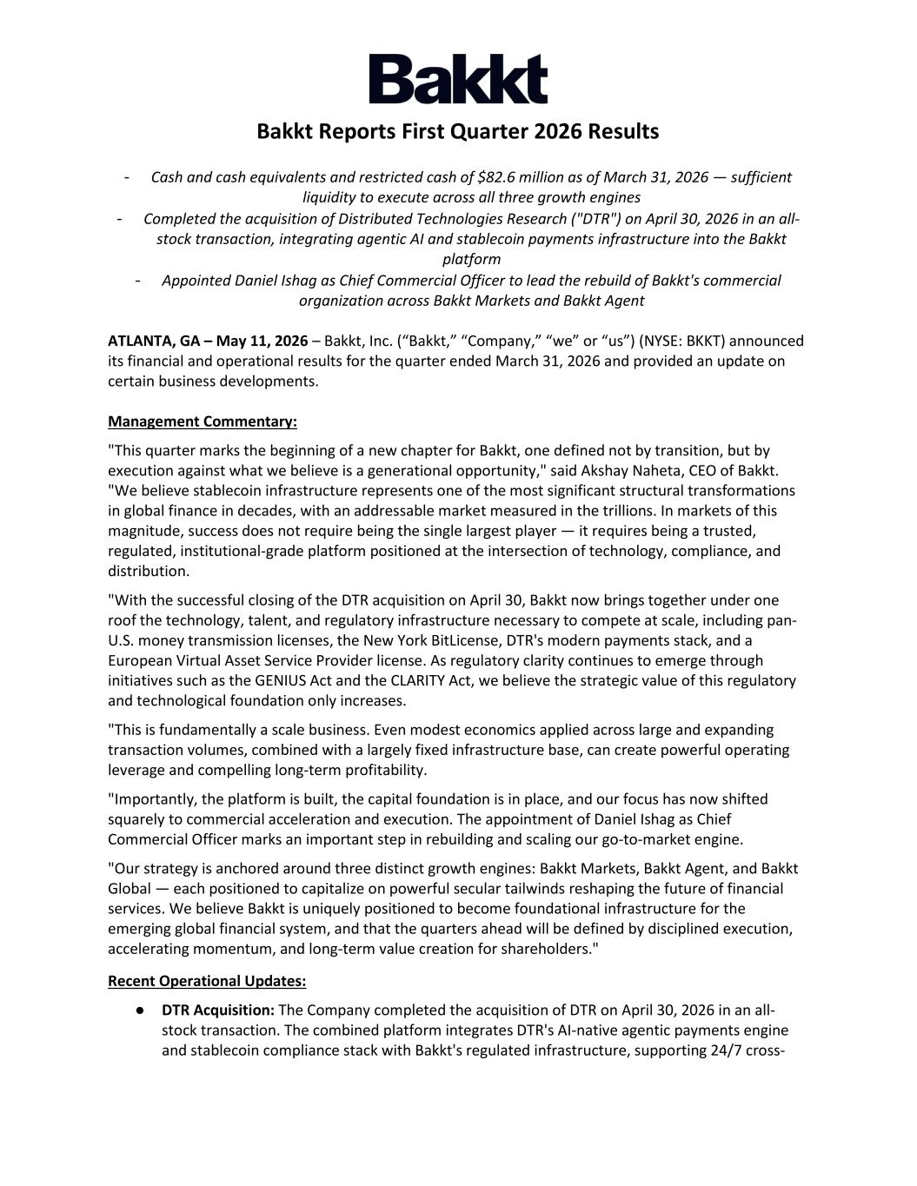

Bakkt Reports First Quarter 2026 Results - Cash and cash equivalents and restricted cash of $82.6 million as of March 31, 2026 — sufficient liquidity to execute across all three growth engines - Completed the acquisition of Distributed Technologies Research ("DTR") on April 30, 2026 in an all- stock transaction, integrating agentic AI and stablecoin payments infrastructure into the Bakkt platform - Appointed Daniel Ishag as Chief Commercial Officer to lead the rebuild of Bakkt's commercial organization across Bakkt Markets and Bakkt Agent ATLANTA, GA – May 11, 2026 – Bakkt, Inc. (“Bakkt,” “Company,” “we” or “us”) (NYSE: BKKT) announced its financial and operational results for the quarter ended March 31, 2026 and provided an update on certain business developments. Management Commentary: "This quarter marks the beginning of a new chapter for Bakkt, one defined not by transition, but by execution against what we believe is a generational opportunity," said Akshay Naheta, CEO of Bakkt. "We believe stablecoin infrastructure represents one of the most significant structural transformations in global finance in decades, with an addressable market measured in the trillions. In markets of this magnitude, success does not require being the single largest player — it requires being a trusted, regulated, institutional-grade platform positioned at the intersection of technology, compliance, and distribution. "With the successful closing of the DTR acquisition on April 30, Bakkt now brings together under one roof the technology, talent, and regulatory infrastructure necessary to compete at scale, including pan- U.S. money transmission licenses, the New York BitLicense, DTR's modern payments stack, and a European Virtual Asset Service Provider license. As regulatory clarity continues to emerge through initiatives such as the GENIUS Act and the CLARITY Act, we believe the strategic value of this regulatory and technological foundation only increases. "This is fundamentally a scale business. Even modest economics applied across large and expanding transaction volumes, combined with a largely fixed infrastructure base, can create powerful operating leverage and compelling long-term profitability. "Importantly, the platform is built, the capital foundation is in place, and our focus has now shifted squarely to commercial acceleration and execution. The appointment of Daniel Ishag as Chief Commercial Officer marks an important step in rebuilding and scaling our go-to-market engine. "Our strategy is anchored around three distinct growth engines: Bakkt Markets, Bakkt Agent, and Bakkt Global — each positioned to capitalize on powerful secular tailwinds reshaping the future of financial services. We believe Bakkt is uniquely positioned to become foundational infrastructure for the emerging global financial system, and that the quarters ahead will be defined by disciplined execution, accelerating momentum, and long-term value creation for shareholders." Recent Operational Updates: ● DTR Acquisition: The Company completed the acquisition of DTR on April 30, 2026 in an all- stock transaction. The combined platform integrates DTR's AI-native agentic payments engine and stablecoin compliance stack with Bakkt's regulated infrastructure, supporting 24/7 cross-

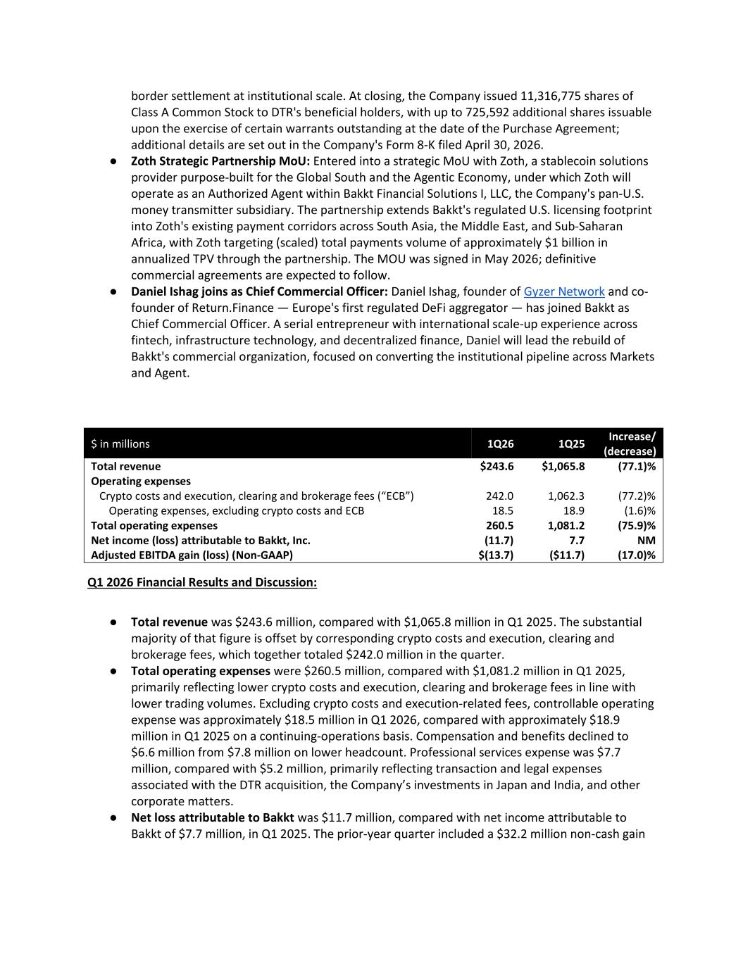
border settlement at institutional scale. At closing, the Company issued 11,316,775 shares of Class A Common Stock to DTR's beneficial holders, with up to 725,592 additional shares issuable upon the exercise of certain warrants outstanding at the date of the Purchase Agreement; additional details are set out in the Company's Form 8-K filed April 30, 2026. ● Zoth Strategic Partnership MoU: Entered into a strategic MoU with Zoth, a stablecoin solutions provider purpose-built for the Global South and the Agentic Economy, under which Zoth will operate as an Authorized Agent within Bakkt Financial Solutions I, LLC, the Company's pan-U.S. money transmitter subsidiary. The partnership extends Bakkt's regulated U.S. licensing footprint into Zoth's existing payment corridors across South Asia, the Middle East, and Sub-Saharan Africa, with Zoth targeting (scaled) total payments volume of approximately $1 billion in annualized TPV through the partnership. The MOU was signed in May 2026; definitive commercial agreements are expected to follow. ● Daniel Ishag joins as Chief Commercial Officer: Daniel Ishag, founder of Gyzer Network and co- founder of Return.Finance — Europe's first regulated DeFi aggregator — has joined Bakkt as Chief Commercial Officer. A serial entrepreneur with international scale-up experience across fintech, infrastructure technology, and decentralized finance, Daniel will lead the rebuild of Bakkt's commercial organization, focused on converting the institutional pipeline across Markets and Agent. Q1 2026 Financial Results and Discussion: ● Total revenue was $243.6 million, compared with $1,065.8 million in Q1 2025. The substantial majority of that figure is offset by corresponding crypto costs and execution, clearing and brokerage fees, which together totaled $242.0 million in the quarter. ● Total operating expenses were $260.5 million, compared with $1,081.2 million in Q1 2025, primarily reflecting lower crypto costs and execution, clearing and brokerage fees in line with lower trading volumes. Excluding crypto costs and execution-related fees, controllable operating expense was approximately $18.5 million in Q1 2026, compared with approximately $18.9 million in Q1 2025 on a continuing-operations basis. Compensation and benefits declined to $6.6 million from $7.8 million on lower headcount. Professional services expense was $7.7 million, compared with $5.2 million, primarily reflecting transaction and legal expenses associated with the DTR acquisition, the Company’s investments in Japan and India, and other corporate matters. ● Net loss attributable to Bakkt was $11.7 million, compared with net income attributable to Bakkt of $7.7 million, in Q1 2025. The prior-year quarter included a $32.2 million non-cash gain $ in millions 1Q26 1Q25 Increase/ (decrease) Total revenue $243.6 $1,065.8 (77.1)% Operating expenses Crypto costs and execution, clearing and brokerage fees (“ECB”) 242.0 1,062.3 (77.2)% Operating expenses, excluding crypto costs and ECB 18.5 18.9 (1.6)% Total operating expenses 260.5 1,081.2 (75.9)% Net income (loss) attributable to Bakkt, Inc. (11.7) 7.7 NM Adjusted EBITDA gain (loss) (Non-GAAP) $(13.7) ($11.7) (17.0)%

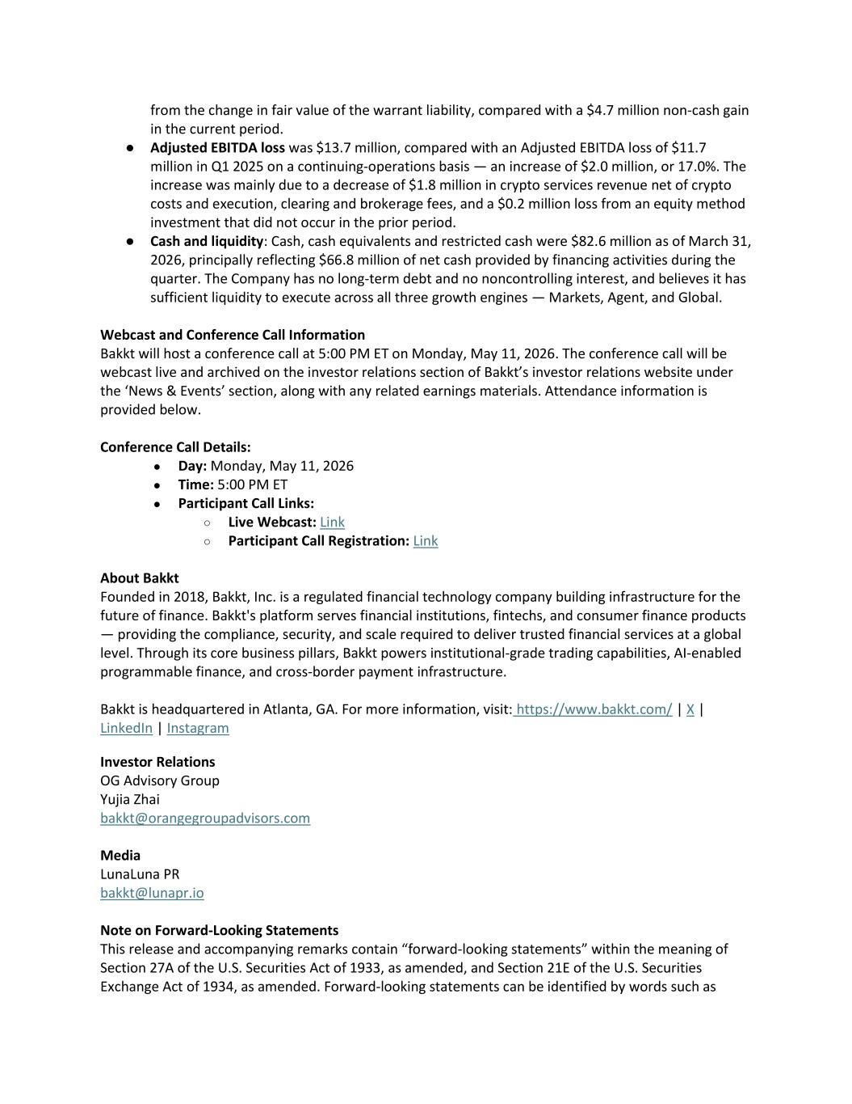
from the change in fair value of the warrant liability, compared with a $4.7 million non-cash gain in the current period. ● Adjusted EBITDA loss was $13.7 million, compared with an Adjusted EBITDA loss of $11.7 million in Q1 2025 on a continuing-operations basis — an increase of $2.0 million, or 17.0%. The increase was mainly due to a decrease of $1.8 million in crypto services revenue net of crypto costs and execution, clearing and brokerage fees, and a $0.2 million loss from an equity method investment that did not occur in the prior period. ● Cash and liquidity: Cash, cash equivalents and restricted cash were $82.6 million as of March 31, 2026, principally reflecting $66.8 million of net cash provided by financing activities during the quarter. The Company has no long-term debt and no noncontrolling interest, and believes it has sufficient liquidity to execute across all three growth engines — Markets, Agent, and Global. Webcast and Conference Call Information Bakkt will host a conference call at 5:00 PM ET on Monday, May 11, 2026. The conference call will be webcast live and archived on the investor relations section of Bakkt’s investor relations website under the ‘News & Events’ section, along with any related earnings materials. Attendance information is provided below. Conference Call Details: ● Day: Monday, May 11, 2026 ● Time: 5:00 PM ET ● Participant Call Links: ○ Live Webcast: Link ○ Participant Call Registration: Link About Bakkt Founded in 2018, Bakkt, Inc. is a regulated financial technology company building infrastructure for the future of finance. Bakkt's platform serves financial institutions, fintechs, and consumer finance products — providing the compliance, security, and scale required to deliver trusted financial services at a global level. Through its core business pillars, Bakkt powers institutional-grade trading capabilities, AI-enabled programmable finance, and cross-border payment infrastructure. Bakkt is headquartered in Atlanta, GA. For more information, visit: https://www.bakkt.com/ | X | LinkedIn | Instagram Investor Relations OG Advisory Group Yujia Zhai bakkt@orangegroupadvisors.com Media LunaLuna PR bakkt@lunapr.io Note on Forward-Looking Statements This release and accompanying remarks contain “forward-looking statements” within the meaning of Section 27A of the U.S. Securities Act of 1933, as amended, and Section 21E of the U.S. Securities Exchange Act of 1934, as amended. Forward-looking statements can be identified by words such as

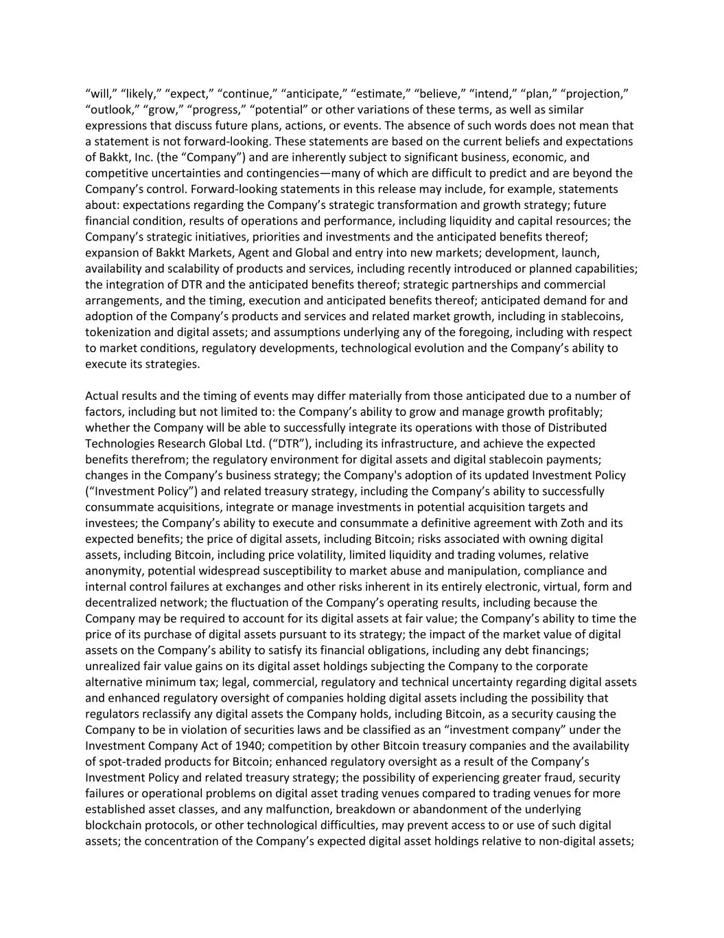
“will,” “likely,” “expect,” “continue,” “anticipate,” “estimate,” “believe,” “intend,” “plan,” “projection,” “outlook,” “grow,” “progress,” “potential” or other variations of these terms, as well as similar expressions that discuss future plans, actions, or events. The absence of such words does not mean that a statement is not forward-looking. These statements are based on the current beliefs and expectations of Bakkt, Inc. (the “Company”) and are inherently subject to significant business, economic, and competitive uncertainties and contingencies—many of which are difficult to predict and are beyond the Company’s control. Forward-looking statements in this release may include, for example, statements about: expectations regarding the Company’s strategic transformation and growth strategy; future financial condition, results of operations and performance, including liquidity and capital resources; the Company’s strategic initiatives, priorities and investments and the anticipated benefits thereof; expansion of Bakkt Markets, Agent and Global and entry into new markets; development, launch, availability and scalability of products and services, including recently introduced or planned capabilities; the integration of DTR and the anticipated benefits thereof; strategic partnerships and commercial arrangements, and the timing, execution and anticipated benefits thereof; anticipated demand for and adoption of the Company’s products and services and related market growth, including in stablecoins, tokenization and digital assets; and assumptions underlying any of the foregoing, including with respect to market conditions, regulatory developments, technological evolution and the Company’s ability to execute its strategies. Actual results and the timing of events may differ materially from those anticipated due to a number of factors, including but not limited to: the Company’s ability to grow and manage growth profitably; whether the Company will be able to successfully integrate its operations with those of Distributed Technologies Research Global Ltd. (“DTR”), including its infrastructure, and achieve the expected benefits therefrom; the regulatory environment for digital assets and digital stablecoin payments; changes in the Company’s business strategy; the Company's adoption of its updated Investment Policy (“Investment Policy”) and related treasury strategy, including the Company’s ability to successfully consummate acquisitions, integrate or manage investments in potential acquisition targets and investees; the Company’s ability to execute and consummate a definitive agreement with Zoth and its expected benefits; the price of digital assets, including Bitcoin; risks associated with owning digital assets, including Bitcoin, including price volatility, limited liquidity and trading volumes, relative anonymity, potential widespread susceptibility to market abuse and manipulation, compliance and internal control failures at exchanges and other risks inherent in its entirely electronic, virtual, form and decentralized network; the fluctuation of the Company’s operating results, including because the Company may be required to account for its digital assets at fair value; the Company’s ability to time the price of its purchase of digital assets pursuant to its strategy; the impact of the market value of digital assets on the Company’s ability to satisfy its financial obligations, including any debt financings; unrealized fair value gains on its digital asset holdings subjecting the Company to the corporate alternative minimum tax; legal, commercial, regulatory and technical uncertainty regarding digital assets and enhanced regulatory oversight of companies holding digital assets including the possibility that regulators reclassify any digital assets the Company holds, including Bitcoin, as a security causing the Company to be in violation of securities laws and be classified as an “investment company” under the Investment Company Act of 1940; competition by other Bitcoin treasury companies and the availability of spot-traded products for Bitcoin; enhanced regulatory oversight as a result of the Company’s Investment Policy and related treasury strategy; the possibility of experiencing greater fraud, security failures or operational problems on digital asset trading venues compared to trading venues for more established asset classes, and any malfunction, breakdown or abandonment of the underlying blockchain protocols, or other technological difficulties, may prevent access to or use of such digital assets; the concentration of the Company’s expected digital asset holdings relative to non-digital assets;

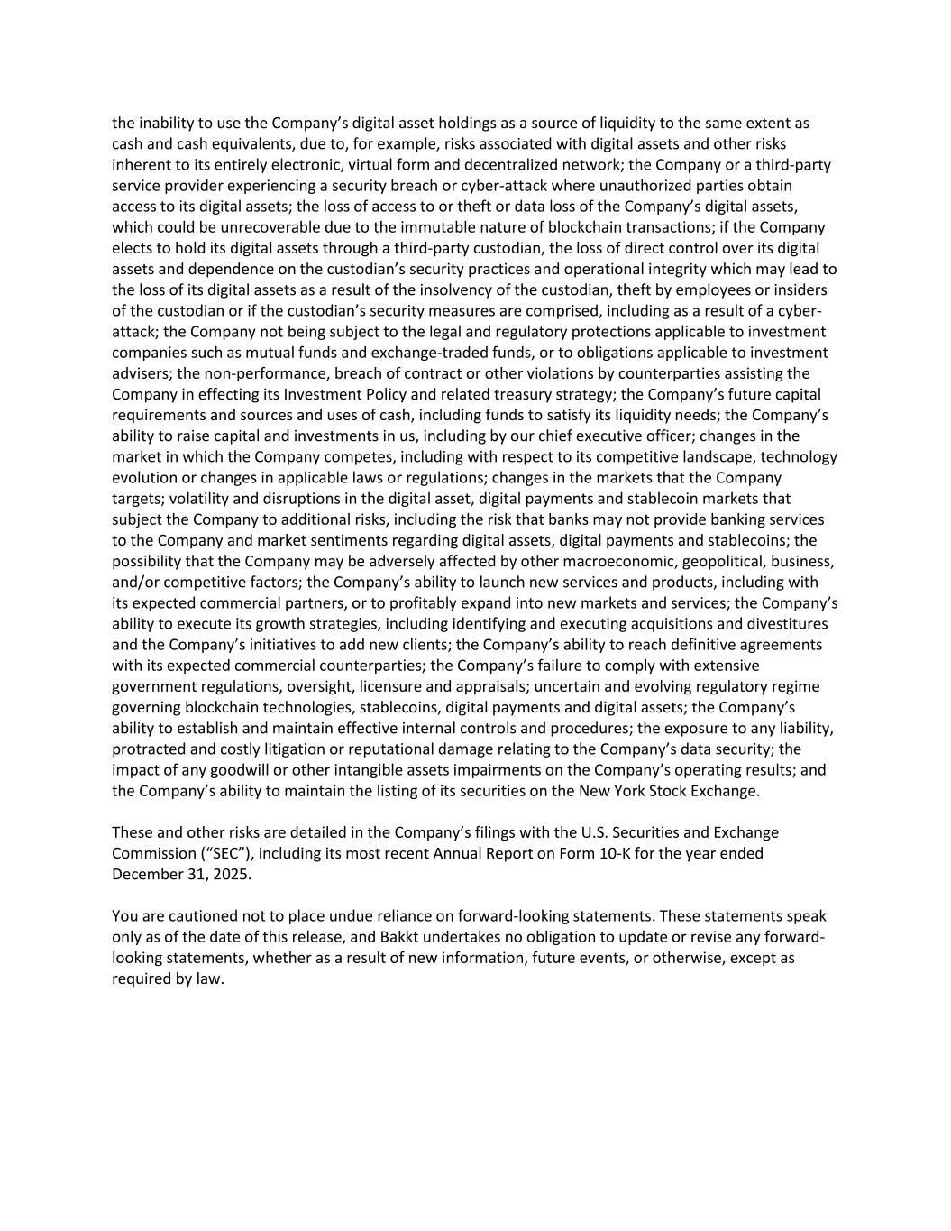
the inability to use the Company’s digital asset holdings as a source of liquidity to the same extent as cash and cash equivalents, due to, for example, risks associated with digital assets and other risks inherent to its entirely electronic, virtual form and decentralized network; the Company or a third-party service provider experiencing a security breach or cyber-attack where unauthorized parties obtain access to its digital assets; the loss of access to or theft or data loss of the Company’s digital assets, which could be unrecoverable due to the immutable nature of blockchain transactions; if the Company elects to hold its digital assets through a third-party custodian, the loss of direct control over its digital assets and dependence on the custodian’s security practices and operational integrity which may lead to the loss of its digital assets as a result of the insolvency of the custodian, theft by employees or insiders of the custodian or if the custodian’s security measures are comprised, including as a result of a cyber- attack; the Company not being subject to the legal and regulatory protections applicable to investment companies such as mutual funds and exchange-traded funds, or to obligations applicable to investment advisers; the non-performance, breach of contract or other violations by counterparties assisting the Company in effecting its Investment Policy and related treasury strategy; the Company’s future capital requirements and sources and uses of cash, including funds to satisfy its liquidity needs; the Company’s ability to raise capital and investments in us, including by our chief executive officer; changes in the market in which the Company competes, including with respect to its competitive landscape, technology evolution or changes in applicable laws or regulations; changes in the markets that the Company targets; volatility and disruptions in the digital asset, digital payments and stablecoin markets that subject the Company to additional risks, including the risk that banks may not provide banking services to the Company and market sentiments regarding digital assets, digital payments and stablecoins; the possibility that the Company may be adversely affected by other macroeconomic, geopolitical, business, and/or competitive factors; the Company’s ability to launch new services and products, including with its expected commercial partners, or to profitably expand into new markets and services; the Company’s ability to execute its growth strategies, including identifying and executing acquisitions and divestitures and the Company’s initiatives to add new clients; the Company’s ability to reach definitive agreements with its expected commercial counterparties; the Company’s failure to comply with extensive government regulations, oversight, licensure and appraisals; uncertain and evolving regulatory regime governing blockchain technologies, stablecoins, digital payments and digital assets; the Company’s ability to establish and maintain effective internal controls and procedures; the exposure to any liability, protracted and costly litigation or reputational damage relating to the Company’s data security; the impact of any goodwill or other intangible assets impairments on the Company’s operating results; and the Company’s ability to maintain the listing of its securities on the New York Stock Exchange. These and other risks are detailed in the Company’s filings with the U.S. Securities and Exchange Commission (“SEC”), including its most recent Annual Report on Form 10-K for the year ended December 31, 2025. You are cautioned not to place undue reliance on forward-looking statements. These statements speak only as of the date of this release, and Bakkt undertakes no obligation to update or revise any forward- looking statements, whether as a result of new information, future events, or otherwise, except as required by law.

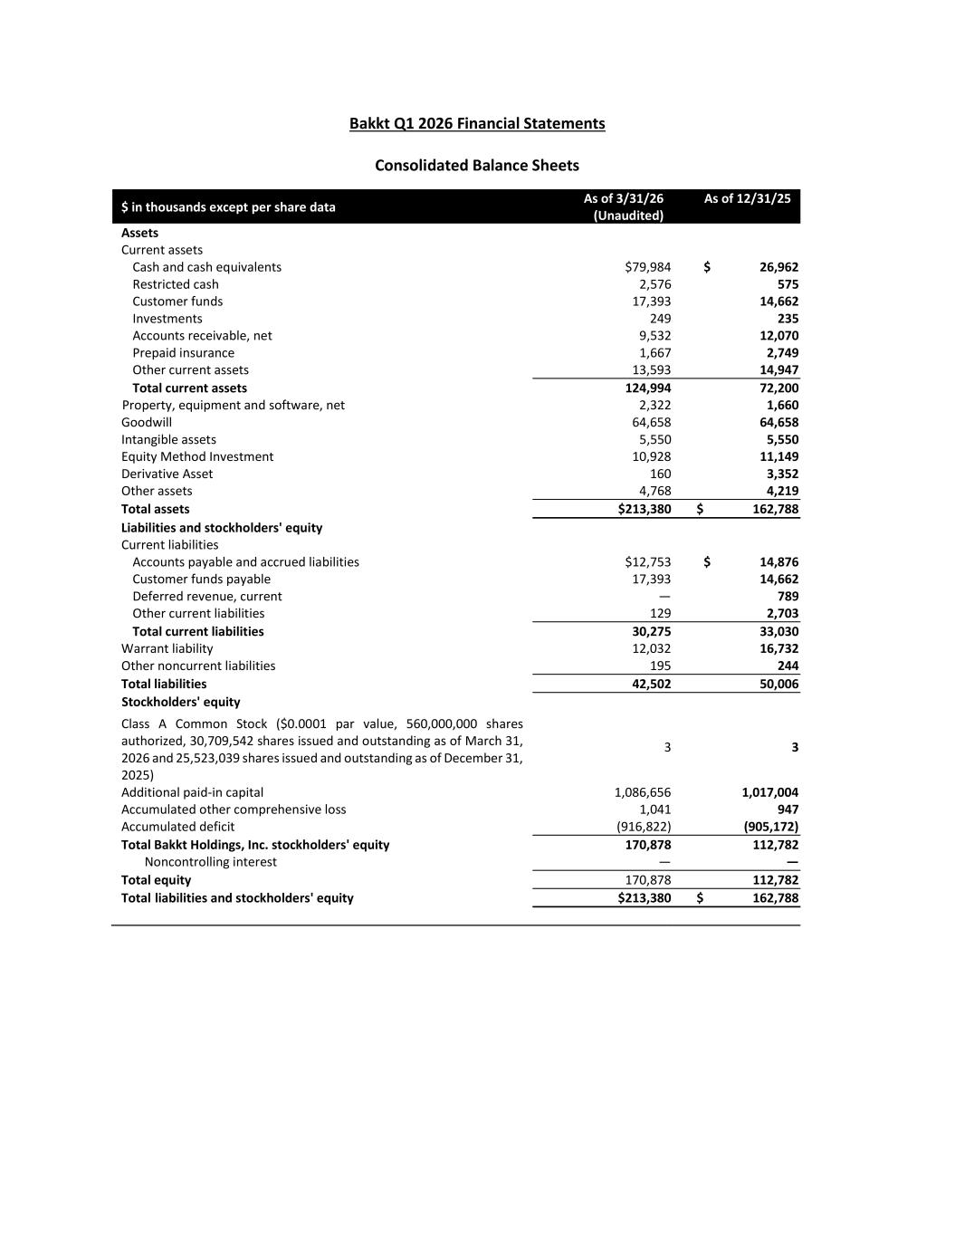
Bakkt Q1 2026 Financial Statements Consolidated Balance Sheets $ in thousands except per share data As of 3/31/26 (Unaudited) As of 12/31/25 Assets Current assets Cash and cash equivalents $79,984 $ 26,962 Restricted cash 2,576 575 Customer funds 17,393 14,662 Investments 249 235 Accounts receivable, net 9,532 12,070 Prepaid insurance 1,667 2,749 Other current assets 13,593 14,947 Total current assets 124,994 72,200 Property, equipment and software, net 2,322 1,660 Goodwill 64,658 64,658 Intangible assets 5,550 5,550 Equity Method Investment 10,928 11,149 Derivative Asset 160 3,352 Other assets 4,768 4,219 Total assets $213,380 $ 162,788 Liabilities and stockholders' equity Current liabilities Accounts payable and accrued liabilities $12,753 $ 14,876 Customer funds payable 17,393 14,662 Deferred revenue, current — 789 Other current liabilities 129 2,703 Total current liabilities 30,275 33,030 Warrant liability 12,032 16,732 Other noncurrent liabilities 195 244 Total liabilities 42,502 50,006 Stockholders' equity Class A Common Stock ($0.0001 par value, 560,000,000 shares authorized, 30,709,542 shares issued and outstanding as of March 31, 2026 and 25,523,039 shares issued and outstanding as of December 31, 2025) 3 3 Additional paid-in capital 1,086,656 1,017,004 Accumulated other comprehensive loss 1,041 947 Accumulated deficit (916,822) (905,172) Total Bakkt Holdings, Inc. stockholders' equity 170,878 112,782 Noncontrolling interest — — Total equity 170,878 112,782 Total liabilities and stockholders' equity $213,380 $ 162,788



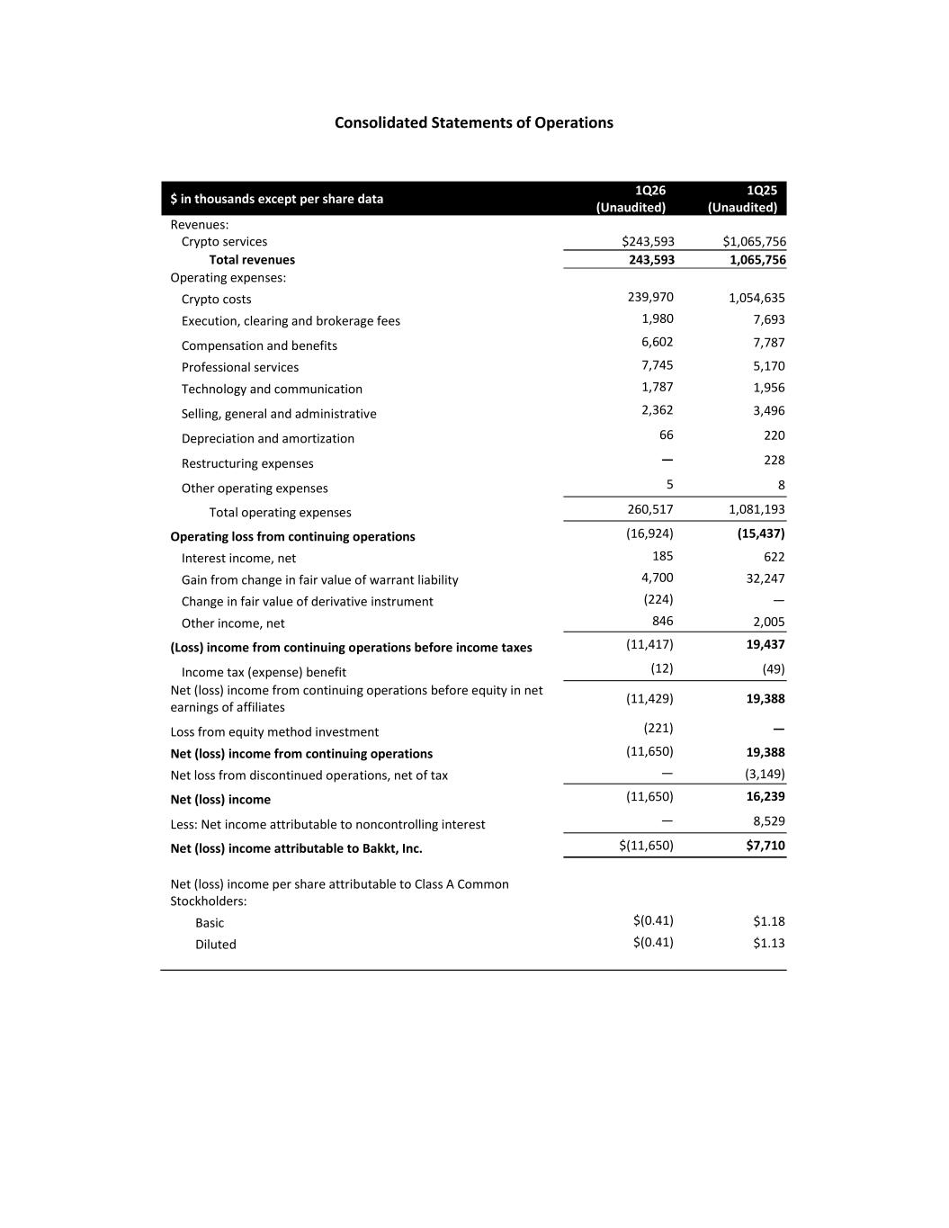
Consolidated Statements of Operations $ in thousands except per share data 1Q26 (Unaudited) 1Q25 (Unaudited) Revenues: Crypto services $243,593 $1,065,756 Total revenues 243,593 1,065,756 Operating expenses: Crypto costs 239,970 1,054,635 Execution, clearing and brokerage fees 1,980 7,693 Compensation and benefits 6,602 7,787 Professional services 7,745 5,170 Technology and communication 1,787 1,956 Selling, general and administrative 2,362 3,496 Depreciation and amortization 66 220 Restructuring expenses — 228 Other operating expenses 5 8 Total operating expenses 260,517 1,081,193 Operating loss from continuing operations (16,924) (15,437) Interest income, net 185 622 Gain from change in fair value of warrant liability 4,700 32,247 Change in fair value of derivative instrument (224) — Other income, net 846 2,005 (Loss) income from continuing operations before income taxes (11,417) 19,437 Income tax (expense) benefit (12) (49) Net (loss) income from continuing operations before equity in net earnings of affiliates (11,429) 19,388 Loss from equity method investment (221) — Net (loss) income from continuing operations (11,650) 19,388 Net loss from discontinued operations, net of tax — (3,149) Net (loss) income (11,650) 16,239 Less: Net income attributable to noncontrolling interest — 8,529 Net (loss) income attributable to Bakkt, Inc. $(11,650) $7,710 Net (loss) income per share attributable to Class A Common Stockholders: Basic $(0.41) $1.18 Diluted $(0.41) $1.13


Consolidated Statements of Cash Flows

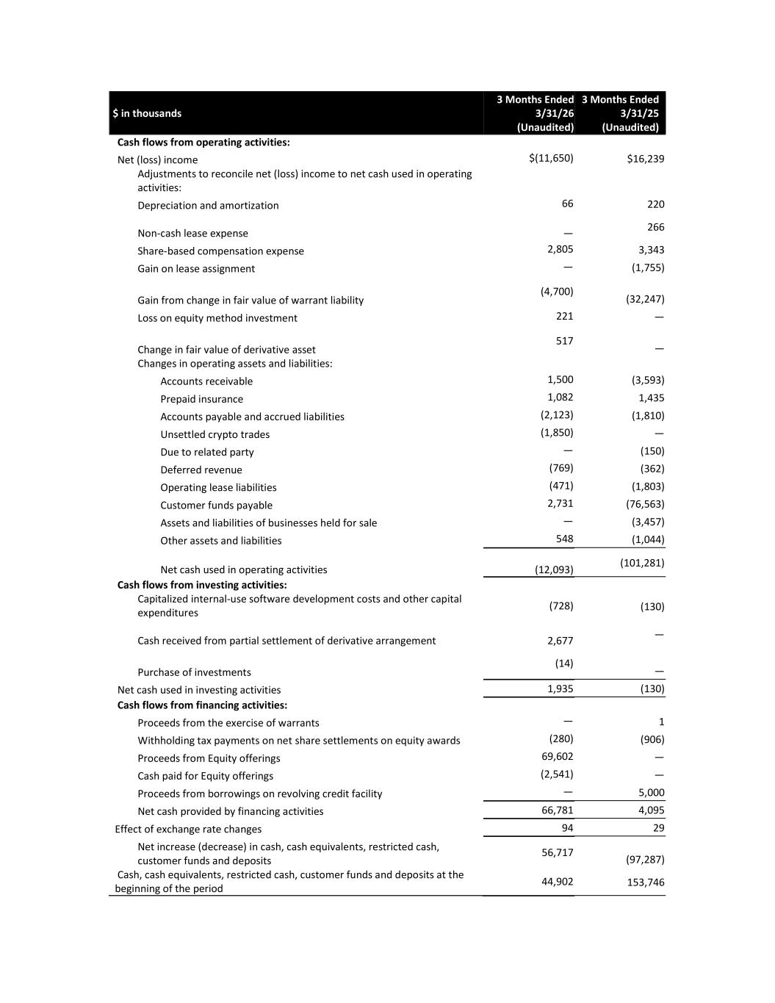
$ in thousands 3 Months Ended 3/31/26 (Unaudited) 3 Months Ended 3/31/25 (Unaudited) Cash flows from operating activities: Net (loss) income $(11,650) $16,239 Adjustments to reconcile net (loss) income to net cash used in operating activities: Depreciation and amortization 66 220 Non-cash lease expense — 266 Share-based compensation expense 2,805 3,343 Gain on lease assignment — (1,755) Gain from change in fair value of warrant liability (4,700) (32,247) Loss on equity method investment 221 — Change in fair value of derivative asset 517 — Changes in operating assets and liabilities: Accounts receivable 1,500 (3,593) Prepaid insurance 1,082 1,435 Accounts payable and accrued liabilities (2,123) (1,810) Unsettled crypto trades (1,850) — Due to related party — (150) Deferred revenue (769) (362) Operating lease liabilities (471) (1,803) Customer funds payable 2,731 (76,563) Assets and liabilities of businesses held for sale — (3,457) Other assets and liabilities 548 (1,044) Net cash used in operating activities (12,093) (101,281) Cash flows from investing activities: Capitalized internal-use software development costs and other capital expenditures (728) (130) Cash received from partial settlement of derivative arrangement 2,677 — Purchase of investments (14) — Net cash used in investing activities 1,935 (130) Cash flows from financing activities: Proceeds from the exercise of warrants — 1 Withholding tax payments on net share settlements on equity awards (280) (906) Proceeds from Equity offerings 69,602 — Cash paid for Equity offerings (2,541) — Proceeds from borrowings on revolving credit facility — 5,000 Net cash provided by financing activities 66,781 4,095 Effect of exchange rate changes 94 29 Net increase (decrease) in cash, cash equivalents, restricted cash, customer funds and deposits 56,717 (97,287) Cash, cash equivalents, restricted cash, customer funds and deposits at the beginning of the period 44,902 153,746


Cash, cash equivalents, restricted cash, customer funds and deposits at the end of the period $101,619 $56,459

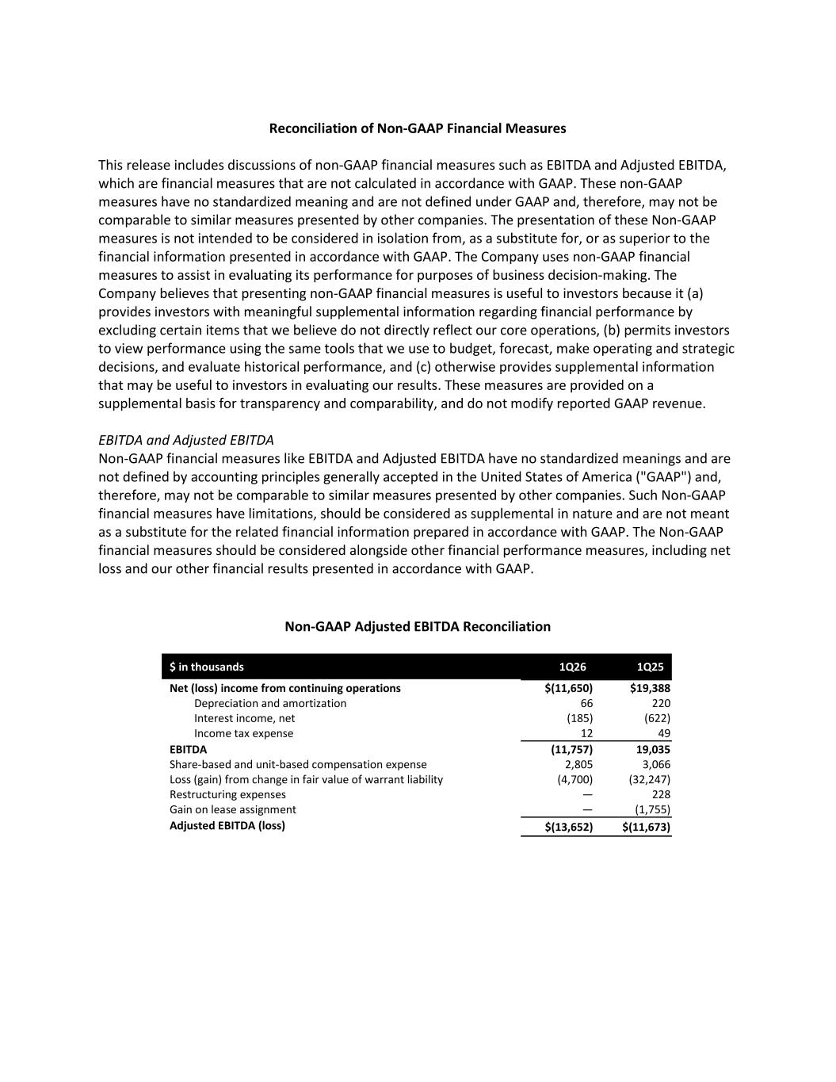
Reconciliation of Non-GAAP Financial Measures This release includes discussions of non-GAAP financial measures such as EBITDA and Adjusted EBITDA, which are financial measures that are not calculated in accordance with GAAP. These non-GAAP measures have no standardized meaning and are not defined under GAAP and, therefore, may not be comparable to similar measures presented by other companies. The presentation of these Non-GAAP measures is not intended to be considered in isolation from, as a substitute for, or as superior to the financial information presented in accordance with GAAP. The Company uses non-GAAP financial measures to assist in evaluating its performance for purposes of business decision-making. The Company believes that presenting non-GAAP financial measures is useful to investors because it (a) provides investors with meaningful supplemental information regarding financial performance by excluding certain items that we believe do not directly reflect our core operations, (b) permits investors to view performance using the same tools that we use to budget, forecast, make operating and strategic decisions, and evaluate historical performance, and (c) otherwise provides supplemental information that may be useful to investors in evaluating our results. These measures are provided on a supplemental basis for transparency and comparability, and do not modify reported GAAP revenue. EBITDA and Adjusted EBITDA Non-GAAP financial measures like EBITDA and Adjusted EBITDA have no standardized meanings and are not defined by accounting principles generally accepted in the United States of America ("GAAP") and, therefore, may not be comparable to similar measures presented by other companies. Such Non-GAAP financial measures have limitations, should be considered as supplemental in nature and are not meant as a substitute for the related financial information prepared in accordance with GAAP. The Non-GAAP financial measures should be considered alongside other financial performance measures, including net loss and our other financial results presented in accordance with GAAP. Non-GAAP Adjusted EBITDA Reconciliation $ in thousands 1Q26 1Q25 Net (loss) income from continuing operations $(11,650) $19,388 Depreciation and amortization 66 220 Interest income, net (185) (622) Income tax expense 12 49 EBITDA (11,757) 19,035 Share-based and unit-based compensation expense 2,805 3,066 Loss (gain) from change in fair value of warrant liability (4,700) (32,247) Restructuring expenses — 228 Gain on lease assignment — (1,755) Adjusted EBITDA (loss) $(13,652) $(11,673)

