UNITED STATES
SECURITIES AND EXCHANGE COMMISSION
Washington, D.C. 20549

SCHEDULE 14A
PROXY STATEMENT PURSUANT TO SECTION 14(a) OF THE
SECURITIES EXCHANGE ACT OF 1934

Filed by the Registrant ☒
Filed by a party other than the Registrant ☐
Check the appropriate box:

☐ | Preliminary Proxy Statement

☐ | Confidential, for Use of the Commission Only (as permitted by Rule 14a-6(e)(2))

☐ | Definitive Proxy Statement

☒ | Definitive Additional Materials

☐ | Soliciting Material Pursuant to §240.14a-12
BAKKT, INC.
(Name of Registrant as Specified In Its Charter)
(Name of Person(s) Filing Proxy Statement, if other than the Registrant)
Payment of Filing Fee (Check all boxes that apply):

☒ | No fee required.

☐ | Fee paid previously with preliminary materials.

☐ | Fee computed on table in exhibit required by Item 25(b) per Exchange Act Rules 14a-6(i)(1) and 0-11.


Amendment to the Proxy Statement
For the Annual Meeting of Stockholders
To be Held on June 23, 2026
Explanatory Note
On April 30, 2026, Bakkt, Inc. (“Bakkt” or the “Company”) filed its definitive proxy statement (the “Proxy Statement”) with the Securities and Exchange Commission (“SEC”) for its annual meeting of stockholders to be held on June 23, 2026 (the “Annual Meeting”).
The Company is filing this amendment to the Proxy Statement (this “Amendment”) to (i) revise the biography of director nominee Lyn Alden, (ii) make clarifying and administrative revisions to the disclosures under “Corporate Governance—Attendance at Board and Stockholder Meetings”, (iii) correct certain footnote disclosures in the table of outstanding equity awards held by non-employee directors as of December 31, 2025 under “Director Compensation—Director Compensation for Fiscal 2025” and (iv) replace the form of proxy card included in the Proxy Statement.
This Amendment consists of the cover page, this explanatory note, revised disclosure under the sections of the Proxy Statement identified below and the corrected form of proxy card. Except as specifically amended or supplemented by this Amendment and the changes set forth in the Amendment to the Proxy Statement filed with the Securities and Exchange Commission on May 15, 2026, no other changes have been made to the Proxy Statement. This Amendment does not reflect events occurring after the date of the Proxy Statement and does not update any disclosures contained in the Proxy Statement to reflect facts or events occurring after the date of the Proxy Statement, except to the extent expressly set forth herein.
THIS AMENDMENT SHOULD BE READ IN CONJUNCTION WITH THE PROXY STATEMENT.
The information in this Amendment should be read in conjunction with the Proxy Statement, which should be read in its entirety. Section references in the below disclosures are to sections in the Proxy Statement, and defined terms used but not defined herein have the meanings set forth in the Proxy Statement. To the extent the following information differs from or conflicts with the information contained in the Proxy Statement, the information set forth below shall be deemed to supersede the respective information in the Proxy Statement.
Amendments
Proxy Statement
Proposal One: Election of Class II Directors—Director Nominees
The biography of Lyn Alden is amended and restated in its entirety as follows:
“Madelyn Alden Schwartzer aka Lyn Alden is a Member of the Bakkt Board of Directors, joining in October 2025. Since 2022, Ms. Alden has collaborated with venture firm Ego Death Capital, serving as general partner. Previously, she founded the research firm Lyn Alden Investment Strategy in 2016, providing investment research for retail and institutional investors. Ms. Alden began pursuing her investing career concurrently with her career as an Engineer from 2009-2021, culminating in her role as Head Engineer and System Integrator at the Federal Aviation Administration’s Cockpit Simulation Facility. Her work is frequently cited in publications including the Wall Street Journal, the Financial Times, and other prestigious media outlets. Additionally, Ms. Alden is a best-selling author, having written 2023’s Broken Money, examining how new technologies have shaped monetary trends. Ms. Alden has a Bachelor of Science in Electrical Engineering from Penn State and a Master of Engineering Management from Rowan University.”
Corporate Governance—Attendance at Board and Stockholder Meetings
The first sentence is amended and restated in its entirety as follows:
“During our fiscal year ended December 31, 2025, our Board held 15 meetings (including regularly scheduled and special meetings), and each director attended at least 75 % of (1) the total number of meetings of our Board held during the period for which he or she has been a director and (2) the total number of meetings held by each committee on which he or she served during the periods that he or she served.”

Director Compensation—Director Compensation for Fiscal 2025
The table of all outstanding equity awards held by non-employee directors as of December 31, 2025 appearing in the third paragraph is amended and restated in its entirety as follows:

Name |  | Number of Shares Underlying  Outstanding Stock Awards
Sean Collins(1) |  |  | 30,191
Colleen Brown(2) |  |  | 16,543
Michael Alfred(3) |  |  | 28,476
Lyn Alden(4) |  |  | 4,809
Richard Galvin(5) |  |  | 6,654
De’Ana Dow(6) |  |  | —
Michelle J. Goldberg(7) |  |  | —
Jill Simone(8) |  |  | —
Gordon Watson(9) |  |  | —
David Clifton(10) |  |  | —
Andrew A. Main(11) |  |  | —

(1) | Mr. Collins was appointed to serve as a director in December 2018. He is a Class III director.
(2) | Ms. Brown was appointed to serve as a Class III director on July 19, 2024.
(3) | Mr. Alfred was appointed to serve as a Class II director on September 17, 2025, filling the vacancy created by Ms. Dow’s resignation.
(4) | Ms. Alden was appointed to serve as a Class II director on October 19, 2025.
(5) | Mr. Galvin was appointed to serve as a Class I director on November 8, 2025.
(6) | Ms. Dow resigned as a member of the Board on September 17, 2025. Upon Ms. Dow’s resignation from the Board, and in recognition of her service during the then-current annual director compensation cycle, a pro rata portion of Ms. Dow’s unvested RSUs granted in respect of the then-current annual director compensation cycle vested upon her separation date based on the number of days she served as a director during that cycle.
(7) | Ms. Goldberg resigned as a member of our Board on November 8, 2025.
(8) | Ms. Simeone resigned as a member of our Board on November 7, 2025.
(9) | Mr. Watson resigned as a member of our Board on August 8, 2025, effective as of August 11, 2025. Upon Mr. Watson’s resignation from the Board, and in recognition of his service during the then-current annual director compensation cycle, a pro rata portion of Mr. Watson’s unvested RSUs granted in respect of the then-current annual director compensation cycle vested upon his separation date based on the number of days he served as a director during that cycle.
(10) | Mr. Clifton resigned as a member of our Board on October 31, 2025.
(11) | Mr. Main resigned as a member of our Board on August 11, 2025.
Form of Proxy Card
The form of proxy card previously filed with the Proxy Statement is hereby replaced in its entirety with the following corrected form of proxy card:

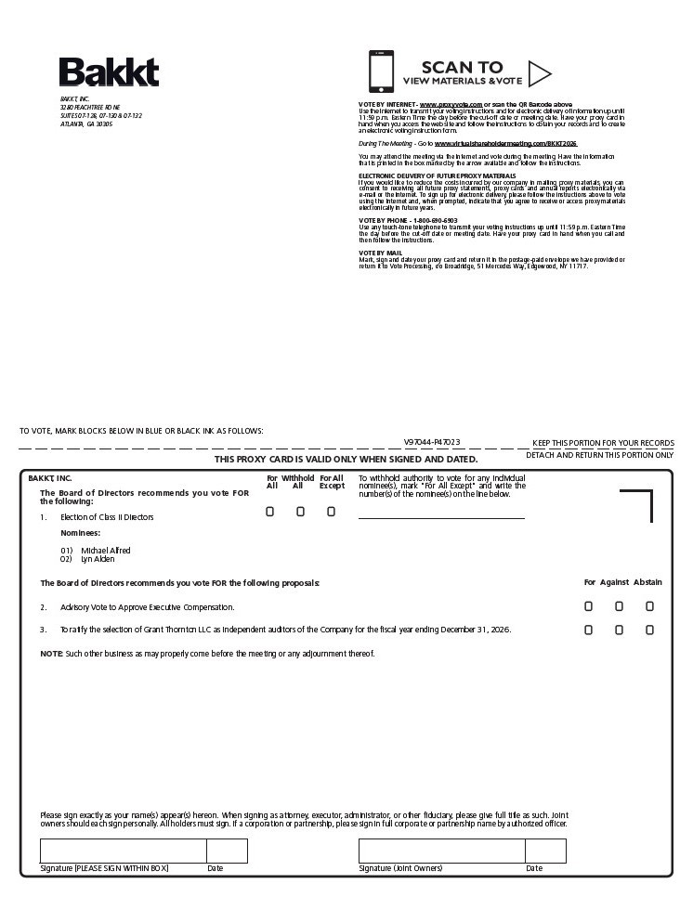
SCAN TO VIEW MATERIALS & Vote BAKKT, INC.3280 PEACHTREE RD NESUITES 07-128, 07-130 & 07-132ATLANTA, GA 30305 VOTE BY INTERNET - www.proxyvote.com or scan the QR Barcode above Use the Internet to transmit your voting instructions and for electronic delivery of information up until 11:59 p.m. Eastern Time the day before the cut-off date or meeting date. Have your proxy card in hand when you access the web site and follow the instructions to obtain your records and to create an electronic voting instruction form. During The Meeting - Go to www.virtualshareholdermeeting.com/BKKT2026 You may attend the meeting via the Internet and vote during the meeting. Have the information that is printed in the box marked by the arrow available and follow the instructions. ELECTRONIC DELIVERY OF FUTURE PROXY MATERIALS If you would like to reduce the costs incurred by our company in mailing proxy materials, you can consent to receiving all future proxy statements, proxy cards and annual reports electronically via e-mail or the Internet. To sign up for electronic delivery, please follow the instructions above to vote using the Internet and, when prompted, indicate that you agree to receive or access proxy materials electronically in future years. VOTE BY PHONE - 1-800-690-6903 Use any touch-tone telephone to transmit your voting instructions up until 11:59 p.m. Eastern Time the day before the cut-off date or meeting date. Have your proxy card in hand when you call and then follow the instructions. VOTE BY MAIL Mark, sign and date your proxy card and return it in the postage-paid envelope we have provided or return it to Vote Processing, c/o Broadridge, 51 Mercedes Way, Edgewood, NY 11717. V97044-P47023 BAKKT, INC. For With hold For All To withhold authority to vote for any individual All All Except nominee(s), mark “For All Except” and write the The Board of Directors recommends you vote FOR number(s) of the nominee(s) on the line below. The following: !!! 1.Election of Class II Directors Nominees: 01) Michael Alfred02) Lynn Alden The Board of Directors recommends you vote FOR the following proposals: For Against Abstai2. Advisoryry Vote to Approve Executive Compensation.!!! 3.To ratify the selection of Grant Thornton LLC as independent auditors of the Company for the fiscal year ending December 31, 2026. !!! NOTE: Such other business as may properly come before the meeting or any adjournment thereof. Please sign exactly as your name(s) appear(s) hereon. When signing as attorney, executor, administrator, or other fiduciary, please give full title as such. Joint owners should each sign personally. All holders must sign. If a corporation or partnership, please sign in full corporate or partnership name by authorized officer.

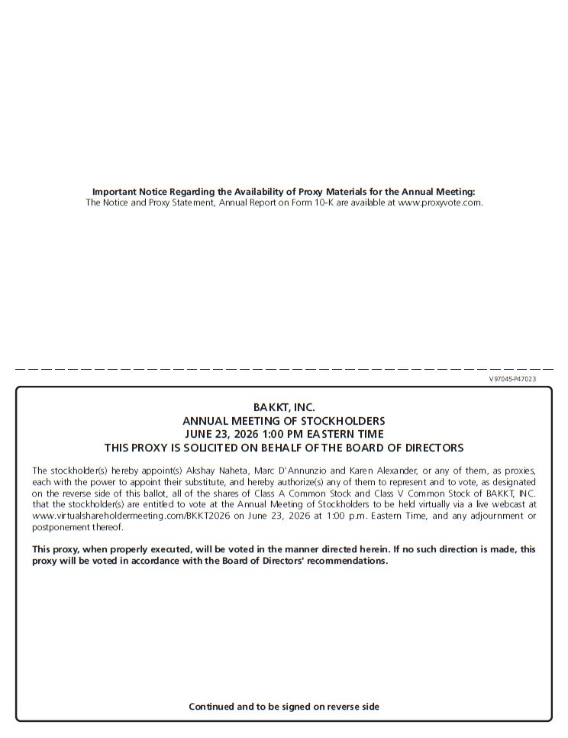
Important Notice Regarding the Availability of Proxy Materials for the Annual Meeting: The Notice and Proxy Statement, Annual Report on Form 10-K are available at www.proxyvote.com. V97045-P47023 BAKKT, INC. ANNUAL MEETING OF STOCKHOLDERS JUNE 23, 2026 1:00 PM EASTERN TIME THIS PROXY IS SOLICITED ON BEHALF OF THE BOARD OF DIRECTORS The stockholder(s) hereby appoint(s) Akshay Naheta, Marc D’Annunzio and Karen Alexander, or any of them, as proxies, each with the power to appoint their substitute, and hereby authorize(s) any of them to represent and to vote, as designated on the reverse side of this ballot, all of the shares of Class A Common Stock and Class V Common Stock of BAKKT, INC. that the stockholder(s) are entitled to vote at the Annual Meeting of Stockholders to be held virtually via a live webcast atwww.virtualshareholdermeeting.com/BKKT2026 on June 23, 2026 at 1:00 p.m. Eastern Time, and any adjournment or postponement thereof. This proxy, when properly executed, will be voted in the manner directed herein. If no such direction is made, this proxy will be voted in accordance with the Board of Directors’ recommendations. Continued and to be signed on reverse side

