UNITED STATES
SECURITIES AND EXCHANGE COMMISSION

WASHINGTON, DC 20549

FORM 8-K/A

Delaware

(State or other jurisdiction

of incorporation)

Amendment No. 2

CURRENT REPORT
Pursuant to Section 13 OR 15(d)
of The Securities Exchange Act of 1934

Date of Report (Date of earliest event reported)

April 1, 2023

Bakkt Holdings, Inc.

(Exact name of registrant as specified in its charter)

001-39544 | 98-1550750
(Commission | (IRS Employer
File Number) | Identification No.)

10000 Avalon Boulevard, Suite 1000, | 30009
Alpharetta, Georgia | 30009
(Address of principal executive offices) | (Zip Code)
Registrant’s telephone number, including area code: (678) 534-5849

Check the appropriate box below if the Form 8-K filing is intended to simultaneously satisfy the filing obligation of the registrant under any of the following provisions (see General Instruction A.2.
below):

- Written communication pursuant to Rule 425 under the Securities Act (17 CFR 230.425)

- Soliciting material pursuant to Rule 14a-12 under the Exchange Act (17 CFR 240.14a-12)

- Pre-commencement communications pursuant to Rule 14d-2(b) under the Exchange Act (17 CFR 240.14d-2(b))

- Pre-commencement communications pursuant to Rule 13e-4(c) under the Exchange Act (17 CFR 240.13e-4(c)) Securities registered pursuant to Section 12(b) of the Act:

Title of each class | Trading Symbol(s) | Name of each exchange
Title of each class |  | on which registered
Class A Common Stock, par value $0.0001 per share | BKKT | The New York Stock Exchange
Warrants to purchase Class A Common Stock | BKKT WS | The New York Stock Exchange

Indicate by check mark whether the registrant is an emerging growth company as defined in Rule 405 of the Securities Act of 1933 (§230.405 of this chapter) or Rule 12b-2 of the Securities Exchange Act of 1934 (§240.12b-2 of this chapter).

Emerging growth company ☒

If an emerging growth company, indicate by check mark if the registrant has elected not to use the extended transition period for complying with any new or revised financial accounting standards provided pursuant to Section 13(a) of the Exchange Act. ☐

Explanatory Note

This Amendment No. 2 on Form 8-K/A (“Amendment No. 2”) amends the Current Report on Form 8-K of Bakkt Holdings, Inc. (‘Bakkt” or the “Company”) filed with the Securities and Exchange Commission on April 3, 2023 (as amended by the Amendment No. 1 on Form 8-K/A to the Initial Filing, as filed with the Securities and Exchanges Commission on April 18, 2023, the “Initial Filing”), in which the Company reported, among other things, the closing of the previously announced acquisition (the “Acquisition”) by Bakkt Marketplace, LLC, an indirect wholly owned subsidiary of the Company (“Bakkt Marketplace” and, together with Bakkt, the “Bakkt Parties”), of all of the membership interests in Apex Crypto LLC, a Delaware limited liability company (“Target”), from Apex Fintech Solutions Inc., a Delaware corporation (“Seller” and, together with Target, the “Seller Parties”), pursuant to the terms of a Membership Interest Purchase Agreement, dated as of November 2, 2022, by and among the Bakkt Parties and the Seller Parties, as amended.

This Amendment No. 2 does not amend any other items of the Initial Filing or purport to provide an update or a discussion of any developments at the Company or its subsidiaries subsequent to the filing date of the Initial Filing and is being filed solely to provide the disclosures required by Item 9.01 of Form 8-K that were not previously filed with the Initial Filing. The information previously reported in or filed with the Initial Filing is incorporated herein by reference.

Item 9.01 Financial Statements and Exhibits.

- Financial Statements of Business Acquired

The unaudited financial statements of Target as and for the three months ended March 31, 2023, and the related notes, are filed herewith as Exhibit 99.1 and incorporated herein by reference.

- Pro Forma Financial Information

Certain unaudited pro forma financial information for the nine months ended September 30, 2023, are filed herewith as Exhibit 99.2 and incorporated herein by reference.

- Exhibits

Exhibit No. |  |  | Description
99.1 |  |  | Unaudited financial statements of Apex Crypto, LLC as of and for the three months ended March 31, 2023
99.2 |  |  | Unaudited pro forma combined financial information for the nine months ended September 30, 2023
104 |  |  | Cover Page Interactive Data File (embedded within the Inline XBRL document)

SIGNATURE

Pursuant to the requirements of the Securities Exchange Act of 1934, the registrant has duly caused this report to be signed on its behalf by the undersigned, hereunto duly authorized.

Dated: February 14, 2024

BAKKT HOLDINGS, INC.

By: /s/ Marc D'Annunzio

Name: | Marc D’Annunzio
Title: | General Counsel and Secretary



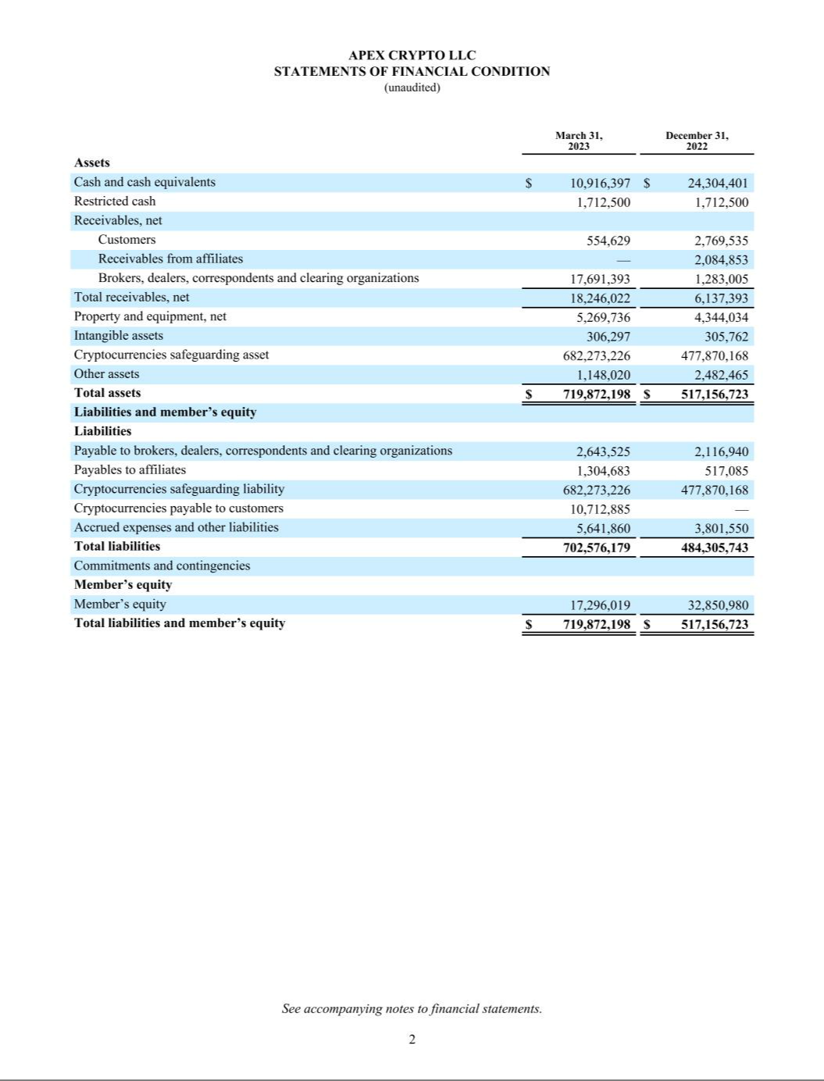

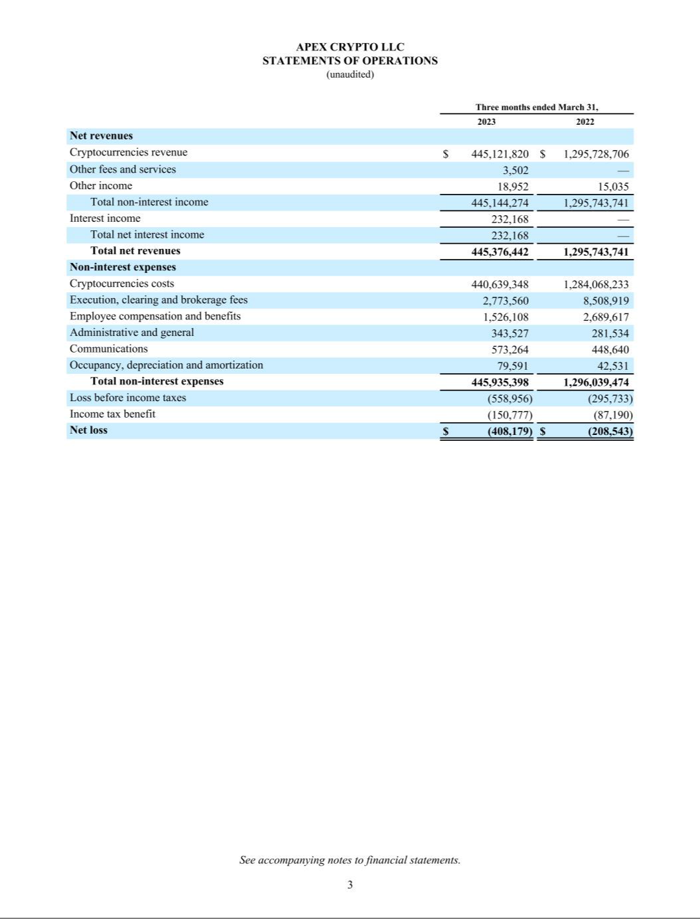

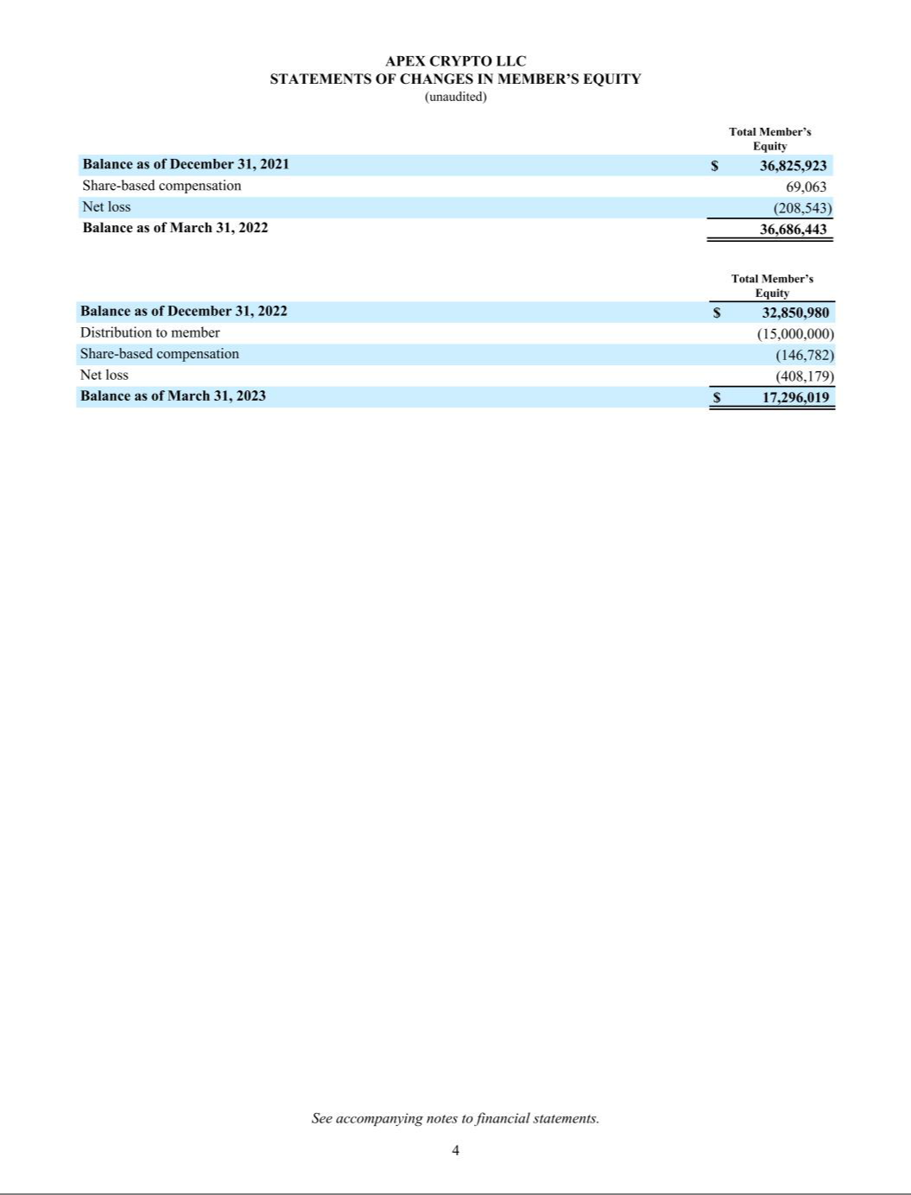

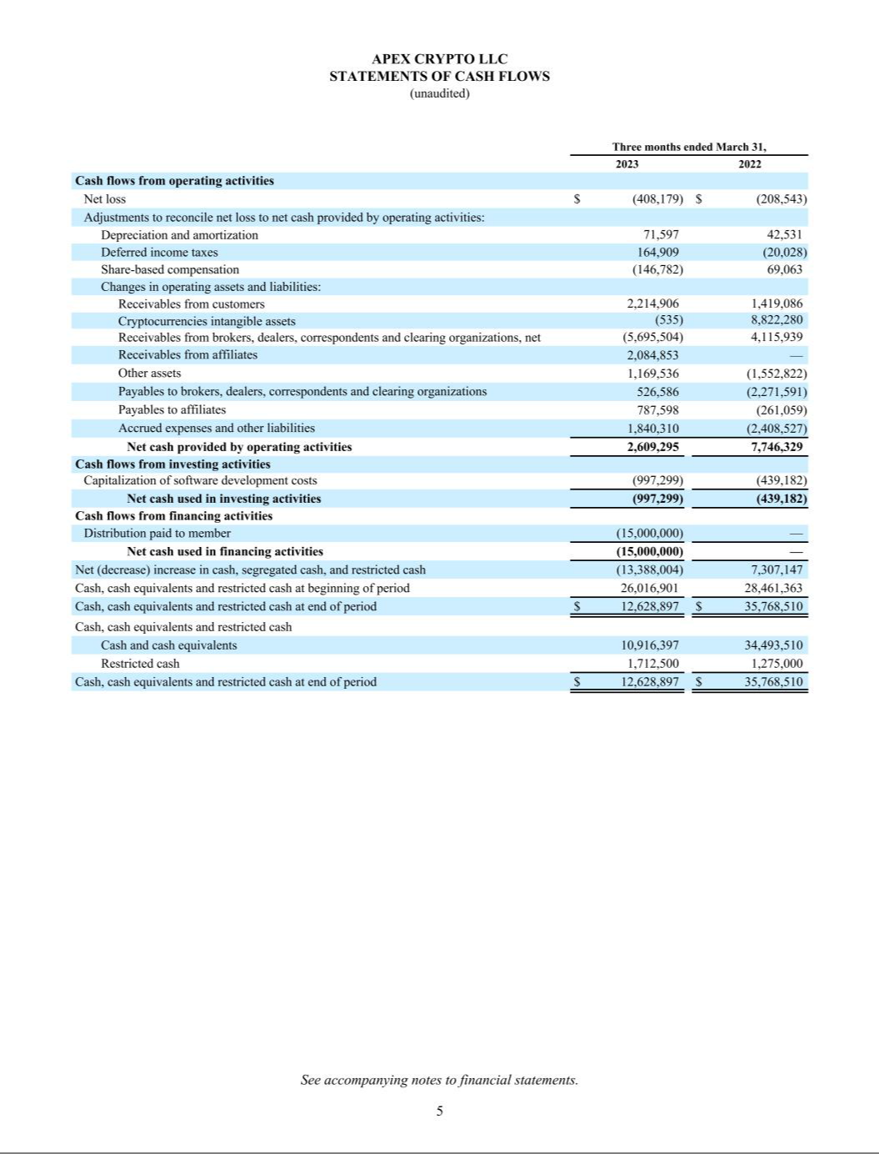

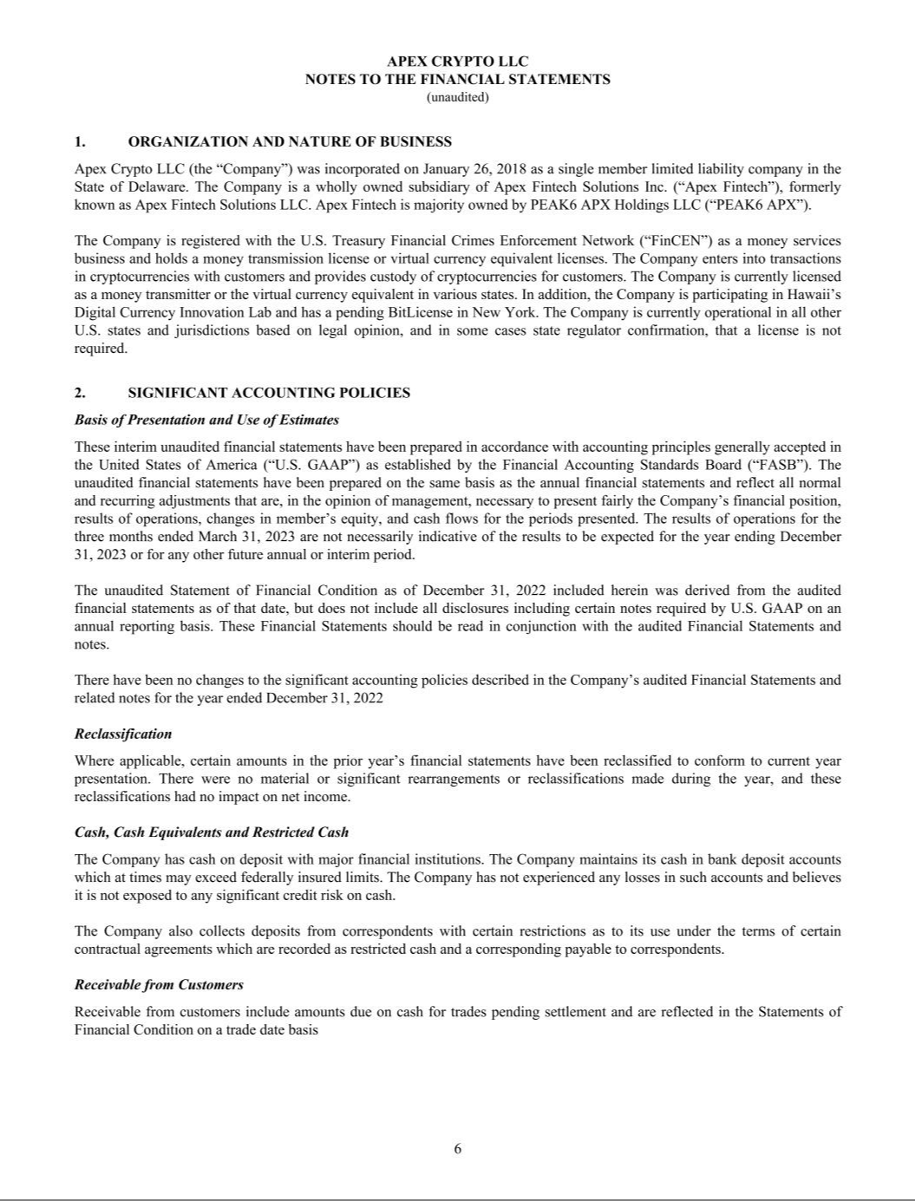

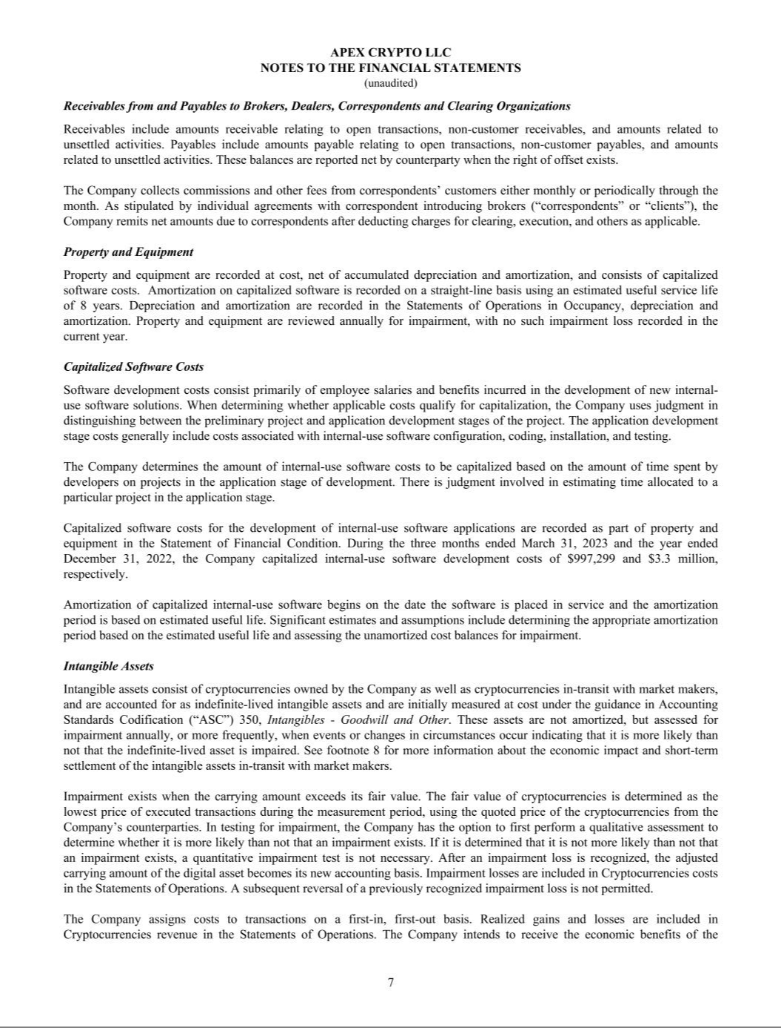

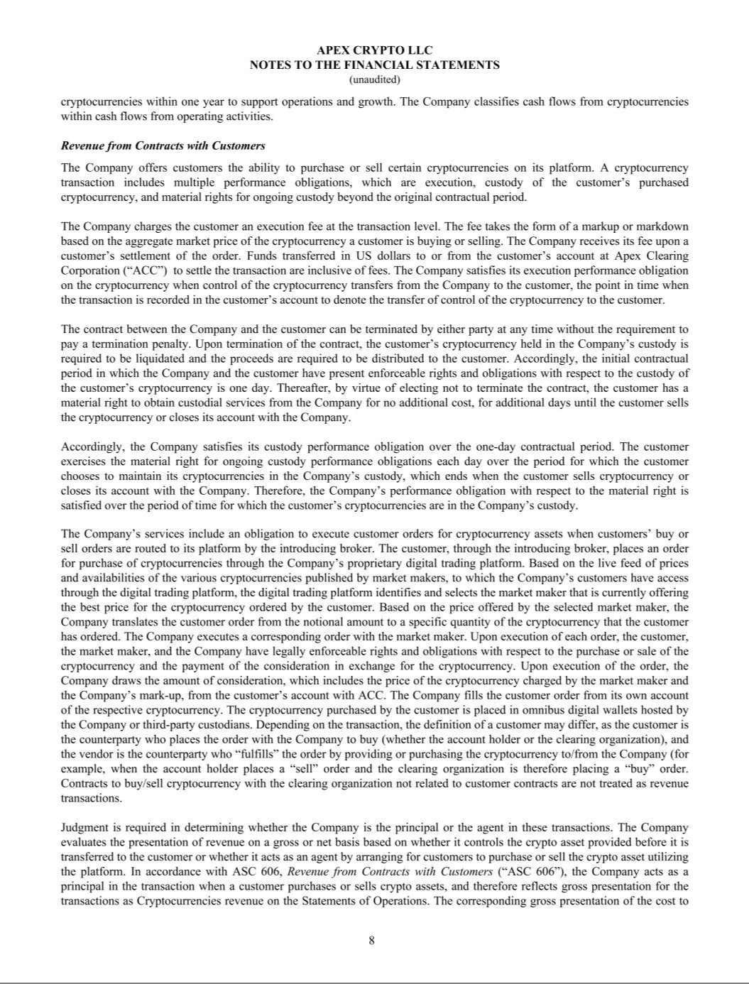

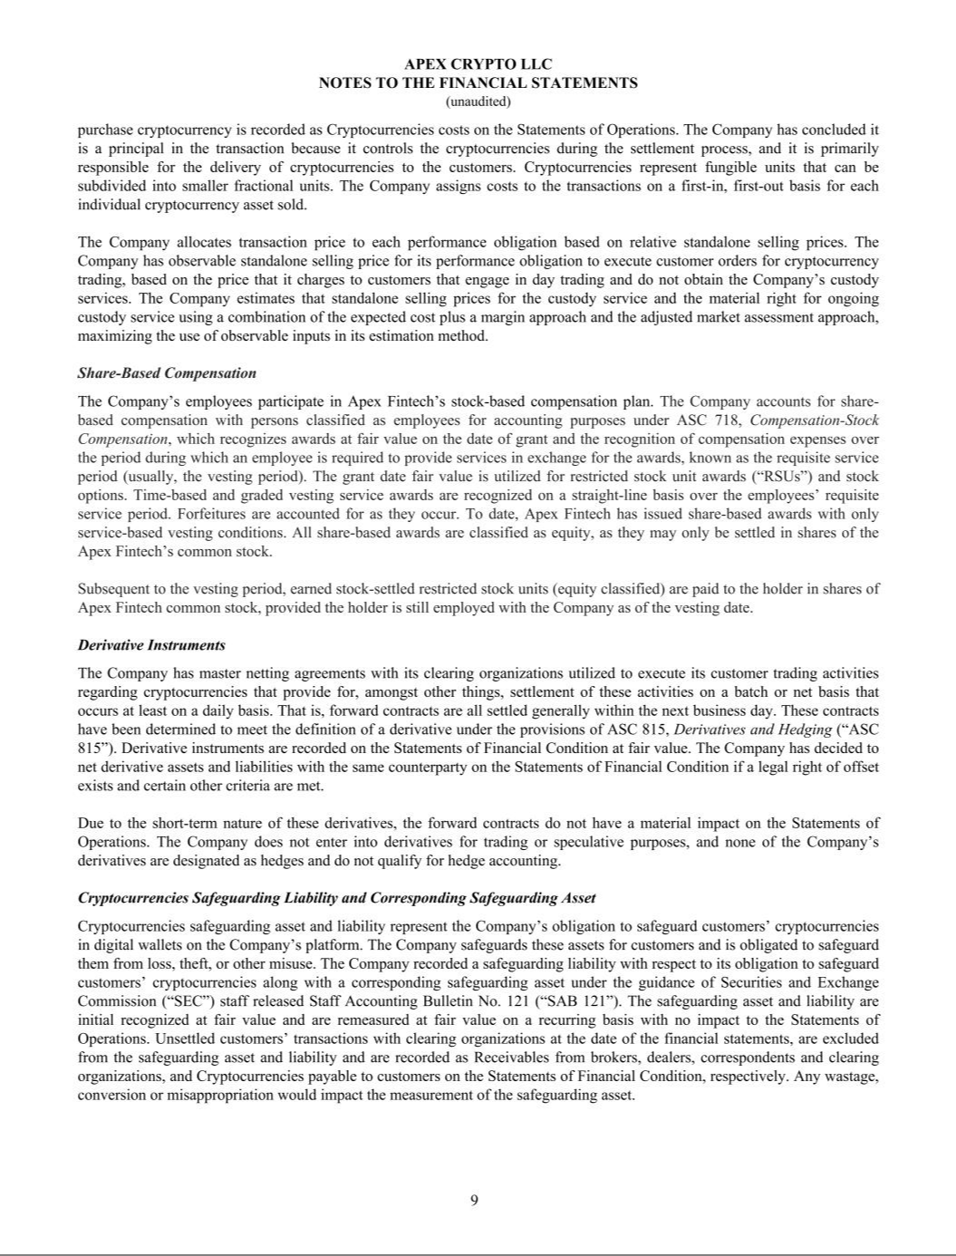

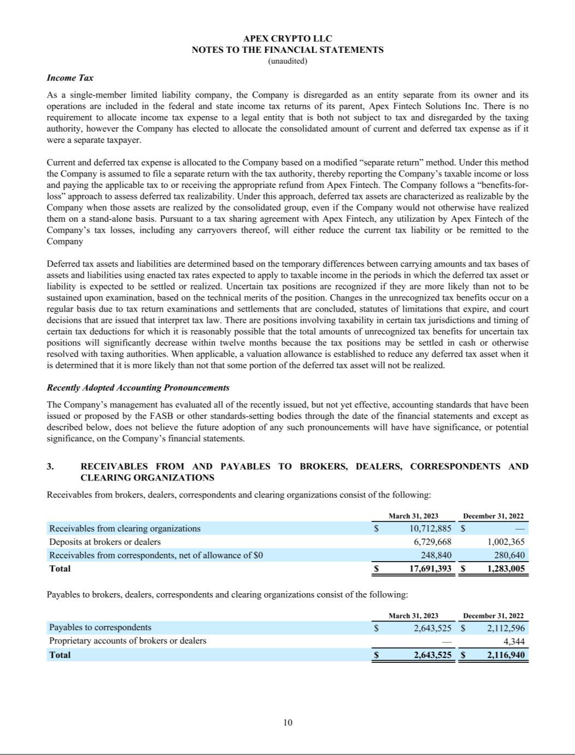

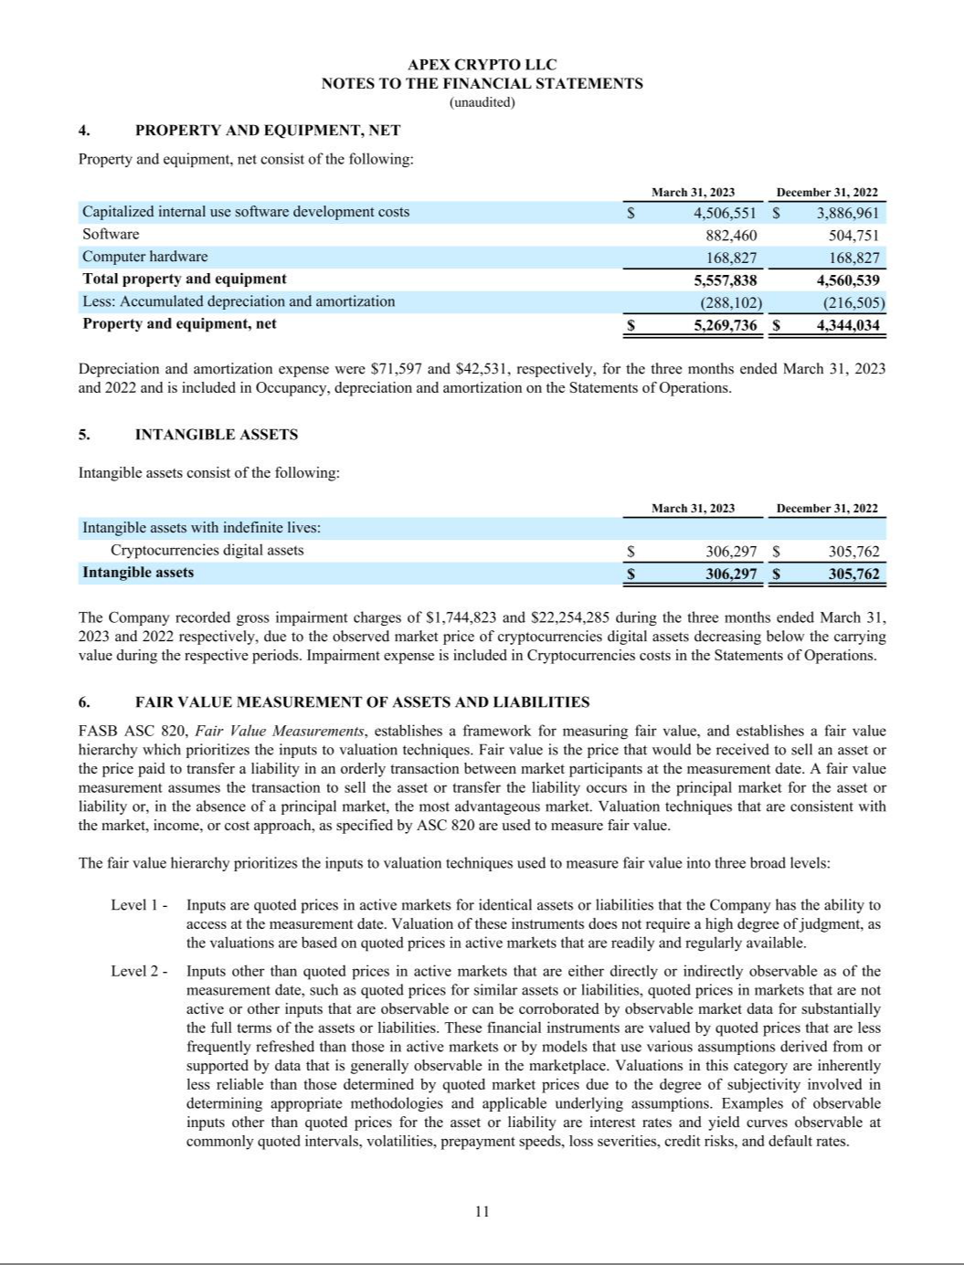

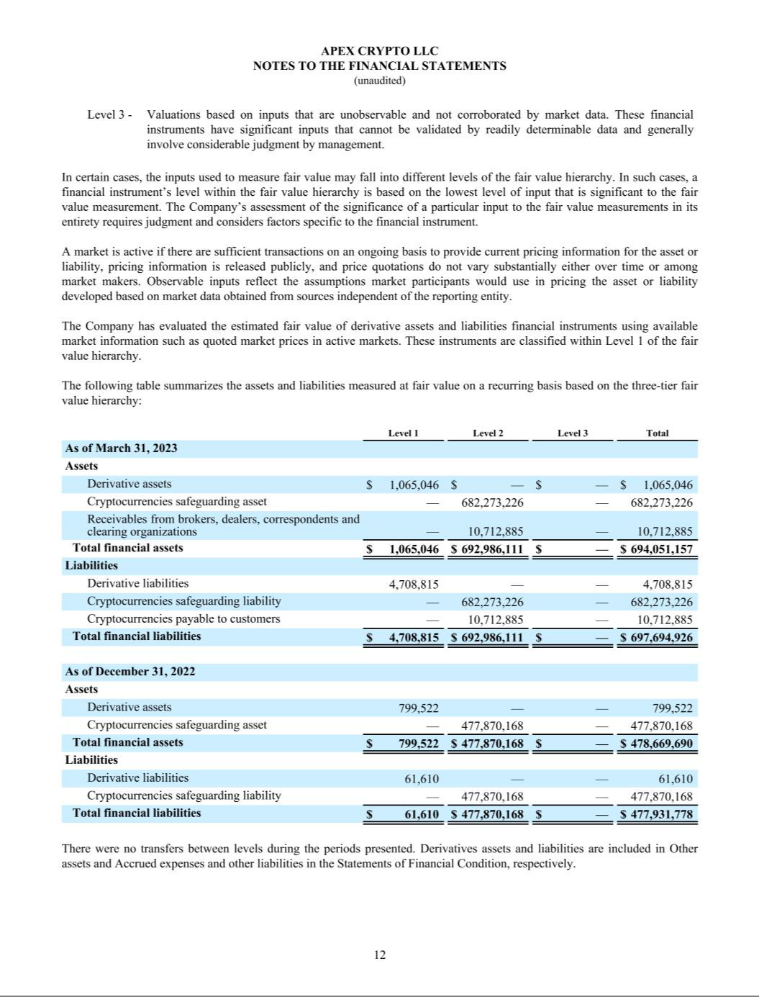

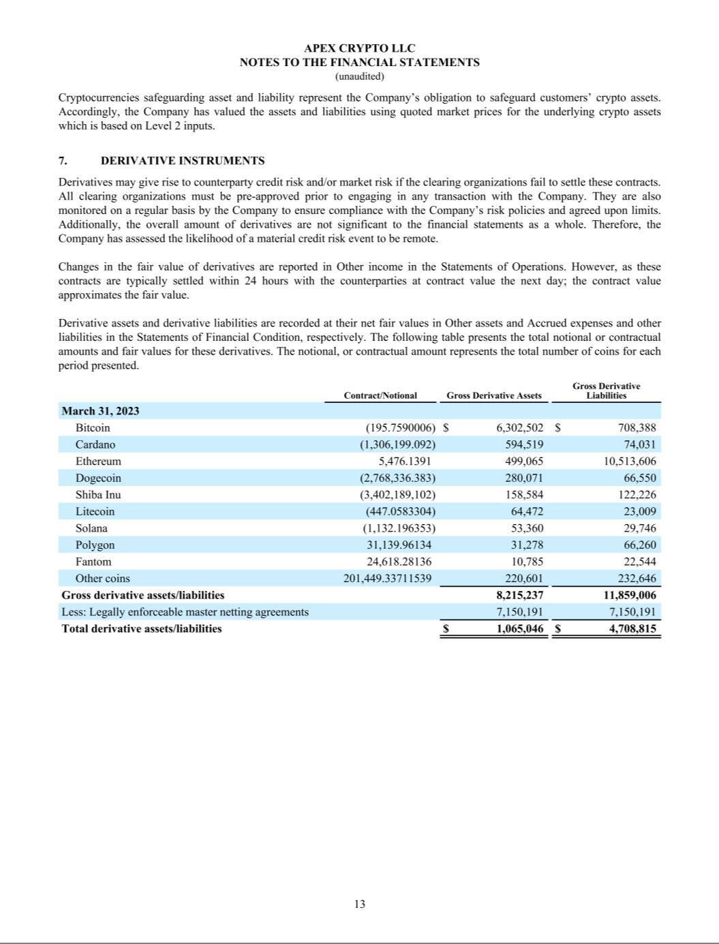

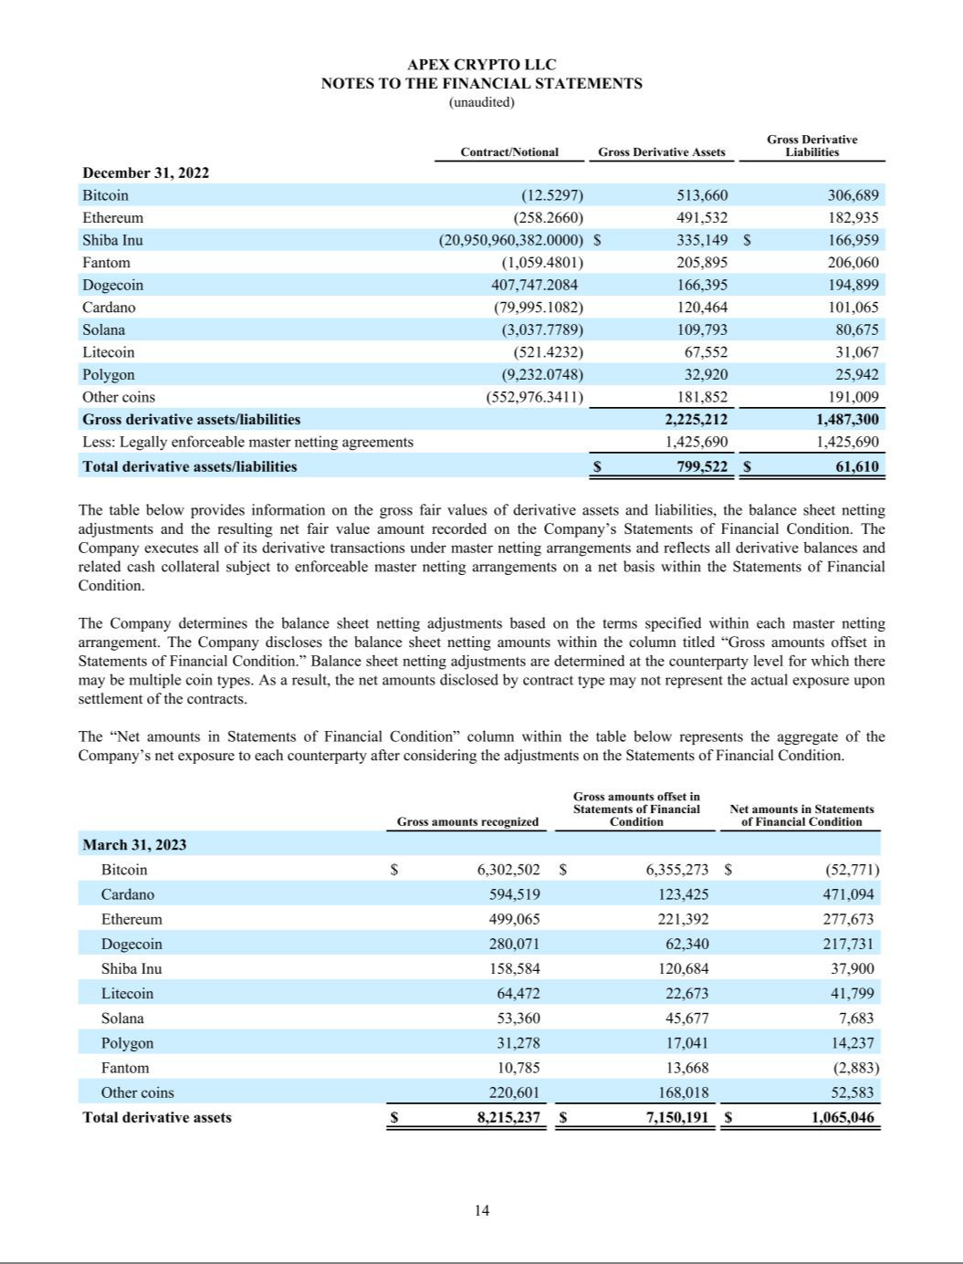

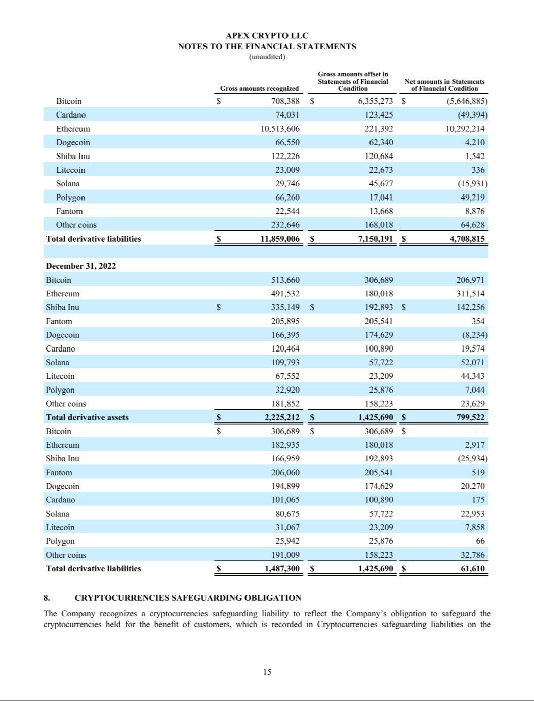

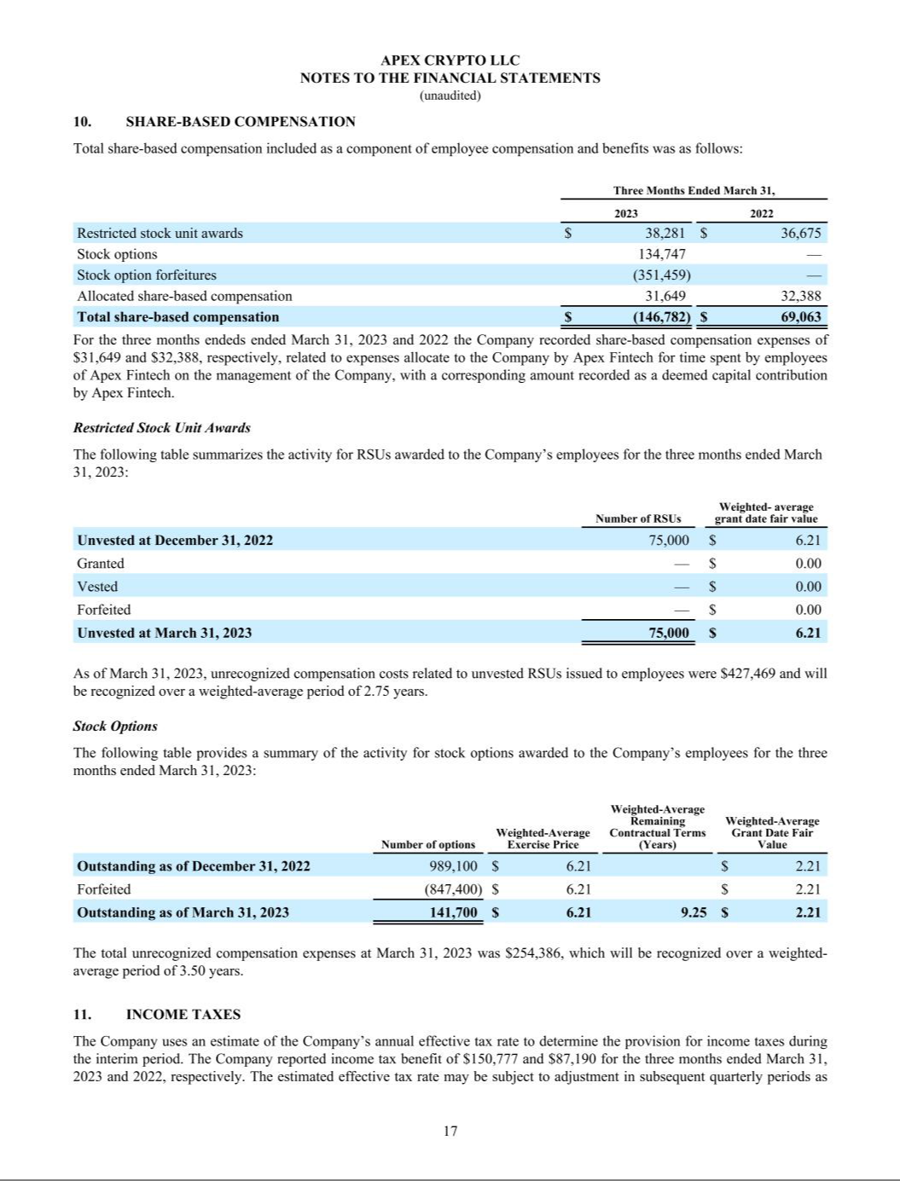

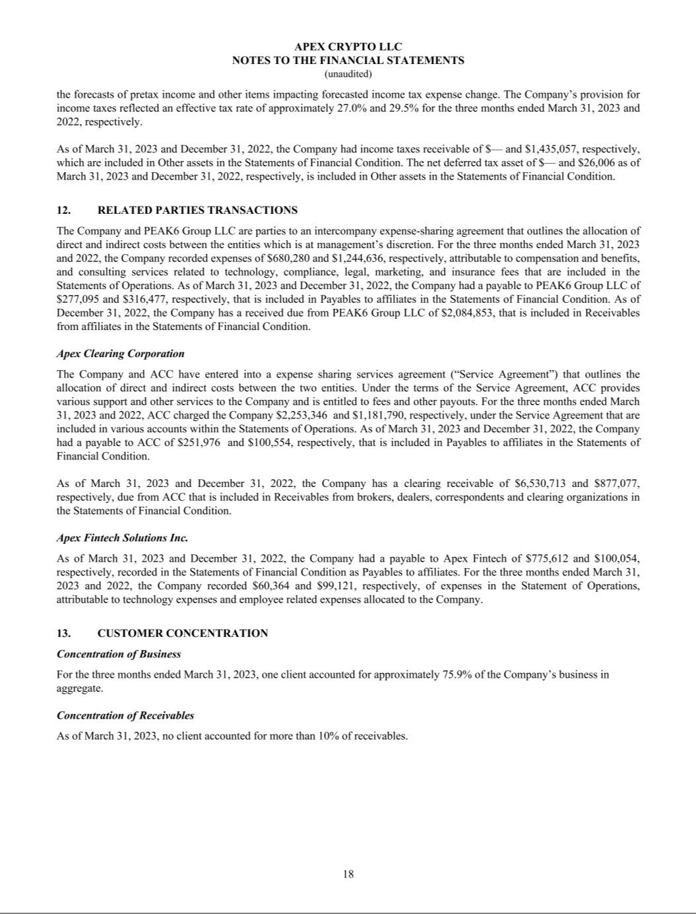

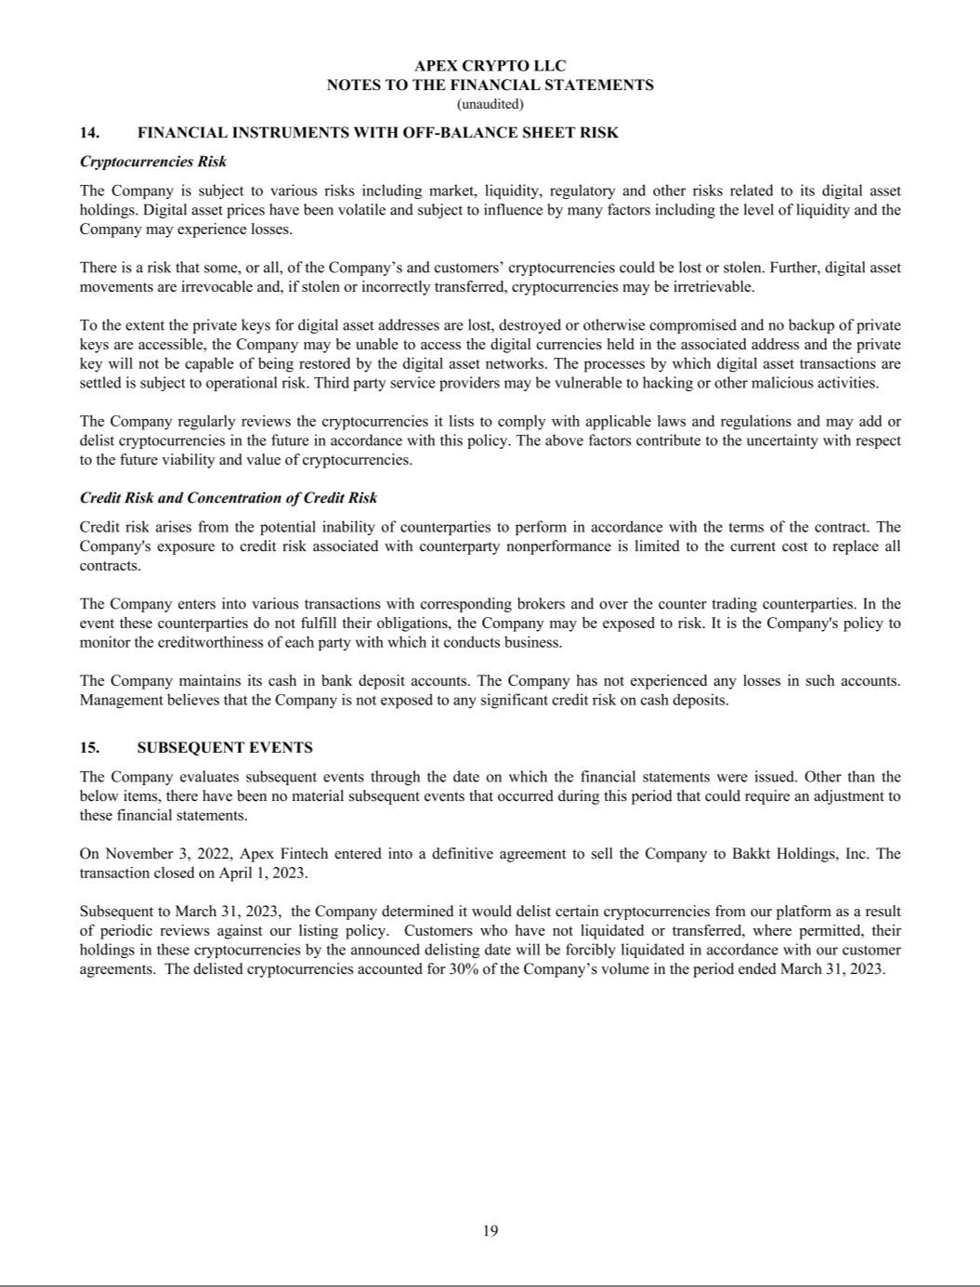

Exhibit 99.2

UNAUDITED PRO FORMA CONDENSED COMBINED FINANCIAL INFORMATION

Introduction:

The unaudited pro forma condensed combined financial information is prepared in accordance with Article 11 of Regulation S-X. The unaudited pro forma condensed combined financial information presents the pro forma effects of the acquisition of Apex Crypto LLC (“Apex”) by Bakkt Holdings, Inc. (the “Company”) on April 1, 2023 (the “Acquisition”). Apex is a financial technology company with an integrated crypto trading platform that was wholly owned by Apex Fintech Solutions, Inc. (“AFS”).

The unaudited pro forma condensed combined financial information is based upon, and should be read in conjunction with, the historical financial statement and related notes of the Company and Apex. The pro forma statement of operations has been presented for information purposes only and is not necessarily indicative of what the Company’s statement of operations actually would have been had the Acquisition been completed as of the date indicated, nor does it purport to project the future operating results of the Company. The actual results of operations may differ significantly from the pro forma amounts reflected herein due to a variety of factors. The pro forma financial information is presented for illustrative purposes only and does not reflect the costs of any integration activities or cost savings or synergies that may be achieved as a result of the Acquisition.

The unaudited pro forma condensed combined statement of operations for the nine months ended September 30, 2023 gives pro forma effect of the Acquisition as if it had been consummated on January 1, 2022.

The pro forma statement of operations was prepared using the acquisition method of accounting under the provisions of ASC 805 (“ASC 805”) on the basis of the Company as the accounting acquirer and Apex as the accounting acquiree. Under the acquisition method of accounting, the purchase price is allocated to the tangible and identifiable intangible assets acquired and liabilities assumed of Apex, based on their estimated acquisition-date fair values. These estimates are determined through established and generally accepted valuation techniques.

The following the unaudited pro forma condensed combined statement of operations for the nine months ended September 30, 2023 are based on the historical financial statement of the Company and Apex, each as filed with the Securities and Exchange Commission (the “SEC”). The unaudited pro forma adjustments are based on information currently available, and assumptions and estimates underlying the unaudited pro forma adjustments are described in the accompanying notes. Actual results may differ materially from the assumptions used to present the accompanying unaudited pro forma condensed combined financial information.

Unaudited Pro Forma Condensed Combined Statement of Operations for the Nine Months Ended September 30, 2023

 |  | Historical Financials
($ in millions, except share and per share data) | Bakkt (Historical Nine Months |  |  | Apex (Historical Three Months |  |  | Transaction Accounting |  |  |  | Pro Forma Combined
($ in millions, except share and per share data) |  | Ended 9/30/2023) |  | Ended 3/31/2023) |  |  |  | Adjustments |  |  | Pro Forma Combined
Revenues:
Crypto services | $ | 527.5 | $ |  | 445.1 |  | $ | — | $ |  | 972.6
Loyalty services, net |  | 38.1 |  |  | — |  |  | — |  |  | 38.1
Total revenues |  | 565.6 |  |  | 445.1 |  |  | — |  |  | 1,010.7
Operating expenses:
Crypto costs |  | 521.6 |  |  | 440.6 |  |  | — |  |  | 962.2
Execution, clearing and brokerage fees |  | 2.9 |  |  | 2.8 |  |  | — |  |  | 5.7
Compensation and benefits |  | 85.8 |  |  | 1.5 |  |  | 0.3 | AA |  | 87.6
Professional services |  | 7.2 |  |  | — |  |  | — |  |  | 7.2
Technology and communication |  | 15.6 |  |  | 0.6 |  |  | — |  |  | 16.2
Selling, general and administrative |  | 21.7 |  |  | 0.3 |  |  | — |  |  | 22.0
Acquisition-related expenses |  | 17.1 |  |  | — |  |  | — |  |  | 17.1
Depreciation and amortization |  | 10.8 |  |  | 0.1 |  |  | 0.5 | BB |  | 11.4
Related party expenses |  | 3.1 |  |  | — |  |  | — |  |  | 3.1
Goodwill and intangible assets impairments |  | 23.3 |  |  | — |  |  | — |  |  | 23.3
Impairment of long-lived assets |  | 0.1 |  |  | — |  |  | — |  |  | 0.1
Restructuring expenses |  | 4.5 |  |  | — |  |  | — |  |  | 4.5
Other operating expenses |  | 1.2 |  |  | — |  |  | — |  |  | 1.2
Total operating expenses |  | 715.0 |  |  | 445.9 |  |  | 0.8 |  |  | 1,161.7
Operating loss |  | (149.4) |  |  | (0.8) |  |  | (0.8) |  |  | (151.0)
Interest income, net |  | 3.5 |  |  | 0.2 |  |  | — |  |  | 3.7
Loss from change in fair value of warrant liability |  | (0.9) |  |  | — |  |  | — |  |  | (0.9)
Other income, net |  | 0.0 |  |  | 0.0 |  |  | — |  |  | 0.0
Loss before income taxes |  | (146.7) |  |  | (0.6) |  |  | (0.8) |  |  | (148.1)
Income tax (expense) benefit |  | (0.4) |  |  | 0.2 |  |  | (0.2) CC |  |  | (0.4)
Net loss |  | (147.1) |  | $ | (0.4) |  |  | (1.0) |  |  | (148.5)
Less: Net loss attributable to noncontrolling interest |  | (99.0) |  |  |  |  |  | (0.3) DD |  |  | (99.3)
Net loss attributable to Bakkt Holdings, Inc. | $ | (48.2) |  |  |  |  | $ | (0.7) |  | $ | (48.9)
Earnings per share
Weighted average shares outstanding of Class A common shares (basic) |  | 87,726,210 |  |  |  |  |  |  |  |  | 89,750,487
Net loss per share (basic) | $ | (0.55) |  |  |  |  |  |  | $ |  | (0.55)
Weighted average shares outstanding of Class A common shares (diluted) |  | 87,726,210 |  |  |  |  |  |  |  |  | 89,750,487
Net loss per share (diluted) | $ | (0.55) |  |  |  |  |  |  | $ |  | (0.55)

See Notes to Unaudited Pro Forma Condensed Combined Statement of Operations.

Notes to Unaudited Pro Forma Condensed Combined Financial Information

1. Basis of Pro Forma Presentation

The unaudited pro forma condensed combined statement of operations has been prepared using the acquisition method of accounting with the Company as the acquiring entity. Under the acquisition method of accounting, the Company’s assets and liabilities will retain their carrying values and the assets and liabilities associated with Apex are recorded at their fair values measured as of the acquisition date. The excess of the purchase price over the estimated fair values of the net assets acquired, if applicable, are recorded as goodwill. The acquisition method of accounting is based on ASC 805 and uses the fair value concepts defined in ASC Topic 820, Fair Value Measurements (“ASC 820”). In general, ASC 805 requires, among other things, that assets acquired and liabilities assumed be recognized at their fair values as of the acquisition date by the Company, who was determined to be the accounting acquirer.

ASC 820 defines fair value, establishes a framework for measuring fair value, and sets forth a fair value hierarchy that prioritizes and ranks the level of observability of inputs used to develop the fair value measurements. Fair value is defined in ASC 820 as “the price that would be received to sell an asset or paid to transfer a liability in an orderly transaction between market participants at the measurement date.” This is an exit price concept for the valuation of the asset or liability. In addition, market participants are assumed to be buyers and sellers in the principal (or the most advantageous) market for the asset or liability. Fair value measurements for a non-financial asset assume the highest and best use by these market participants. Many of these fair value measurements can be highly subjective, and it is possible that other professionals applying reasonable judgment to the same facts and circumstances, could develop and support a range of alternative estimated amounts.

The pro forma adjustments represent management’s estimates based on information available as of the date of the filing of the condensed combined statement of operations and do not reflect possible adjustments related to restructuring or integration activities that have yet to be determined. Further, estimated one-time transaction-related expenses incurred in connection with the consummation of the Acquisition are presented in the unaudited pro forma condensed combined statement of operations as if it was consummated on January 1, 2022.

The accompanying unaudited pro forma condensed combined statement of operations was prepared using the acquisition method of accounting in accordance with ASC 805 and are based on certain currently available information and certain assumptions and methodologies that the Company believes are reasonable under the circumstances. The Company believes that its assumptions and methodologies provide a reasonable basis for presenting all of the significant effects of the Acquisition based on information available to management at this time and that the pro forma adjustments give appropriate effect to those assumptions and are properly applied in the unaudited pro forma condensed combined financial information.

The unaudited pro forma condensed combined statement of operations for the nine months ended September 30, 2023 presents the pro forma effect of the Acquisition as if it had been consummated on January 1,

2022.

2. Description of the Acquisition

Pursuant to the Apex Crypto LLC Membership Interest Purchase Agreement dated November 2, 2022, the Company received all of the membership interests of Apex for consideration consisting of an initial purchase price of $55.0 million in cash, up to $45.0 million in shares of our Class A common stock that may be earned if Apex achieved certain profitability targets for the fourth quarter of 2022, and up to an additional $100.0 million in shares of our Class A common stock depending on Apex’s achievement of certain financial targets through 2025. The actual achievement of the fourth quarter 2022 profitability growth target resulted in $9.1 million Class A common stock issuable to AFS.

- Transaction Accounting Adjustments to Pro Forma Condensed Combined Statement of Operations Explanations of the transaction accounting adjustments to the pro forma balance sheet are as follows:
  - Represents post-Acquisition pro forma expense adjustment associated with the Company and Apex’s non-cash compensation. We did not acquire all of the employees of Apex crypto and the individuals that were employees of Apex received restricted stock units upon consummation of the Acquisition resulting in a net decrease in stock compensation. The pro forma expense adjustment is based on the March 31, 2023 closing price of Class A common stock of $1.72 per share, which was the last trading day immediately prior to the Acquisition.

  - Represents adjustments to incorporate estimated additional tangible and intangible assets depreciation and amortization for the step-up basis from purchase price accounting at the closing of the Acquisition. This pro forma adjustment has been proposed assuming the Acquisition happened on January 1, 2022. The following table is a summary of information related to certain intangible assets acquired, including information used to calculate the pro forma change in amortization expenses:

($ in millions) | Expected Useful Life (Years) |  |  | Fair Value |  | Amortization Expense for the Three Months
($ in millions) |  |  |  |  |  |  | Ended March 31, 2023
Customer Relationships | 10.0 |  |  | 10.2 |  |  | 0.3
Developed Technology | 5.0 |  |  | 5.6 |  |  | 0.3
Total |  |  | $ | 15.8 |  | $ | 0.6
Less: Historical amortization expenses |  |  |  |  |  |  | (0.1)
Pro forma adjustments to amortization expenses |  |  |  |  |  | $ | 0.5

(CC) Reversal of Apex’s income tax expense to reflect the Company’s full valuation allowance.

  - Represents the impact of the change in the Company’s non-controlling ownership percentage as if the issuance of 6,140,611 shares of Class A Common Stock, described below, had occurred on January 1, 2022, as well as the impact of Transaction Accounting Adjustments on Noncontrolling Interest.

- Pro Forma Earnings Per Share Information

As a result of the Acquisition, both the pro forma basic and diluted weighted average shares outstanding are inclusive of an additional 6,140,611 shares of Class A Common Stock issued for Apex’s achievement of certain profitability targets for the fourth quarter of 2022. The per share calculation does not give effect to the issuance of additional contingent consideration shares as the future targets are currently not expected to be met.

(in millions, except per share data) |  | Nine Months Ended September
(in millions, except per share data) |  | 30, 2023
Net loss attributable to Bakkt Holdings, Inc. | $ | (48.9)
Weighted average shares outstanding (basic) |  | 89.8
Loss per share (basic) | $ | (0.55)
Weighted average shares outstanding (diluted) |  | 89.8
Loss per share (diluted) | $ | (0.55)

Earnings per share exclude potential common shares that would be anti-dilutive to pro forma EPS, including (i) 13.0 million restricted stock units and performance stock units, (ii) 7.1 million public warrants,

- 0.2 million participation units, (iv) 0.8 million private placement warrants, (v) 2.1 Bakkt Holdings, LLC (“Opco”) incentive units, and (vi) 181.1 million Opco common units that are exchangeable (together with the cancellation of an equal number of shares of voting, non-economic Class V Common Stock) into Class A Common Stock.

