UNITED STATES
SECURITIES AND EXCHANGE COMMISSION
WASHINGTON, DC 20549
FORM 8-K/A
CURRENT REPORT
Pursuant to Section 13 OR 15(d)
of The Securities Exchange Act of 1934

Date of Report (Date of earliest event reported)
April 30, 2026
Bakkt, Inc.
(Exact name of registrant as specified in its charter)
Delaware |  |  |  |  |  | 001-39544 |  |  |  |  |  | 41-2324812
(State or other jurisdiction  of incorporation) |  |  |  |  |  | (Commission  File Number) |  |  |  |  |  | (IRS Employer  Identification No.)
3280 Peachtree Road NE, 7th Floor  Atlanta, Georgia |  |  |  |  |  | 30305
(Address of principal executive offices) |  |  |  |  |  | (Zip Code)
Registrant’s telephone number, including area code: (332) 203-3017

Check the appropriate box below if the Form 8-K filing is intended to simultaneously satisfy the filing obligation of the registrant under any of the following provisions (see General Instruction A.2. below):
☐ |  |  | Written communication pursuant to Rule 425 under the Securities Act (17 CFR 230.425)
☐ |  |  | Soliciting material pursuant to Rule 14a-12 under the Exchange Act (17 CFR 240.14a-12)
☐ |  |  | Pre-commencement communications pursuant to Rule 14d-2(b) under the Exchange Act (17 CFR 240.14d-2(b))
☐ |  |  | Pre-commencement communications pursuant to Rule 13e-4(c) under the Exchange Act (17 CFR 240.13e-4(c))
Securities registered pursuant to Section 12(b) of the Act:
Title of each class |  |  |  |  |  |  |  |  | Trading Symbol(s) |  |  |  |  |  | Name of each exchange  on which registered
Class A Common Stock, par value $0.0001 per share |  |  |  |  |  |  |  |  | BKKT |  |  |  |  |  | The New York Stock Exchange
Warrants to purchase Class A Common Stock |  |  |  |  |  |  |  |  | BKKT WS |  |  |  |  |  | The New York Stock Exchange
Indicate by check mark whether the registrant is an emerging growth company as defined in Rule 405 of the Securities Act of 1933 (§230.405 of this chapter) or Rule 12b-2 of the Securities Exchange Act of 1934 (§240.12b-2 of this chapter).

Emerging growth company ☐

If an emerging growth company, indicate by check mark if the registrant has elected not to use the extended transition period for complying with any new or revised financial accounting standards provided pursuant to Section 13(a) of the Exchange Act. ☐

EXPLANATORY NOTE

This Current Report on Form 8-K/A amends the Current Report on Form 8-K filed by Bakkt, Inc. (the “Company”) on April 30, 2026 solely to provide the financial statements and pro forma financial information required by Item 9.01 of Form 8-K.

As described in the Company’s definitive proxy statement dated February 13, 2026 (the “Proxy Statement”), the Proxy Statement included, for informational purposes only, combined unaudited financial information for the year ended December 31, 2025 (“FY2025”) of (x) Distributed Technologies Research Global Ltd. (“DTR”) and its consolidated subsidiaries (collectively, the “DTR Group”) and (y) UAB Unblock LT (“Unblock”). Although Unblock was not part of the DTR Group during FY2025, those entities were under common management during the period and, as described further below, the operations of Unblock were transferred to an entity that is part of the DTR Group effective January 1, 2026. This Current Report instead includes the audited consolidated financial statements (the “FY2025 Audited Financial Statements”) of the DTR Group, which constitutes the acquired business for purposes of Item 9.01 of Form 8-K. Because Unblock was not a consolidated subsidiary of DTR during FY2025, its historical results are not included in the FY2025 Audited Financial Statements, which are required by Item 9.01.

Unblock operated under a Lithuanian virtual asset service provider license through December 31, 2025. Effective January 1, 2026, the regulated financial services activities previously conducted through Unblock were transitioned to Peermanent Prosta Spółka Akcyjna (Poland), a wholly owned consolidated subsidiary of DTR. Accordingly, the results of those operations are reflected in the unaudited consolidated financial statements of the DTR Group for the three months ended March 31, 2026 included as Exhibit 99.2 to this Current Report and, consequently, in the unaudited pro forma financial information for the three months ended March 31, 2026 included as Exhibit 99.3 to this Current Report.

Item 9.01 Financial Statements and Exhibits.

(a) Audited financial statements of the acquired business as of and for the year ended December 31, 2025.

(b) Unaudited financial statements of the acquired business as of and for the three months ended March 31, 2026.

(c) Unaudited pro forma financial information.

(d) Exhibits

Exhibit No. |  |  |  |  |  |  |  |  |  |  |  | Description
23.1 |  |  |  |  |  |  |  |  |  |  |  | Consent of Accounting Firm
99.1 |  |  |  |  |  |  |  |  |  |  |  | Audited Financial Statements of the Acquired Business as of and for the Year Ended December 31, 2025ABS()
99.2 |  |  |  |  |  |  |  |  |  |  |  | Unaudited Financial Statements of the Acquired Business as of and for the three months ended March 31, 2026
99.3 |  |  |  |  |  |  |  |  |  |  |  | Unaudited Pro Forma Financial Information
104 |  |  |  |  |  |  |  |  |  |  |  | Cover Page Interactive Data File (embedded within the Inline XBRL document)

SIGNATURE
Pursuant to the requirements of the Securities Exchange Act of 1934, the registrant has duly caused this report to be signed on its behalf by the undersigned, hereunto duly authorized.
Dated: July 16, 2026
 |  |  | BAKKT, INC.
 |  |  | By: |  |  | /s/ Karen Alexander
 |  |  | Name: |  |  | Karen Alexander
 |  |  | Title: |  |  | Chief Financial Officer

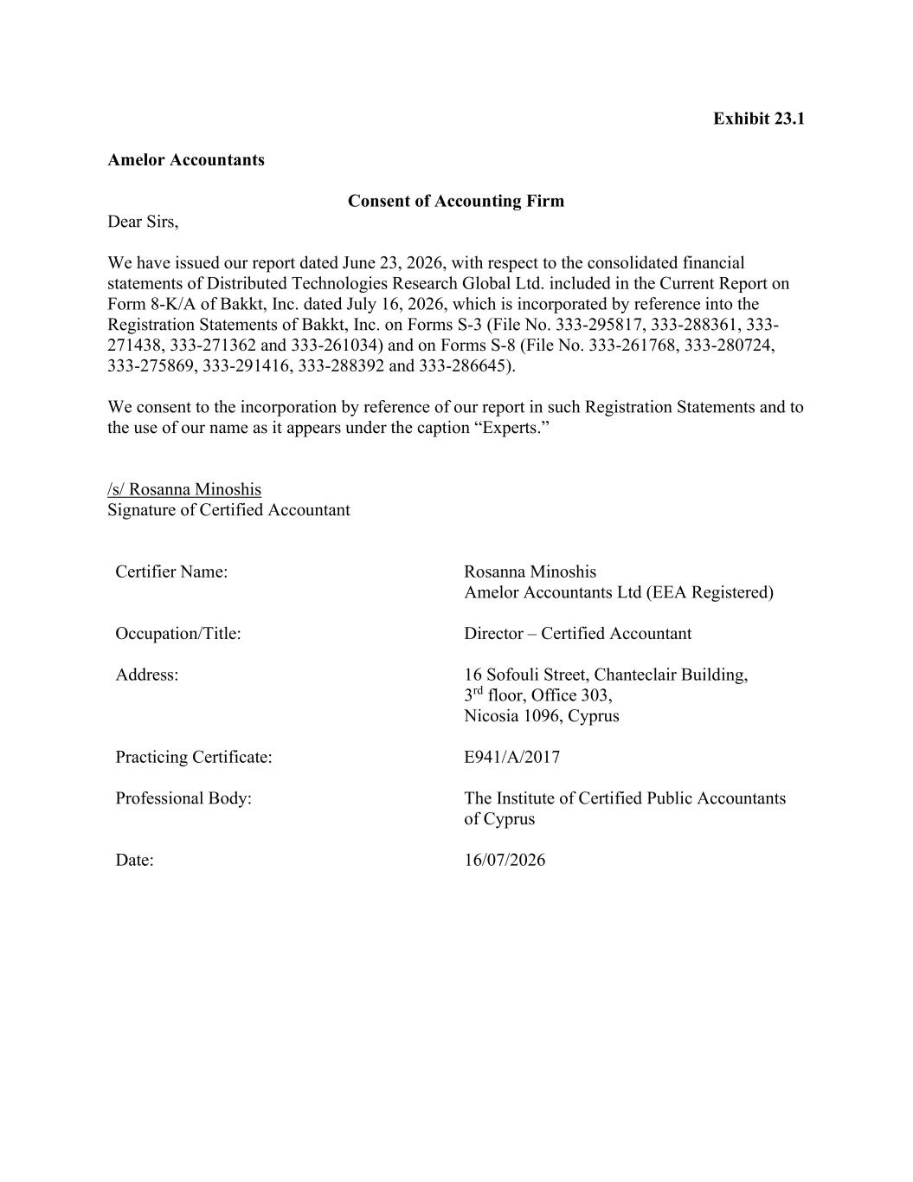

Exhibit 23.1 Amelor Accountants Consent of Accounting Firm Dear Sirs, We have issued our report dated June 23, 2026, with respect to the consolidated financial statements of Distributed Technologies Research Global Ltd. included in the Current Report on Form 8-K/A of Bakkt, Inc. dated July 16, 2026, which is incorporated by reference into the Registration Statements of Bakkt, Inc. on Forms S-3 (File No. 333-295817, 333-288361, 333- 271438, 333-271362 and 333-261034) and on Forms S-8 (File No. 333-261768, 333-280724, 333-275869, 333-291416, 333-288392 and 333-286645). We consent to the incorporation by reference of our report in such Registration Statements and to the use of our name as it appears under the caption “Experts.” /s/ Rosanna Minoshis Signature of Certified Accountant Certifier Name: Rosanna Minoshis Amelor Accountants Ltd (EEA Registered) Occupation/Title: Director – Certified Accountant Address: 16 Sofouli Street, Chanteclair Building, 3rd floor, Office 303, Nicosia 1096, Cyprus Practicing Certificate: E941/A/2017 Professional Body: The Institute of Certified Public Accountants of Cyprus Date: 16/07/2026

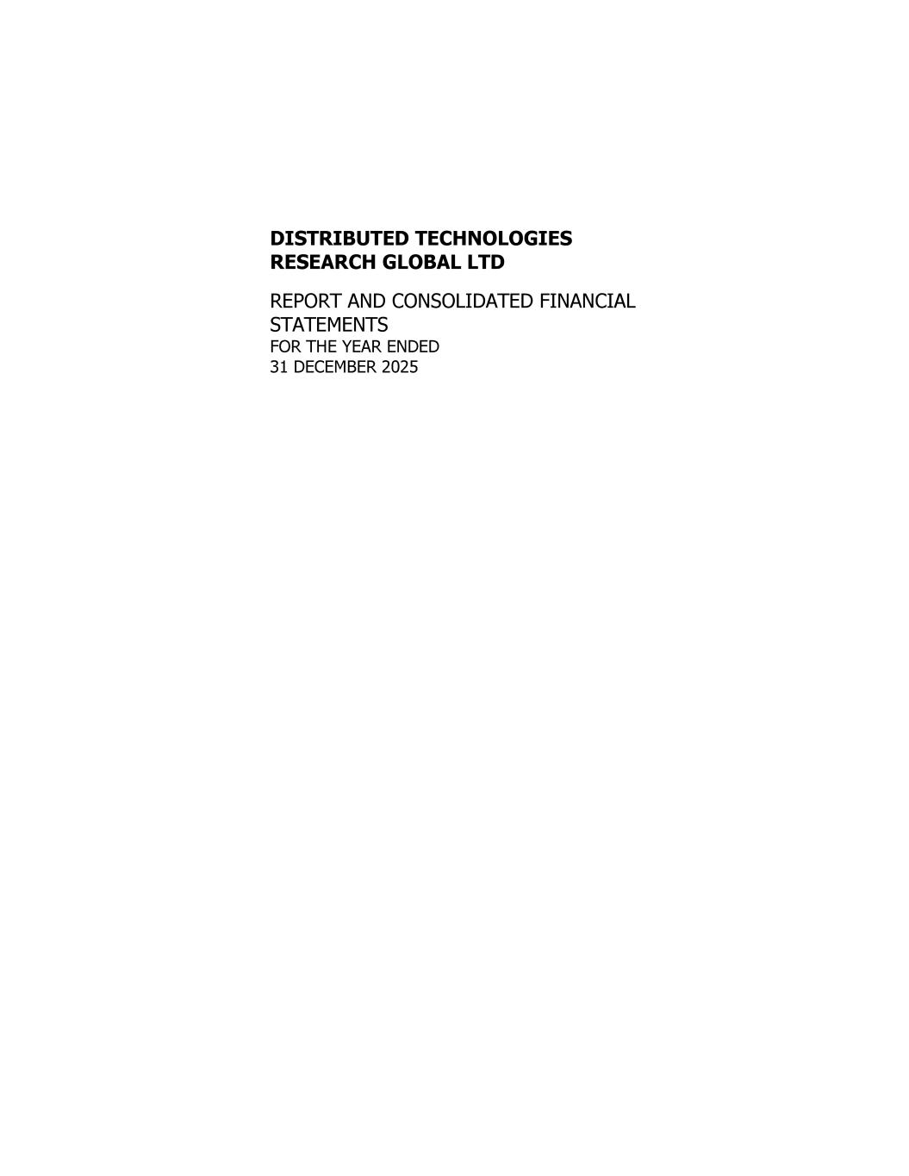

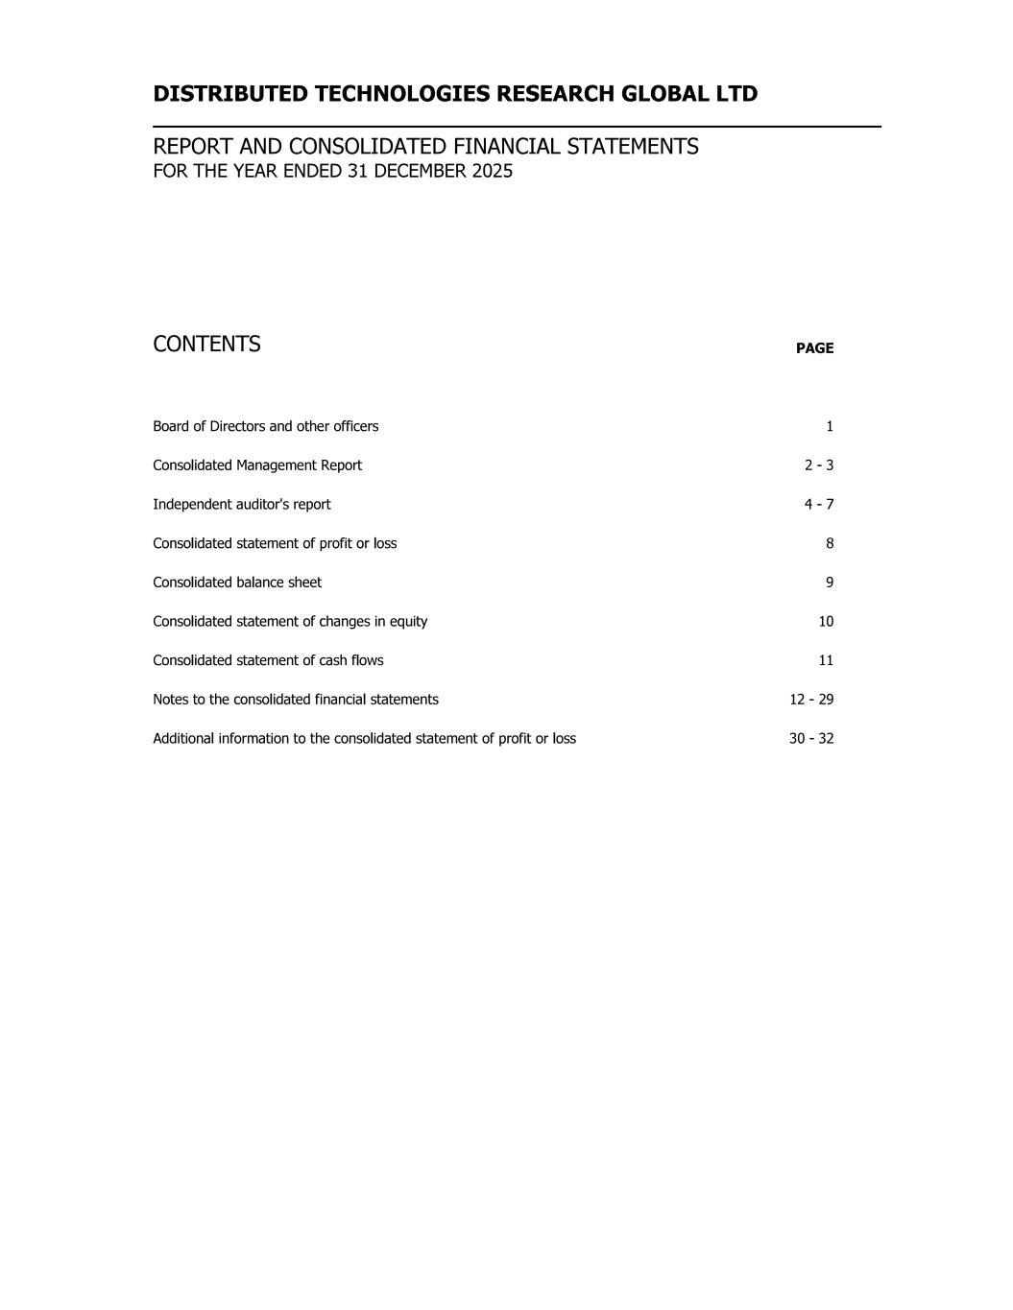

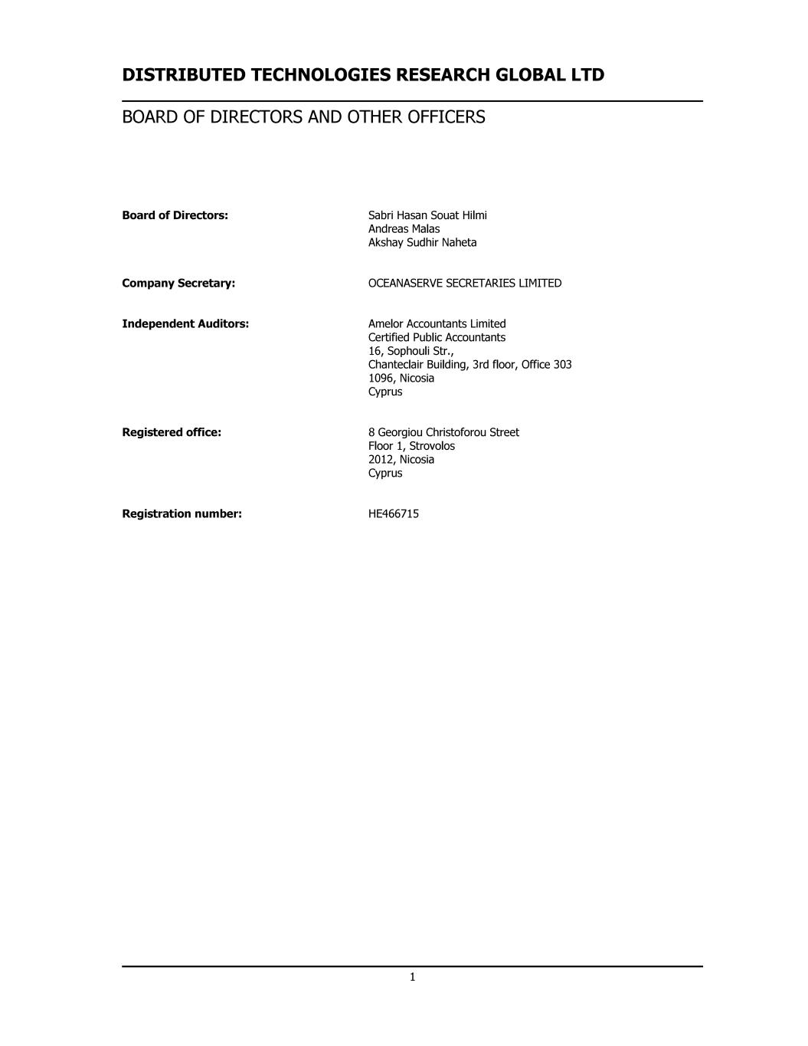

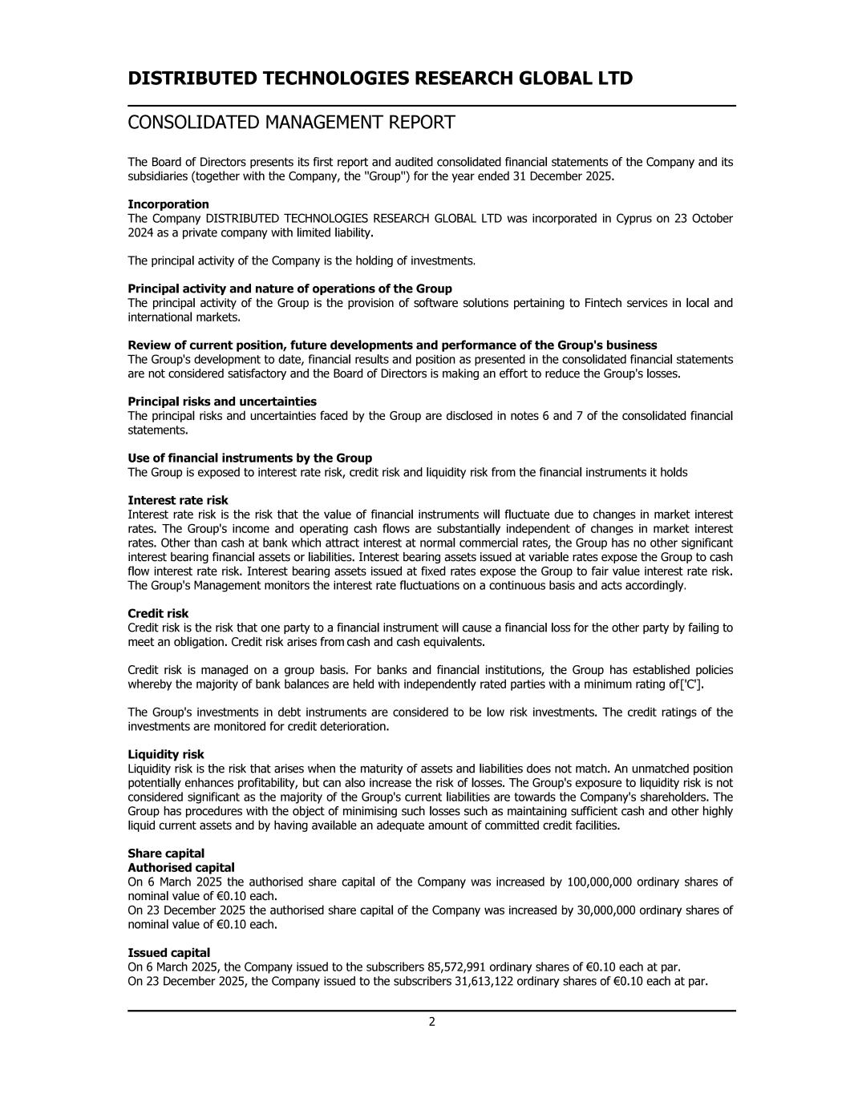

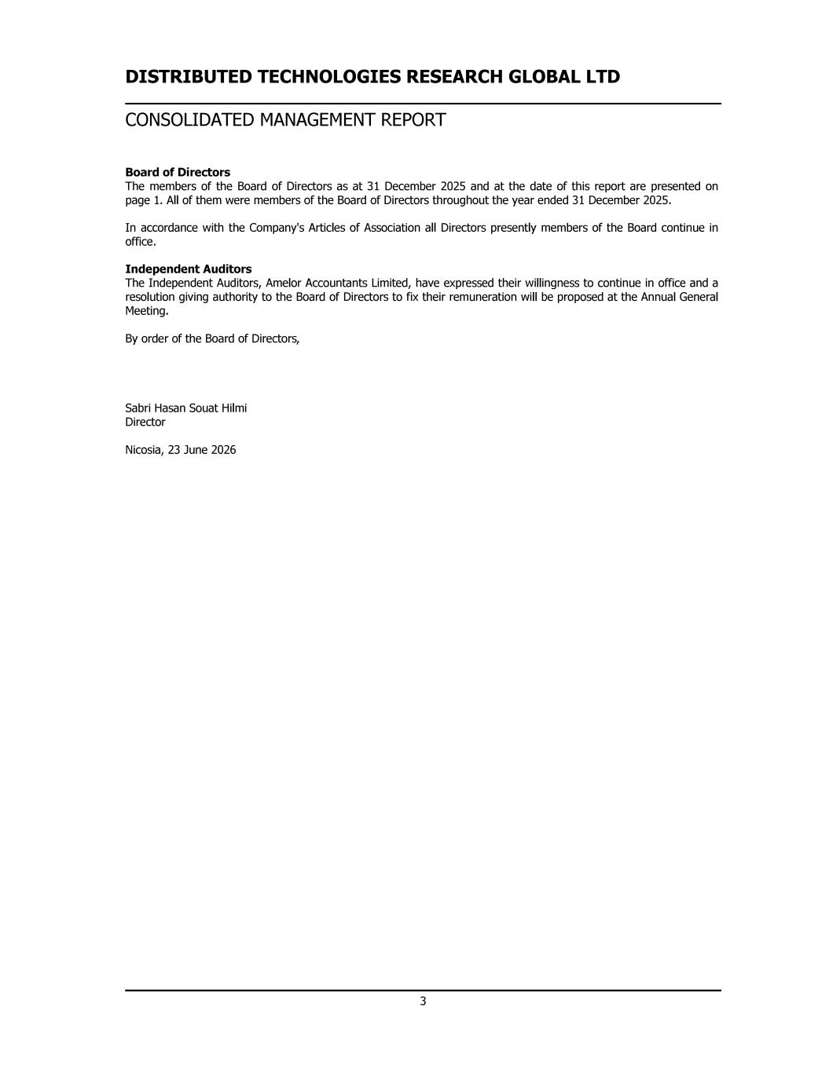

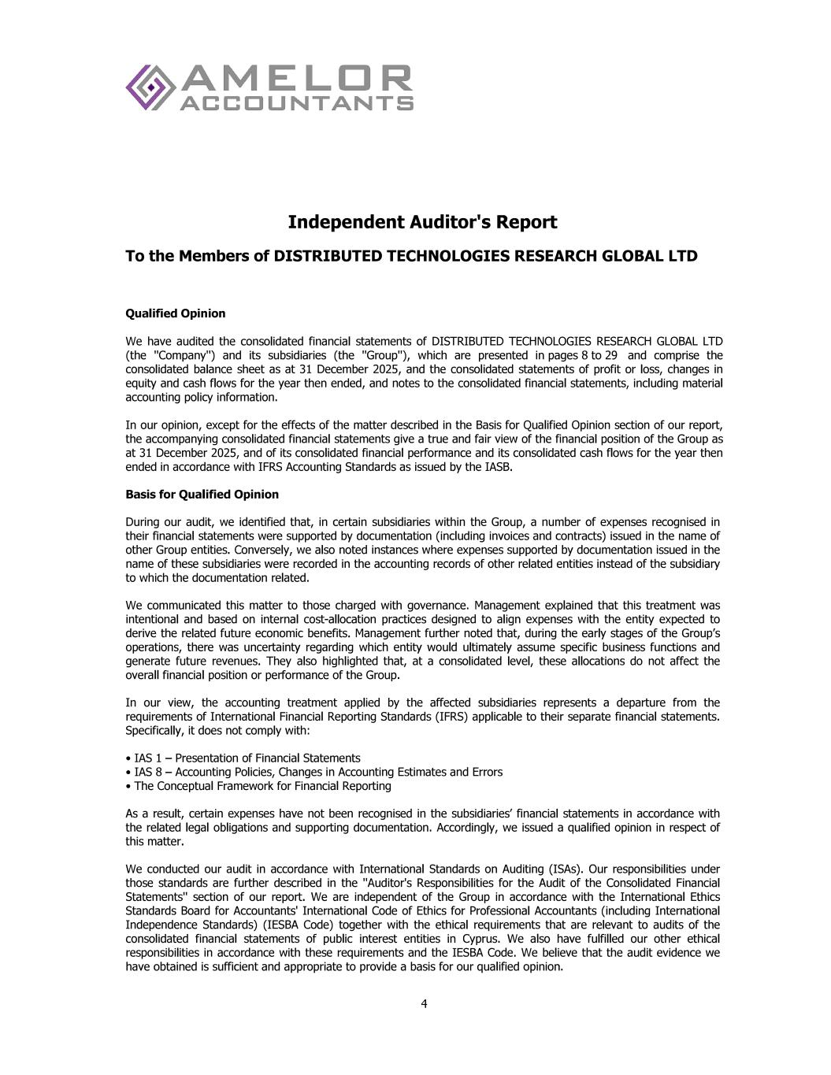

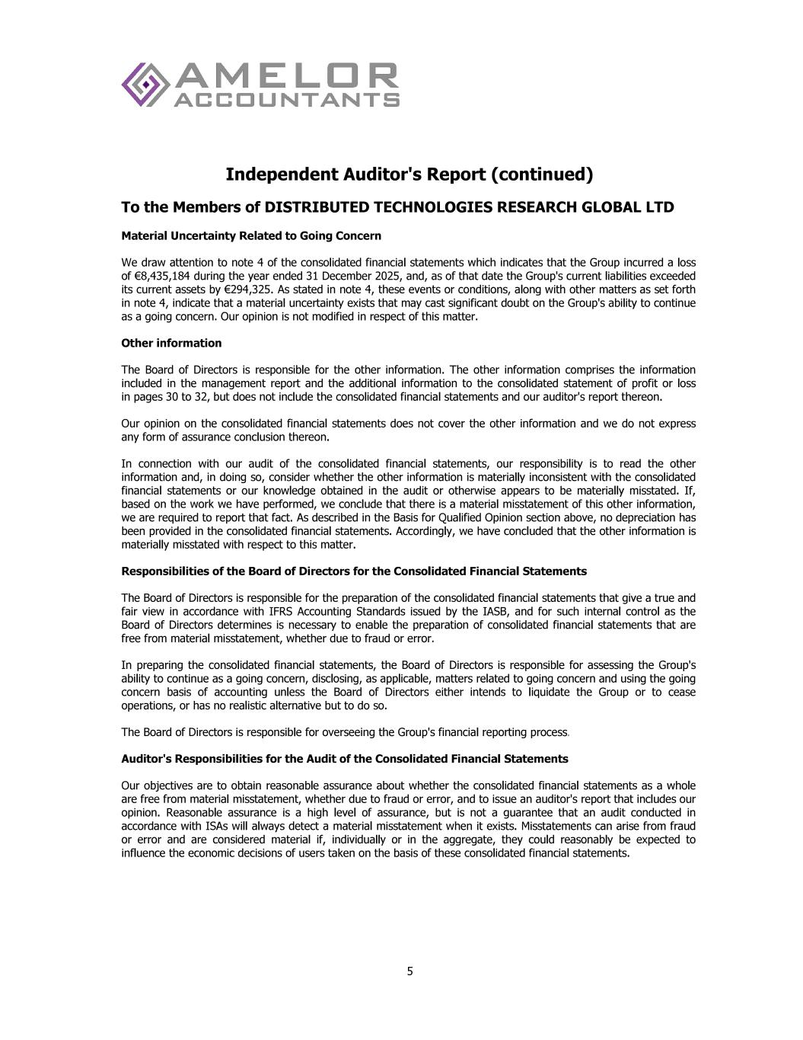

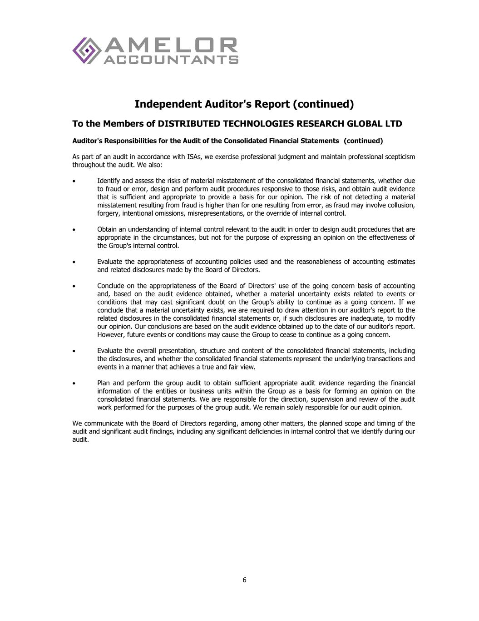

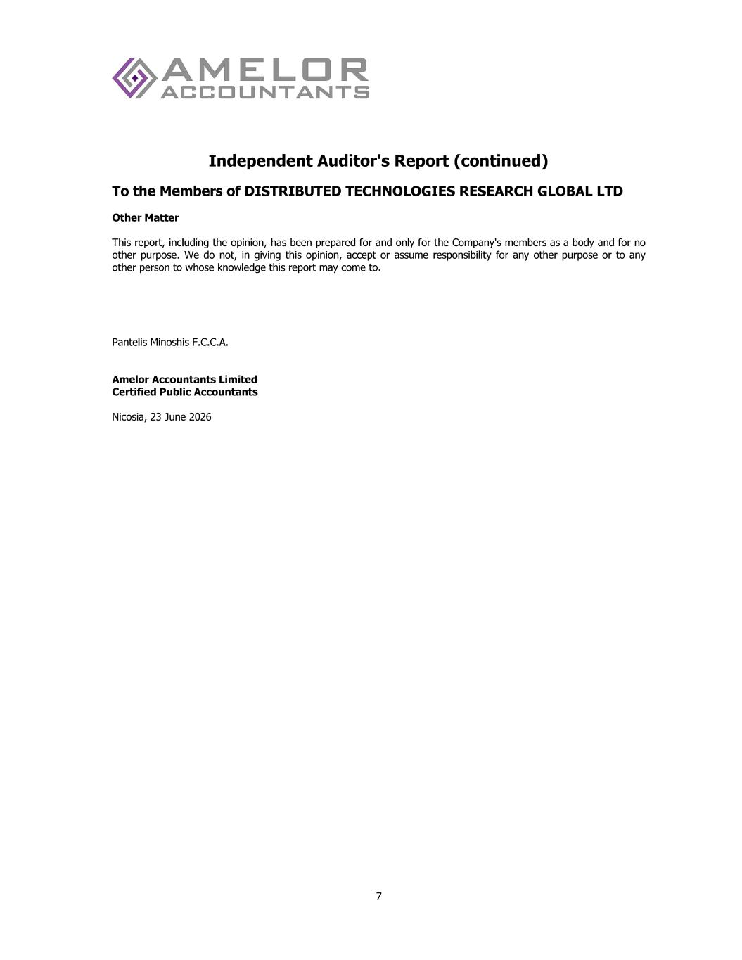

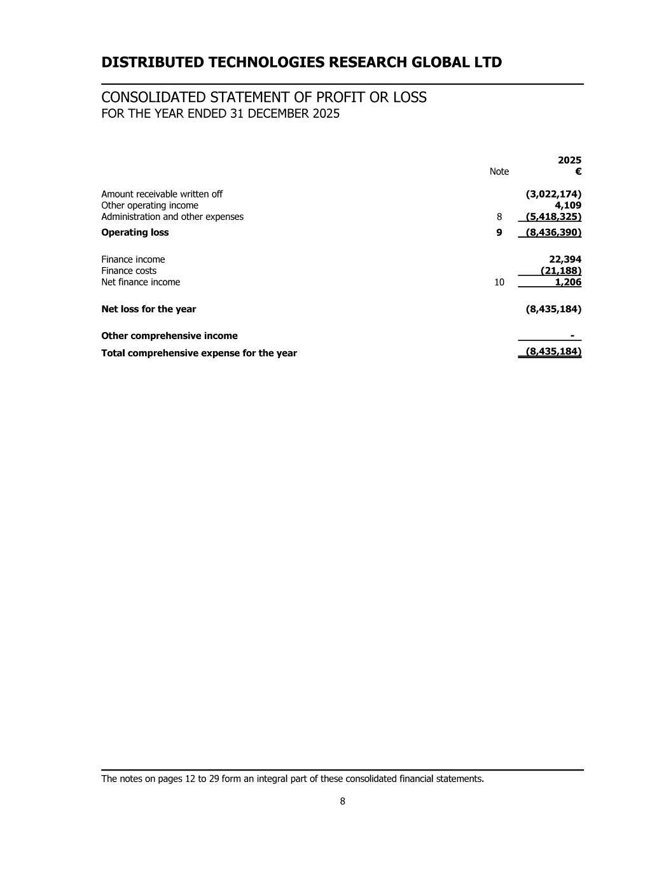

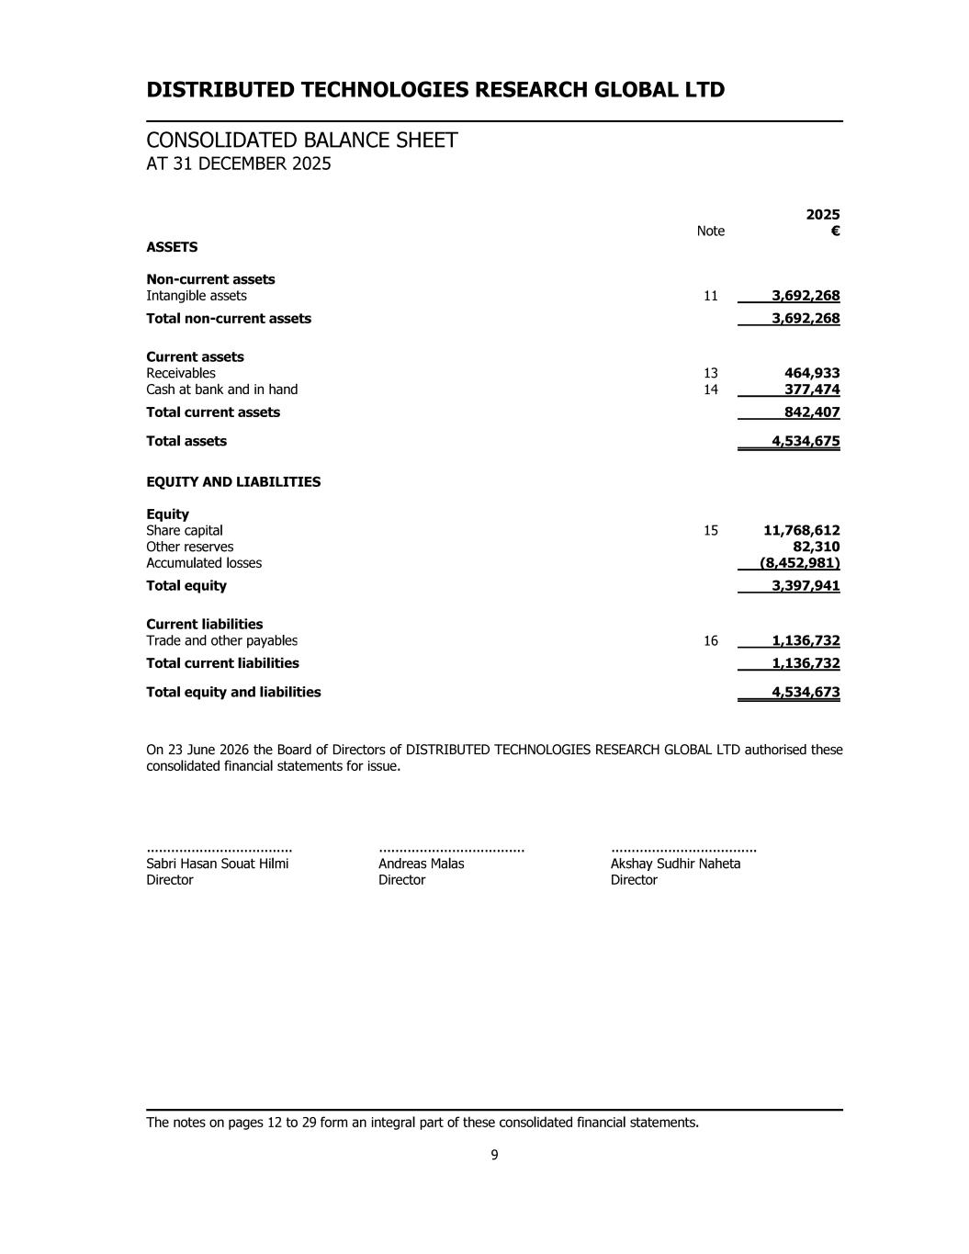

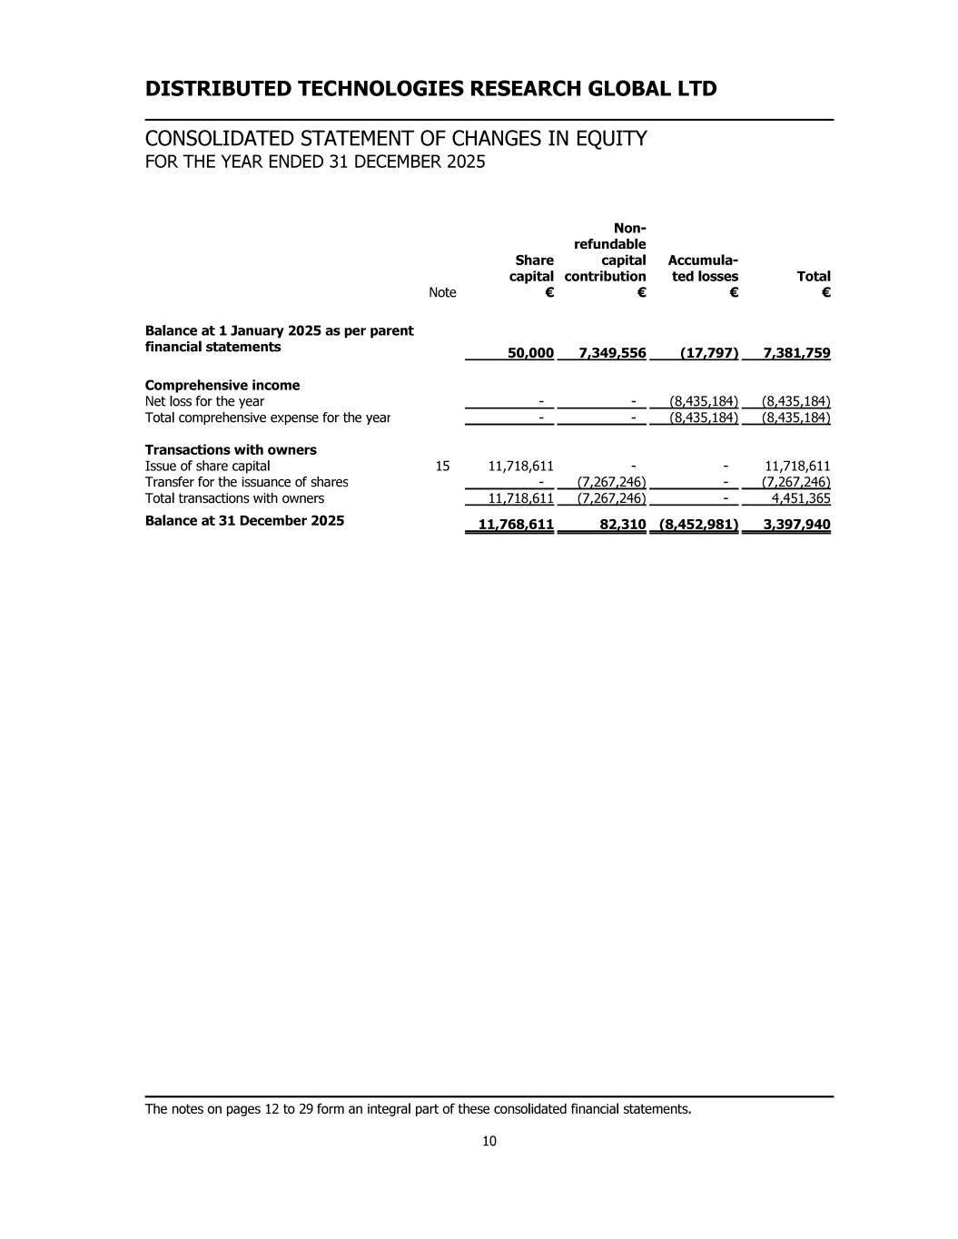

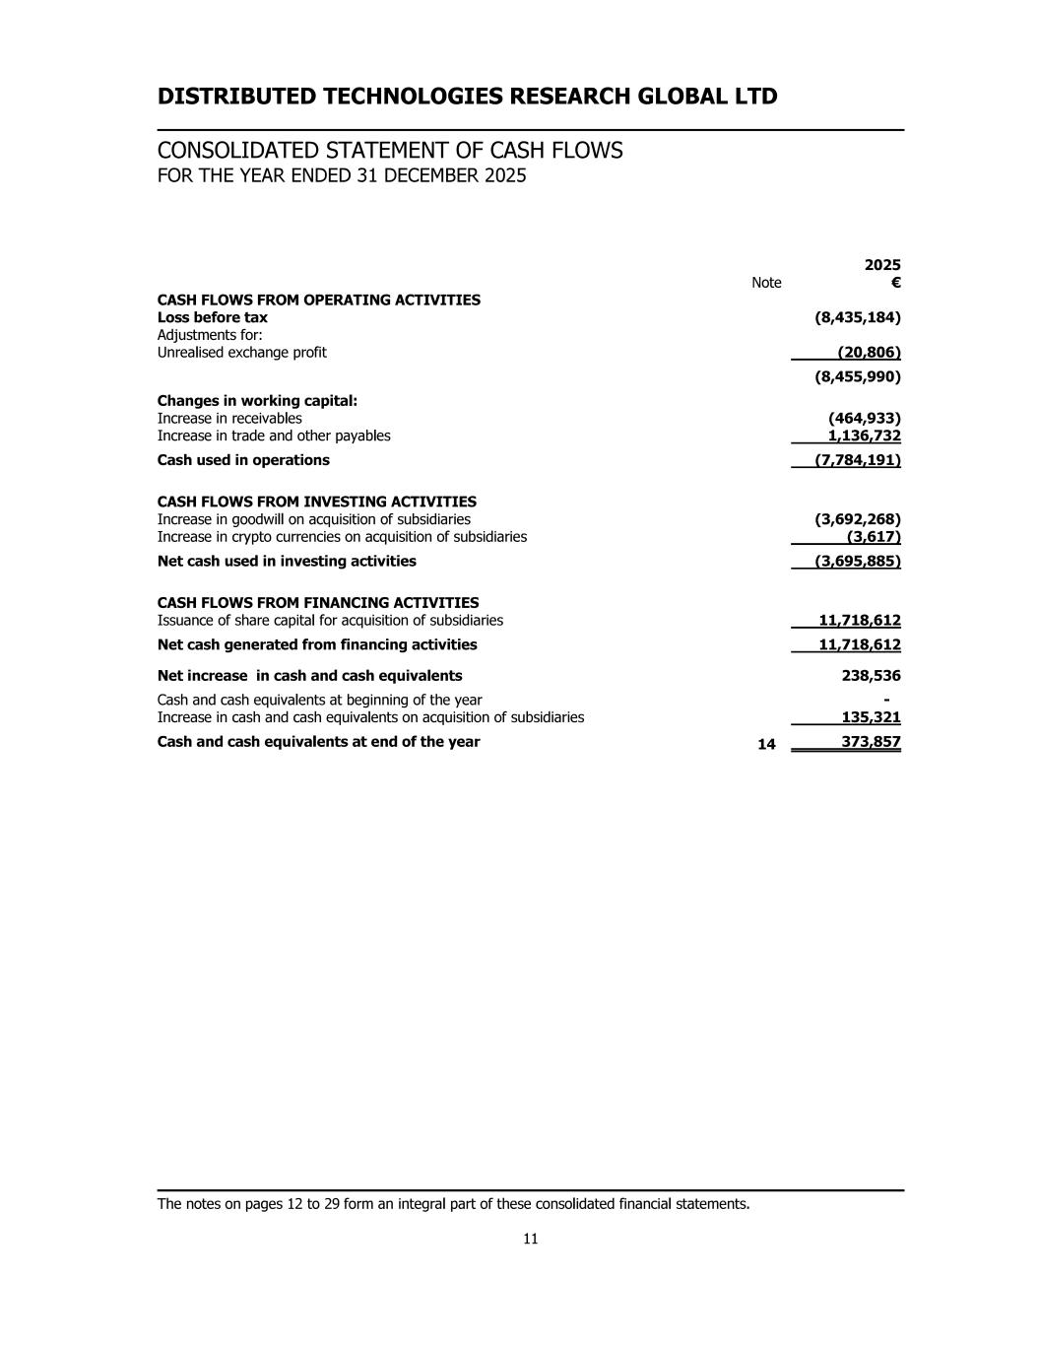

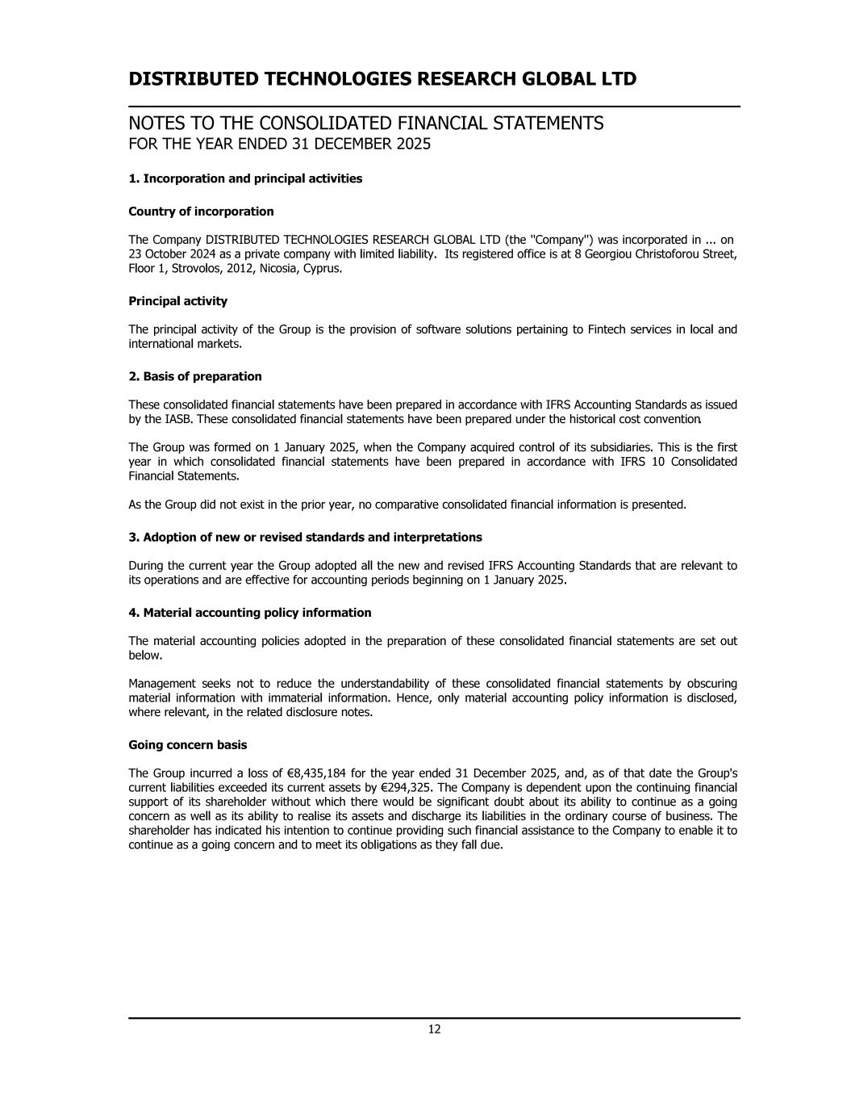

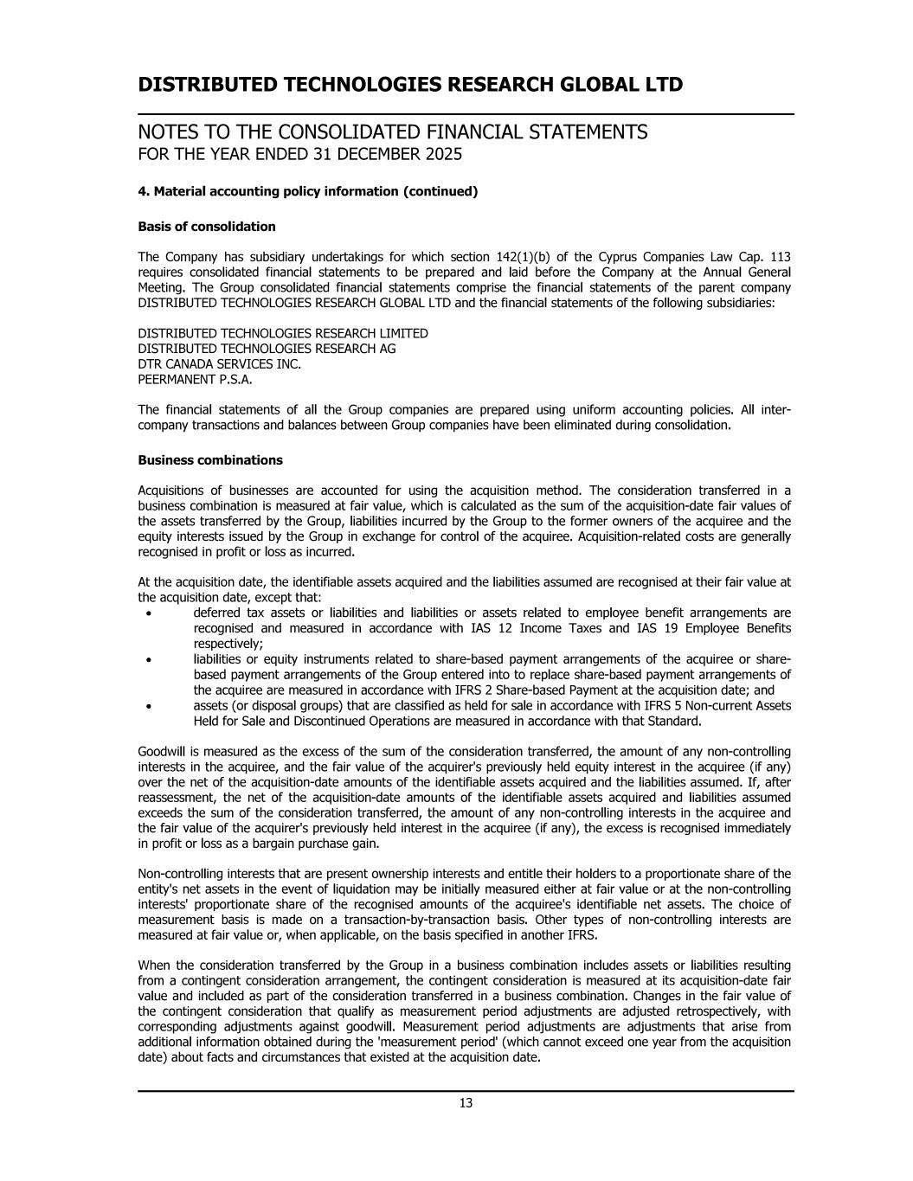

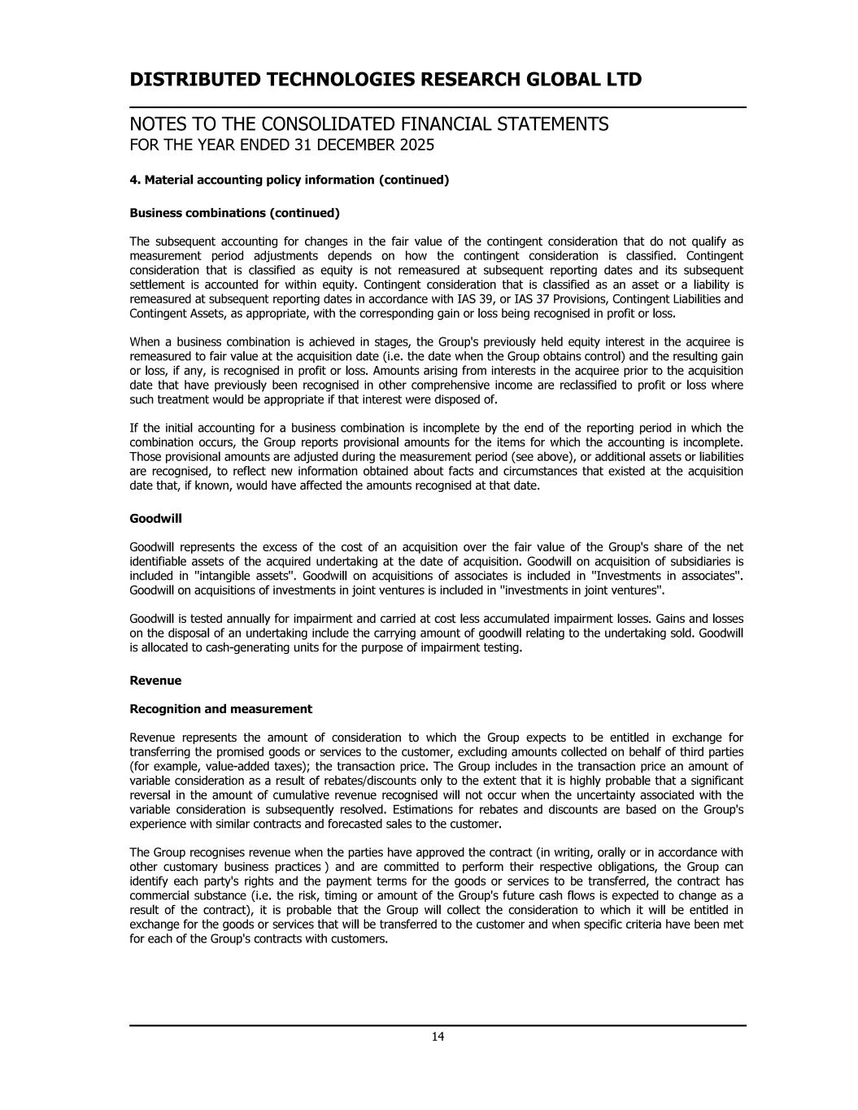

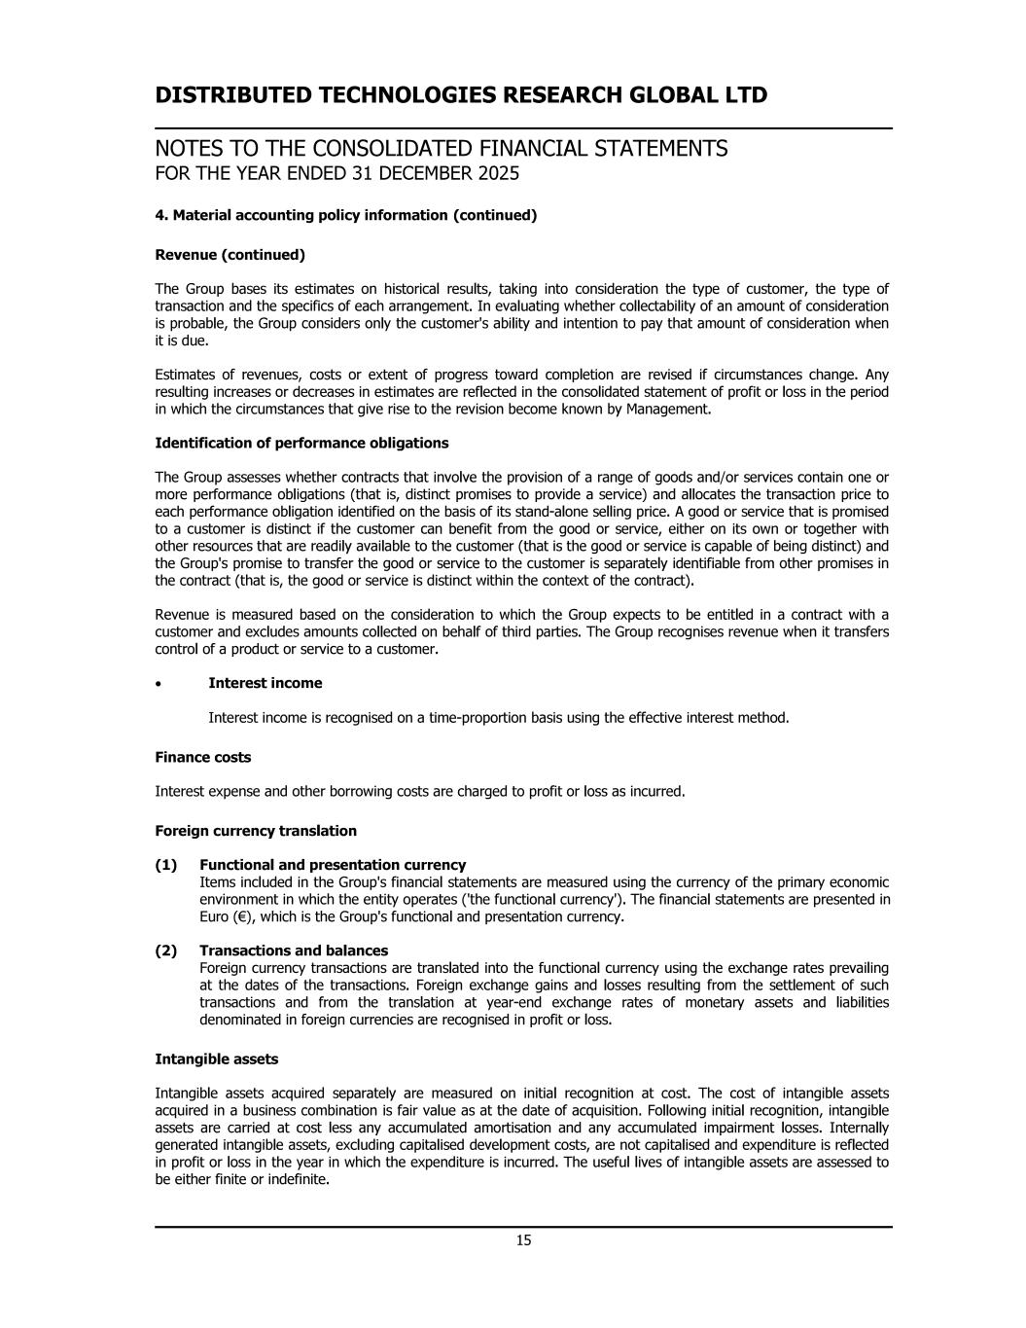

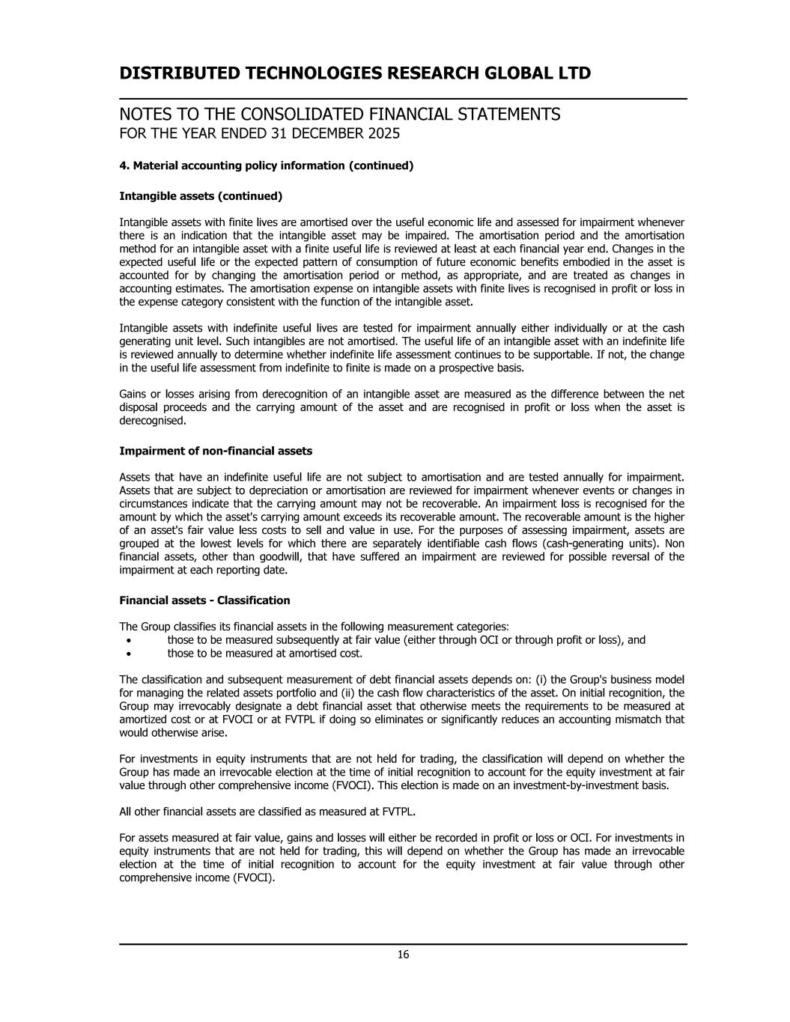

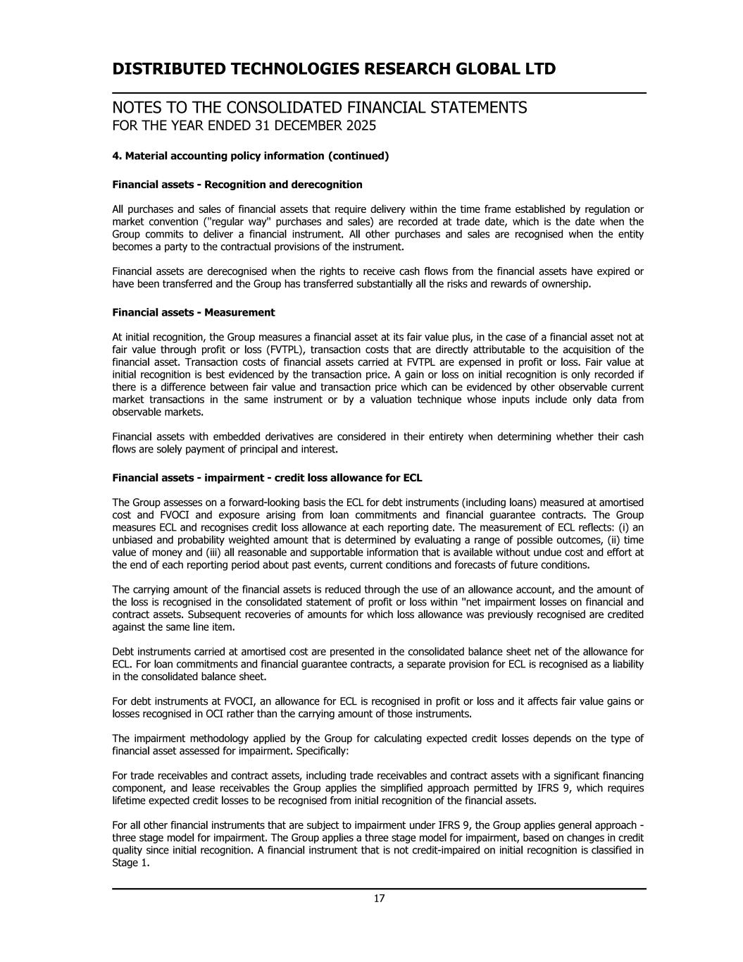

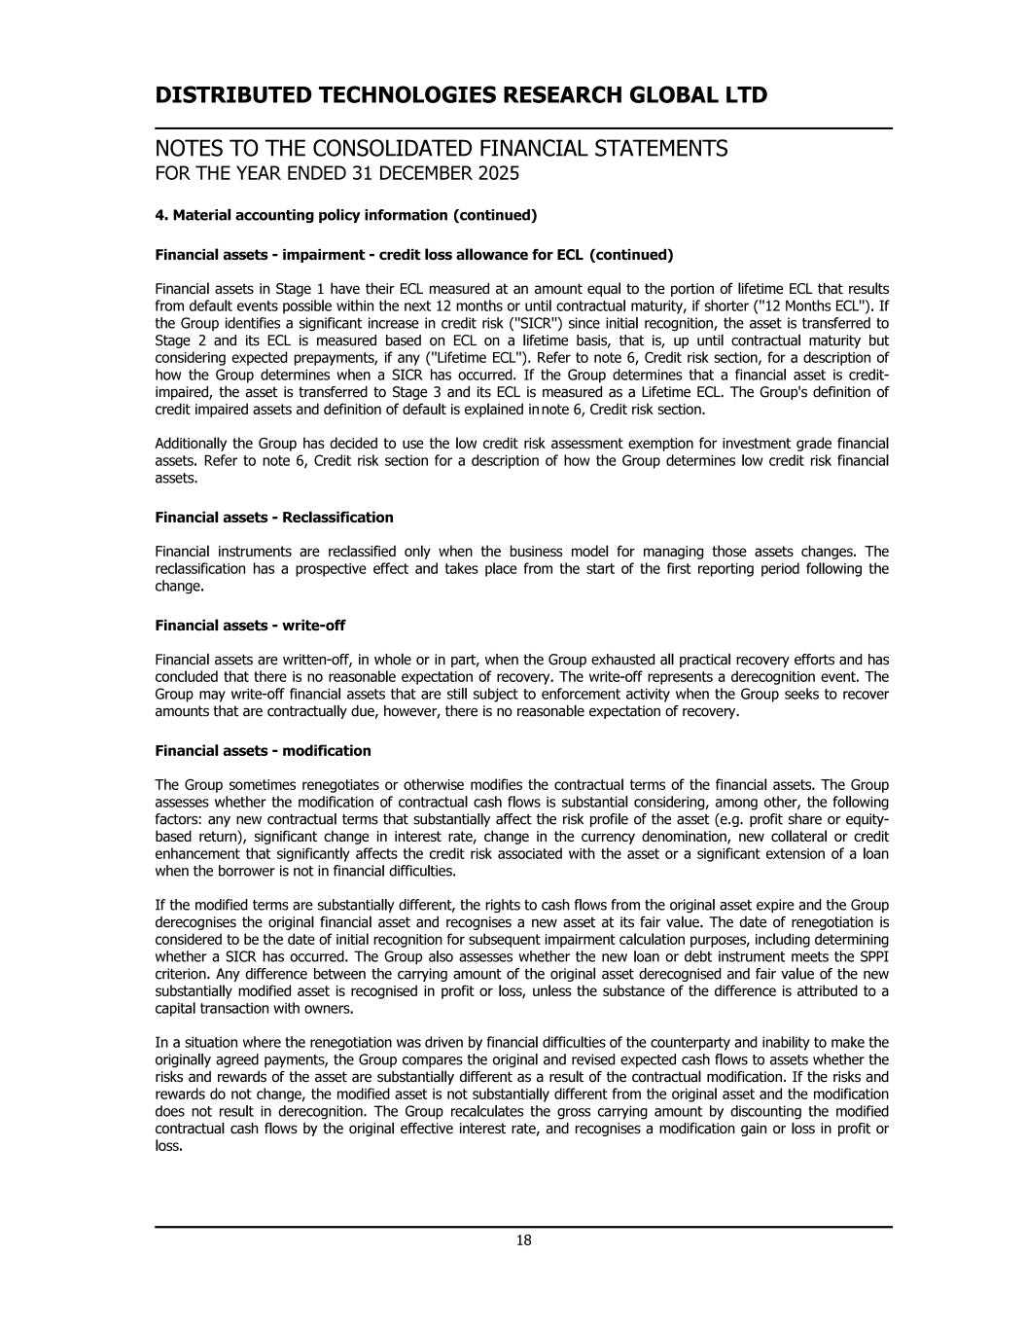

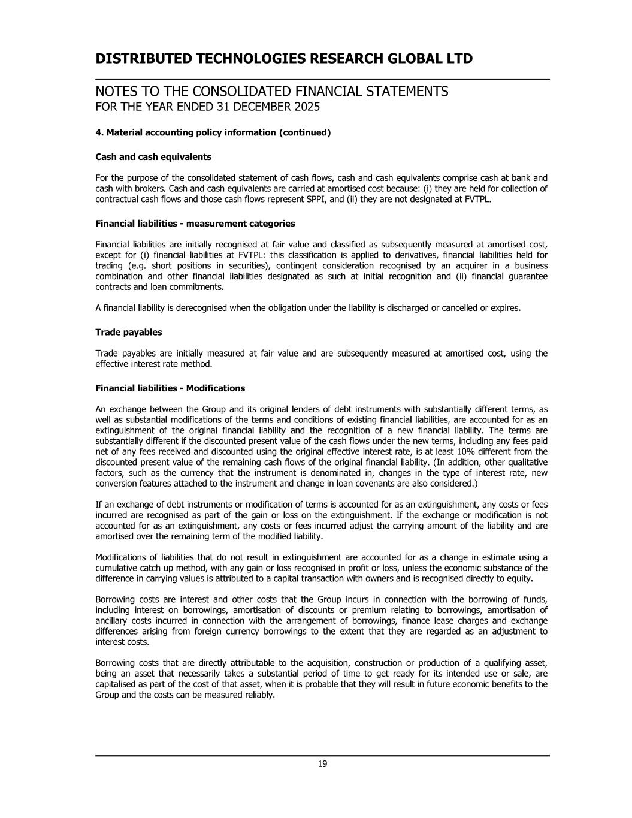

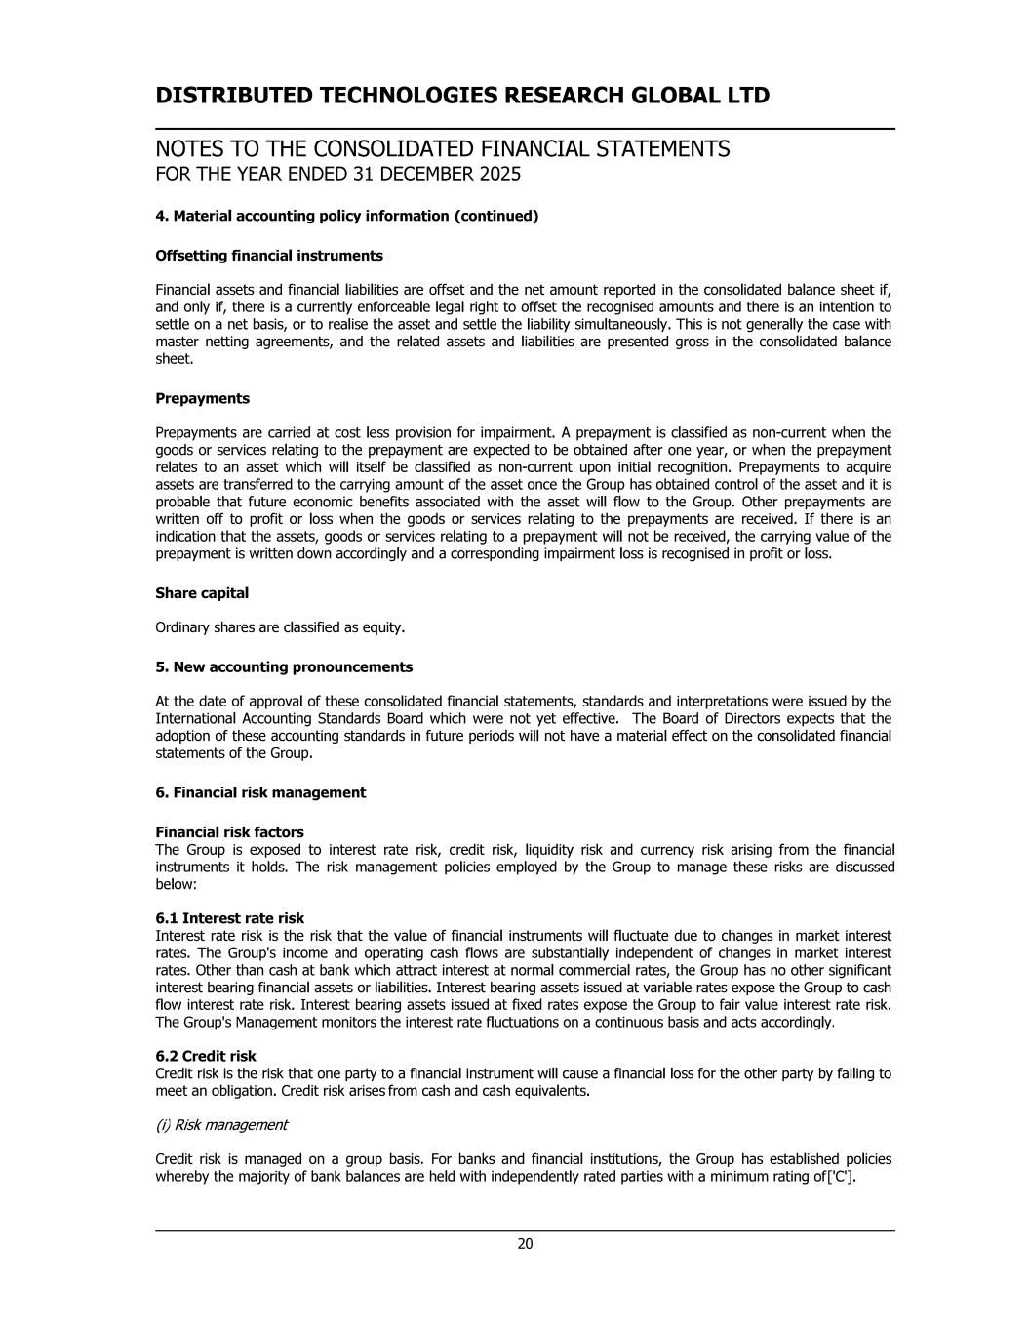

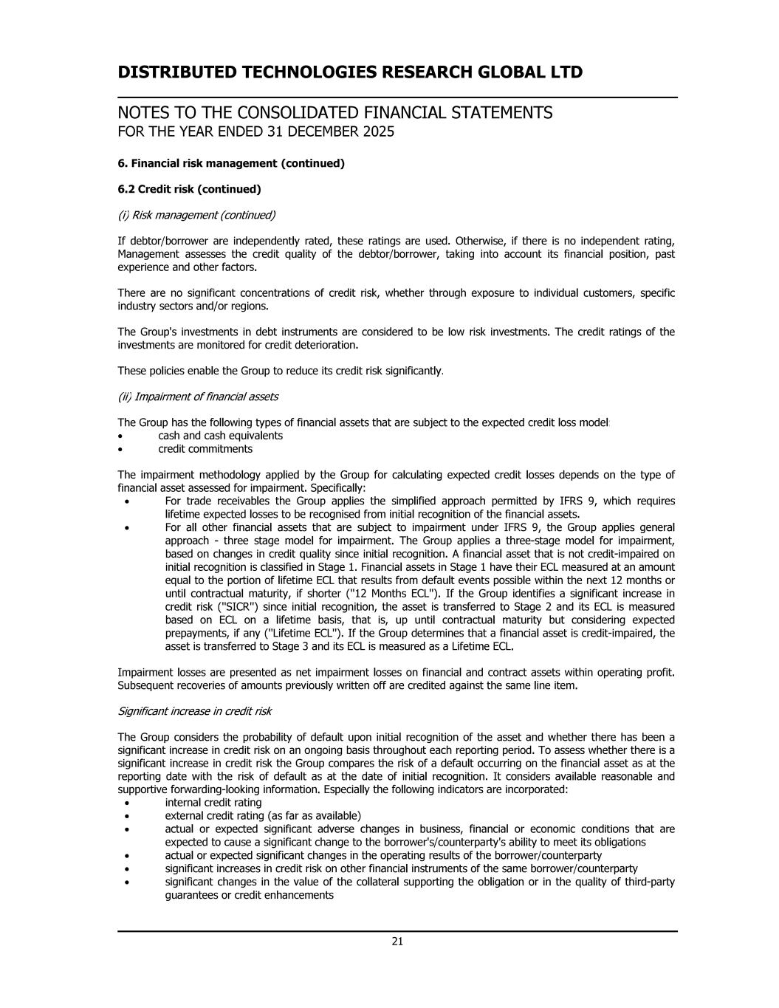

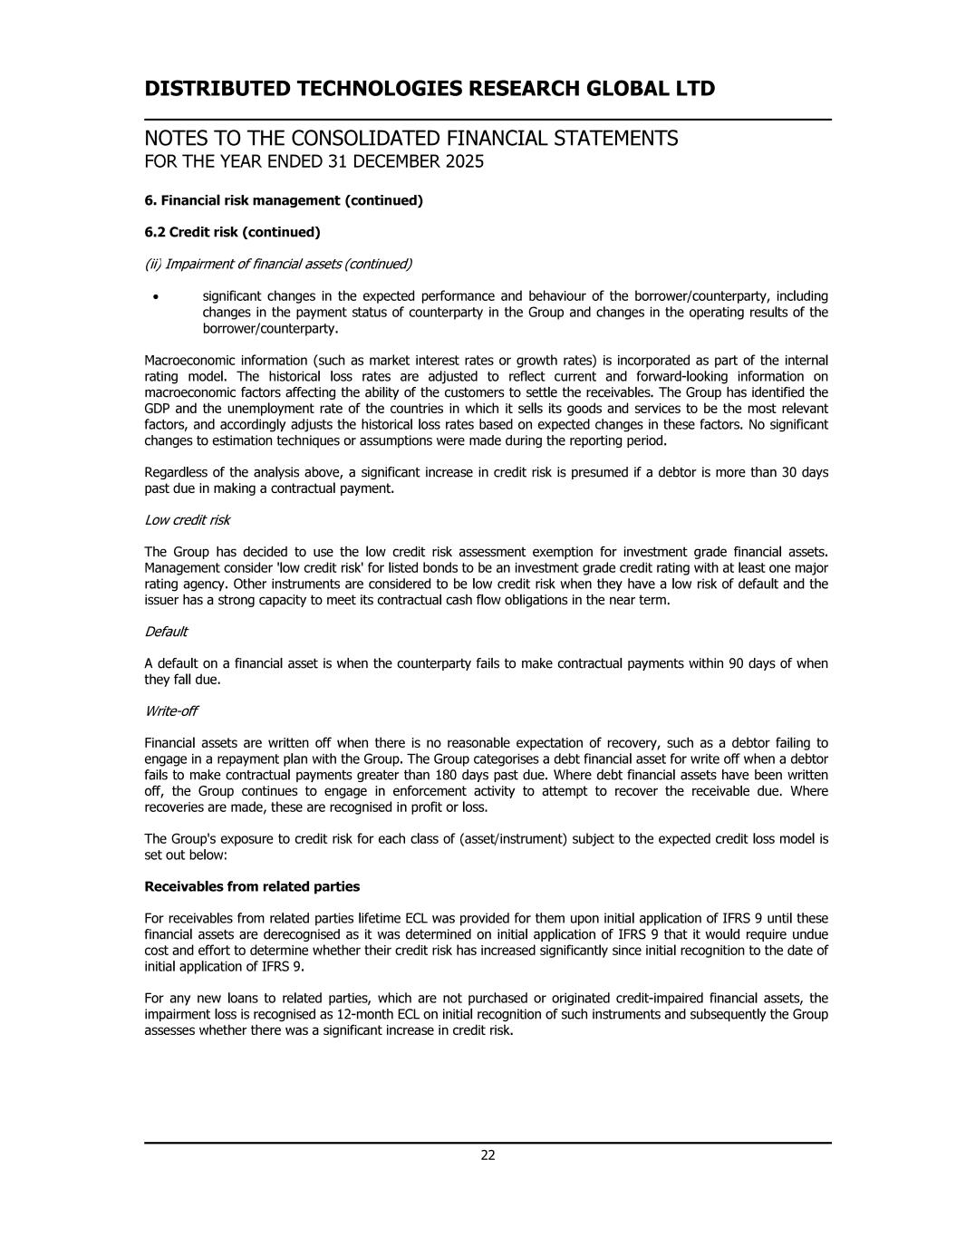

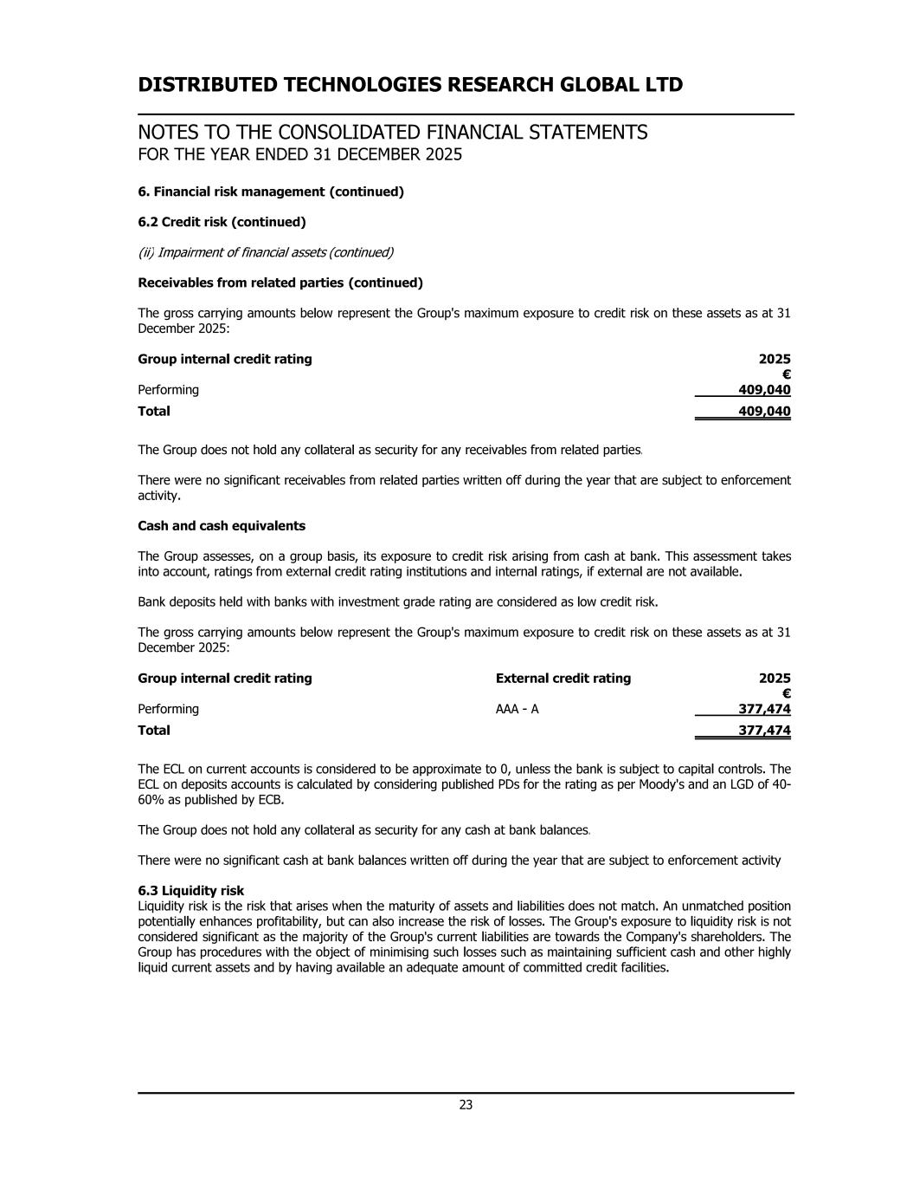

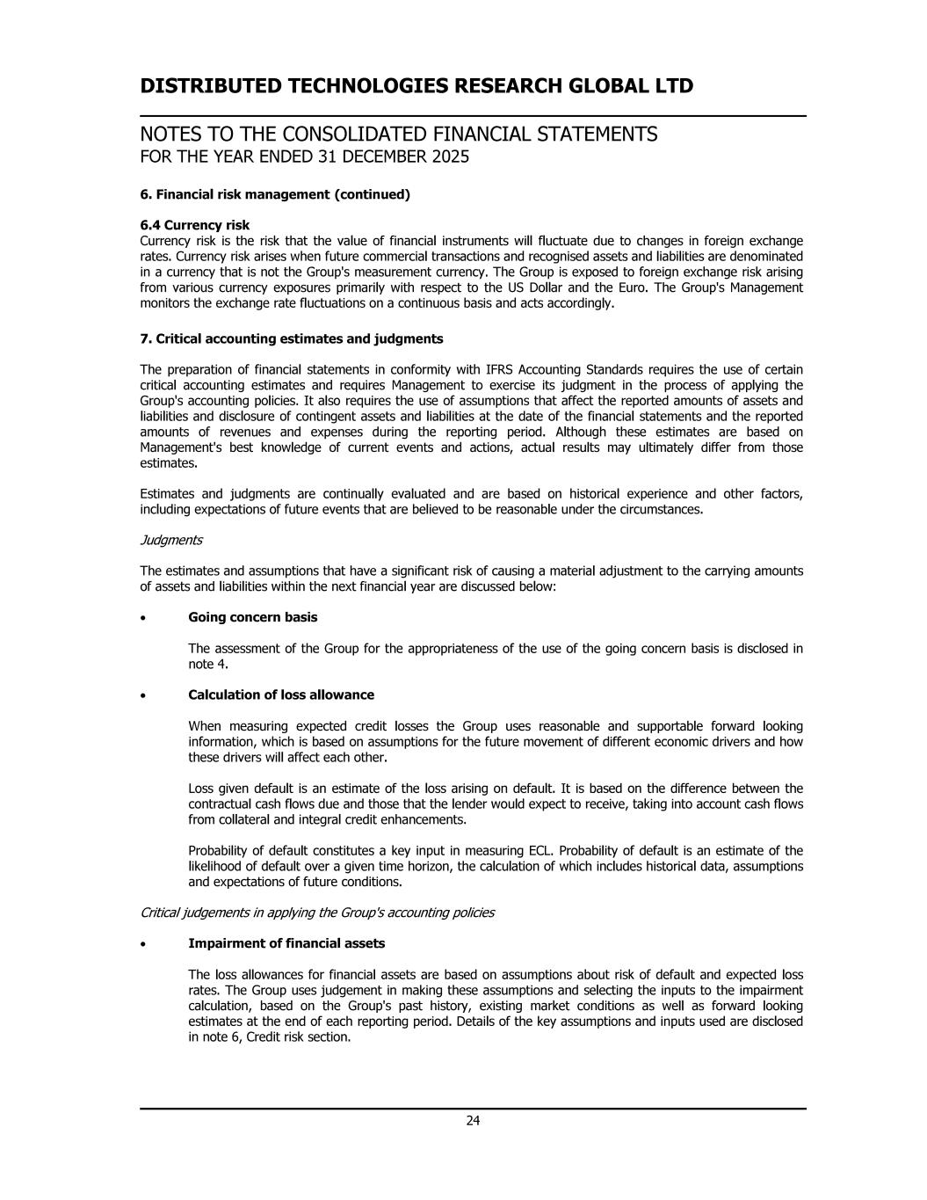

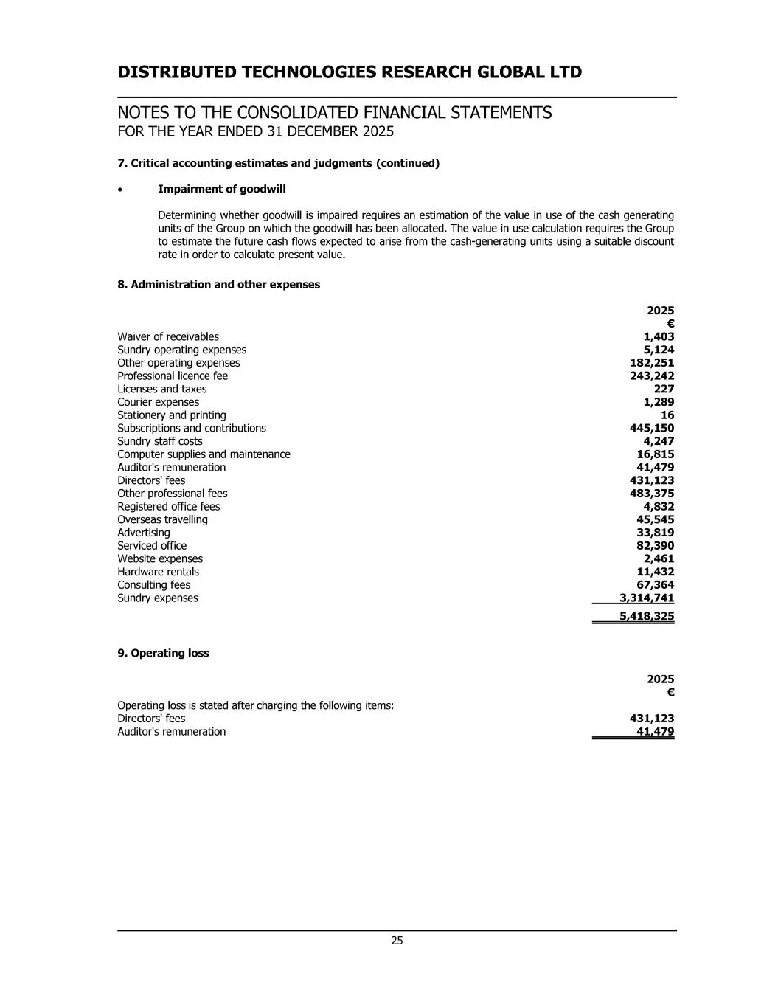

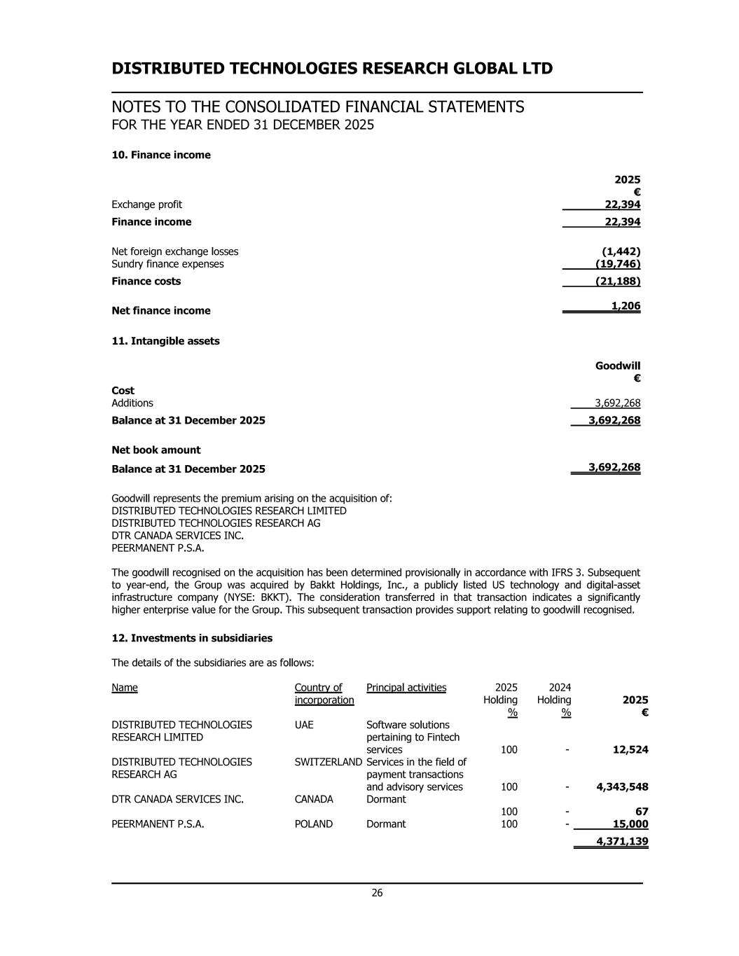

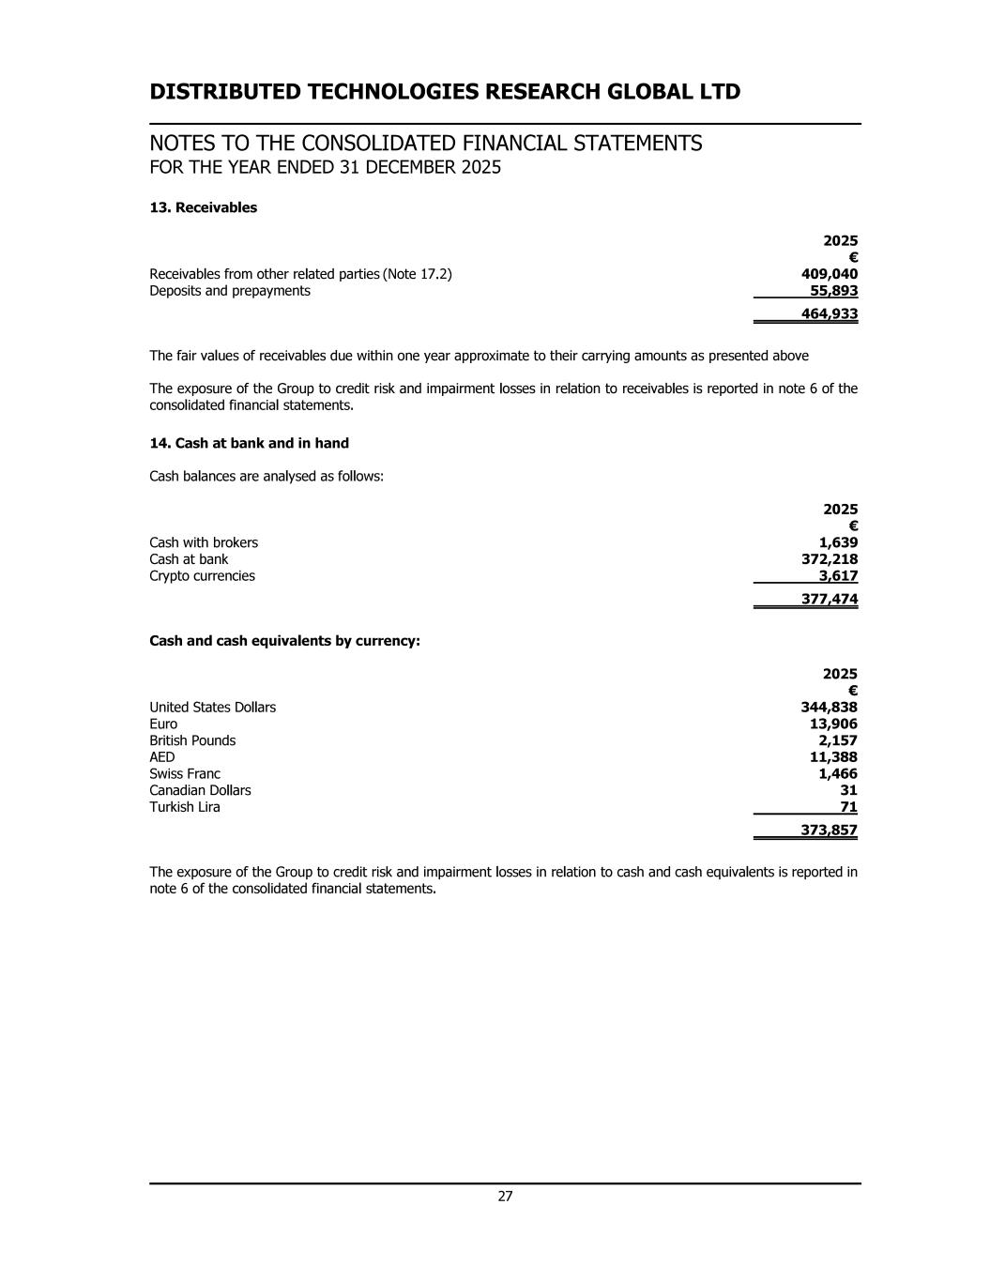

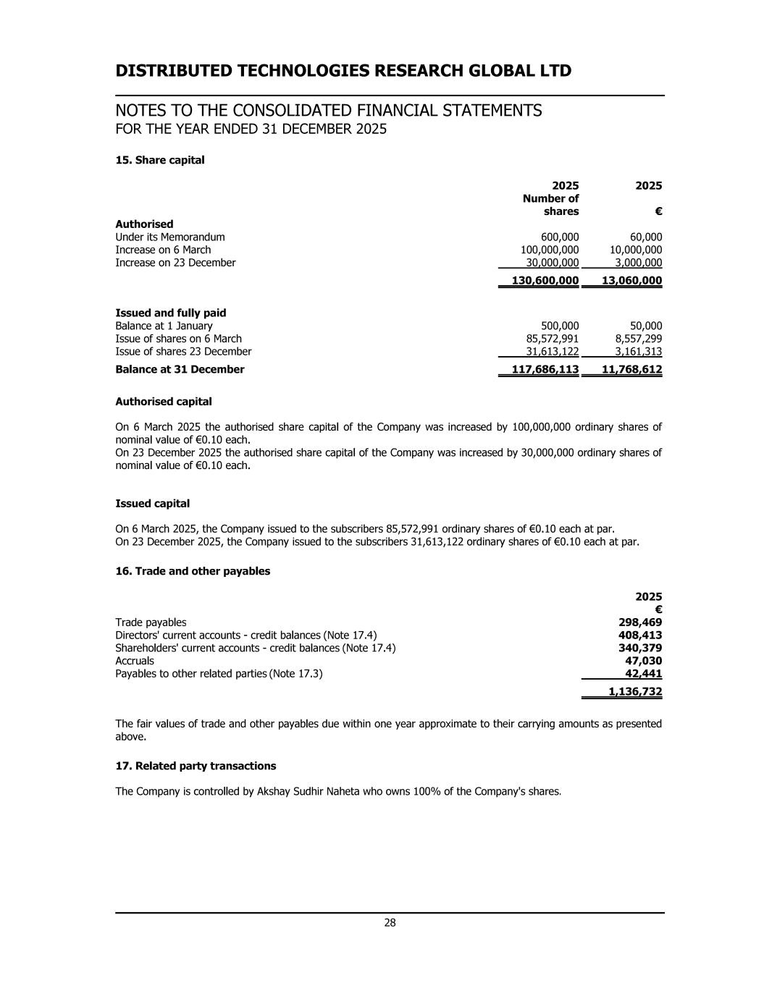

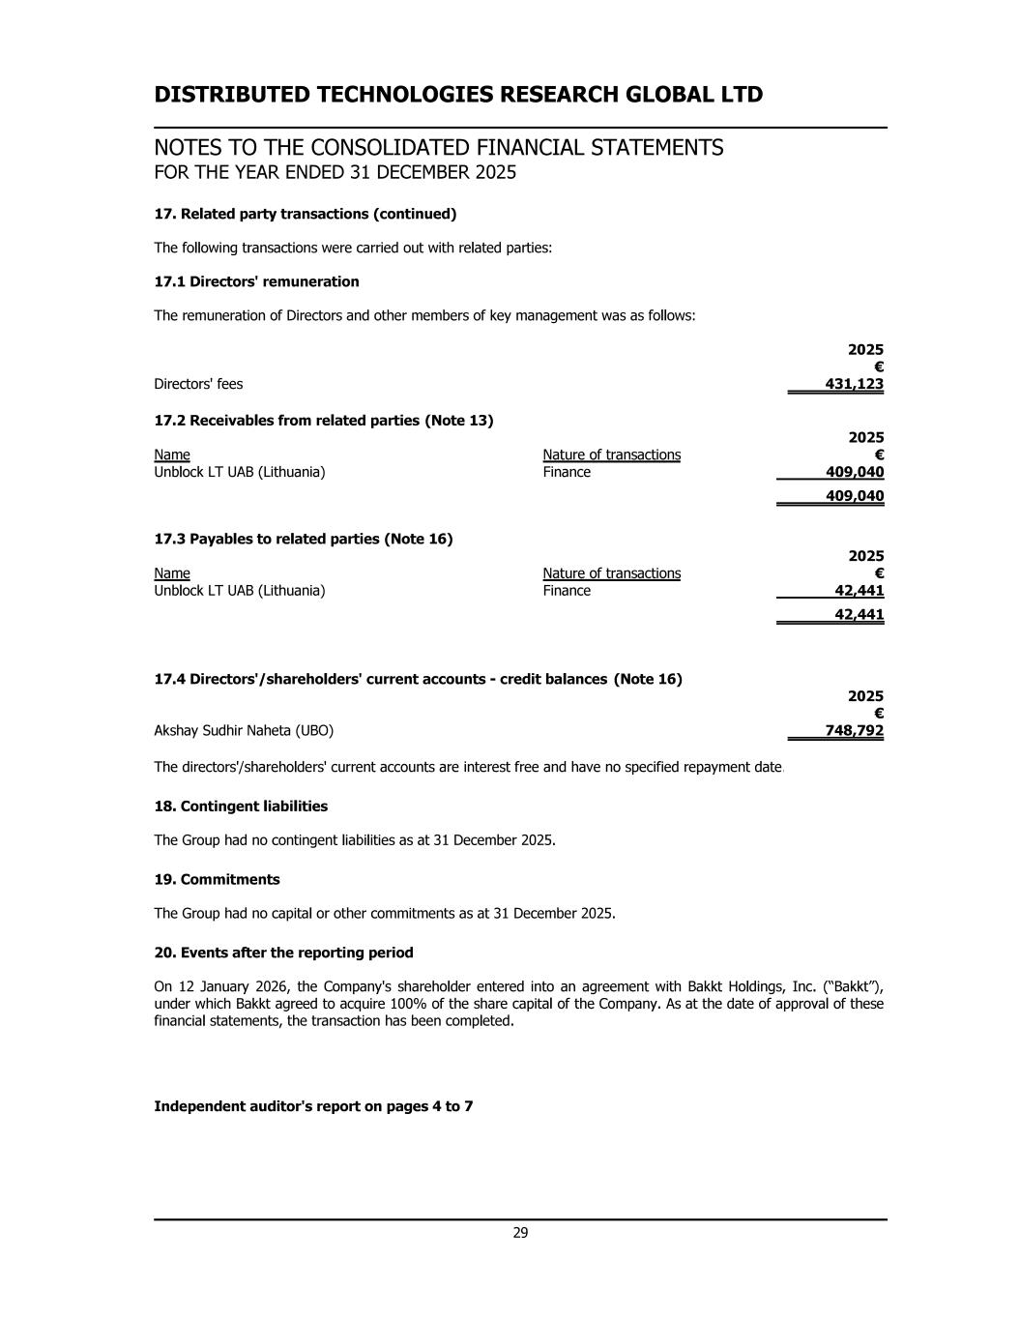

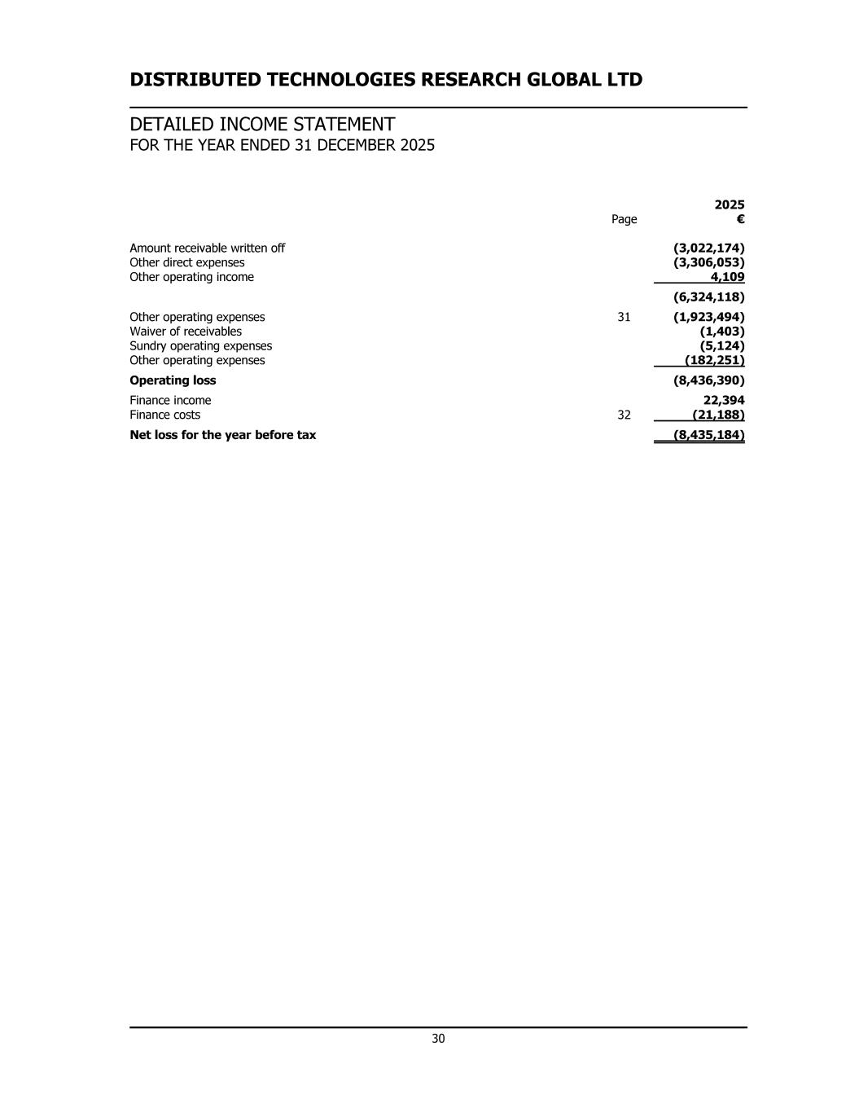

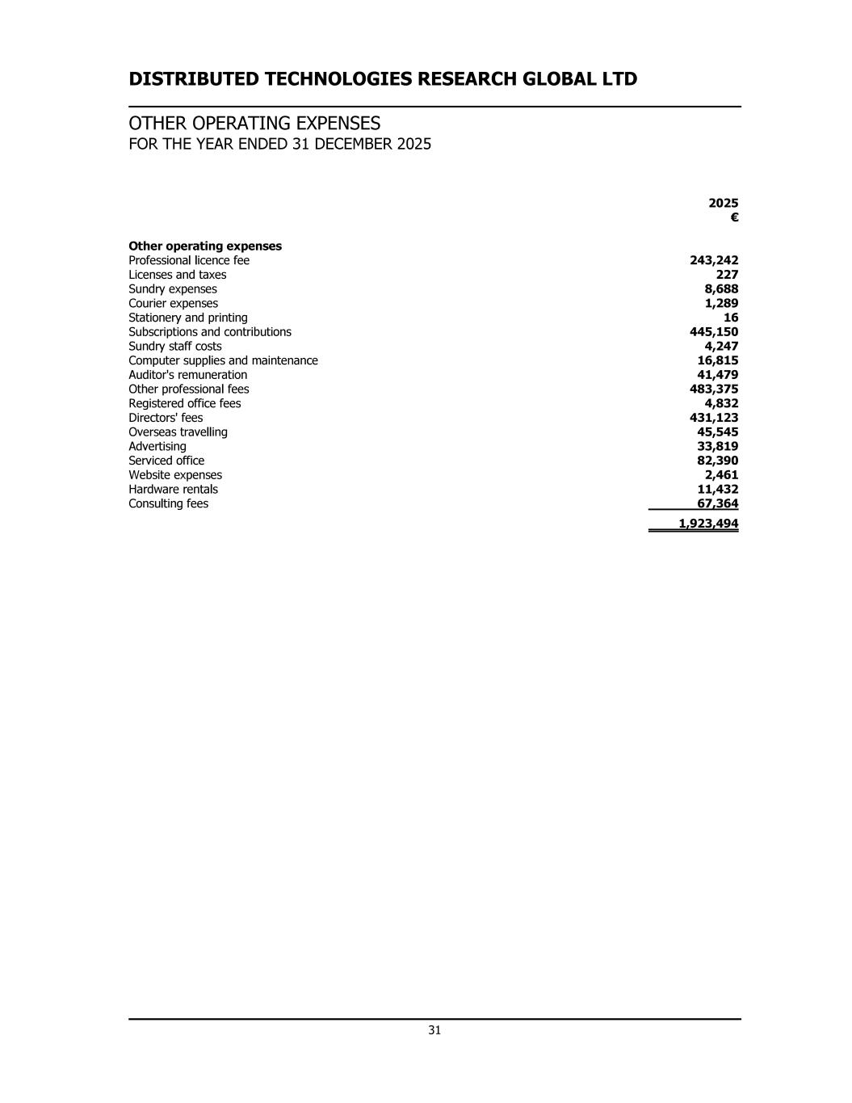

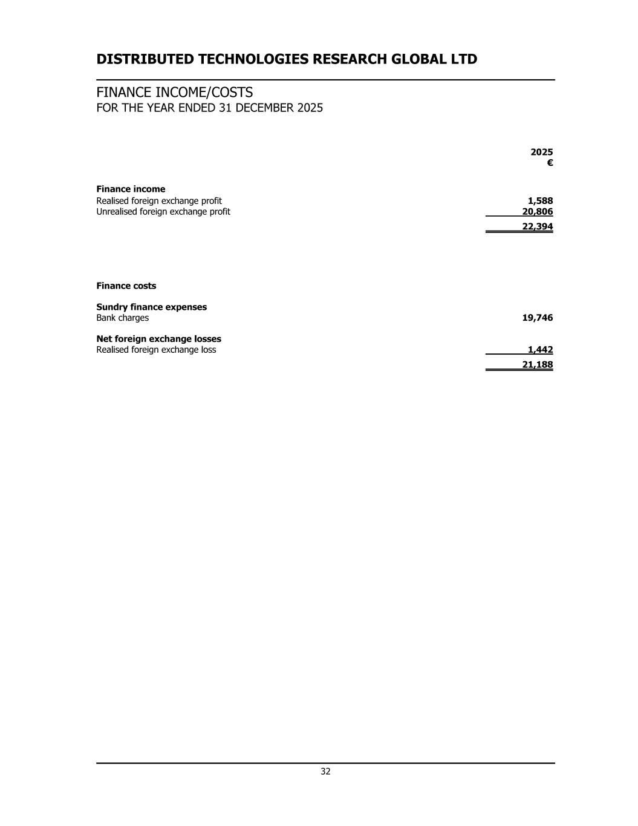

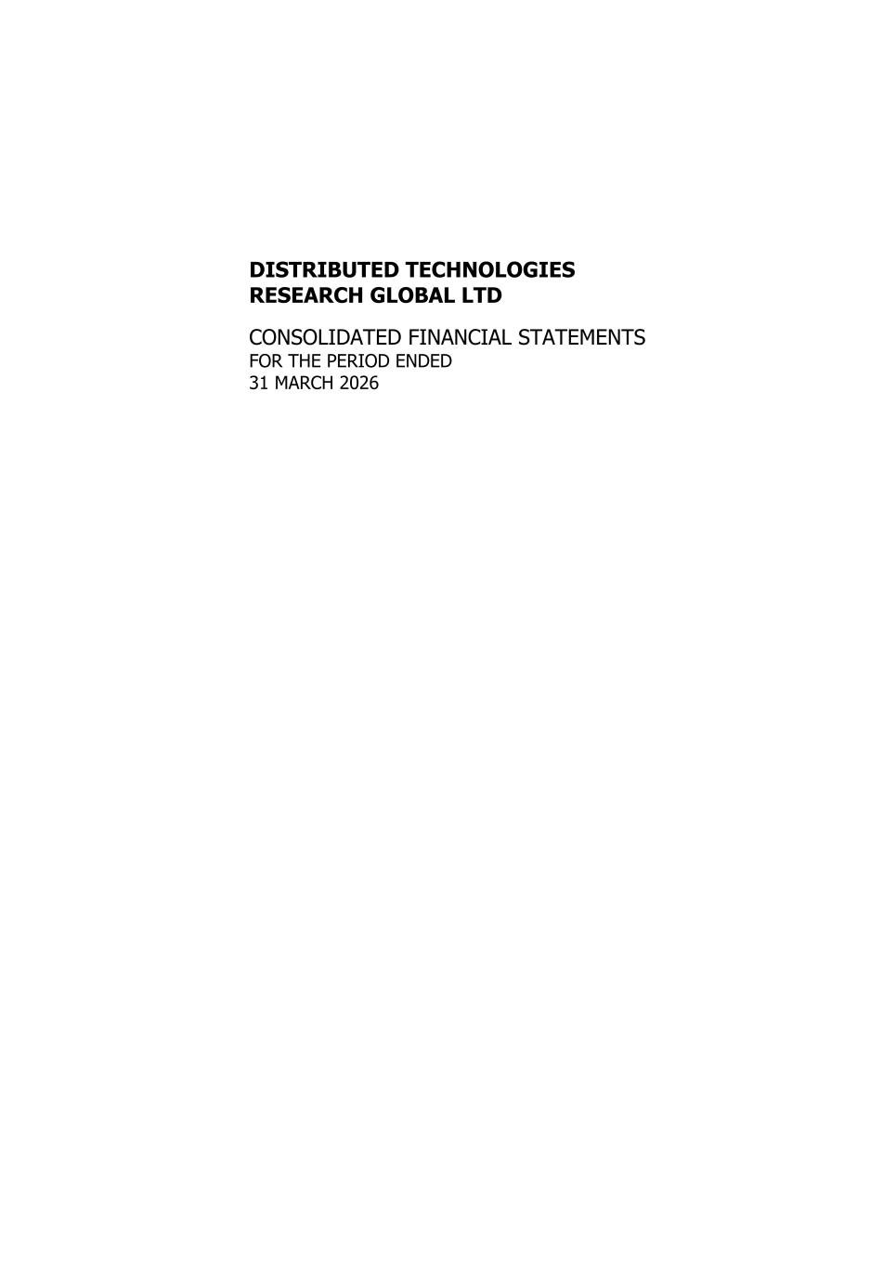
DISTRIBUTED TECHNOLOGIES RESEARCH GLOBAL LTD CONSOLIDATED FINANCIAL STATEMENTS FOR THE PERIOD ENDED 31 MARCH 2026

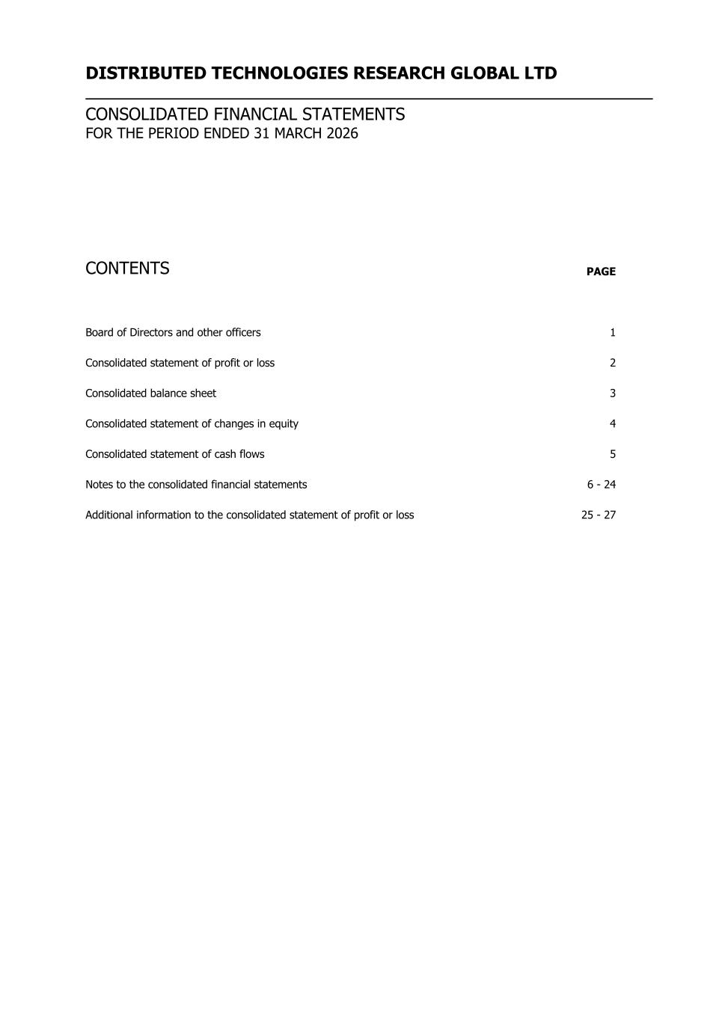
DISTRIBUTED TECHNOLOGIES RESEARCH GLOBAL LTD CONSOLIDATED FINANCIAL STATEMENTS FOR THE PERIOD ENDED 31 MARCH 2026 CONTENTS PAGE Board of Directors and other officers 1 Consolidated statement of profit or loss 2 Consolidated balance sheet 3 Consolidated statement of changes in equity 4 Consolidated statement of cash flows 5 Notes to the consolidated financial statements 6 - 24 Additional information to the consolidated statement of profit or loss 25 - 27

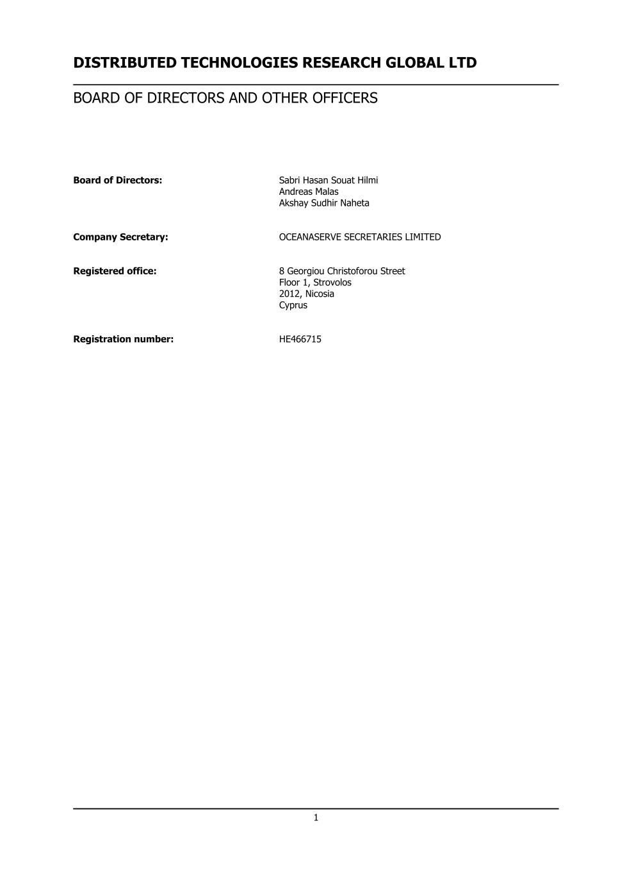
DISTRIBUTED TECHNOLOGIES RESEARCH GLOBAL LTD BOARD OF DIRECTORS AND OTHER OFFICERS Board of Directors: Sabri Hasan Souat Hilmi Andreas Malas Akshay Sudhir Naheta Company Secretary: OCEANASERVE SECRETARIES LIMITED Registered office: 8 Georgiou Christoforou Street Floor 1, Strovolos 2012, Nicosia Cyprus Registration number: ΗΕ466715 1

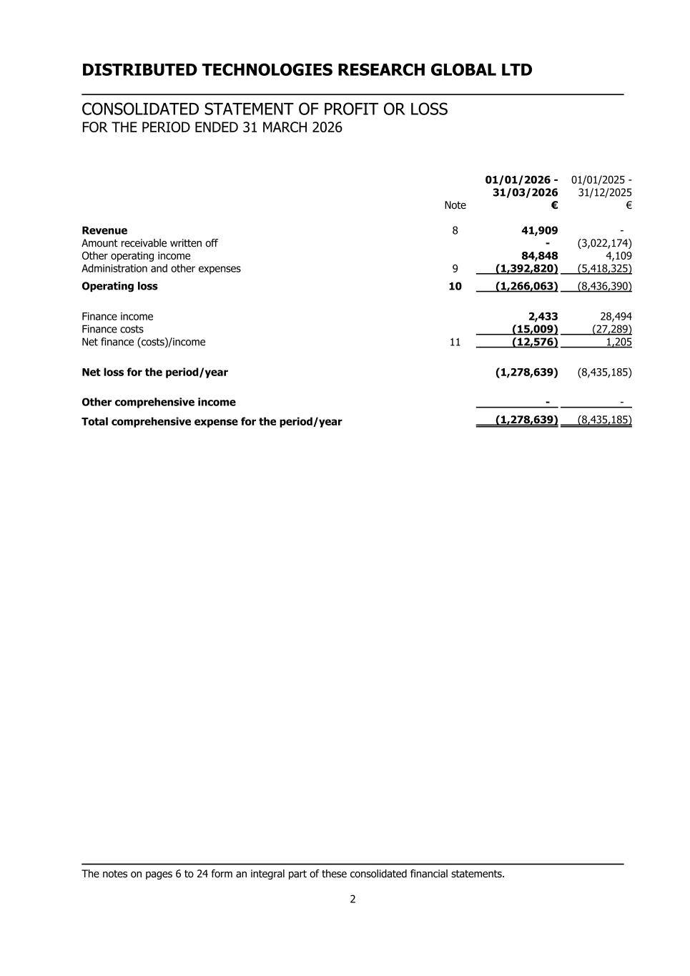
DISTRIBUTED TECHNOLOGIES RESEARCH GLOBAL LTD CONSOLIDATED STATEMENT OF PROFIT OR LOSS FOR THE PERIOD ENDED 31 MARCH 2026 01/01/2026 - 31/03/2026 01/01/2025 - 31/12/2025 Note € € Revenue 8 41,909 - Amount receivable written off - (3,022,174) Other operating income 84,848 4,109 Administration and other expenses 9 (1,392,820) (5,418,325) Operating loss 10 (1,266,063) (8,436,390) Finance income 2,433 28,494 Finance costs (15,009) (27,289) Net finance (costs)/income 11 (12,576) 1,205 Net loss for the period/year (1,278,639) (8,435,185) Other comprehensive income - - Total comprehensive expense for the period/year (1,278,639) (8,435,185) The notes on pages 6 to 24 form an integral part of these consolidated financial statements. 2

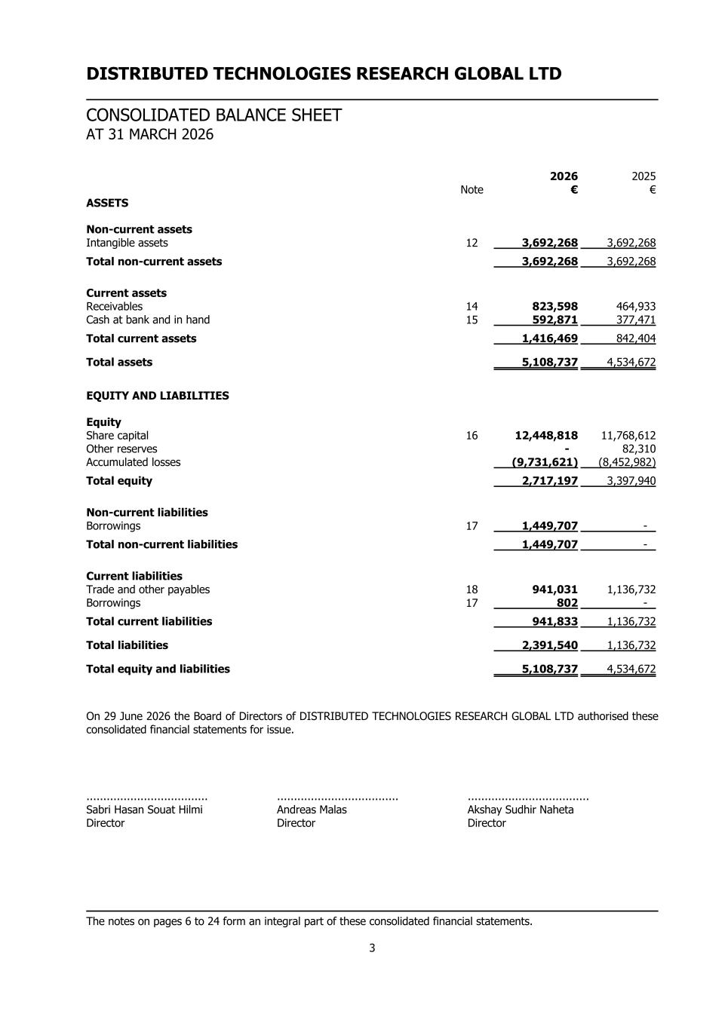
DISTRIBUTED TECHNOLOGIES RESEARCH GLOBAL LTD CONSOLIDATED BALANCE SHEET AT 31 MARCH 2026 2026 2025 Note € € ASSETS Non-current assets Intangible assets 12 3,692,268 3,692,268 Total non-current assets 3,692,268 3,692,268 Current assets Receivables 14 823,598 464,933 Cash at bank and in hand 15 592,871 377,471 Total current assets 1,416,469 842,404 Total assets 5,108,737 4,534,672 EQUITY AND LIABILITIES Equity Share capital 16 12,448,818 11,768,612 Other reserves - 82,310 Accumulated losses (9,731,621) (8,452,982) Total equity 2,717,197 3,397,940 Non-current liabilities Borrowings 17 1,449,707 - Total non-current liabilities 1,449,707 - Current liabilities Trade and other payables 18 941,031 1,136,732 Borrowings 17 802 - Total current liabilities 941,833 1,136,732 Total liabilities 2,391,540 1,136,732 Total equity and liabilities 5,108,737 4,534,672 On 29 June 2026 the Board of Directors of DISTRIBUTED TECHNOLOGIES RESEARCH GLOBAL LTD authorised these consolidated financial statements for issue. .................................... .................................... .................................... Sabri Hasan Souat Hilmi Andreas Malas Akshay Sudhir Naheta Director Director Director The notes on pages 6 to 24 form an integral part of these consolidated financial statements. 3

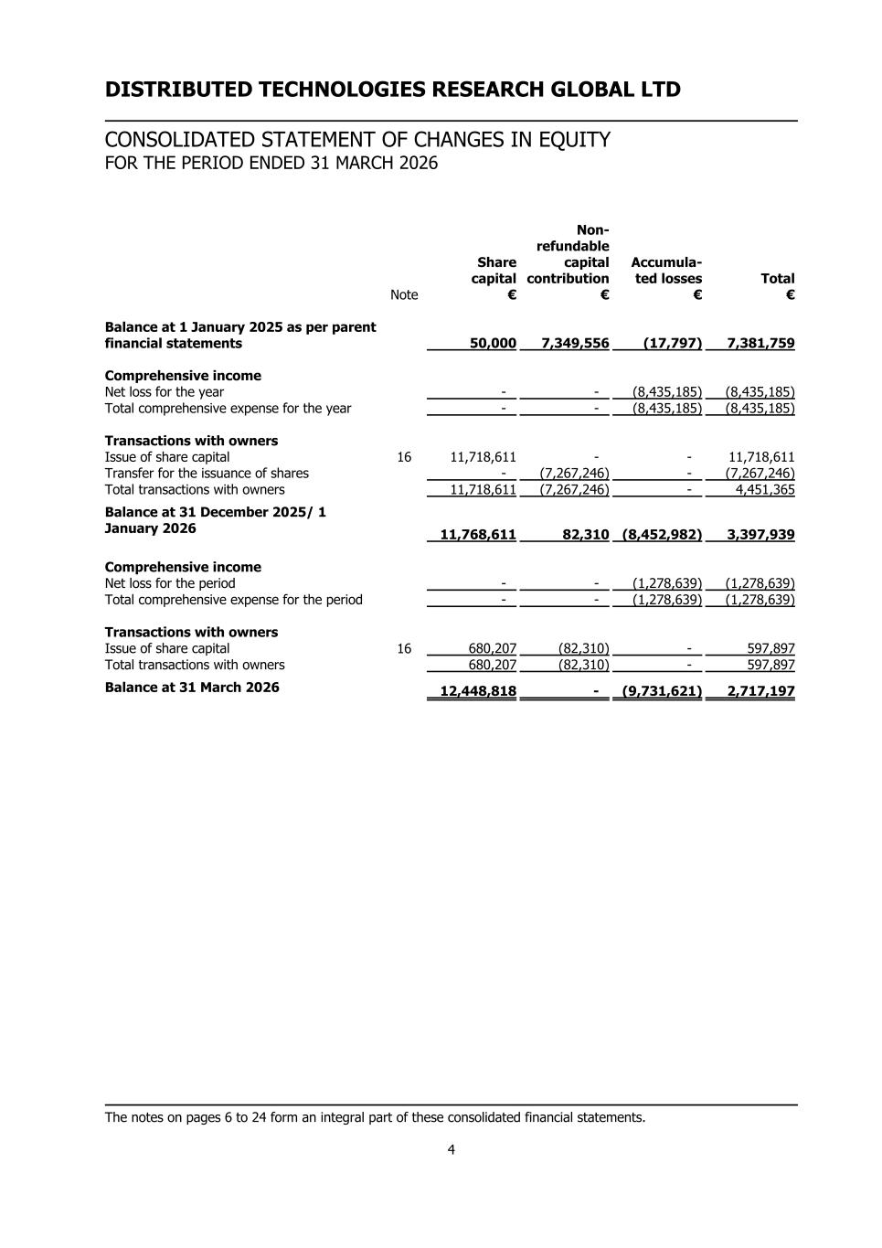
DISTRIBUTED TECHNOLOGIES RESEARCH GLOBAL LTD CONSOLIDATED STATEMENT OF CHANGES IN EQUITY FOR THE PERIOD ENDED 31 MARCH 2026 Share capital Non- refundable capital contribution Accumula- ted losses Total Note € € € € Balance at 1 January 2025 as per parent financial statements 50,000 7,349,556 (17,797) 7,381,759 Comprehensive income Net loss for the year - - (8,435,185) (8,435,185) Total comprehensive expense for the year - - (8,435,185) (8,435,185) Transactions with owners Issue of share capital 16 11,718,611 - - 11,718,611 Transfer for the issuance of shares - (7,267,246) - (7,267,246) Total transactions with owners 11,718,611 (7,267,246) - 4,451,365 Balance at 31 December 2025/ 1 January 2026 11,768,611 82,310 (8,452,982) 3,397,939 Comprehensive income Net loss for the period - - (1,278,639) (1,278,639) Total comprehensive expense for the period - - (1,278,639) (1,278,639) Transactions with owners Issue of share capital 16 680,207 (82,310) - 597,897 Total transactions with owners 680,207 (82,310) - 597,897 Balance at 31 March 2026 12,448,818 - (9,731,621) 2,717,197 The notes on pages 6 to 24 form an integral part of these consolidated financial statements. 4

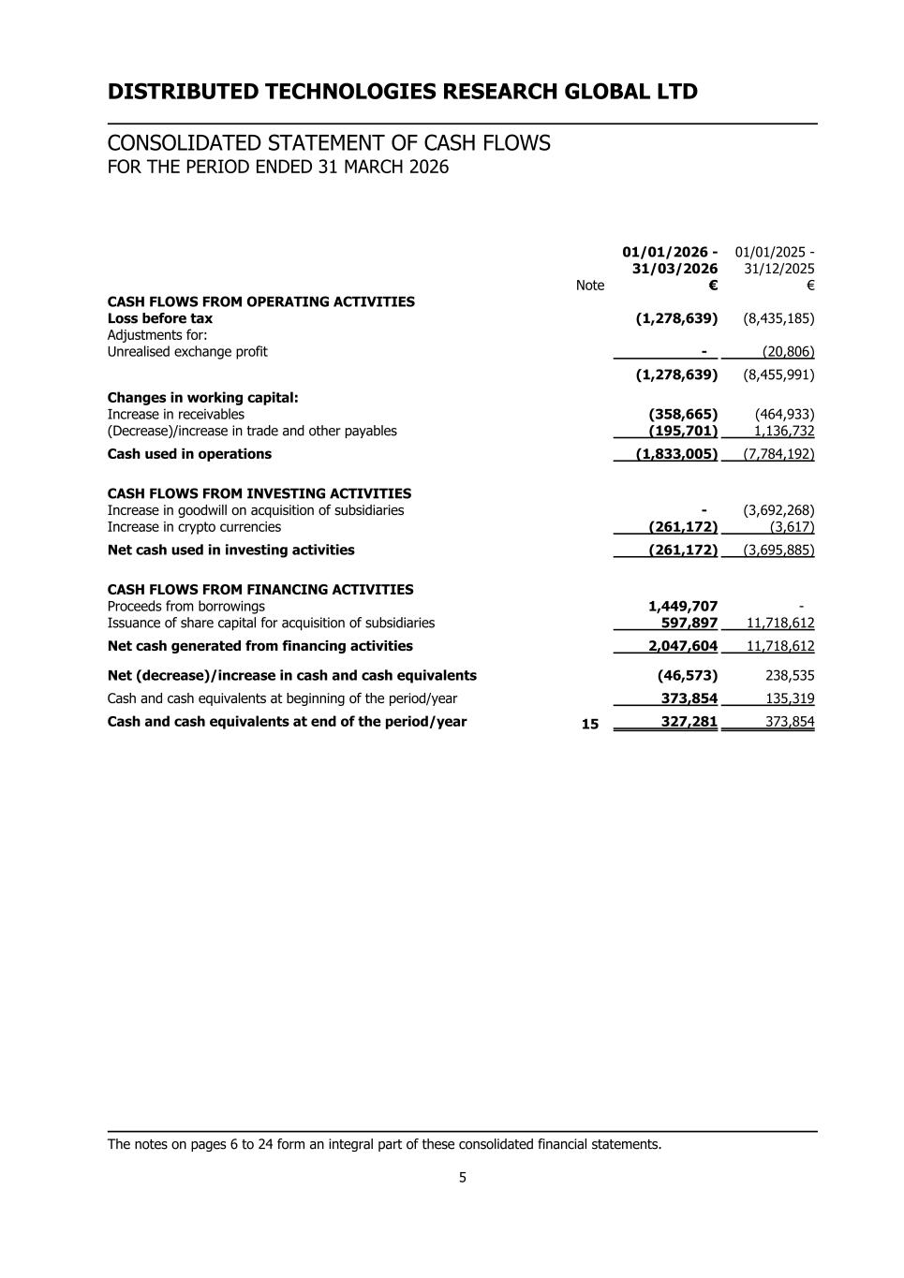
DISTRIBUTED TECHNOLOGIES RESEARCH GLOBAL LTD CONSOLIDATED STATEMENT OF CASH FLOWS FOR THE PERIOD ENDED 31 MARCH 2026 01/01/2026 - 31/03/2026 01/01/2025 - 31/12/2025 Note € € CASH FLOWS FROM OPERATING ACTIVITIES Loss before tax (1,278,639) (8,435,185) Adjustments for: Unrealised exchange profit - (20,806) (1,278,639) (8,455,991) Changes in working capital: Increase in receivables (358,665) (464,933) (Decrease)/increase in trade and other payables (195,701) 1,136,732 Cash used in operations (1,833,005) (7,784,192) CASH FLOWS FROM INVESTING ACTIVITIES Increase in goodwill on acquisition of subsidiaries - (3,692,268) Increase in crypto currencies (261,172) (3,617) Net cash used in investing activities (261,172) (3,695,885) CASH FLOWS FROM FINANCING ACTIVITIES Proceeds from borrowings 1,449,707 - Issuance of share capital for acquisition of subsidiaries 597,897 11,718,612 Net cash generated from financing activities 2,047,604 11,718,612 Net (decrease)/increase in cash and cash equivalents (46,573) 238,535 Cash and cash equivalents at beginning of the period/year 373,854 135,319 Cash and cash equivalents at end of the period/year 15 327,281 373,854 The notes on pages 6 to 24 form an integral part of these consolidated financial statements. 5

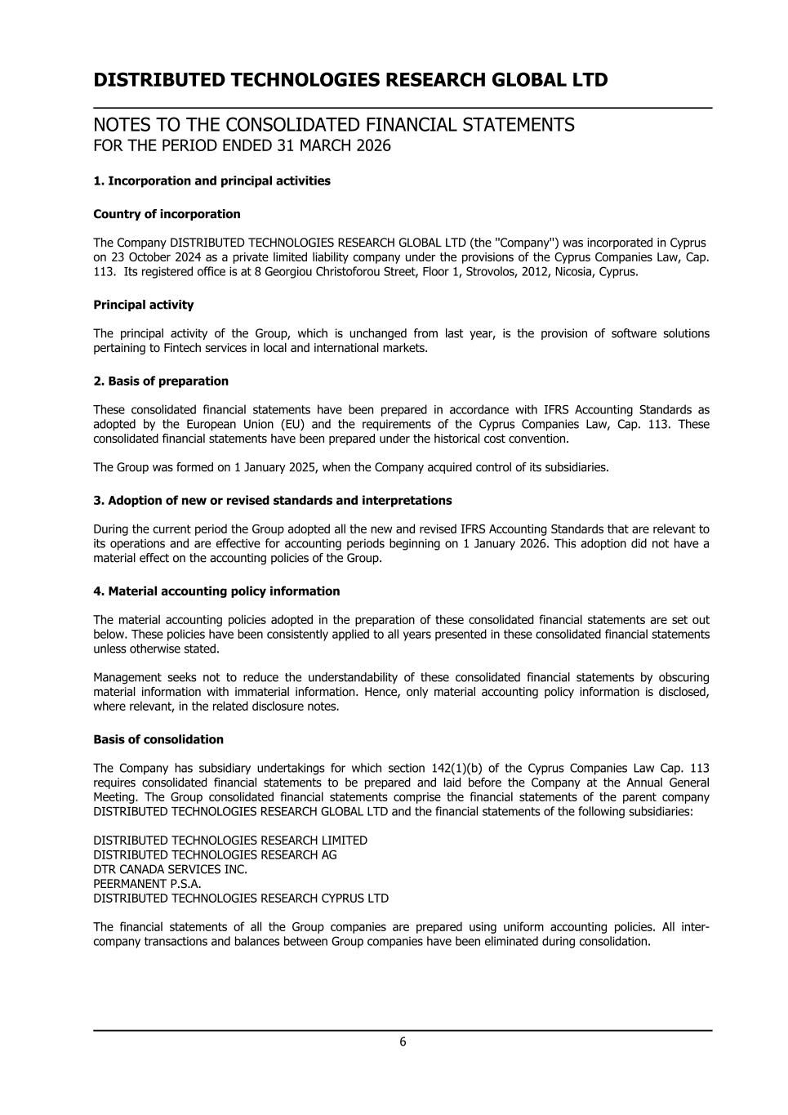
DISTRIBUTED TECHNOLOGIES RESEARCH GLOBAL LTD NOTES TO THE CONSOLIDATED FINANCIAL STATEMENTS FOR THE PERIOD ENDED 31 MARCH 2026 1. Incorporation and principal activities Country of incorporation The Company DISTRIBUTED TECHNOLOGIES RESEARCH GLOBAL LTD (the ''Company'') was incorporated in Cyprus on 23 October 2024 as a private limited liability company under the provisions of the Cyprus Companies Law, Cap. 113. Its registered office is at 8 Georgiou Christoforou Street, Floor 1, Strovolos, 2012, Nicosia, Cyprus. Principal activity The principal activity of the Group, which is unchanged from last year, is the provision of software solutions pertaining to Fintech services in local and international markets. 2. Basis of preparation These consolidated financial statements have been prepared in accordance with IFRS Accounting Standards as adopted by the European Union (EU) and the requirements of the Cyprus Companies Law, Cap. 113. These consolidated financial statements have been prepared under the historical cost convention. The Group was formed on 1 January 2025, when the Company acquired control of its subsidiaries. 3. Adoption of new or revised standards and interpretations During the current period the Group adopted all the new and revised IFRS Accounting Standards that are relevant to its operations and are effective for accounting periods beginning on 1 January 2026. This adoption did not have a material effect on the accounting policies of the Group. 4. Material accounting policy information The material accounting policies adopted in the preparation of these consolidated financial statements are set out below. These policies have been consistently applied to all years presented in these consolidated financial statements unless otherwise stated. Management seeks not to reduce the understandability of these consolidated financial statements by obscuring material information with immaterial information. Hence, only material accounting policy information is disclosed, where relevant, in the related disclosure notes. Basis of consolidation The Company has subsidiary undertakings for which section 142(1)(b) of the Cyprus Companies Law Cap. 113 requires consolidated financial statements to be prepared and laid before the Company at the Annual General Meeting. The Group consolidated financial statements comprise the financial statements of the parent company DISTRIBUTED TECHNOLOGIES RESEARCH GLOBAL LTD and the financial statements of the following subsidiaries: DISTRIBUTED TECHNOLOGIES RESEARCH LIMITED DISTRIBUTED TECHNOLOGIES RESEARCH AG DTR CANADA SERVICES INC. PEERMANENT P.S.A. DISTRIBUTED TECHNOLOGIES RESEARCH CYPRUS LTD The financial statements of all the Group companies are prepared using uniform accounting policies. All inter- company transactions and balances between Group companies have been eliminated during consolidation. 6

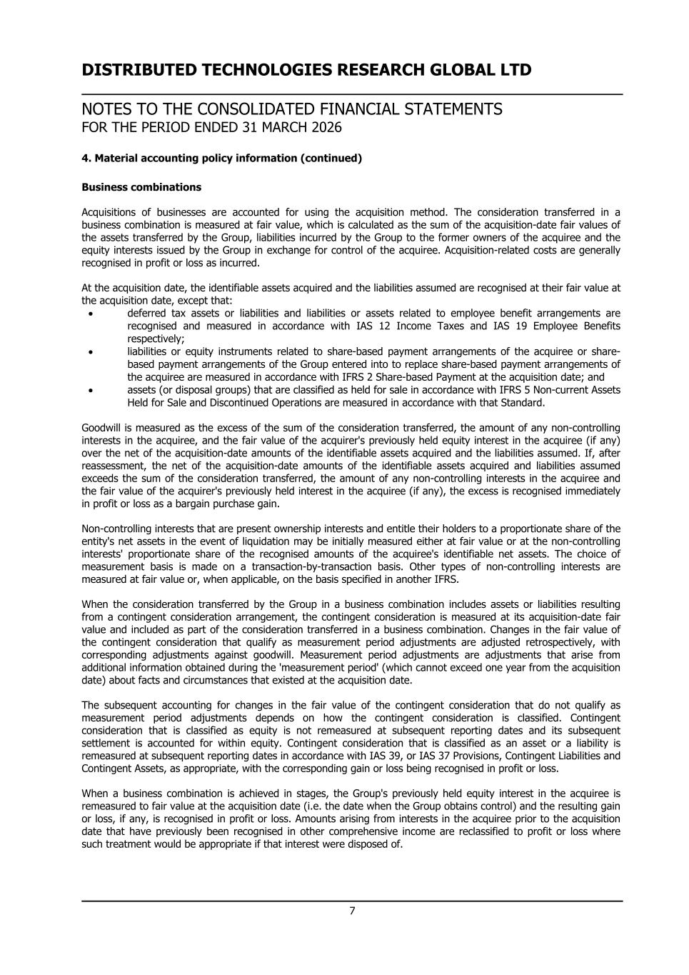
DISTRIBUTED TECHNOLOGIES RESEARCH GLOBAL LTD NOTES TO THE CONSOLIDATED FINANCIAL STATEMENTS FOR THE PERIOD ENDED 31 MARCH 2026 4. Material accounting policy information (continued) Business combinations Acquisitions of businesses are accounted for using the acquisition method. The consideration transferred in a business combination is measured at fair value, which is calculated as the sum of the acquisition-date fair values of the assets transferred by the Group, liabilities incurred by the Group to the former owners of the acquiree and the equity interests issued by the Group in exchange for control of the acquiree. Acquisition-related costs are generally recognised in profit or loss as incurred. At the acquisition date, the identifiable assets acquired and the liabilities assumed are recognised at their fair value at the acquisition date, except that: • deferred tax assets or liabilities and liabilities or assets related to employee benefit arrangements are recognised and measured in accordance with IAS 12 Income Taxes and IAS 19 Employee Benefits respectively; • liabilities or equity instruments related to share-based payment arrangements of the acquiree or share- based payment arrangements of the Group entered into to replace share-based payment arrangements of the acquiree are measured in accordance with IFRS 2 Share-based Payment at the acquisition date; and • assets (or disposal groups) that are classified as held for sale in accordance with IFRS 5 Non-current Assets Held for Sale and Discontinued Operations are measured in accordance with that Standard. Goodwill is measured as the excess of the sum of the consideration transferred, the amount of any non-controlling interests in the acquiree, and the fair value of the acquirer's previously held equity interest in the acquiree (if any) over the net of the acquisition-date amounts of the identifiable assets acquired and the liabilities assumed. If, after reassessment, the net of the acquisition-date amounts of the identifiable assets acquired and liabilities assumed exceeds the sum of the consideration transferred, the amount of any non-controlling interests in the acquiree and the fair value of the acquirer's previously held interest in the acquiree (if any), the excess is recognised immediately in profit or loss as a bargain purchase gain. Non-controlling interests that are present ownership interests and entitle their holders to a proportionate share of the entity's net assets in the event of liquidation may be initially measured either at fair value or at the non-controlling interests' proportionate share of the recognised amounts of the acquiree's identifiable net assets. The choice of measurement basis is made on a transaction-by-transaction basis. Other types of non-controlling interests are measured at fair value or, when applicable, on the basis specified in another IFRS. When the consideration transferred by the Group in a business combination includes assets or liabilities resulting from a contingent consideration arrangement, the contingent consideration is measured at its acquisition-date fair value and included as part of the consideration transferred in a business combination. Changes in the fair value of the contingent consideration that qualify as measurement period adjustments are adjusted retrospectively, with corresponding adjustments against goodwill. Measurement period adjustments are adjustments that arise from additional information obtained during the 'measurement period' (which cannot exceed one year from the acquisition date) about facts and circumstances that existed at the acquisition date. The subsequent accounting for changes in the fair value of the contingent consideration that do not qualify as measurement period adjustments depends on how the contingent consideration is classified. Contingent consideration that is classified as equity is not remeasured at subsequent reporting dates and its subsequent settlement is accounted for within equity. Contingent consideration that is classified as an asset or a liability is remeasured at subsequent reporting dates in accordance with IAS 39, or IAS 37 Provisions, Contingent Liabilities and Contingent Assets, as appropriate, with the corresponding gain or loss being recognised in profit or loss. When a business combination is achieved in stages, the Group's previously held equity interest in the acquiree is remeasured to fair value at the acquisition date (i.e. the date when the Group obtains control) and the resulting gain or loss, if any, is recognised in profit or loss. Amounts arising from interests in the acquiree prior to the acquisition date that have previously been recognised in other comprehensive income are reclassified to profit or loss where such treatment would be appropriate if that interest were disposed of. 7

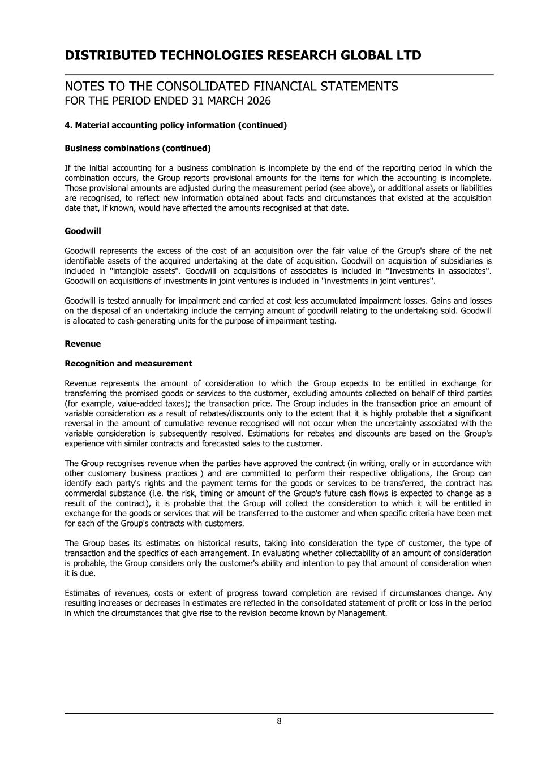
DISTRIBUTED TECHNOLOGIES RESEARCH GLOBAL LTD NOTES TO THE CONSOLIDATED FINANCIAL STATEMENTS FOR THE PERIOD ENDED 31 MARCH 2026 4. Material accounting policy information (continued) Business combinations (continued) If the initial accounting for a business combination is incomplete by the end of the reporting period in which the combination occurs, the Group reports provisional amounts for the items for which the accounting is incomplete. Those provisional amounts are adjusted during the measurement period (see above), or additional assets or liabilities are recognised, to reflect new information obtained about facts and circumstances that existed at the acquisition date that, if known, would have affected the amounts recognised at that date. Goodwill Goodwill represents the excess of the cost of an acquisition over the fair value of the Group's share of the net identifiable assets of the acquired undertaking at the date of acquisition. Goodwill on acquisition of subsidiaries is included in ''intangible assets''. Goodwill on acquisitions of associates is included in ''Investments in associates''. Goodwill on acquisitions of investments in joint ventures is included in ''investments in joint ventures''. Goodwill is tested annually for impairment and carried at cost less accumulated impairment losses. Gains and losses on the disposal of an undertaking include the carrying amount of goodwill relating to the undertaking sold. Goodwill is allocated to cash-generating units for the purpose of impairment testing. Revenue Recognition and measurement Revenue represents the amount of consideration to which the Group expects to be entitled in exchange for transferring the promised goods or services to the customer, excluding amounts collected on behalf of third parties (for example, value-added taxes); the transaction price. The Group includes in the transaction price an amount of variable consideration as a result of rebates/discounts only to the extent that it is highly probable that a significant reversal in the amount of cumulative revenue recognised will not occur when the uncertainty associated with the variable consideration is subsequently resolved. Estimations for rebates and discounts are based on the Group's experience with similar contracts and forecasted sales to the customer. The Group recognises revenue when the parties have approved the contract (in writing, orally or in accordance with other customary business practices ) and are committed to perform their respective obligations, the Group can identify each party's rights and the payment terms for the goods or services to be transferred, the contract has commercial substance (i.e. the risk, timing or amount of the Group's future cash flows is expected to change as a result of the contract), it is probable that the Group will collect the consideration to which it will be entitled in exchange for the goods or services that will be transferred to the customer and when specific criteria have been met for each of the Group's contracts with customers. The Group bases its estimates on historical results, taking into consideration the type of customer, the type of transaction and the specifics of each arrangement. In evaluating whether collectability of an amount of consideration is probable, the Group considers only the customer's ability and intention to pay that amount of consideration when it is due. Estimates of revenues, costs or extent of progress toward completion are revised if circumstances change. Any resulting increases or decreases in estimates are reflected in the consolidated statement of profit or loss in the period in which the circumstances that give rise to the revision become known by Management. 8

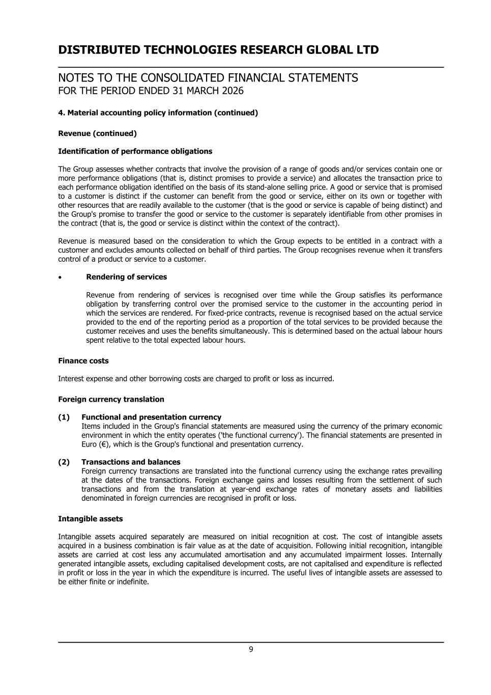
DISTRIBUTED TECHNOLOGIES RESEARCH GLOBAL LTD NOTES TO THE CONSOLIDATED FINANCIAL STATEMENTS FOR THE PERIOD ENDED 31 MARCH 2026 4. Material accounting policy information (continued) Revenue (continued) Identification of performance obligations The Group assesses whether contracts that involve the provision of a range of goods and/or services contain one or more performance obligations (that is, distinct promises to provide a service) and allocates the transaction price to each performance obligation identified on the basis of its stand-alone selling price. A good or service that is promised to a customer is distinct if the customer can benefit from the good or service, either on its own or together with other resources that are readily available to the customer (that is the good or service is capable of being distinct) and the Group's promise to transfer the good or service to the customer is separately identifiable from other promises in the contract (that is, the good or service is distinct within the context of the contract). Revenue is measured based on the consideration to which the Group expects to be entitled in a contract with a customer and excludes amounts collected on behalf of third parties. The Group recognises revenue when it transfers control of a product or service to a customer. • Rendering of services Revenue from rendering of services is recognised over time while the Group satisfies its performance obligation by transferring control over the promised service to the customer in the accounting period in which the services are rendered. For fixed-price contracts, revenue is recognised based on the actual service provided to the end of the reporting period as a proportion of the total services to be provided because the customer receives and uses the benefits simultaneously. This is determined based on the actual labour hours spent relative to the total expected labour hours. Finance costs Interest expense and other borrowing costs are charged to profit or loss as incurred. Foreign currency translation (1) Functional and presentation currency Items included in the Group's financial statements are measured using the currency of the primary economic environment in which the entity operates ('the functional currency'). The financial statements are presented in Euro (€), which is the Group's functional and presentation currency. (2) Transactions and balances Foreign currency transactions are translated into the functional currency using the exchange rates prevailing at the dates of the transactions. Foreign exchange gains and losses resulting from the settlement of such transactions and from the translation at year-end exchange rates of monetary assets and liabilities denominated in foreign currencies are recognised in profit or loss. Intangible assets Intangible assets acquired separately are measured on initial recognition at cost. The cost of intangible assets acquired in a business combination is fair value as at the date of acquisition. Following initial recognition, intangible assets are carried at cost less any accumulated amortisation and any accumulated impairment losses. Internally generated intangible assets, excluding capitalised development costs, are not capitalised and expenditure is reflected in profit or loss in the year in which the expenditure is incurred. The useful lives of intangible assets are assessed to be either finite or indefinite. 9

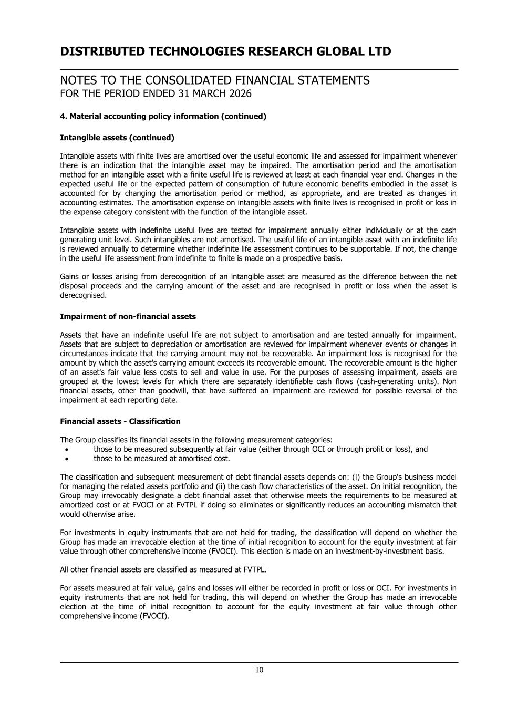
DISTRIBUTED TECHNOLOGIES RESEARCH GLOBAL LTD NOTES TO THE CONSOLIDATED FINANCIAL STATEMENTS FOR THE PERIOD ENDED 31 MARCH 2026 4. Material accounting policy information (continued) Intangible assets (continued) Intangible assets with finite lives are amortised over the useful economic life and assessed for impairment whenever there is an indication that the intangible asset may be impaired. The amortisation period and the amortisation method for an intangible asset with a finite useful life is reviewed at least at each financial year end. Changes in the expected useful life or the expected pattern of consumption of future economic benefits embodied in the asset is accounted for by changing the amortisation period or method, as appropriate, and are treated as changes in accounting estimates. The amortisation expense on intangible assets with finite lives is recognised in profit or loss in the expense category consistent with the function of the intangible asset. Intangible assets with indefinite useful lives are tested for impairment annually either individually or at the cash generating unit level. Such intangibles are not amortised. The useful life of an intangible asset with an indefinite life is reviewed annually to determine whether indefinite life assessment continues to be supportable. If not, the change in the useful life assessment from indefinite to finite is made on a prospective basis. Gains or losses arising from derecognition of an intangible asset are measured as the difference between the net disposal proceeds and the carrying amount of the asset and are recognised in profit or loss when the asset is derecognised. Impairment of non-financial assets Assets that have an indefinite useful life are not subject to amortisation and are tested annually for impairment. Assets that are subject to depreciation or amortisation are reviewed for impairment whenever events or changes in circumstances indicate that the carrying amount may not be recoverable. An impairment loss is recognised for the amount by which the asset's carrying amount exceeds its recoverable amount. The recoverable amount is the higher of an asset's fair value less costs to sell and value in use. For the purposes of assessing impairment, assets are grouped at the lowest levels for which there are separately identifiable cash flows (cash-generating units). Non financial assets, other than goodwill, that have suffered an impairment are reviewed for possible reversal of the impairment at each reporting date. Financial assets - Classification The Group classifies its financial assets in the following measurement categories: • those to be measured subsequently at fair value (either through OCI or through profit or loss), and • those to be measured at amortised cost. The classification and subsequent measurement of debt financial assets depends on: (i) the Group's business model for managing the related assets portfolio and (ii) the cash flow characteristics of the asset. On initial recognition, the Group may irrevocably designate a debt financial asset that otherwise meets the requirements to be measured at amortized cost or at FVOCI or at FVTPL if doing so eliminates or significantly reduces an accounting mismatch that would otherwise arise. For investments in equity instruments that are not held for trading, the classification will depend on whether the Group has made an irrevocable election at the time of initial recognition to account for the equity investment at fair value through other comprehensive income (FVOCI). This election is made on an investment-by-investment basis. All other financial assets are classified as measured at FVTPL. For assets measured at fair value, gains and losses will either be recorded in profit or loss or OCI. For investments in equity instruments that are not held for trading, this will depend on whether the Group has made an irrevocable election at the time of initial recognition to account for the equity investment at fair value through other comprehensive income (FVOCI). 10

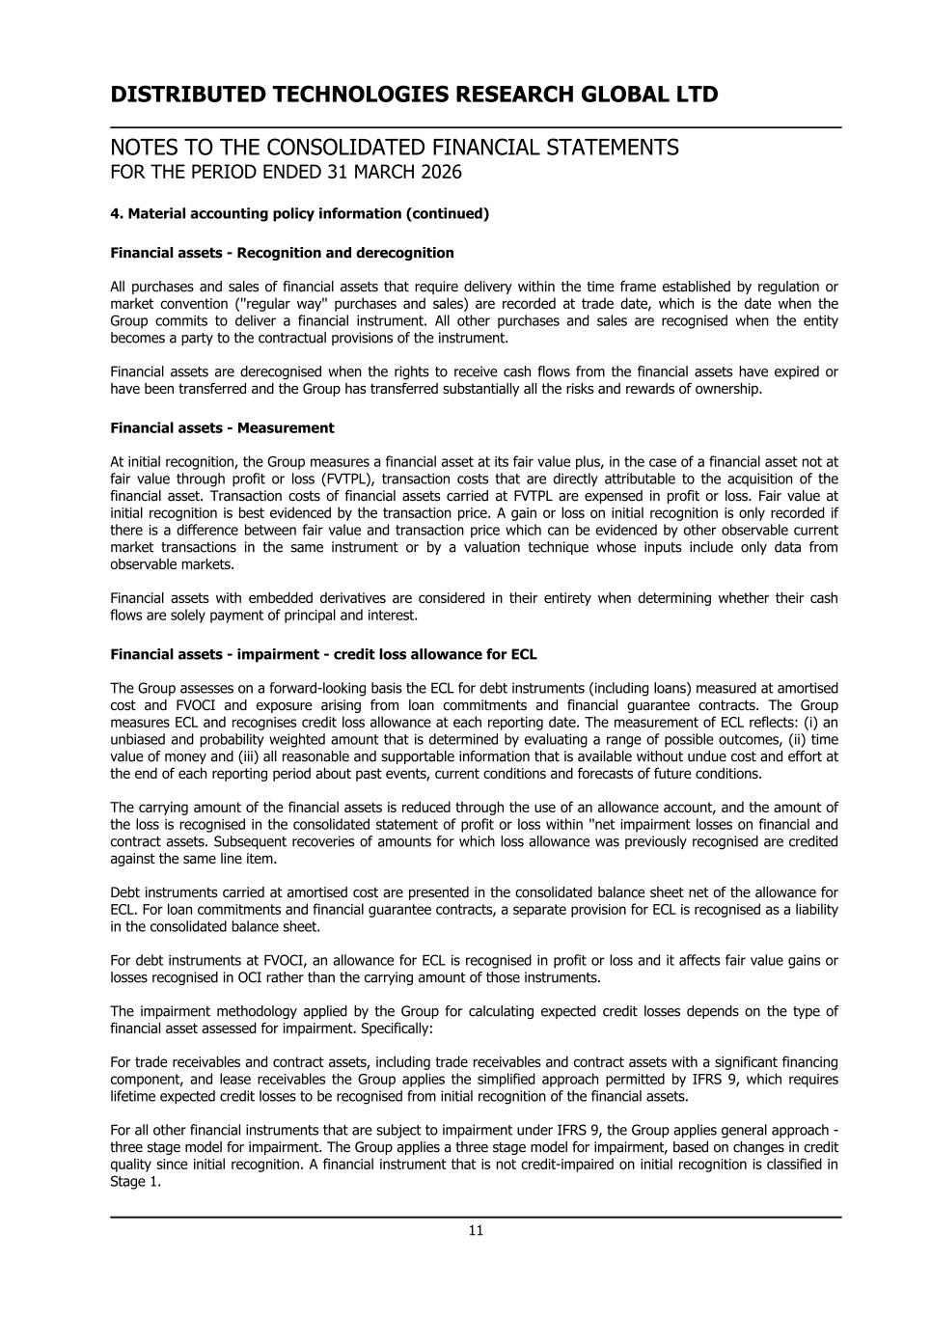
DISTRIBUTED TECHNOLOGIES RESEARCH GLOBAL LTD NOTES TO THE CONSOLIDATED FINANCIAL STATEMENTS FOR THE PERIOD ENDED 31 MARCH 2026 4. Material accounting policy information (continued) Financial assets - Recognition and derecognition All purchases and sales of financial assets that require delivery within the time frame established by regulation or market convention (''regular way'' purchases and sales) are recorded at trade date, which is the date when the Group commits to deliver a financial instrument. All other purchases and sales are recognised when the entity becomes a party to the contractual provisions of the instrument. Financial assets are derecognised when the rights to receive cash flows from the financial assets have expired or have been transferred and the Group has transferred substantially all the risks and rewards of ownership. Financial assets - Measurement At initial recognition, the Group measures a financial asset at its fair value plus, in the case of a financial asset not at fair value through profit or loss (FVTPL), transaction costs that are directly attributable to the acquisition of the financial asset. Transaction costs of financial assets carried at FVTPL are expensed in profit or loss. Fair value at initial recognition is best evidenced by the transaction price. A gain or loss on initial recognition is only recorded if there is a difference between fair value and transaction price which can be evidenced by other observable current market transactions in the same instrument or by a valuation technique whose inputs include only data from observable markets. Financial assets with embedded derivatives are considered in their entirety when determining whether their cash flows are solely payment of principal and interest. Financial assets - impairment - credit loss allowance for ECL The Group assesses on a forward-looking basis the ECL for debt instruments (including loans) measured at amortised cost and FVOCI and exposure arising from loan commitments and financial guarantee contracts. The Group measures ECL and recognises credit loss allowance at each reporting date. The measurement of ECL reflects: (i) an unbiased and probability weighted amount that is determined by evaluating a range of possible outcomes, (ii) time value of money and (iii) all reasonable and supportable information that is available without undue cost and effort at the end of each reporting period about past events, current conditions and forecasts of future conditions. The carrying amount of the financial assets is reduced through the use of an allowance account, and the amount of the loss is recognised in the consolidated statement of profit or loss within ''net impairment losses on financial and contract assets. Subsequent recoveries of amounts for which loss allowance was previously recognised are credited against the same line item. Debt instruments carried at amortised cost are presented in the consolidated balance sheet net of the allowance for ECL. For loan commitments and financial guarantee contracts, a separate provision for ECL is recognised as a liability in the consolidated balance sheet. For debt instruments at FVOCI, an allowance for ECL is recognised in profit or loss and it affects fair value gains or losses recognised in OCI rather than the carrying amount of those instruments. The impairment methodology applied by the Group for calculating expected credit losses depends on the type of financial asset assessed for impairment. Specifically: For trade receivables and contract assets, including trade receivables and contract assets with a significant financing component, and lease receivables the Group applies the simplified approach permitted by IFRS 9, which requires lifetime expected credit losses to be recognised from initial recognition of the financial assets. For all other financial instruments that are subject to impairment under IFRS 9, the Group applies general approach - three stage model for impairment. The Group applies a three stage model for impairment, based on changes in credit quality since initial recognition. A financial instrument that is not credit-impaired on initial recognition is classified in Stage 1. 11

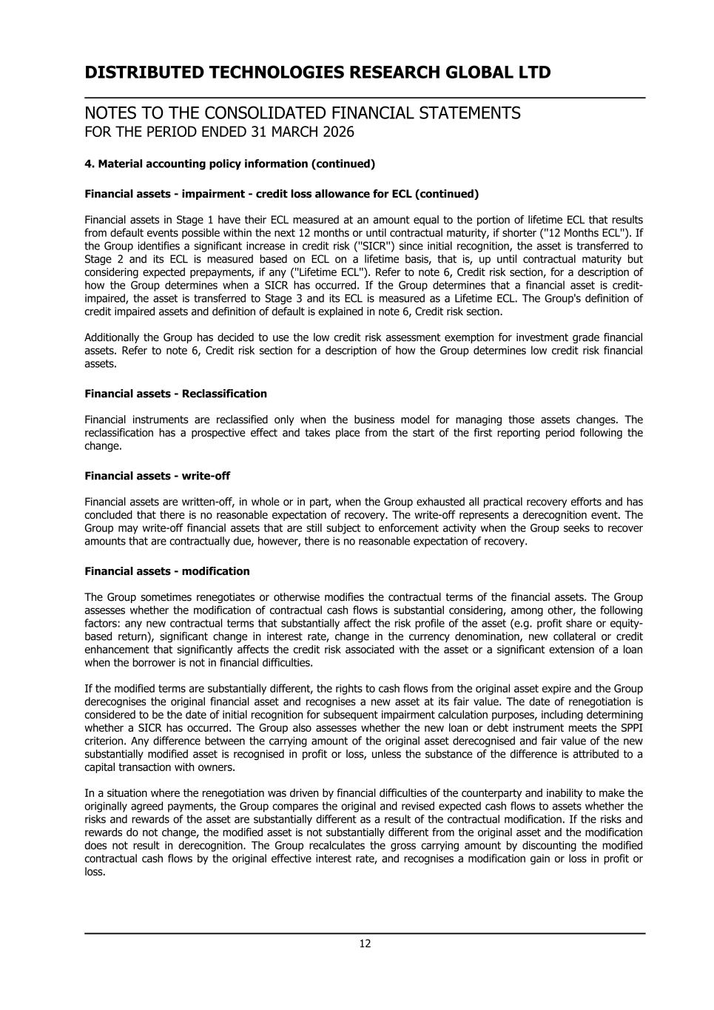
DISTRIBUTED TECHNOLOGIES RESEARCH GLOBAL LTD NOTES TO THE CONSOLIDATED FINANCIAL STATEMENTS FOR THE PERIOD ENDED 31 MARCH 2026 4. Material accounting policy information (continued) Financial assets - impairment - credit loss allowance for ECL (continued) Financial assets in Stage 1 have their ECL measured at an amount equal to the portion of lifetime ECL that results from default events possible within the next 12 months or until contractual maturity, if shorter (''12 Months ECL''). If the Group identifies a significant increase in credit risk (''SICR'') since initial recognition, the asset is transferred to Stage 2 and its ECL is measured based on ECL on a lifetime basis, that is, up until contractual maturity but considering expected prepayments, if any (''Lifetime ECL''). Refer to note 6, Credit risk section, for a description of how the Group determines when a SICR has occurred. If the Group determines that a financial asset is credit- impaired, the asset is transferred to Stage 3 and its ECL is measured as a Lifetime ECL. The Group's definition of credit impaired assets and definition of default is explained in note 6, Credit risk section. Additionally the Group has decided to use the low credit risk assessment exemption for investment grade financial assets. Refer to note 6, Credit risk section for a description of how the Group determines low credit risk financial assets. Financial assets - Reclassification Financial instruments are reclassified only when the business model for managing those assets changes. The reclassification has a prospective effect and takes place from the start of the first reporting period following the change. Financial assets - write-off Financial assets are written-off, in whole or in part, when the Group exhausted all practical recovery efforts and has concluded that there is no reasonable expectation of recovery. The write-off represents a derecognition event. The Group may write-off financial assets that are still subject to enforcement activity when the Group seeks to recover amounts that are contractually due, however, there is no reasonable expectation of recovery. Financial assets - modification The Group sometimes renegotiates or otherwise modifies the contractual terms of the financial assets. The Group assesses whether the modification of contractual cash flows is substantial considering, among other, the following factors: any new contractual terms that substantially affect the risk profile of the asset (e.g. profit share or equity- based return), significant change in interest rate, change in the currency denomination, new collateral or credit enhancement that significantly affects the credit risk associated with the asset or a significant extension of a loan when the borrower is not in financial difficulties. If the modified terms are substantially different, the rights to cash flows from the original asset expire and the Group derecognises the original financial asset and recognises a new asset at its fair value. The date of renegotiation is considered to be the date of initial recognition for subsequent impairment calculation purposes, including determining whether a SICR has occurred. The Group also assesses whether the new loan or debt instrument meets the SPPI criterion. Any difference between the carrying amount of the original asset derecognised and fair value of the new substantially modified asset is recognised in profit or loss, unless the substance of the difference is attributed to a capital transaction with owners. In a situation where the renegotiation was driven by financial difficulties of the counterparty and inability to make the originally agreed payments, the Group compares the original and revised expected cash flows to assets whether the risks and rewards of the asset are substantially different as a result of the contractual modification. If the risks and rewards do not change, the modified asset is not substantially different from the original asset and the modification does not result in derecognition. The Group recalculates the gross carrying amount by discounting the modified contractual cash flows by the original effective interest rate, and recognises a modification gain or loss in profit or loss. 12

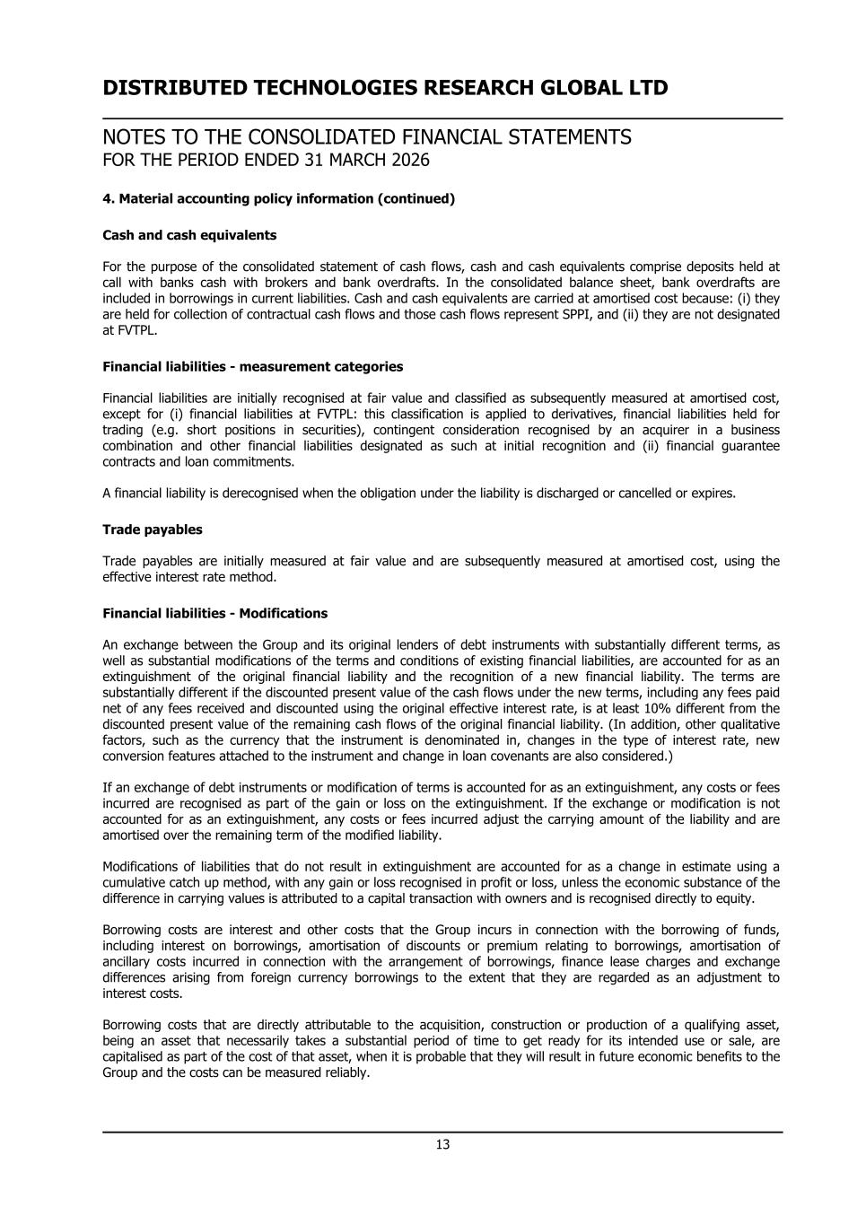
DISTRIBUTED TECHNOLOGIES RESEARCH GLOBAL LTD NOTES TO THE CONSOLIDATED FINANCIAL STATEMENTS FOR THE PERIOD ENDED 31 MARCH 2026 4. Material accounting policy information (continued) Cash and cash equivalents For the purpose of the consolidated statement of cash flows, cash and cash equivalents comprise deposits held at call with banks cash with brokers and bank overdrafts. In the consolidated balance sheet, bank overdrafts are included in borrowings in current liabilities. Cash and cash equivalents are carried at amortised cost because: (i) they are held for collection of contractual cash flows and those cash flows represent SPPI, and (ii) they are not designated at FVTPL. Financial liabilities - measurement categories Financial liabilities are initially recognised at fair value and classified as subsequently measured at amortised cost, except for (i) financial liabilities at FVTPL: this classification is applied to derivatives, financial liabilities held for trading (e.g. short positions in securities), contingent consideration recognised by an acquirer in a business combination and other financial liabilities designated as such at initial recognition and (ii) financial guarantee contracts and loan commitments. A financial liability is derecognised when the obligation under the liability is discharged or cancelled or expires. Trade payables Trade payables are initially measured at fair value and are subsequently measured at amortised cost, using the effective interest rate method. Financial liabilities - Modifications An exchange between the Group and its original lenders of debt instruments with substantially different terms, as well as substantial modifications of the terms and conditions of existing financial liabilities, are accounted for as an extinguishment of the original financial liability and the recognition of a new financial liability. The terms are substantially different if the discounted present value of the cash flows under the new terms, including any fees paid net of any fees received and discounted using the original effective interest rate, is at least 10% different from the discounted present value of the remaining cash flows of the original financial liability. (In addition, other qualitative factors, such as the currency that the instrument is denominated in, changes in the type of interest rate, new conversion features attached to the instrument and change in loan covenants are also considered.) If an exchange of debt instruments or modification of terms is accounted for as an extinguishment, any costs or fees incurred are recognised as part of the gain or loss on the extinguishment. If the exchange or modification is not accounted for as an extinguishment, any costs or fees incurred adjust the carrying amount of the liability and are amortised over the remaining term of the modified liability. Modifications of liabilities that do not result in extinguishment are accounted for as a change in estimate using a cumulative catch up method, with any gain or loss recognised in profit or loss, unless the economic substance of the difference in carrying values is attributed to a capital transaction with owners and is recognised directly to equity. Borrowing costs are interest and other costs that the Group incurs in connection with the borrowing of funds, including interest on borrowings, amortisation of discounts or premium relating to borrowings, amortisation of ancillary costs incurred in connection with the arrangement of borrowings, finance lease charges and exchange differences arising from foreign currency borrowings to the extent that they are regarded as an adjustment to interest costs. Borrowing costs that are directly attributable to the acquisition, construction or production of a qualifying asset, being an asset that necessarily takes a substantial period of time to get ready for its intended use or sale, are capitalised as part of the cost of that asset, when it is probable that they will result in future economic benefits to the Group and the costs can be measured reliably. 13

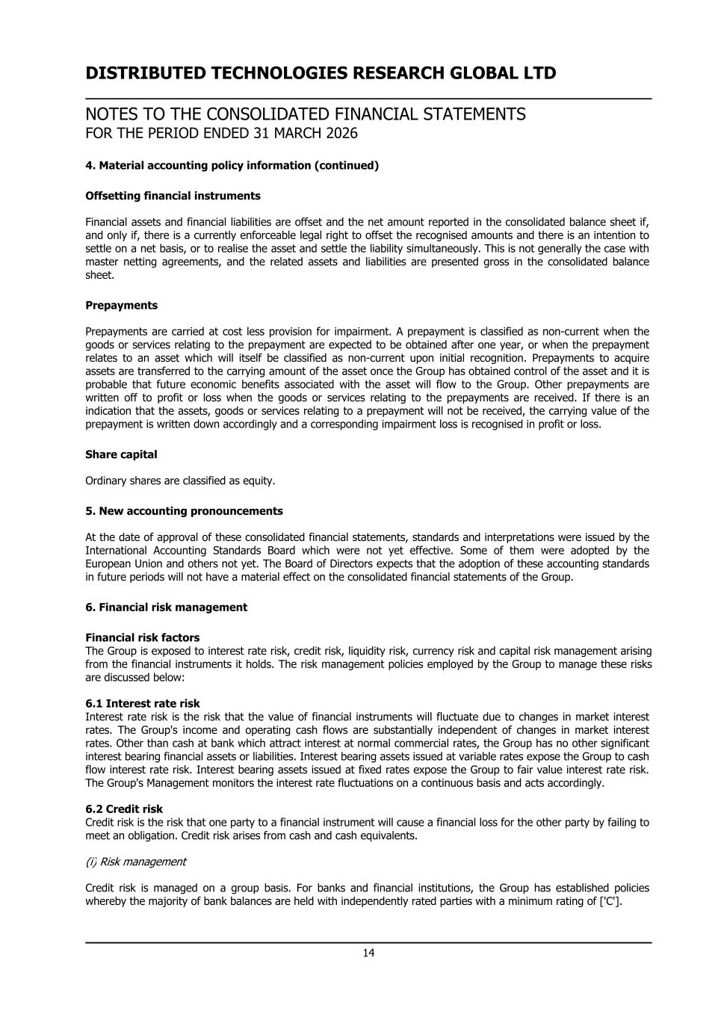
DISTRIBUTED TECHNOLOGIES RESEARCH GLOBAL LTD NOTES TO THE CONSOLIDATED FINANCIAL STATEMENTS FOR THE PERIOD ENDED 31 MARCH 2026 4. Material accounting policy information (continued) Offsetting financial instruments Financial assets and financial liabilities are offset and the net amount reported in the consolidated balance sheet if, and only if, there is a currently enforceable legal right to offset the recognised amounts and there is an intention to settle on a net basis, or to realise the asset and settle the liability simultaneously. This is not generally the case with master netting agreements, and the related assets and liabilities are presented gross in the consolidated balance sheet. Prepayments Prepayments are carried at cost less provision for impairment. A prepayment is classified as non-current when the goods or services relating to the prepayment are expected to be obtained after one year, or when the prepayment relates to an asset which will itself be classified as non-current upon initial recognition. Prepayments to acquire assets are transferred to the carrying amount of the asset once the Group has obtained control of the asset and it is probable that future economic benefits associated with the asset will flow to the Group. Other prepayments are written off to profit or loss when the goods or services relating to the prepayments are received. If there is an indication that the assets, goods or services relating to a prepayment will not be received, the carrying value of the prepayment is written down accordingly and a corresponding impairment loss is recognised in profit or loss. Share capital Ordinary shares are classified as equity. 5. New accounting pronouncements At the date of approval of these consolidated financial statements, standards and interpretations were issued by the International Accounting Standards Board which were not yet effective. Some of them were adopted by the European Union and others not yet. The Board of Directors expects that the adoption of these accounting standards in future periods will not have a material effect on the consolidated financial statements of the Group. 6. Financial risk management Financial risk factors The Group is exposed to interest rate risk, credit risk, liquidity risk, currency risk and capital risk management arising from the financial instruments it holds. The risk management policies employed by the Group to manage these risks are discussed below: 6.1 Interest rate risk Interest rate risk is the risk that the value of financial instruments will fluctuate due to changes in market interest rates. The Group's income and operating cash flows are substantially independent of changes in market interest rates. Other than cash at bank which attract interest at normal commercial rates, the Group has no other significant interest bearing financial assets or liabilities. Interest bearing assets issued at variable rates expose the Group to cash flow interest rate risk. Interest bearing assets issued at fixed rates expose the Group to fair value interest rate risk. The Group's Management monitors the interest rate fluctuations on a continuous basis and acts accordingly. 6.2 Credit risk Credit risk is the risk that one party to a financial instrument will cause a financial loss for the other party by failing to meet an obligation. Credit risk arises from cash and cash equivalents. (i) Risk management Credit risk is managed on a group basis. For banks and financial institutions, the Group has established policies whereby the majority of bank balances are held with independently rated parties with a minimum rating of ['C']. 14

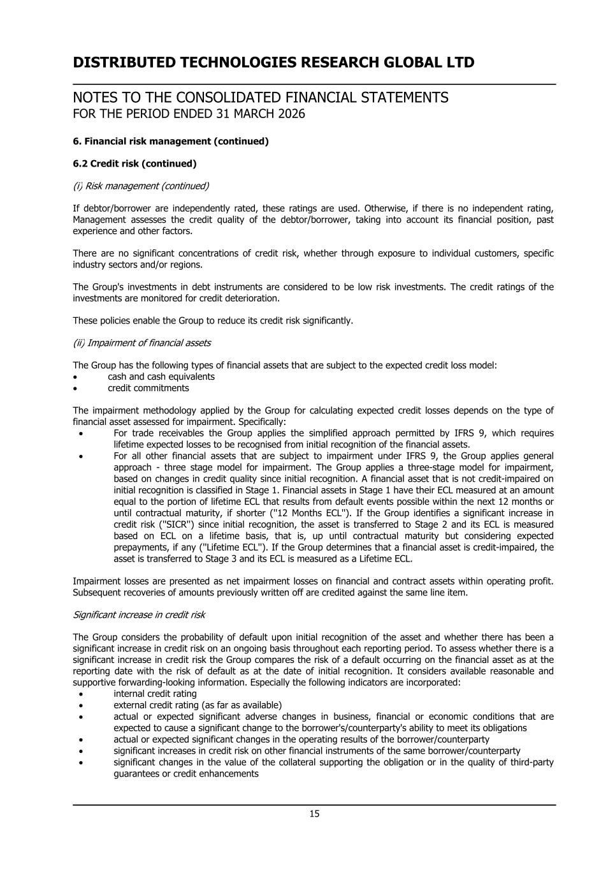
DISTRIBUTED TECHNOLOGIES RESEARCH GLOBAL LTD NOTES TO THE CONSOLIDATED FINANCIAL STATEMENTS FOR THE PERIOD ENDED 31 MARCH 2026 6. Financial risk management (continued) 6.2 Credit risk (continued) (i) Risk management (continued) If debtor/borrower are independently rated, these ratings are used. Otherwise, if there is no independent rating, Management assesses the credit quality of the debtor/borrower, taking into account its financial position, past experience and other factors. There are no significant concentrations of credit risk, whether through exposure to individual customers, specific industry sectors and/or regions. The Group's investments in debt instruments are considered to be low risk investments. The credit ratings of the investments are monitored for credit deterioration. These policies enable the Group to reduce its credit risk significantly. (ii) Impairment of financial assets The Group has the following types of financial assets that are subject to the expected credit loss model: • cash and cash equivalents • credit commitments The impairment methodology applied by the Group for calculating expected credit losses depends on the type of financial asset assessed for impairment. Specifically: • For trade receivables the Group applies the simplified approach permitted by IFRS 9, which requires lifetime expected losses to be recognised from initial recognition of the financial assets. • For all other financial assets that are subject to impairment under IFRS 9, the Group applies general approach - three stage model for impairment. The Group applies a three-stage model for impairment, based on changes in credit quality since initial recognition. A financial asset that is not credit-impaired on initial recognition is classified in Stage 1. Financial assets in Stage 1 have their ECL measured at an amount equal to the portion of lifetime ECL that results from default events possible within the next 12 months or until contractual maturity, if shorter (''12 Months ECL''). If the Group identifies a significant increase in credit risk (''SICR'') since initial recognition, the asset is transferred to Stage 2 and its ECL is measured based on ECL on a lifetime basis, that is, up until contractual maturity but considering expected prepayments, if any (''Lifetime ECL''). If the Group determines that a financial asset is credit-impaired, the asset is transferred to Stage 3 and its ECL is measured as a Lifetime ECL. Impairment losses are presented as net impairment losses on financial and contract assets within operating profit. Subsequent recoveries of amounts previously written off are credited against the same line item. Significant increase in credit risk The Group considers the probability of default upon initial recognition of the asset and whether there has been a significant increase in credit risk on an ongoing basis throughout each reporting period. To assess whether there is a significant increase in credit risk the Group compares the risk of a default occurring on the financial asset as at the reporting date with the risk of default as at the date of initial recognition. It considers available reasonable and supportive forwarding-looking information. Especially the following indicators are incorporated: • internal credit rating • external credit rating (as far as available) • actual or expected significant adverse changes in business, financial or economic conditions that are expected to cause a significant change to the borrower's/counterparty's ability to meet its obligations • actual or expected significant changes in the operating results of the borrower/counterparty • significant increases in credit risk on other financial instruments of the same borrower/counterparty • significant changes in the value of the collateral supporting the obligation or in the quality of third-party guarantees or credit enhancements 15

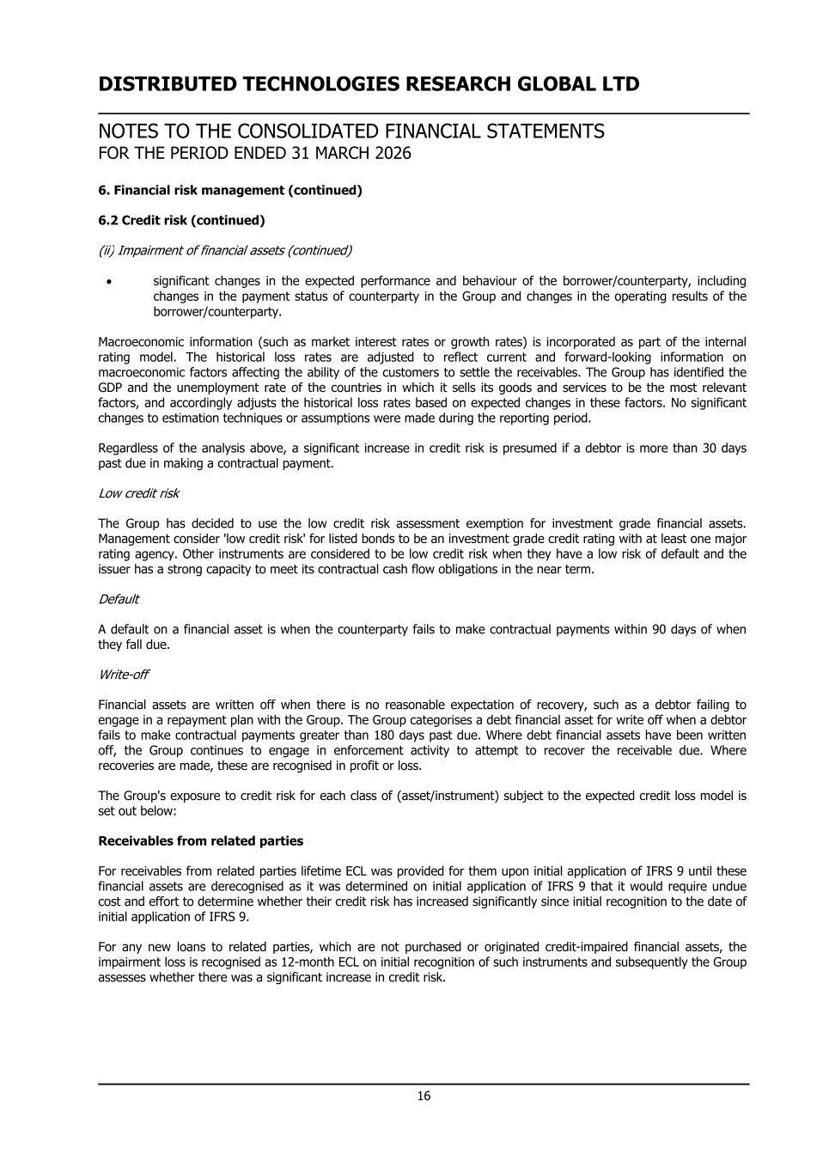
DISTRIBUTED TECHNOLOGIES RESEARCH GLOBAL LTD NOTES TO THE CONSOLIDATED FINANCIAL STATEMENTS FOR THE PERIOD ENDED 31 MARCH 2026 6. Financial risk management (continued) 6.2 Credit risk (continued) (ii) Impairment of financial assets (continued) • significant changes in the expected performance and behaviour of the borrower/counterparty, including changes in the payment status of counterparty in the Group and changes in the operating results of the borrower/counterparty. Macroeconomic information (such as market interest rates or growth rates) is incorporated as part of the internal rating model. The historical loss rates are adjusted to reflect current and forward-looking information on macroeconomic factors affecting the ability of the customers to settle the receivables. The Group has identified the GDP and the unemployment rate of the countries in which it sells its goods and services to be the most relevant factors, and accordingly adjusts the historical loss rates based on expected changes in these factors. No significant changes to estimation techniques or assumptions were made during the reporting period. Regardless of the analysis above, a significant increase in credit risk is presumed if a debtor is more than 30 days past due in making a contractual payment. Low credit risk The Group has decided to use the low credit risk assessment exemption for investment grade financial assets. Management consider 'low credit risk' for listed bonds to be an investment grade credit rating with at least one major rating agency. Other instruments are considered to be low credit risk when they have a low risk of default and the issuer has a strong capacity to meet its contractual cash flow obligations in the near term. Default A default on a financial asset is when the counterparty fails to make contractual payments within 90 days of when they fall due. Write-off Financial assets are written off when there is no reasonable expectation of recovery, such as a debtor failing to engage in a repayment plan with the Group. The Group categorises a debt financial asset for write off when a debtor fails to make contractual payments greater than 180 days past due. Where debt financial assets have been written off, the Group continues to engage in enforcement activity to attempt to recover the receivable due. Where recoveries are made, these are recognised in profit or loss. The Group's exposure to credit risk for each class of (asset/instrument) subject to the expected credit loss model is set out below: Receivables from related parties For receivables from related parties lifetime ECL was provided for them upon initial application of IFRS 9 until these financial assets are derecognised as it was determined on initial application of IFRS 9 that it would require undue cost and effort to determine whether their credit risk has increased significantly since initial recognition to the date of initial application of IFRS 9. For any new loans to related parties, which are not purchased or originated credit-impaired financial assets, the impairment loss is recognised as 12-month ECL on initial recognition of such instruments and subsequently the Group assesses whether there was a significant increase in credit risk. 16

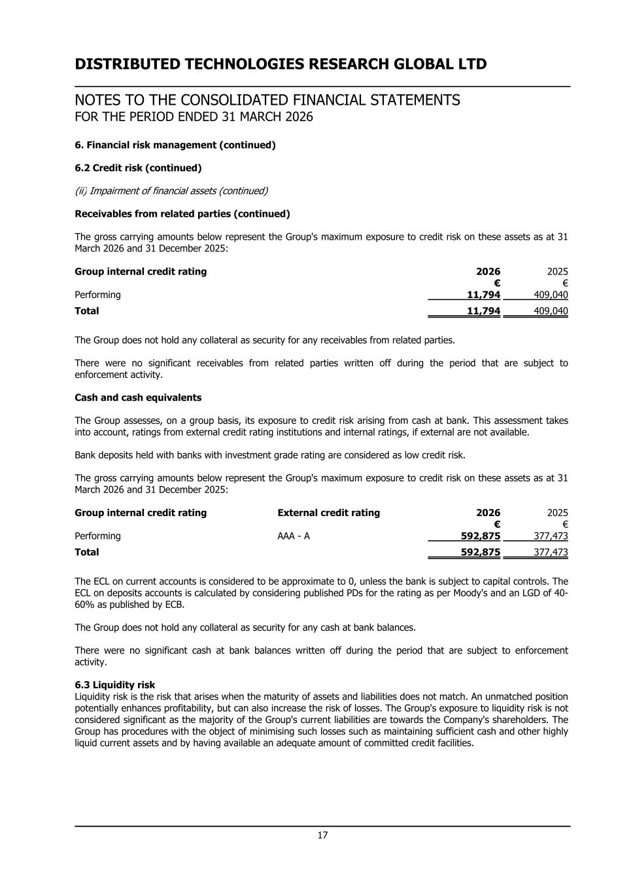
DISTRIBUTED TECHNOLOGIES RESEARCH GLOBAL LTD NOTES TO THE CONSOLIDATED FINANCIAL STATEMENTS FOR THE PERIOD ENDED 31 MARCH 2026 6. Financial risk management (continued) 6.2 Credit risk (continued) (ii) Impairment of financial assets (continued) Receivables from related parties (continued) The gross carrying amounts below represent the Group's maximum exposure to credit risk on these assets as at 31 March 2026 and 31 December 2025: Group internal credit rating 2026 2025 € € Performing 11,794 409,040 Total 11,794 409,040 The Group does not hold any collateral as security for any receivables from related parties. There were no significant receivables from related parties written off during the period that are subject to enforcement activity. Cash and cash equivalents The Group assesses, on a group basis, its exposure to credit risk arising from cash at bank. This assessment takes into account, ratings from external credit rating institutions and internal ratings, if external are not available. Bank deposits held with banks with investment grade rating are considered as low credit risk. The gross carrying amounts below represent the Group's maximum exposure to credit risk on these assets as at 31 March 2026 and 31 December 2025: Group internal credit rating External credit rating 2026 2025 € € Performing AAA - A 592,875 377,473 Total 592,875 377,473 The ECL on current accounts is considered to be approximate to 0, unless the bank is subject to capital controls. The ECL on deposits accounts is calculated by considering published PDs for the rating as per Moody's and an LGD of 40- 60% as published by ECB. The Group does not hold any collateral as security for any cash at bank balances. There were no significant cash at bank balances written off during the period that are subject to enforcement activity. 6.3 Liquidity risk Liquidity risk is the risk that arises when the maturity of assets and liabilities does not match. An unmatched position potentially enhances profitability, but can also increase the risk of losses. The Group's exposure to liquidity risk is not considered significant as the majority of the Group's current liabilities are towards the Company's shareholders. The Group has procedures with the object of minimising such losses such as maintaining sufficient cash and other highly liquid current assets and by having available an adequate amount of committed credit facilities. 17

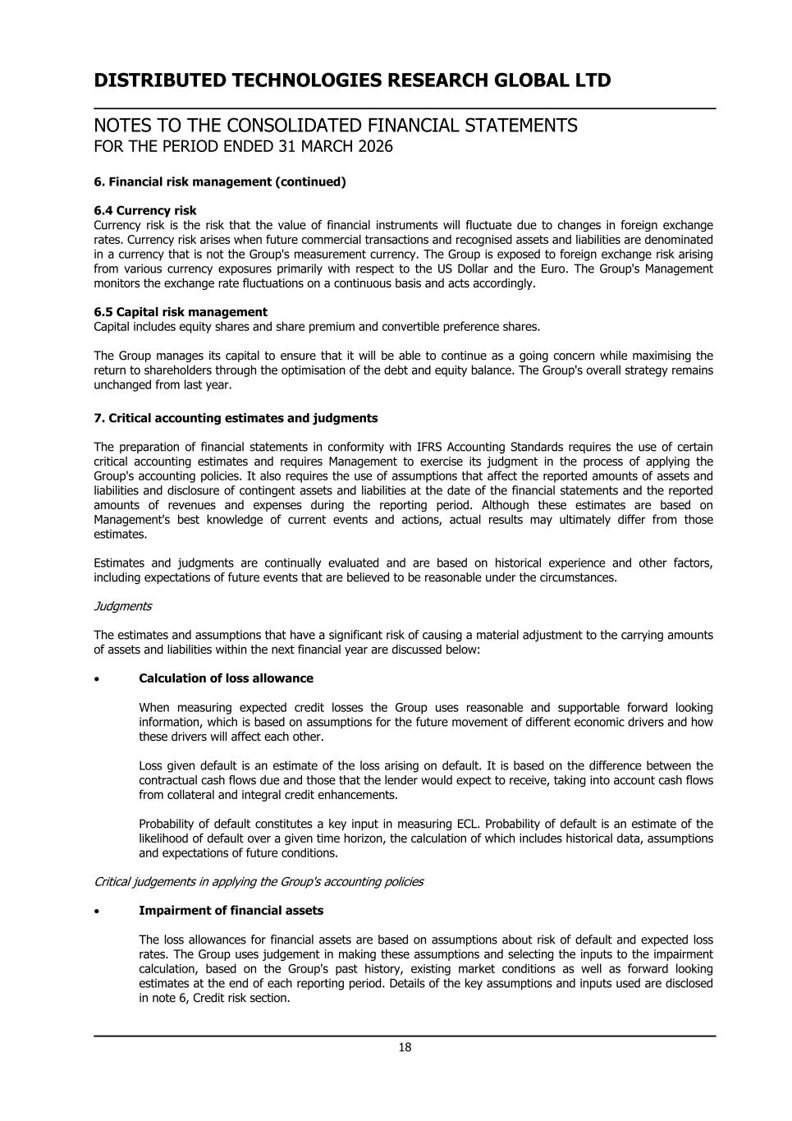
DISTRIBUTED TECHNOLOGIES RESEARCH GLOBAL LTD NOTES TO THE CONSOLIDATED FINANCIAL STATEMENTS FOR THE PERIOD ENDED 31 MARCH 2026 6. Financial risk management (continued) 6.4 Currency risk Currency risk is the risk that the value of financial instruments will fluctuate due to changes in foreign exchange rates. Currency risk arises when future commercial transactions and recognised assets and liabilities are denominated in a currency that is not the Group's measurement currency. The Group is exposed to foreign exchange risk arising from various currency exposures primarily with respect to the US Dollar and the Euro. The Group's Management monitors the exchange rate fluctuations on a continuous basis and acts accordingly. 6.5 Capital risk management Capital includes equity shares and share premium and convertible preference shares. The Group manages its capital to ensure that it will be able to continue as a going concern while maximising the return to shareholders through the optimisation of the debt and equity balance. The Group's overall strategy remains unchanged from last year. 7. Critical accounting estimates and judgments The preparation of financial statements in conformity with IFRS Accounting Standards requires the use of certain critical accounting estimates and requires Management to exercise its judgment in the process of applying the Group's accounting policies. It also requires the use of assumptions that affect the reported amounts of assets and liabilities and disclosure of contingent assets and liabilities at the date of the financial statements and the reported amounts of revenues and expenses during the reporting period. Although these estimates are based on Management's best knowledge of current events and actions, actual results may ultimately differ from those estimates. Estimates and judgments are continually evaluated and are based on historical experience and other factors, including expectations of future events that are believed to be reasonable under the circumstances. Judgments The estimates and assumptions that have a significant risk of causing a material adjustment to the carrying amounts of assets and liabilities within the next financial year are discussed below: • Calculation of loss allowance When measuring expected credit losses the Group uses reasonable and supportable forward looking information, which is based on assumptions for the future movement of different economic drivers and how these drivers will affect each other. Loss given default is an estimate of the loss arising on default. It is based on the difference between the contractual cash flows due and those that the lender would expect to receive, taking into account cash flows from collateral and integral credit enhancements. Probability of default constitutes a key input in measuring ECL. Probability of default is an estimate of the likelihood of default over a given time horizon, the calculation of which includes historical data, assumptions and expectations of future conditions. Critical judgements in applying the Group's accounting policies • Impairment of financial assets The loss allowances for financial assets are based on assumptions about risk of default and expected loss rates. The Group uses judgement in making these assumptions and selecting the inputs to the impairment calculation, based on the Group's past history, existing market conditions as well as forward looking estimates at the end of each reporting period. Details of the key assumptions and inputs used are disclosed in note 6, Credit risk section. 18

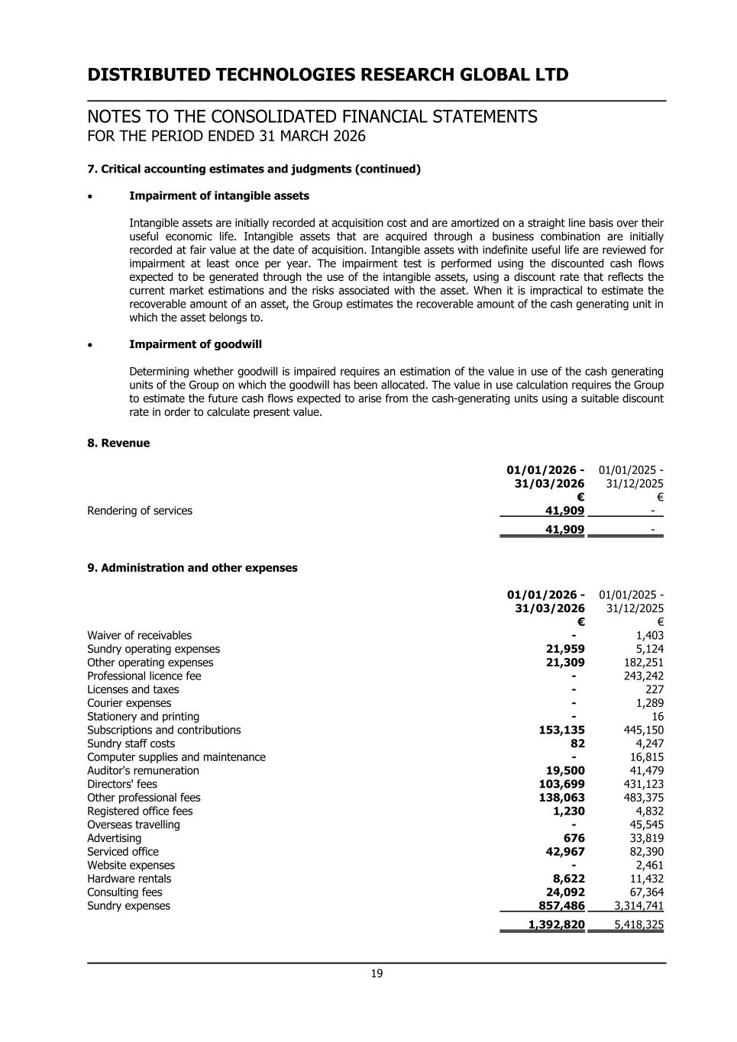
DISTRIBUTED TECHNOLOGIES RESEARCH GLOBAL LTD NOTES TO THE CONSOLIDATED FINANCIAL STATEMENTS FOR THE PERIOD ENDED 31 MARCH 2026 7. Critical accounting estimates and judgments (continued) • Impairment of intangible assets Intangible assets are initially recorded at acquisition cost and are amortized on a straight line basis over their useful economic life. Intangible assets that are acquired through a business combination are initially recorded at fair value at the date of acquisition. Intangible assets with indefinite useful life are reviewed for impairment at least once per year. The impairment test is performed using the discounted cash flows expected to be generated through the use of the intangible assets, using a discount rate that reflects the current market estimations and the risks associated with the asset. When it is impractical to estimate the recoverable amount of an asset, the Group estimates the recoverable amount of the cash generating unit in which the asset belongs to. • Impairment of goodwill Determining whether goodwill is impaired requires an estimation of the value in use of the cash generating units of the Group on which the goodwill has been allocated. The value in use calculation requires the Group to estimate the future cash flows expected to arise from the cash-generating units using a suitable discount rate in order to calculate present value. 8. Revenue 01/01/2026 - 31/03/2026 01/01/2025 - 31/12/2025 € € Rendering of services 41,909 - 41,909 - 9. Administration and other expenses 01/01/2026 - 31/03/2026 01/01/2025 - 31/12/2025 € € Waiver of receivables - 1,403 Sundry operating expenses 21,959 5,124 Other operating expenses 21,309 182,251 Professional licence fee - 243,242 Licenses and taxes - 227 Courier expenses - 1,289 Stationery and printing - 16 Subscriptions and contributions 153,135 445,150 Sundry staff costs 82 4,247 Computer supplies and maintenance - 16,815 Auditor's remuneration 19,500 41,479 Directors' fees 103,699 431,123 Other professional fees 138,063 483,375 Registered office fees 1,230 4,832 Overseas travelling - 45,545 Advertising 676 33,819 Serviced office 42,967 82,390 Website expenses - 2,461 Hardware rentals 8,622 11,432 Consulting fees 24,092 67,364 Sundry expenses 857,486 3,314,741 1,392,820 5,418,325 19

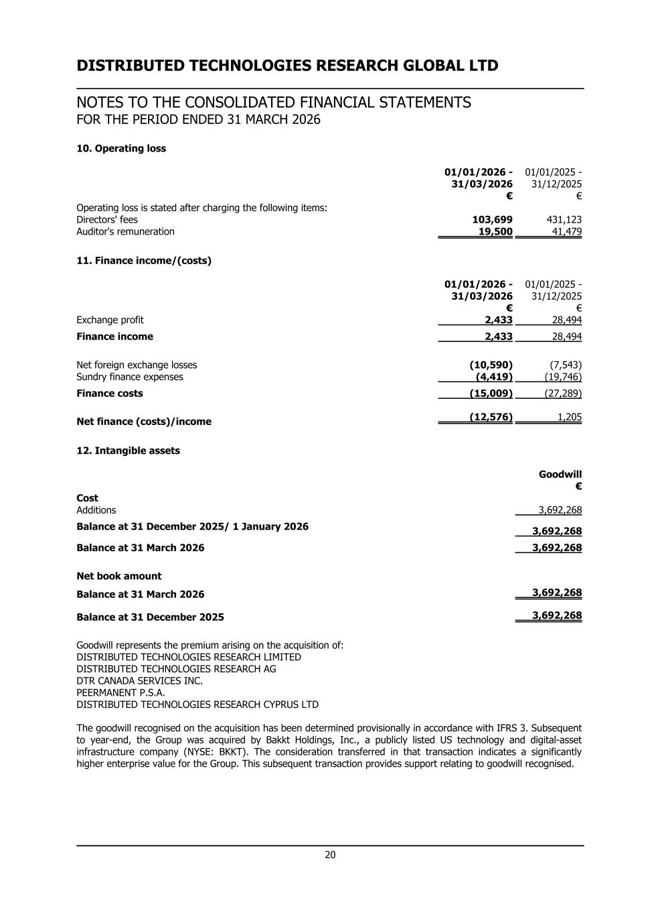
DISTRIBUTED TECHNOLOGIES RESEARCH GLOBAL LTD NOTES TO THE CONSOLIDATED FINANCIAL STATEMENTS FOR THE PERIOD ENDED 31 MARCH 2026 10. Operating loss 01/01/2026 - 31/03/2026 01/01/2025 - 31/12/2025 € € Operating loss is stated after charging the following items: Directors' fees 103,699 431,123 Auditor's remuneration 19,500 41,479 11. Finance income/(costs) 01/01/2026 - 31/03/2026 01/01/2025 - 31/12/2025 € € Exchange profit 2,433 28,494 Finance income 2,433 28,494 Net foreign exchange losses (10,590) (7,543) Sundry finance expenses (4,419) (19,746) Finance costs (15,009) (27,289) Net finance (costs)/income (12,576) 1,205 12. Intangible assets Goodwill € Cost Additions 3,692,268 Balance at 31 December 2025/ 1 January 2026 3,692,268 Balance at 31 March 2026 3,692,268 Net book amount Balance at 31 March 2026 3,692,268 Balance at 31 December 2025 3,692,268 Goodwill represents the premium arising on the acquisition of: DISTRIBUTED TECHNOLOGIES RESEARCH LIMITED DISTRIBUTED TECHNOLOGIES RESEARCH AG DTR CANADA SERVICES INC. PEERMANENT P.S.A. DISTRIBUTED TECHNOLOGIES RESEARCH CYPRUS LTD The goodwill recognised on the acquisition has been determined provisionally in accordance with IFRS 3. Subsequent to year-end, the Group was acquired by Bakkt Holdings, Inc., a publicly listed US technology and digital-asset infrastructure company (NYSE: BKKT). The consideration transferred in that transaction indicates a significantly higher enterprise value for the Group. This subsequent transaction provides support relating to goodwill recognised. 20

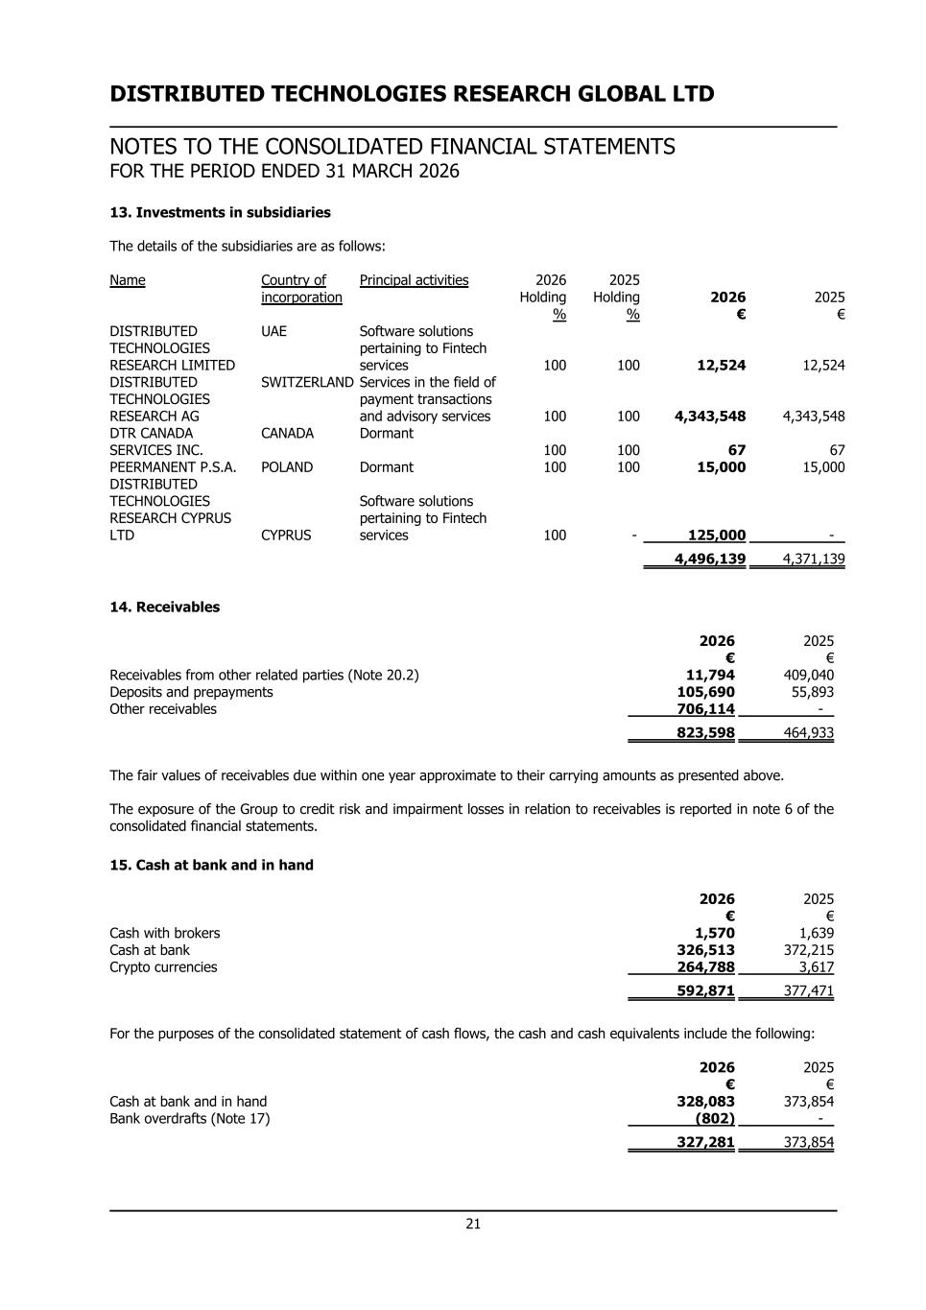
DISTRIBUTED TECHNOLOGIES RESEARCH GLOBAL LTD NOTES TO THE CONSOLIDATED FINANCIAL STATEMENTS FOR THE PERIOD ENDED 31 MARCH 2026 13. Investments in subsidiaries The details of the subsidiaries are as follows: Name Country of incorporation Principal activities 2026 Holding % 2025 Holding % 2026 € 2025 € DISTRIBUTED TECHNOLOGIES RESEARCH LIMITED UAE Software solutions pertaining to Fintech services 100 100 12,524 12,524 DISTRIBUTED TECHNOLOGIES RESEARCH AG SWITZERLAND Services in the field of payment transactions and advisory services 100 100 4,343,548 4,343,548 DTR CANADA SERVICES INC. CANADA Dormant 100 100 67 67 PEERMANENT P.S.A. POLAND Dormant 100 100 15,000 15,000 DISTRIBUTED TECHNOLOGIES RESEARCH CYPRUS LTD CYPRUS Software solutions pertaining to Fintech services 100 - 125,000 - 4,496,139 4,371,139 14. Receivables 2026 2025 € € Receivables from other related parties (Note 20.2) 11,794 409,040 Deposits and prepayments 105,690 55,893 Other receivables 706,114 - 823,598 464,933 The fair values of receivables due within one year approximate to their carrying amounts as presented above. The exposure of the Group to credit risk and impairment losses in relation to receivables is reported in note 6 of the consolidated financial statements. 15. Cash at bank and in hand 2026 2025 € € Cash with brokers 1,570 1,639 Cash at bank 326,513 372,215 Crypto currencies 264,788 3,617 592,871 377,471 For the purposes of the consolidated statement of cash flows, the cash and cash equivalents include the following: 2026 2025 € € Cash at bank and in hand 328,083 373,854 Bank overdrafts (Note 17) (802) - 327,281 373,854 21

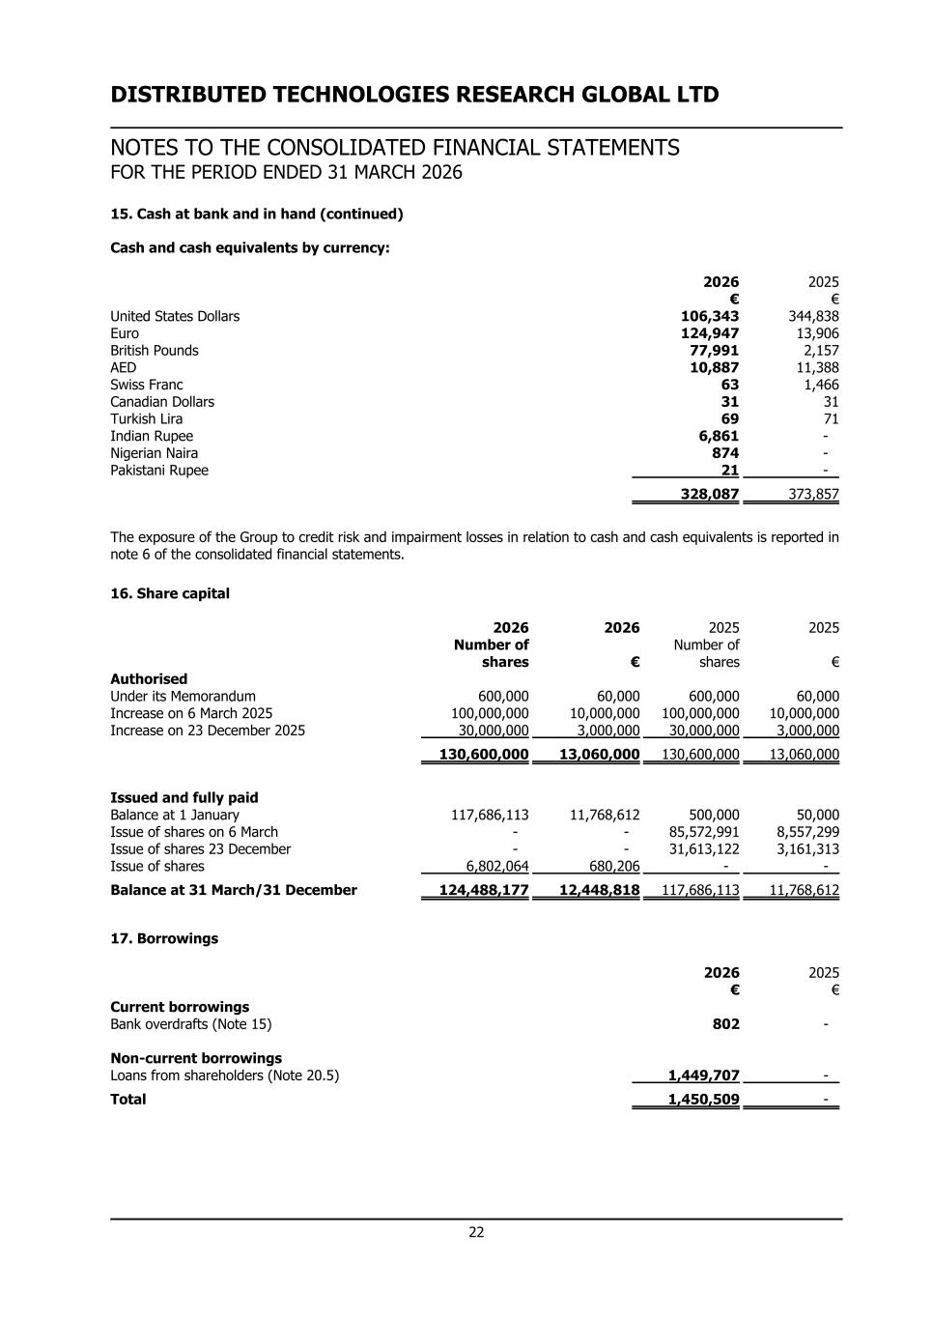
DISTRIBUTED TECHNOLOGIES RESEARCH GLOBAL LTD NOTES TO THE CONSOLIDATED FINANCIAL STATEMENTS FOR THE PERIOD ENDED 31 MARCH 2026 15. Cash at bank and in hand (continued) Cash and cash equivalents by currency: 2026 2025 € € United States Dollars 106,343 344,838 Euro 124,947 13,906 British Pounds 77,991 2,157 AED 10,887 11,388 Swiss Franc 63 1,466 Canadian Dollars 31 31 Turkish Lira 69 71 Indian Rupee 6,861 - Nigerian Naira 874 - Pakistani Rupee 21 - 328,087 373,857 The exposure of the Group to credit risk and impairment losses in relation to cash and cash equivalents is reported in note 6 of the consolidated financial statements. 16. Share capital 2026 2026 2025 2025 Number of shares € Number of shares € Authorised Under its Memorandum 600,000 60,000 600,000 60,000 Increase on 6 March 2025 100,000,000 10,000,000 100,000,000 10,000,000 Increase on 23 December 2025 30,000,000 3,000,000 30,000,000 3,000,000 130,600,000 13,060,000 130,600,000 13,060,000 Issued and fully paid Balance at 1 January 117,686,113 11,768,612 500,000 50,000 Issue of shares on 6 March - - 85,572,991 8,557,299 Issue of shares 23 December - - 31,613,122 3,161,313 Issue of shares 6,802,064 680,206 - - Balance at 31 March/31 December 124,488,177 12,448,818 117,686,113 11,768,612 17. Borrowings 2026 2025 € € Current borrowings Bank overdrafts (Note 15) 802 - Non-current borrowings Loans from shareholders (Note 20.5) 1,449,707 - Total 1,450,509 - 22

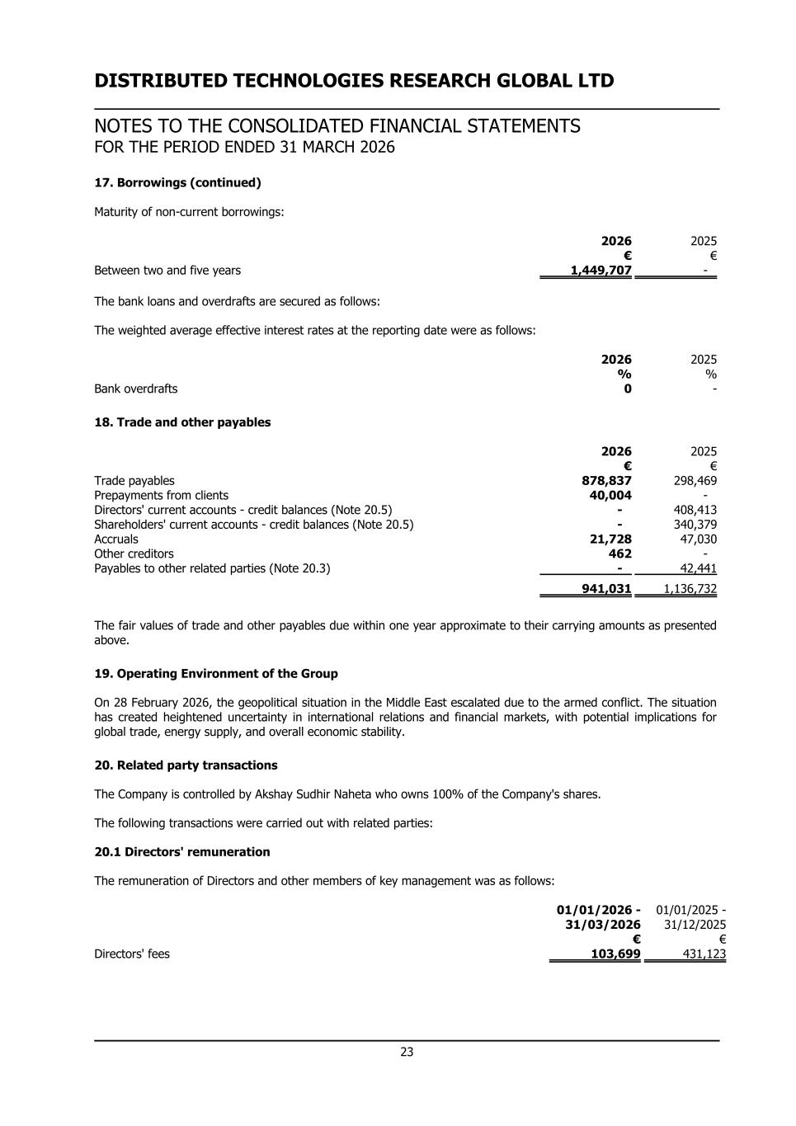
DISTRIBUTED TECHNOLOGIES RESEARCH GLOBAL LTD NOTES TO THE CONSOLIDATED FINANCIAL STATEMENTS FOR THE PERIOD ENDED 31 MARCH 2026 17. Borrowings (continued) Maturity of non-current borrowings: 2026 2025 € € Between two and five years 1,449,707 - The bank loans and overdrafts are secured as follows: The weighted average effective interest rates at the reporting date were as follows: 2026 2025 % % Bank overdrafts 0 - 18. Trade and other payables 2026 2025 € € Trade payables 878,837 298,469 Prepayments from clients 40,004 - Directors' current accounts - credit balances (Note 20.5) - 408,413 Shareholders' current accounts - credit balances (Note 20.5) - 340,379 Accruals 21,728 47,030 Other creditors 462 - Payables to other related parties (Note 20.3) - 42,441 941,031 1,136,732 The fair values of trade and other payables due within one year approximate to their carrying amounts as presented above. 19. Operating Environment of the Group On 28 February 2026, the geopolitical situation in the Middle East escalated due to the armed conflict. The situation has created heightened uncertainty in international relations and financial markets, with potential implications for global trade, energy supply, and overall economic stability. 20. Related party transactions The Company is controlled by Akshay Sudhir Naheta who owns 100% of the Company's shares. The following transactions were carried out with related parties: 20.1 Directors' remuneration The remuneration of Directors and other members of key management was as follows: 01/01/2026 - 31/03/2026 01/01/2025 - 31/12/2025 € € Directors' fees 103,699 431,123 23

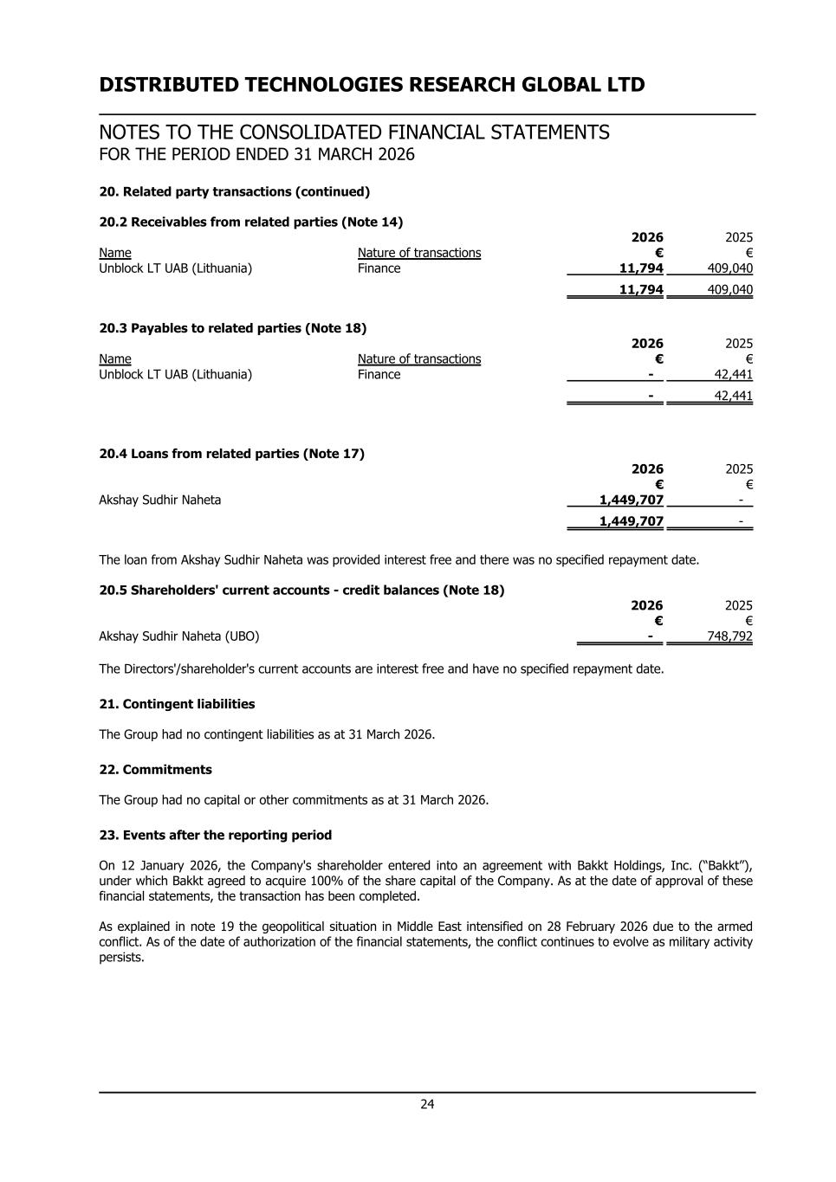
DISTRIBUTED TECHNOLOGIES RESEARCH GLOBAL LTD NOTES TO THE CONSOLIDATED FINANCIAL STATEMENTS FOR THE PERIOD ENDED 31 MARCH 2026 20. Related party transactions (continued) 20.2 Receivables from related parties (Note 14) 2026 2025 Name Nature of transactions € € Unblock LT UAB (Lithuania) Finance 11,794 409,040 11,794 409,040 20.3 Payables to related parties (Note 18) 2026 2025 Name Nature of transactions € € Unblock LT UAB (Lithuania) Finance - 42,441 - 42,441 20.4 Loans from related parties (Note 17) 2026 2025 € € Akshay Sudhir Naheta 1,449,707 - 1,449,707 - The loan from Akshay Sudhir Naheta was provided interest free and there was no specified repayment date. 20.5 Shareholders' current accounts - credit balances (Note 18) 2026 2025 € € Akshay Sudhir Naheta (UBO) - 748,792 The Directors'/shareholder's current accounts are interest free and have no specified repayment date. 21. Contingent liabilities The Group had no contingent liabilities as at 31 March 2026. 22. Commitments The Group had no capital or other commitments as at 31 March 2026. 23. Events after the reporting period On 12 January 2026, the Company's shareholder entered into an agreement with Bakkt Holdings, Inc. (“Bakkt”), under which Bakkt agreed to acquire 100% of the share capital of the Company. As at the date of approval of these financial statements, the transaction has been completed. As explained in note 19 the geopolitical situation in Middle East intensified on 28 February 2026 due to the armed conflict. As of the date of authorization of the financial statements, the conflict continues to evolve as military activity persists. 24

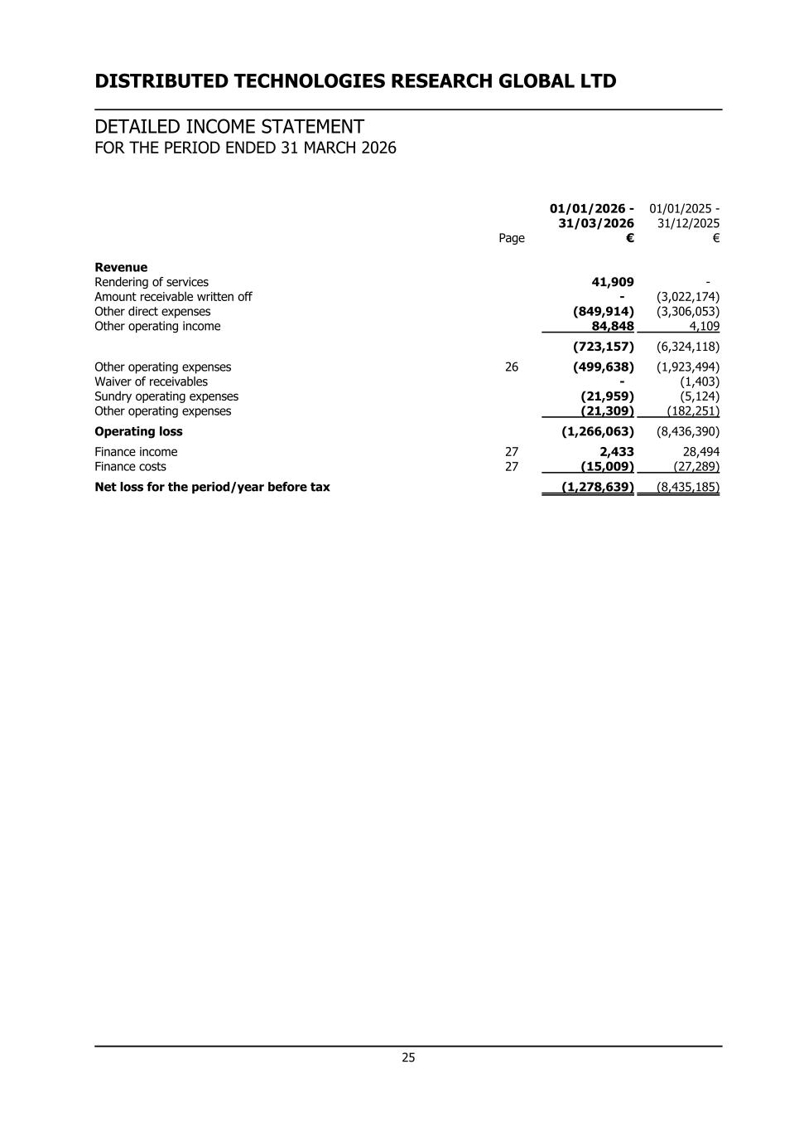
DISTRIBUTED TECHNOLOGIES RESEARCH GLOBAL LTD DETAILED INCOME STATEMENT FOR THE PERIOD ENDED 31 MARCH 2026 01/01/2026 - 31/03/2026 01/01/2025 - 31/12/2025 Page € € Revenue Rendering of services 41,909 - Amount receivable written off - (3,022,174) Other direct expenses (849,914) (3,306,053) Other operating income 84,848 4,109 (723,157) (6,324,118) Other operating expenses 26 (499,638) (1,923,494) Waiver of receivables - (1,403) Sundry operating expenses (21,959) (5,124) Other operating expenses (21,309) (182,251) Operating loss (1,266,063) (8,436,390) Finance income 27 2,433 28,494 Finance costs 27 (15,009) (27,289) Net loss for the period/year before tax (1,278,639) (8,435,185) 25

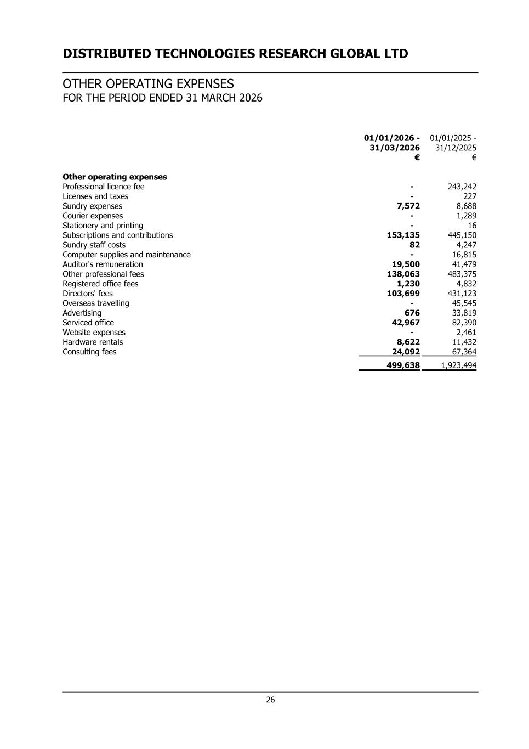
DISTRIBUTED TECHNOLOGIES RESEARCH GLOBAL LTD OTHER OPERATING EXPENSES FOR THE PERIOD ENDED 31 MARCH 2026 01/01/2026 - 31/03/2026 01/01/2025 - 31/12/2025 € € Other operating expenses Professional licence fee - 243,242 Licenses and taxes - 227 Sundry expenses 7,572 8,688 Courier expenses - 1,289 Stationery and printing - 16 Subscriptions and contributions 153,135 445,150 Sundry staff costs 82 4,247 Computer supplies and maintenance - 16,815 Auditor's remuneration 19,500 41,479 Other professional fees 138,063 483,375 Registered office fees 1,230 4,832 Directors' fees 103,699 431,123 Overseas travelling - 45,545 Advertising 676 33,819 Serviced office 42,967 82,390 Website expenses - 2,461 Hardware rentals 8,622 11,432 Consulting fees 24,092 67,364 499,638 1,923,494 26

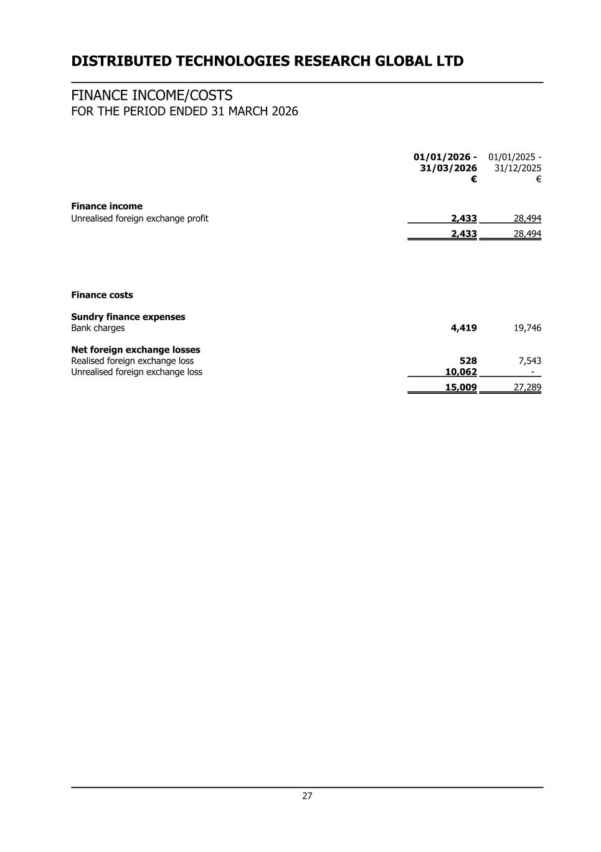
DISTRIBUTED TECHNOLOGIES RESEARCH GLOBAL LTD FINANCE INCOME/COSTS FOR THE PERIOD ENDED 31 MARCH 2026 01/01/2026 - 31/03/2026 01/01/2025 - 31/12/2025 € € Finance income Unrealised foreign exchange profit 2,433 28,494 2,433 28,494 Finance costs Sundry finance expenses Bank charges 4,419 19,746 Net foreign exchange losses Realised foreign exchange loss 528 7,543 Unrealised foreign exchange loss 10,062 - 15,009 27,289 27

Unaudited Pro Forma Condensed Combined Financial Information

On April 30, 2026 (the “Closing Date”), Bakkt, Inc. ("Bakkt" or the "Company"), through its indirect wholly-owned subsidiary Bividen Limited, completed the acquisition of 100% of the share capital of Distributed Technologies Research Global Ltd. ("DTR" or the "Target"), a private limited company incorporated in Cyprus, pursuant to a Share Purchase Agreement dated January 11, 2026.

Consideration consisted of 11,316,775 shares of Bakkt Class A Common Stock issued to DTR's beneficial holders (with up to 725,592 additional shares potentially issuable upon exercise of certain outstanding warrants). For purposes of these unaudited pro forma condensed combined financial statements, the total purchase price was calculated based on the closing price of Bakkt’s Class A Common Stock on the NYSE on April 30, 2026 of $8.62 per share. DTR is controlled by Akshay Naheta, Bakkt's Chief Executive Officer; the transaction is therefore a related-party transaction that was reviewed and approved by a Special Committee of Bakkt’s independent Board of Directors.

The following unaudited pro forma condensed combined balance sheet as of March 31, 2026, gives effect to the acquisition of DTR by Bakkt. The unaudited pro forma condensed combined balance sheet assumes that the acquisition occurred on March 31, 2026. The historical financial data of Bakkt has been derived from its unaudited interim financial statements as of March 31, 2026. The historical financial data of DTR has been derived from its unaudited interim financial statements as of March 31, 2026, which were prepared under International Financial Reporting Standards ("IFRS") and in Euros, and have been translated into U.S. Dollars and conformed to U.S. GAAP for purposes of this presentation. The pro forma adjustments are based on available information and certain assumptions that management believes are reasonable under the circumstances.

The following unaudited pro forma condensed combined statements of operations for the year ended December 31, 2025, and for the three months ended March 31, 2026, assume that the acquisition occurred on January 1, 2025. The historical financial data has been derived from the audited financial statements of Bakkt for the year ended December 31, 2025, the unaudited interim financial statements of Bakkt for the three months ended March 31, 2026, and the historical financial statements of DTR for the respective periods (adjusted and conformed to U.S. GAAP as described above). The pro forma adjustments are based on available information and certain assumptions that management believes are reasonable under the circumstances.
The unaudited pro forma adjustments are preliminary and have been made solely for the purpose of providing this unaudited pro forma condensed combined financial information. The final acquisition accounting adjustments may be materially different from the unaudited pro forma adjustments described in these notes. The Company expects to complete the final purchase price allocation within 12 months of the Closing Date as additional valuation information becomes available and is evaluated.

Bakkt, Inc. / DTR — Unaudited Pro Forma Condensed Combined Balance Sheet as of March 31, 2026
(in thousands)
Line Item |  |  | Bakkt, Inc. (Historical US GAAP) |  |  | DTR (Historical IFRS, USD) |  |  | IFRS to US GAAP Conversion Adjustments |  |  | Target Adjusted (US GAAP Subtotal) |  |  | Transaction Accounting Adjustments |  |  | Pro Forma Combined |  |  | Note Ref
ASSETS
Current assets:
Cash and cash equivalents |  |  | $ | 79,984 |  | $ | 685 |  | $ | — |  | $ | 685 |  | $ | (2,200) |  | $ | 78,469 |  | PPA-3, PPA-4
Restricted cash |  |  | $ | 2,576 |  | $ | — |  | $ | — |  | $ | — |  | $ | — |  | $ | 2,576
Customer funds |  |  | $ | 17,393 |  | $ | — |  | $ | — |  | $ | — |  | $ | — |  | $ | 17,393
Investments |  |  | $ | 249 |  | $ | — |  | $ | — |  | $ | — |  | $ | — |  | $ | 249
Accounts receivable, net |  |  | $ | 9,532 |  | $ | 952 |  | $ | — |  | $ | 952 |  | $ | — |  | $ | 10,484
Prepaid insurance |  |  | $ | 1,667 |  | $ | — |  | $ | — |  | $ | — |  | $ | — |  | $ | 1,667
Other current assets |  |  | $ | 13,593 |  | $ | — |  | $ | — |  | $ | — |  | $ | — |  | $ | 13,593
Total current assets |  |  | $ | 124,994 |  | $ | 1,637 |  | $ | — |  | $ | 1,637 |  | $ | (2,200) |  | $ | 124,431
Property, equipment and software, net |  |  | $ | 2,322 |  | $ | — |  | $ | — |  | $ | — |  | $ | — |  | $ | 2,322
Goodwill |  |  | $ | 64,658 |  | $ | 4,268 |  | $ | — |  | $ | 4,268 |  | $ | 76,452 |  | $ | 145,378 |  | PPA-1
Identified intangible assets acquired — DTR Acquisition, net |  |  | $ | — |  | $ | — |  | $ | — |  | $ | — |  | $ | 20,690 |  | $ | 20,690 |  | PPA-5
Intangible assets |  |  | $ | 5,550 |  | $ | — |  | $ | — |  | $ | — |  | $ | — |  | $ | 5,550
Equity method investment |  |  | $ | 10,928 |  | $ | — |  | $ | — |  | $ | — |  | $ | — |  | $ | 10,928
Derivative asset |  |  | $ | 160 |  | $ | — |  | $ | — |  | $ | — |  | $ | — |  | $ | 160
Other assets |  |  | $ | 4,768 |  | $ | — |  | $ | — |  | $ | — |  | $ | — |  | $ | 4,768
Total assets |  |  | $ | 213,380 |  | $ | 5,905 |  | $ | — |  | $ | 5,905 |  | $ | 94,942 |  | $ | 314,227
LIABILITIES AND EQUITY
Current liabilities:
Accounts payable and accrued liabilities |  |  | $ | 12,753 |  | $ | 1,088 |  | $ | — |  | $ | 1,088 |  | $ | — |  | $ | 13,841
Customer funds payable |  |  | $ | 17,393 |  | $ | — |  | $ | — |  | $ | — |  | $ | — |  | $ | 17,393
Deferred revenue, current |  |  | $ | — |  | $ | — |  | $ | — |  | $ | — |  | $ | — |  | $ | —
Other current liabilities |  |  | $ | 129 |  | $ | 1 |  | $ | — |  | $ | 1 |  | $ | — |  | $ | 130 |  | PPA-2
Total current liabilities |  |  | $ | 30,275 |  | $ | 1,089 |  | $ | — |  | $ | 1,089 |  | $ | — |  | $ | 31,364
Warrant liabilities |  |  | $ | 12,032 |  | $ | — |  | $ | — |  | $ | — |  | $ | — |  | $ | 12,032
Other noncurrent liabilities |  |  | $ | 195 |  | $ | 1,676 |  | $ | — |  | $ | 1,676 |  | $ | (1,676) |  | $ | 195 |  | PPA-3
Total liabilities |  |  | $ | 42,502 |  | $ | 2,764 |  | $ | — |  | $ | 2,764 |  | $ | (1,676) |  | $ | 43,591
Stockholders' equity:
Common stock |  |  | $ | 3 |  | $ | 14,390 |  | $ | — |  | $ | 14,390 |  | $ | (14,389) |  | $ | 4 |  | H
Additional paid-in capital |  |  | $ | 1,086,656 |  | $ | — |  | $ | — |  | $ | — |  | $ | 99,757 |  | $ | 1,186,413 |  | H, PPA-6
Accumulated other comprehensive income (loss) |  |  | $ | 1,041 |  | $ | — |  | $ | — |  | $ | — |  | $ | — |  | $ | 1,041 |  | H
Accumulated deficit |  |  | $ | (916,822) |  | $ | (11,249) |  | $ | — |  | $ | (11,249) |  | $ | 11,249 |  | $ | (916,822) |  | H
Total Bakkt / stockholders' equity |  |  | $ | 170,878 |  | $ | 3,141 |  | $ | — |  | $ | 3,141 |  | $ | 96,618 |  | $ | 270,637
Noncontrolling interest |  |  | $ | — |  | $ | — |  | $ | — |  | $ | — |  | $ | — |  | $ | —
Total equity |  |  | $ | 170,878 |  | $ | 3,141 |  | $ | — |  | $ | 3,141 |  | $ | 96,618 |  | $ | 270,637
Total liabilities and equity |  |  | $ | 213,380 |  | $ | 5,905 |  | $ | — |  | $ | 5,905 |  | $ | 94,942 |  | $ | 314,227

Bakkt, Inc. / DTR — Unaudited Pro Forma Condensed Combined Statement of Operations, Year Ended December 31, 2025
(in thousands except share and per share data)
Line Item |  |  | Bakkt, Inc. (Historical US GAAP) |  |  | DTR (Historical IFRS, USD) |  |  | Transaction Accounting Adjustments |  |  | Pro Forma Combined |  |  | Note Ref
Revenue |  |  | $ | 2,335,243 |  | $ | — |  | $ | — |  | $ | 2,335,243 |  | G1
Operating expenses:
Crypto costs |  |  | $ | (2,308,390) |  | $ | — |  | $ | — |  | $ | (2,308,390) |  | G1
Execution, clearing and brokerage fees |  |  | $ | (18,436) |  | $ | — |  | $ | — |  | $ | (18,436) |  | G1
Compensation and benefits |  |  | $ | (77,336) |  | $ | — |  | $ | — |  | $ | (77,336)
Professional services |  |  | $ | (25,256) |  | $ | — |  | $ | — |  | $ | (25,256)
Technology and communication |  |  | $ | (7,307) |  | $ | — |  | $ | — |  | $ | (7,307)
Selling, general and administrative |  |  | $ | (12,666) |  | $ | (6,130) |  | $ | — |  | $ | (18,796) |  | M1
Acquisition-related expenses |  |  | $ | (53) |  | $ | — |  | $ | — |  | $ | (53)
TRA settlement expense |  |  | $ | (26,875) |  | $ | — |  | $ | — |  | $ | (26,875)
Depreciation and amortization |  |  | $ | (607) |  | $ | — |  | $ | — |  | $ | (607)
Amortization of acquired intangible assets |  |  | $ | — |  | $ | — |  | $ | (5,719) |  | $ | (5,719) |  | PPA-7
Impairment of long-lived assets |  |  | $ | (733) |  | $ | — |  | $ | — |  | $ | (733)
Restructuring expenses |  |  | $ | (5,335) |  | $ | — |  | $ | — |  | $ | (5,335)
Other operating expenses |  |  | $ | (84) |  | $ | — |  | $ | — |  | $ | (84)
Amounts payable written off (DTR) |  |  | $ | — |  | $ | (3,419) |  | $ | — |  | $ | (3,419) |  | M1
Other operating income (DTR) |  |  | $ | — |  | $ | 5 |  | $ | — |  | $ | 5
Total operating expenses |  |  | $ | (2,483,078) |  | $ | (9,544) |  | $ | (5,719) |  | $ | (2,498,341)
Operating loss |  |  | $ | (147,835) |  | $ | (9,544) |  | $ | (5,719) |  | $ | (163,098)
Interest income, net |  |  | $ | 791 |  | $ | 1 |  | $ | — |  | $ | 792 |  | M2
Gain from change in fair value of warrant liability |  |  | $ | 30,191 |  | $ | — |  | $ | — |  | $ | 30,191
Other income, net |  |  | $ | 19,469 |  | $ | — |  | $ | — |  | $ | 19,469
Loss before income taxes and equity in earnings of affiliates |  |  | $ | (97,384) |  | $ | (9,543) |  | $ | (5,719) |  | $ | (112,646)
Income tax benefit |  |  | $ | 49 |  | $ | — |  | $ | — |  | $ | 49 |  | G3
Loss from equity method investment |  |  | $ | (323) |  | $ | — |  | $ | — |  | $ | (323)
Net loss from continuing operations |  |  | $ | (97,658) |  | $ | (9,543) |  | $ | (5,719) |  | $ | (112,920)
Net loss from discontinued operations, net of tax |  |  | $ | (34,574) |  | $ | — |  | $ | — |  | $ | (34,574)
Net loss |  |  | $ | (132,232) |  | $ | (9,543) |  | $ | (5,719) |  | $ | (147,494)
Pro Forma Net Loss Per Share
Historical net loss attributable to noncontrolling interest |  |  | $ | (25,021) |  |  |  |  |  |  |  |  |  |  | EPS1
Pro forma net loss attributable to Bakkt, Inc. |  |  |  |  |  |  |  |  |  |  |  | $ | (122,473)
Historical weighted average shares outstanding — basic |  |  | $ | 12,090,013
Historical weighted average shares outstanding — diluted |  |  | $ | 12,090,013
Shares issued in DTR Acquisition |  |  | $ | 11,316,775 |  |  |  |  |  |  |  |  |  |  | EPS2
Pro forma weighted average shares outstanding — basic |  |  |  |  |  |  |  |  |  |  |  | $ | 23,406,788
Pro forma weighted average shares outstanding — diluted |  |  |  |  |  |  |  |  |  |  |  | $ | 23,406,788
Historical net loss per share attributable to Bakkt, Inc. — basic and diluted |  |  | $ | (8.87)
Pro forma net loss per share attributable to Bakkt, Inc. — basic |  |  |  |  |  |  |  |  |  |  |  | $ | (5.23)
Pro forma net loss per share attributable to Bakkt, Inc. — diluted |  |  |  |  |  |  |  |  |  |  |  | $ | (5.23)

Bakkt, Inc. / DTR — Unaudited Pro Forma Condensed Combined Statement of Operations, Three Months Ended March 31, 2026
(in thousands except share and per share data)
Line Item |  |  | Bakkt, Inc. (Historical US GAAP) |  |  | DTR (Historical IFRS, USD) |  |  | IFRS to US GAAP Conversion Adjustments |  |  | Target Adjusted (US GAAP Subtotal) |  |  | Transaction Accounting Adjustments |  |  | Pro Forma Combined |  |  | Note Ref
Revenue |  |  | $ | 243,593 |  | $ | 49 |  | $ | 9,144 |  | $ | 9,193 |  | $ | — |  | $ | 252,786 |  | G1
Operating expenses:
Crypto costs |  |  | $ | (239,970) |  | $ | — |  | $ | (9,123) |  | $ | (9,123) |  | $ | — |  | $ | (249,093) |  | G1
Execution, clearing and brokerage fees |  |  | $ | (1,980) |  | $ | — |  | $ | (20) |  | $ | (20) |  | $ | — |  | $ | (2,000) |  | G1
Compensation and benefits |  |  | $ | (6,602) |  | $ | — |  | $ | — |  | $ | — |  | $ | — |  | $ | (6,602)
Professional services |  |  | $ | (7,745) |  | $ | — |  | $ | — |  | $ | — |  | $ | — |  | $ | (7,745)
Technology and communication |  |  | $ | (1,787) |  | $ | — |  | $ | — |  | $ | — |  | $ | — |  | $ | (1,787)
Selling, general and administrative |  |  | $ | (2,362) |  | $ | (1,636) |  | $ | — |  | $ | (1,636) |  | $ | — |  | $ | (3,998) |  | M1
Depreciation and amortization |  |  | $ | (66) |  | $ | — |  | $ | — |  | $ | — |  | $ | — |  | $ | (66)
Amortization of acquired intangible assets |  |  | $ | — |  | $ | — |  | $ | — |  | $ | — |  | $ | (1,430) |  | $ | (1,430) |  | PPA-7
Other operating expenses |  |  | $ | (5) |  | $ | — |  | $ | — |  | $ | — |  | $ | — |  | $ | (5)
Other operating income (DTR) |  |  | $ | — |  | $ | 100 |  | $ | — |  | $ | 100 |  | $ | — |  | $ | 100
Total operating expenses |  |  | $ | (260,517) |  | $ | (1,536) |  | $ | (9,144) |  | $ | (10,680) |  | $ | (1,430) |  | $ | (272,626)
Operating loss |  |  | $ | (16,924) |  | $ | (1,487) |  | $ | — |  | $ | (1,487) |  | $ | (1,430) |  | $ | (19,841)
Interest income, net |  |  | $ | 185 |  | $ | (15) |  | $ | — |  | $ | (15) |  | $ | — |  | $ | 170 |  | M2
Gain from change in fair value of warrant liability |  |  | $ | 4,700 |  | $ | — |  | $ | — |  | $ | — |  | $ | — |  | $ | 4,700
Change in fair value of derivative instrument |  |  | $ | (224) |  | $ | — |  | $ | — |  | $ | — |  | $ | — |  | $ | (224)
Other income, net |  |  | $ | 846 |  | $ | — |  | $ | — |  | $ | — |  | $ | — |  | $ | 846
Loss before income taxes and equity in earnings of affiliates |  |  | $ | (11,417) |  | $ | (1,502) |  | $ | — |  | $ | (1,502) |  | $ | (1,430) |  | $ | (14,348)
Income tax expense |  |  | $ | (12) |  | $ | — |  | $ | — |  | $ | — |  | $ | — |  | $ | (12) |  | G3
Loss from equity method investment |  |  | $ | (221) |  | $ | — |  | $ | — |  | $ | — |  | $ | — |  | $ | (221)
Net loss |  |  | $ | (11,650) |  | $ | (1,502) |  | $ | — |  | $ | (1,502) |  | $ | (1,430) |  | $ | (14,581)
Pro Forma Net Loss Per Share
Historical weighted average shares outstanding — basic |  |  | $ | 28,379,941 |  |  |  |  |  |  |  |  |  |  |  |  |  |  |  |  | EPS1
Historical weighted average shares outstanding — diluted |  |  | $ | 28,379,941
Shares issued in DTR Acquisition |  |  | $ | 11,316,775 |  |  |  |  |  |  |  |  |  |  |  |  |  |  |  |  | EPS2
Pro forma weighted average shares outstanding — basic |  |  |  |  |  |  |  |  |  |  |  |  |  |  |  |  |  | $ | 39,696,716
Pro forma weighted average shares outstanding — diluted |  |  |  |  |  |  |  |  |  |  |  |  |  |  |  |  |  | $ | 39,696,716
Historical net loss per share — basic and diluted |  |  | $ | (0.41)
Pro forma net loss per share — basic |  |  |  |  |  |  |  |  |  |  |  |  |  |  |  |  |  | $ | (0.37)
Pro forma net loss per share — diluted |  |  |  |  |  |  |  |  |  |  |  |  |  |  |  |  |  | $ | (0.37)

Explanatory Notes

Note Ref |  |  | Detailed Explanation
PPA-1 |  |  | Goodwill: DTR's pre-existing historical goodwill (€3,692,268, translated at the 3/31/2026 spot rate) is eliminated as it does not represent an acquirer-recognized identifiable asset under ASC 805. New goodwill of approximately $80,717.1K is recognized in the pro forma balance sheet, computed as total consideration transferred less DTR's identifiable net assets on the target balance sheet basis (DTR's 3/31/2026 historical books, translated), less the $20,690.0K of newly identified intangible assets (see Note PPA-5). The valuation itself is preliminary and does not reflect post-valuation closing adjustments and could differ materially.
PPA-5 |  |  | Identified intangible assets: Per the preliminary third-party valuation, $20,690.0K of DTR's purchase price has been allocated to separately identifiable intangible assets: customer relationships ($2,680.0K, 12.0-year useful life, distributor method), developed technology ($12,130.0K, 5.0-year useful life, relief-from-royalty method), marketing-related assets ($260.0K, 1.0-year useful life, relief-from-royalty method), and non-compete agreements ($5,620.0K, 2.0-year useful life, with-and-without method). Resulting straight-line amortization ($5,719.3K annually / $1,430.0K per quarter) is reflected as a new 'Amortization of acquired intangible assets' line on both pro forma income statements (Note PPA-7). Assembled workforce ($1,200.0K) was also valued by the third-party firm but is not separately recognized under US GAAP (ASC 805-20-55-6); it remains embedded in goodwill.
PPA-6 |  |  | Top-up share consideration: Management has concluded that the up to 725,592 additional shares potentially issuable to DTR's former holders upon exercise of certain warrants (designed to preserve DTR's 31.5% pro rata ownership) represent Day 1 consideration transferred under ASC 805, rather than a contingent/measurement-period item. The third-party valuation firm valued this top-up consideration at $2,208.0K using a Monte Carlo simulation. This fair value is included in total consideration transferred and recorded as an increase to Additional Paid-in Capital (equity-classified), since no shares have yet actually been issued as of the balance sheet date.
PPA-7 |  |  | Amortization of acquired intangible assets: Reflects straight-line amortization of the $20,690.0K of identified intangible assets recognized in the DTR Acquisition (see Note PPA-5), assuming the transaction occurred at the beginning of each period presented, per Rule 11-02: a full year ($5,719.3K) for FY2025, and one quarter ($1,430.0K) for Q1 2026. This is a new pro forma transaction accounting adjustment with a real, non-offsetting impact on pro forma operating loss, net loss, and EPS in both periods (unlike the presentation-only gross-up and reclassification adjustments elsewhere in this pro forma).
PPA-2 |  |  | Other current liabilities / current borrowings: DTR's small bank overdraft (€802) is assumed carried forward as an assumed liability of the combined company; no adjustment recorded.
PPA-3 |  |  | Naheta shareholder loan: Bakkt paid Akshay Naheta (DTR's seller and Bakkt's CEO) the outstanding €1,449,707 balance of his non-interest-bearing shareholder loan to DTR in cash at Closing. Because Mr. Naheta is the seller in this related-party transaction, this cash payment is treated as additional consideration transferred under ASC 805, rather than as settlement of a liability assumed from DTR. Consistently, the loan is excluded from ('added back to') DTR's identifiable net assets acquired for purposes of the goodwill calculation, since it was not assumed by the combined company. On the balance sheet, DTR's historical loan liability is eliminated and Cash and cash equivalents is reduced by the same USD-translated amount, reflecting the cash outflow to Mr. Naheta at Closing.
H |  |  | Target Equity Elimination: Standard elimination of DTR's historical equity accounts (share capital, other reserves, accumulated losses) upon acquisition, replaced with the par value and additional paid-in capital of the 11,316,775 shares of Bakkt Class A Common Stock issued as consideration.
G3 |  |  | Income tax: No incremental tax adjustment has been recorded on the purchase accounting adjustments in this draft, as the only material adjustment is provisonally to goodwill that is not tax-deductible/amortizable and does not require a deferred tax adjustment under ASC 805. Once the valuation is finalized, a deferred tax adjustment may be required for identified intangibles. If DTR's local statutory tax attributes (e.g., NOL carryforwards) are expected to transfer and not be limited by the acquisition, a deferred tax adjustment may be required.
G1 |  |  | Revenue gross-up (IFRS to US GAAP presentation): DTR reports revenue net of related transaction costs under its IFRS presentation. Per management's updated gross-up schedules, this has been broken out in the IFRS to US GAAP Conversion Adjustments column into 'Gross revenue' (added to the Revenue line), 'Merchant revenue share' (combined into Bakkt's existing 'Execution, clearing and brokerage fees' line), and 'Cost of crypto' (combined into Bakkt's existing 'Crypto costs' line), consistent with Bakkt's own gross presentation of crypto services revenue, crypto costs, and execution/clearing/brokerage fees. This adjustment has no net effect on operating loss or net loss in either period — it is a presentation-only reclassification.

M2 |  |  | DTR's Finance income and Finance costs have been netted together and combined into Bakkt's existing 'Interest income, net' line (rather than shown as separate DTR lines), for presentational alignment. This has no net effect on operating loss or net loss in either period.
PPA-4 |  |  | Seller legal expenses: Bakkt paid $500,000 of DTR seller's legal expenses in connection with the transaction (per the Project Delta Pre-Closing Statement). Treated as additional consideration transferred under ASC 805 and included in the goodwill calculation; funded out of Cash and cash equivalents at Closing.
EPS1 |  |  | Pro forma EPS (Rule 11-02(a)(9)): For FY2025, the numerator is net loss attributable to Bakkt, Inc. (i.e., excluding the portion of Bakkt's historical consolidated net loss attributable to noncontrolling interest under its former Up-C structure, which was collapsed on November 3, 2025), consistent with how Bakkt itself computes historical EPS. Because DTR is 100%-owned upon acquisition, no incremental noncontrolling interest is introduced by the transaction. For Q1 2026 (post Up-C collapse), there is no noncontrolling interest, so pro forma net loss equals net loss attributable to Bakkt, Inc. Historical weighted average shares and historical EPS are sourced from Bakkt's Form 10-K (FY2025: 12,090,013 basic/diluted weighted average shares; net loss attributable to Bakkt, Inc. of $(107,211) thousand, of which $(25,021) thousand relates to noncontrolling interest) and Form 10-Q (Q1 2026: 28,379,941 basic/diluted weighted average shares). Diluted equals basic in both periods because Bakkt is in a net loss position and potentially dilutive securities are antidilutive.
EPS2 |  |  | Per Rule 11-02(a)(9)(ii), the 11,316,775 shares issued as consideration in the DTR Acquisition are treated as outstanding since the beginning of each period presented (i.e., since January 1, 2025 for the FY2025 EPS calculation, and since January 1, 2026 for the Q1 2026 EPS calculation), regardless of the actual April 30, 2026 Closing date. The up to 725,592 additional contingently issuable shares are excluded from pro forma weighted average shares, consistent with their exclusion from consideration transferred.

