Filed by VPC Impact Acquisition Holdings

Pursuant to Rule 425 under the Securities Act of 1933

and deemed filed pursuant to Rule 14a-12

of the Securities Exchange Act of 1934

Subject Company: VPC Impact Acquisition Holdings

Commission File No. 001-39544

Date: June 9, 2021

Set forth below is a presentation of Bakkt Holdings, LLC (“Bakkt”) used at the Piper Sandler Conference on June 9, 2021, as well as a transcript of Bakkt’s presentation. VPC Impact Acquisition Holdings (“VIH”) is filing the below in connection with the proposed business combination between VIH and Bakkt (the “Proposed Tansaction”).

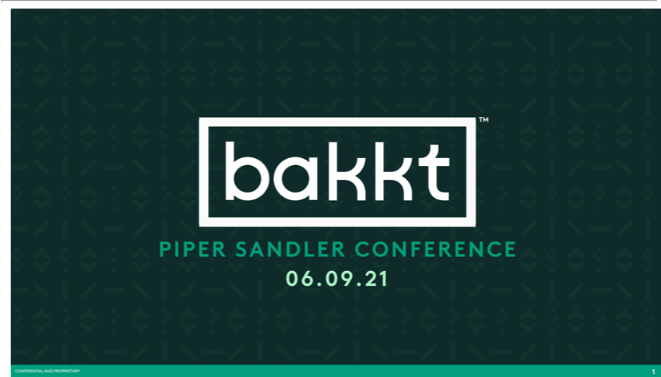

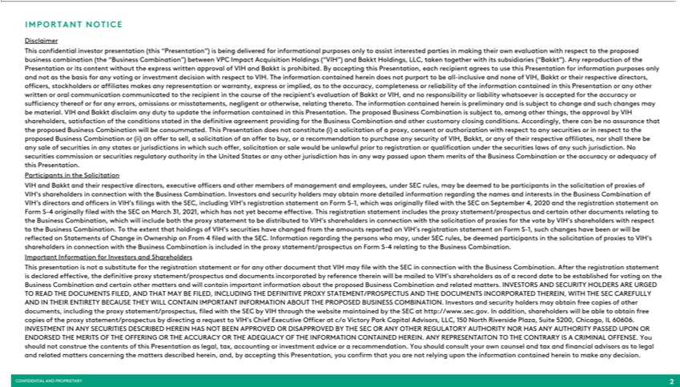

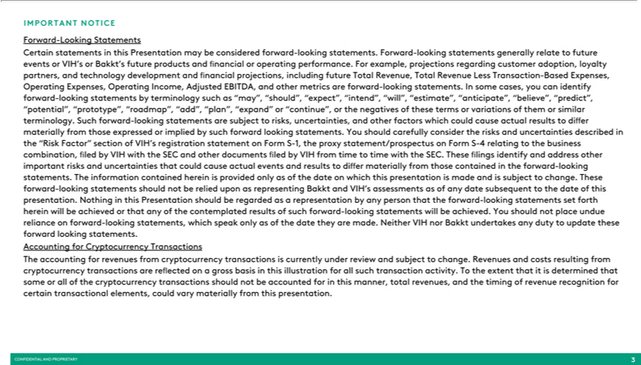

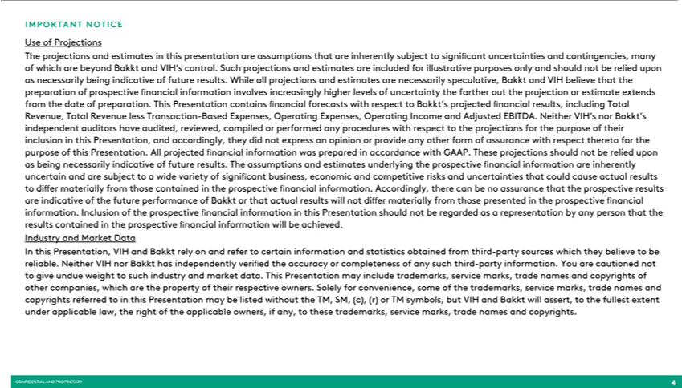

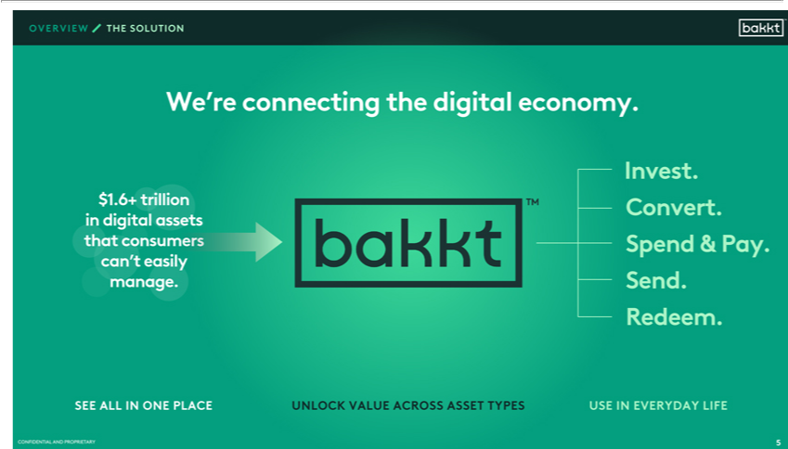

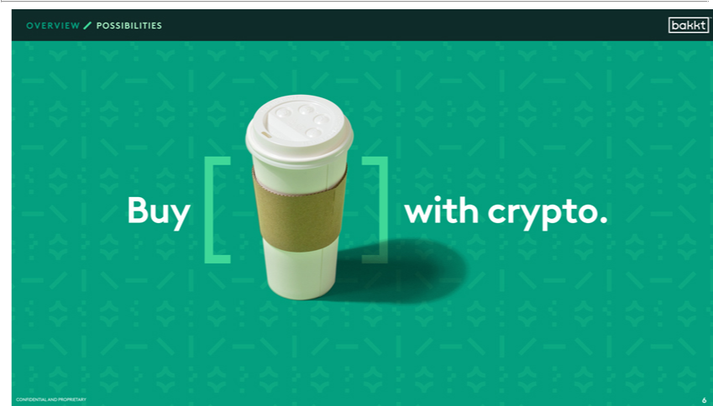







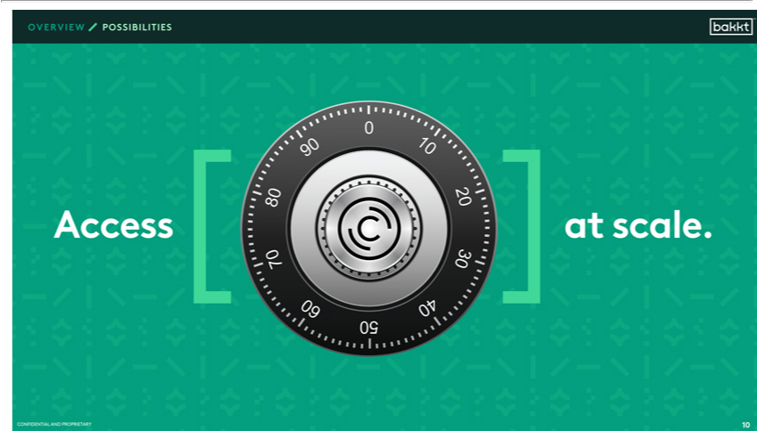

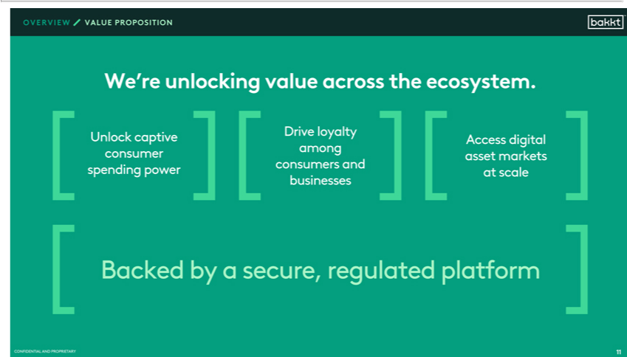

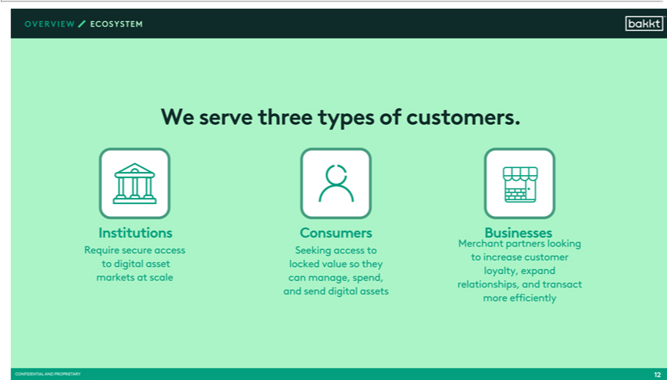

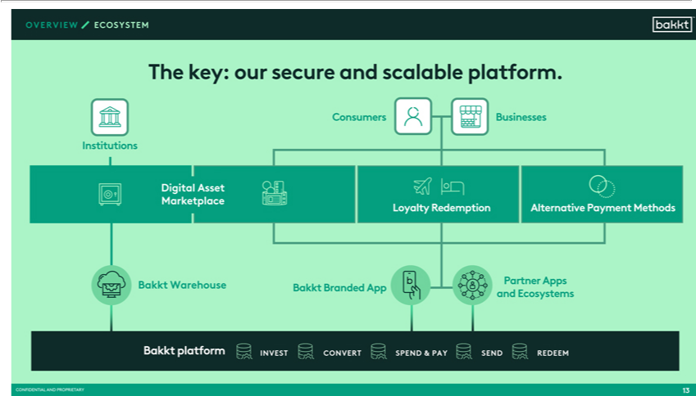

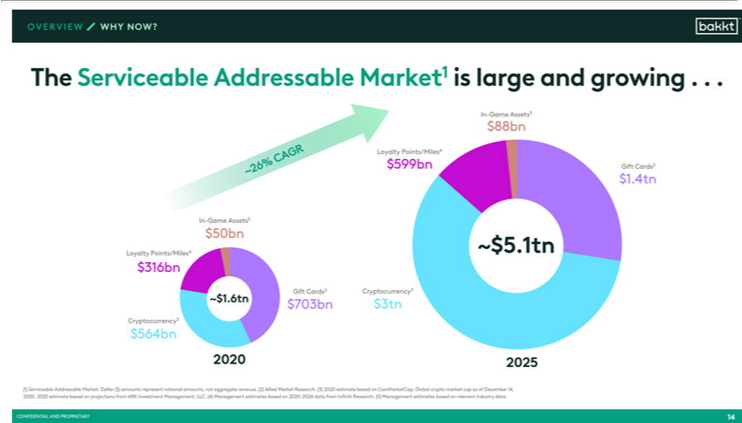

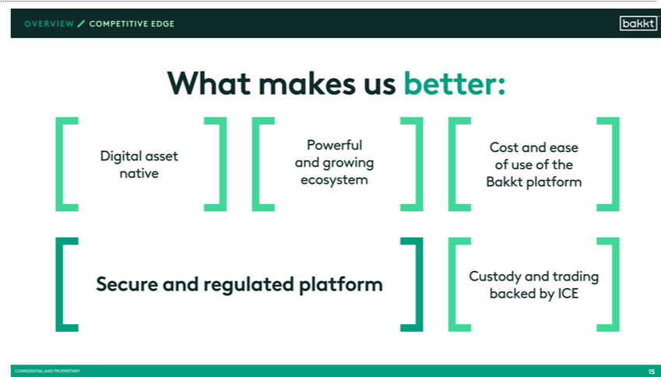

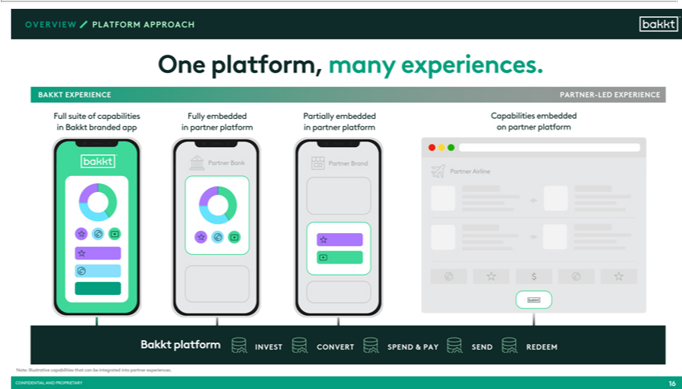

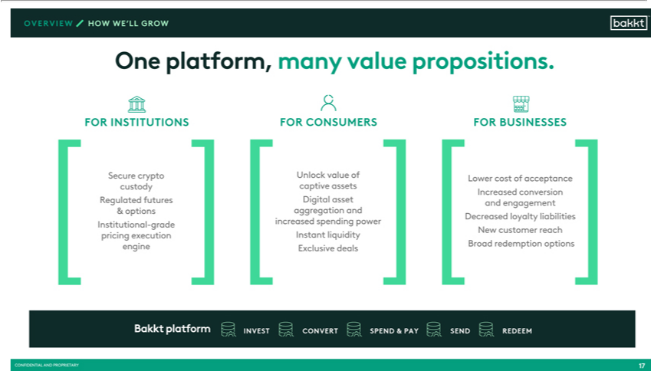

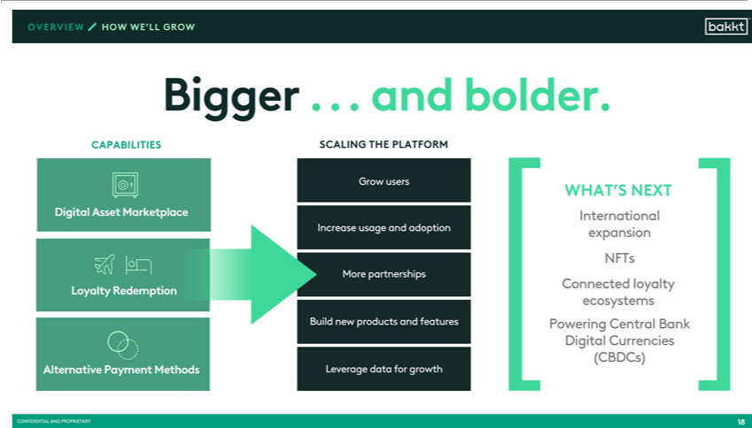

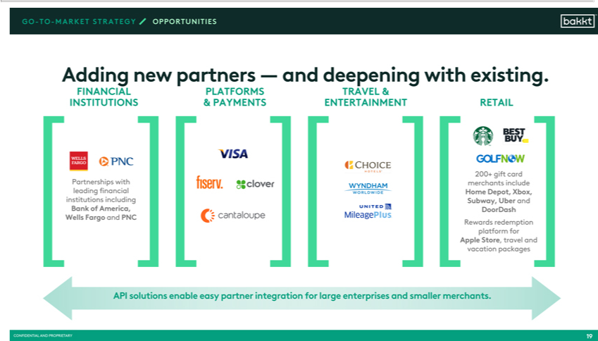

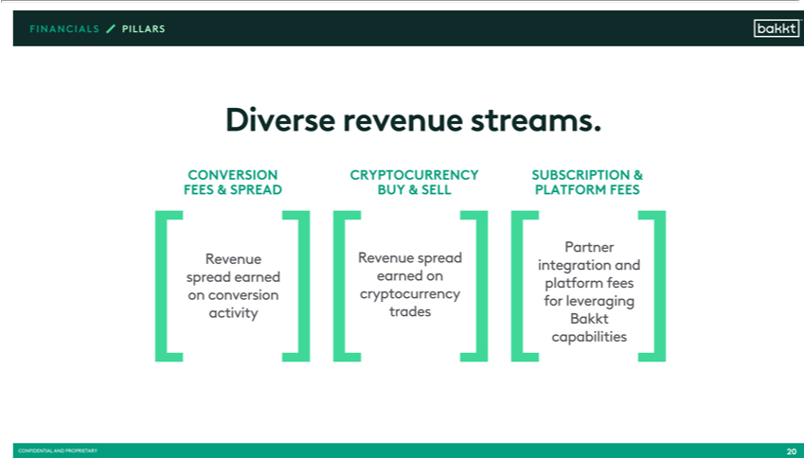

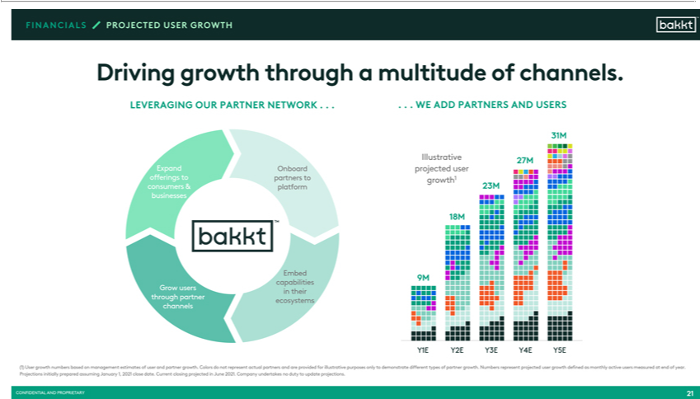

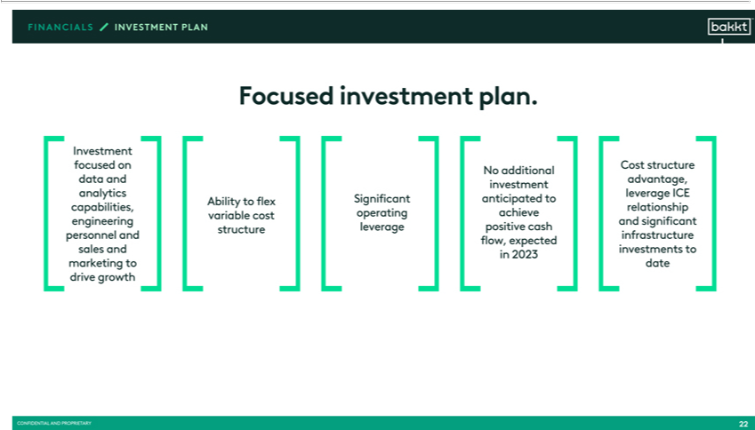

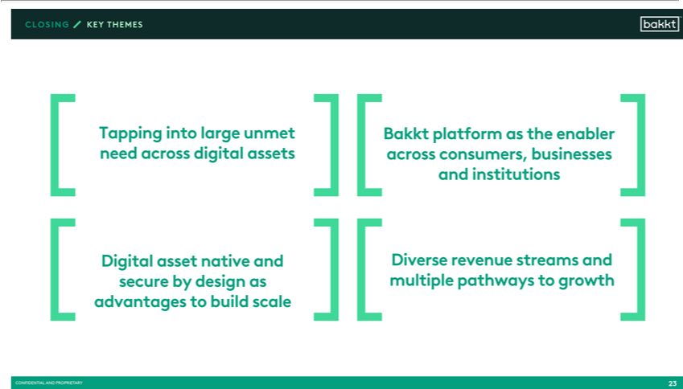

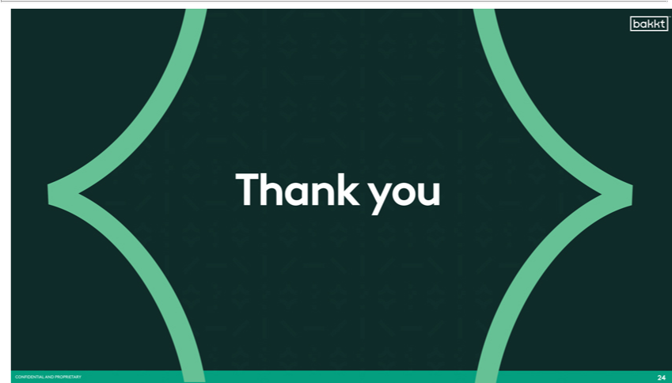

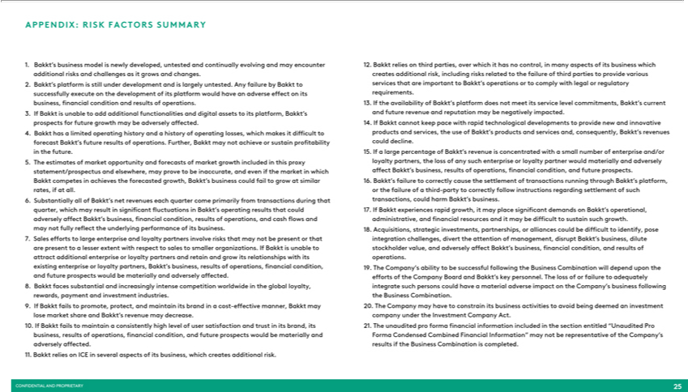

Set forth below is a transcript of Bakkt’s presentation at the Piper Sandler Conference on June 9, 2021. VIH is filing the below in connection with the Proposed Tansaction.

Bakkt Piper Sandler Conference

Richard: We’re on our segment of cryptocurrencies and digital assets. We are very pleased to have back CEO Gavin Michael here to tell us a little bit about Bakkt. Gavin became CEO I believe at the beginning of the year, with the announced SPAC transaction of Bakkt, and a really interesting story about what they’re doing not just with cryptocurrencies but with, like I said, digital assets in general. So I will turn it over to Gavin to go through a little presentation on Bakkt. All yours, Gavin.

Gavin Michael: Thanks, Rich. Good morning everyone, and thank you for joining us for an overview about Bakkt. I’ll just make a couple of quick disclosures.

[audio break]

Respondent: I don’t know what’s happened … Okay. So, early on Bakkt recognized the problem. It’s hard for people to manage all of their digital assets. Our vision is really to connect the digital economy. Digital assets spanning cryptocurrency, loyalty points, rewards, cash, gift cards, equities and newer asset classes like gaming and NFTs comprise a rapidly growing segment of the economy.

Our platform allows consumers and businesses to see and access their digital assets all in one place, unlock the hidden value across asset types, and use them in everyday life for investing, for converting across asset types, for spending and payments, for sending to family and friends, and for redeeming.

Imagine buying your morning cup of coffee with crypto or converting your loyalty points into cash, or redeeming airline points for Apple products, or sending gift cards, cryptocurrency, or cash to family and friends, or simply accessing secure digital asset capabilities at scale.

We’re unlocking new ways to participate in the digital economy, for consumers to be able to aggregate and manage and spend all in one place. For businesses, the opportunity to strengthen loyalty programs and consumer engagement, and for financial institutions to access the digital asset markets at scale. All of this is backed by a secure, highly-regulated platform across all use cases and asset titles.

Our customers fall into three broad categories, institutions, consumers and businesses. We know institutions seek the infrastructure and capabilities to access new markets, products and digital asset ecosystems. We provide greater regulatory clarity, better price discovery, and more effective risk management for institutions. Consumers can access cryptocurrencies, merchant offers, loyalty points, and gift cards, and we increase their spending power and help power commerce.

And we reduce the financial liabilities for businesses associated with loyalty programs. We lower their payment processing costs, and we drive increased brand and loyalty to customers. We also enable access to [00:03:39 new forces] of consumer spending power and loyalty programs that drive growth.

Our platform has three complementary aspects. Our digital asset marketplace is designed to enable participants to transact in digital assets. It has applications for consumers, for businesses, and for institutions. Our loyalty redemption service, particularly our arrangements with leading consumer brands, provide seamless alternatives for consumers to spend their loyalty points and enable loyalty partners to reduce these financial liabilities. And we deliver consumer choice and convenience with an alternate payment method, that allows consumers to use their digital assets across merchants and enable businesses to gain access to consumers’ increased spending power.

All three of these capabilities come together seamlessly in our consumer app, but these same capabilities can be made available in our partners’ apps and in their broader ecosystems. And our Bakkt warehouse is a regulated custodian that really operates as the backbone of both our consumer and institutional proposed solutions. Underlying these products and channels as a core platform with all of these capabilities built with security and regulatory compliance at its core, and it serves all three customer segments effectively

Our serviceable addressable market is large at $1.6 trillion across cryptocurrencies, gift cards, loyalty rewards, and gaming assets. All asset classes in our addressable market is growing, and the overall market is growing in excess of 25% through 2025. We believe that our total addressable market continues to grow, fueled by international growth, increased asset class digitization, increased retail and commerce participation, and new asset classes being offered.

Our business model provides us with many competitive advantages. We have a digital asset-native architecture that is engineered to support digital assets across a wide range of classes, with scalability and strong regulatory and compliance controls at its very core. We have powerful partnerships and integration, big relationships with, and importantly connections into a significant proportion of the premier loyalty partners here in North America.

And then finally, we run a trusted platform. It is secure by design, it’s scalable, and it’s low latency. And all of this capability comes from our partnership with [00:06:43 ICE]. Our Bakkt platform supports a range of customer experiences. Many of our platform’s capabilities come together in our seamless, easy-to-use consumer app, but our partners can also embed a range of experiences in their platforms. When we think about our platform propositions for institutions, our Bakkt warehouse provides Bitcoin futures contracts as well as institutional-grade standalone Bitcoin custody for investors who are really seeking secure Bitcoin storage.

We’re extending this capability into other cryptocurrencies, and once added it will be the foundation upon which will build subsequent product offerings. For consumers our platform and experience helps consumers unlock the value of their captive assets, aggregating their digital assets all in one place, and really increasing their spending power across channels. Our partner and merchant network really expands the payment options that consumers have. It provides additional liquidity and rewards and offers to Bakkt consumer users.

And then for businesses, our loyalty redemption service really offers them greater control of redemption opportunities for businesses to reduce their financial liabilities. We also reduce the cost of payments. We’re displacing transactions off traditional payment infrastructure to gain lower payment fees and faster settlement time.

We believe we’re well-positioned for future growth by leveraging our infrastructure, our expertise, and our institutional and consumer approach. Our platform partners and products will really result in new users and increased usage in adoption from our consumers, and our growth strategies really include increasing the breadth and depth of the digital assets that are supported, adding partnerships, increasing the participation, and leveraging data in smart ways for growth.

As the platform scales we’ll earn the right to expand into new markets, into NFT and well-beyond. Our pipeline is growing and awareness is building. We’re having the most robust partner conversations in the following segments. The first is consumer financial services, where our solutions can embed through these partners, enabling access to cryptocurrency and for rewards to be exchanged for crypto and other digital assets, or simply offering new redemptions to earn and not just burn consumer digital assets.

Partners appreciate a trusted partner in Bakkt who shares the same regulatory-first approach and passion for designing a seamless user experience. The same value proposition exists for the travel and entertainment companies. The airlines, hotels and sporting venues are some of the first to raise their hands to become part of our network.

In other categories such as retail, we can offer lower transaction fee options via direct payment integration with merchants like Starbucks or Best Buy, or the ability to accept our new debit card funded by points or with crypto anywhere Apple Pay or G-Pay is available.

The fourth key category are platform companies such as point-of-sale systems and customer loyalties platform, which gives us an accelerated one-to-many path to merchants.

As we expand with these partners, our revenue in our business model comes primarily from three sources. The first source of revenue is from the spread that we make on transactions completed on the platform and the conversion of points for purchases. We expect to be able to expand revenue in this category by both increasing the number of partners that utilize the platform and expanding the capabilities that really do increase the possibilities of how consumers contract with us.

The second source of revenue is cryptocurrency buy and sell. We earn a spread each time our customers make a trade in crypto.

Finally we see subscription and platform fees that we received directly from partners that utilize our platform.

One of our largest keys to growing our revenue in the future is the growth of the consumer base, and that’s using our platform. This sort of includes customers that are directly – that are directed to the platform through partner channels, and those that download and use the Bakkt app directly. Our growth projections assume that we’re able to rapidly increase users on the platform through a combination of these efforts, B-to-B-to-C, and direct-to-consumer. We believe the more partners we onboard to the platform and the more offerings we provide, the more consumer growth and transaction volume we can generate as a business. And we have the additional advantage of a partner network who assist in growing our customer base.

Our focused and disciplined investment plan increases spend across categories, including the product and tech developers needed to continue building the platform, the sales force needed to grow the business, and the new leadership team that we’ve been recruiting to lead the company forward. Significat investments and acquisitions have already been made in the platforms since Bakkt’s inception in 2018, and we’ll be able to use those investments and our relationship with [00:12:46 ICE] to continue to accelerate the growth of the business.

Our investment plan also includes significant marketing spend, to be used with partners to execute co-marketing agreement, provide incentive for new customers to increase adoption and usage, and a modest amount of direct marketing through the consumer app. We expect to be able to use these flexible tools based upon [00:13:11 global] results, and where we believe we can achieve the lowest customer acquisition costs and the highest consumer engagement.

So before we get into Q&A with Richard, a few things I want to leave you with. Bakkt is tapping into a large and growing digital asset ecosystem with capabilities that enable consumers, businesses and institutions to access and extract value from these assets. Our foundation as a digital asset-native institution and our scalable, regulated, and secure platform will really serve as a differentiator as we expand our capabilities and our products set. And these capabilities and products create a number of diverse revenue streams for Bakkt, for our partners, and our pathway to growth.

So with that, thank you. I appreciate your time.

Additional Information and Where to Find It

In connection with the Proposed Transaction, VIH has filed a registration statement on Form S-4 that includes a proxy statement/prospectus of VIH. This document is not a substitute for the proxy statement/prospectus, that will be both the proxy statement to be distributed to holders of VIH’s ordinary shares in connection with its solicitation of proxies for the vote by VIH’s shareholders with respect to the Proposed Transaction and other matters as may be described in the registration statement, as well as the prospectus relating to the offer and sale of the securities to be issued in the Domestication. After the registration statement is declared effective, VIH will mail a definitive proxy statement/prospectus and other relevant documents to its shareholders. This document does not contain all the information that should be considered concerning the Proposed Transaction and is not intended to form the basis of any investment decision or any other decision in respect of the Proposed Transaction. VIH’s shareholders and other interested persons are advised to read, when available, the preliminary proxy statement/prospectus included in the registration statement and the amendments thereto and the definitive proxy statement/prospectus and other documents filed in connection with the Proposed Transaction, as these materials will contain important information about Bakkt, VIH and the Proposed Transaction.

INVESTORS AND SECURITY HOLDERS AND OTHER INTERESTED PARTIES ARE URGED TO READ THE PROXY STATEMENT/PROSPECTUS AND ANY OTHER RELEVANT DOCUMENTS THAT ARE FILED OR WILL BE FILED WITH THE SEC, AS WELL AS ANY AMENDMENTS OR SUPPLEMENTS TO THESE DOCUMENTS, CAREFULLY AND IN THEIR ENTIRETY WHEN THEY BECOME AVAILABLE BECAUSE THEY WILL CONTAIN IMPORTANT INFORMATION ABOUT BAKKT, VIH, THE PROPOSED TRANSACTION AND RELATED MATTERS.

When available, the definitive proxy statement/prospectus and other relevant materials for the Proposed Transaction will be mailed to shareholders of VIH as of a record date to be established for voting on the Proposed Transaction. VIH shareholders will also be able to obtain copies of the preliminary proxy statement/prospectus, the definitive proxy statement/prospectus and other documents filed with the SEC, without charge, once available, at the SEC’s website at www.sec.gov. These documents (when they are available) can also be obtained free of charge from VIH upon written request to VIH by emailing vihinfo@victoryparkcapital.com or by directing a request to VIH’s secretary at c/o Victory Park Capital Advisors, LLC, 150 North Riverside Plaza, Suite 5200, Chicago, IL 60606.

No Offer or Solicitation

This communication is for informational purposes only and is not intended to and shall not constitute an offer to sell or the solicitation of an offer to sell or the solicitation of an offer to buy or subscribe for any securities or a solicitation of any vote of approval, nor shall there be any sale, issuance or transfer of securities in any jurisdiction in which such offer, solicitation or sale would be unlawful prior to registration or qualification under the securities laws of any such jurisdiction. No offer of securities shall be made except by means of a prospectus meeting the requirements of Section 10 of the Securities Act of 1933, as amended, and otherwise in accordance with applicable law.

Participants in Solicitation

This communication is not a solicitation of a proxy from any investor or securityholder. However, VIH, Bakkt, Intercontinental Exchange Holdings, Inc. (“ICE”) and certain of their respective directors and executive officers may be deemed to be participants in the solicitation of proxies in connection with the Proposed Transaction under the rules of the SEC. Information regarding VIH directors and executive officers may be found in its registration statement on Form S-1, including amendments thereto, and other reports which are filed with the SEC. Additional information regarding the participants will also be included in the registration statement on Form S-4 that includes the preliminary proxy statement/prospectus, when it becomes available. When available, these documents can be obtained free of charge from the sources indicated above.

Cautionary Statement Regarding Forward-Looking Statements

This communication contains “forward-looking statements” within the meaning of the Private Securities Litigation Reform Act of 1995. Such statements include, but are not limited to, statements about future financial and operating results, our plans, objectives, expectations and intentions with respect to future operations, products and services; and other statements identified by words such as “will likely result,” “are expected to,” “will continue,” “is anticipated,” “estimated,” “believe,” “intend,” “plan,” “projection,” “outlook” or words of similar meaning. These forward-looking statements include, but are not limited to, statements regarding Bakkt’s industry and market sizes, future opportunities for VIH, Bakkt and the combined company, VIH’s and Bakkt’s estimated future results and the Proposed Transaction, including the implied enterprise value, the expected transaction and ownership structure and the likelihood and ability of the parties to successfully consummate the Proposed Transaction. Such forward-looking statements are based upon the current beliefs and expectations of our management and are inherently subject to significant business, economic and competitive uncertainties and contingencies, many of which are difficult to predict and generally beyond our control. Actual results and the timing of events may differ materially from the results anticipated in these forward-looking statements.

In addition to factors previously disclosed in VIH’s reports filed with the SEC and those identified elsewhere in this communication, the following factors, among others, could cause actual results and the timing of events to differ materially from the anticipated results or other expectations expressed in the forward-looking statements: (i) inability to meet the closing conditions to the Proposed Transaction, including the occurrence of any event, change or other circumstances that could give rise to the termination of the definitive agreement; (ii) the inability to complete the Proposed Transaction due to the failure to obtain approval of VIH’s shareholders or Bakkt’s members, the failure to achieve the minimum amount of cash available following any redemptions by VIH’s shareholders or the failure to meet the national stock exchange’s listing standards in connection with the consummation of the Proposed Transaction; (iii) costs related to the Proposed Transaction; (iv) a delay or failure to realize the expected benefits from the Proposed Transaction; (v) risks related to disruption of management time from ongoing business operations due to the Proposed Transaction; (vi) the impact of the ongoing COVID-19 pandemic; (vii) changes in the markets in which Bakkt competes, including with respect to its competitive landscape, technology evolution or regulatory changes; (viii) changes in the markets that Bakkt targets; (ix) risk that Bakkt may not be able to execute its growth strategies, including identifying and executing acquisitions; (x) risks relating to data security; and (xi) risk that Bakkt may not be able to develop and maintain effective internal controls. The foregoing list of factors is not exhaustive. You should carefully consider the foregoing factors and the other risks and uncertainties described in the “Risk Factors” section of VIH’s final prospectus dated September 22, 2020 relating to its initial public offering, the registration statement on Form S-4 and proxy statement/prospectus discussed above and other documents filed by VIH from time to time with the SEC. These filings identify and address, or will identify and address, other important risks and uncertainties that could cause actual events and results to differ materially from those contained in the forward-looking statements.

Actual results, performance or achievements may differ materially, and potentially adversely, from any projections and forward-looking statements and the assumptions on which those forward-looking statements are based. There can be no assurance that the data contained herein is reflective of future performance to any degree. You are cautioned not to place undue reliance on forward-looking statements as a predictor of future performance as projected financial information and other information are based on estimates and assumptions that are inherently subject to various significant risks, uncertainties and other factors, many of which are beyond our control. All information set forth herein speaks only as of the date hereof in the case of information about VIH and Bakkt or the date of such information in the case of information from persons other than VIH or Bakkt, and we disclaim any intention or obligation to update any forward looking statements as a result of developments occurring after the date

of this communication. Forecasts and estimates regarding Bakkt’s industry and end markets are based on sources we believe to be reliable, however there can be no assurance these forecasts and estimates will prove accurate in whole or in part. Annualized, pro forma, projected and estimated numbers are used for illustrative purpose only, are not forecasts and may not reflect actual results.

